Leadership Through Facilitation
Module 8: Facilitating Meetings Part 2

Facilitator Guide

Table of Contents
Facilitator’s Information
Table of Contents 1
How to Use This Guide 2
Symbols Used in the Facilitator’s Guide 3
Materials & Equipment for Module 8 of The Facilitative Leader 4
Leadership Through Facilitation Module 8: Agenda 5
Module 8: Introduction 7
Module 8: Facilitating Meetings Part 2 8

How to Use This Guide
This Facilitator’s Guide covers the following:
- Work you’ll need to do prior to the workshop,
- Materials and equipment you’ll need for the workshop, and
- Instructions and verbiage to conduct the workshop.
Headings
The heading for each section indicate the information that will be covered in that particular section.
Instructions Section
On the right-hand side of the workshop instructions pages you’ll find the approximate number of minutes required to complete a topic.
The format for the instructions section contains 2 columns as follows:
- Left-hand Column:  - Contains graphics, such as a copy of a slide or an icon, indicating the major aspect of the training segment. For example, a television set icon indicates that a video will be shown. The next page shows the various icons used. | - Right-hand Column  - Lists the information or instructions to be conveyed to the participants and contains possible starting questions you can ask about the topic to engage participants in a discussion or an activity.  - Describes the activity to be completed. Note that actions to be done will always be in bold.  NOTE: This Facilitator’s Guide is not intended to be used as a script. The words in this column give you one example of how to deliver the content. Part of your preparation is to review this guide and become familiar with its contents, structure, and flow. You should feel free to use your own words, adjust the delivery to your own style, while also adapting to the needs of the group you are facilitating. At all times, be sure to show enthusiasm and comfort with the material when you are presenting. This will provide a more enjoyable and meaningful session for your participants.
 | Anything in a gray box means that you will be “doing” something rather than presenting.

Symbols Used in the Facilitator’s Guide
There are many symbols used in this Facilitator’s Guide to serve as prompts for the type of activity occurring at that point in the program. Here is a list of those symbols and what they mean.
 | Presentation |  |  | Key Information
 | Spring Forward Exercise |  |  | Pull through previous learnings
 | Pair Discussion/Exercise |  |  | Participant Manual “Write-along”
 | Group Discussion/Exercise |  |  | UMU activity
 | Write responses on a flip chart |  |  | Checkpoint
 | Transition to next topic |  |  | Individual Activity
In some cases, an activity will transition from one type to the other (e.g. from individual to group discussion). In such cases, more than one symbol may be used in chronological order.

Materials & Equipment for Module 8 of The Facilitative Leader
Following is a list of the materials to be used in this training session. Be sure to become familiar with all of them.
- Projector and Screen
- Laptop
- PowerPoint Slides – “The Facilitative Leader: Facilitating Meeting Part 2”
- Facilitator Guide (this document)
- Updated Participant List
- Participant Packets (one for each participant)
  - Tent Cards
  - Participant Manual
  - Spring Forward Booklet
- Flipcharts – one for Facilitator, plus one for each table group)
- Pins/tape to hang posters
- Tape
- Pens and Markers
- Post-it notes (one different color package for each table group)

Flip Charts:
- Course Objectives (posted, if appropriate)
- Ground Rules (posted)
- Coming Attractions (posted)
- Module 8 Agenda
- Post Test

Leadership Through Facilitation Module 8: Agenda
TIME | TOPIC
5 minutes | Workshop Introduction  - Checkpoint  - Course Objectives  - TAFA  - Ground Rules  - Your Materials
7 minutes | Homework Review
 | - Have participants share results of their homework (in pairs, table groups, and/or with the class)
2 minutes | Workshop Introduction  - Agenda (Compare to participant objectives)
13 minutes | E. Maintaining Focus During the Meeting  - Using Checkpoints with Each Agenda Item  - Give Clear Directions (PeDeQs)  - Redirect Side Issues  - Record Relevant Information
15 minutes
15 minutes
20 minutes
20 minutes
10 minutes
15 minutes
10 minutes
15 minutes | Spring Forward 5a. Resolving a Disagreement
15 minutes | - Participants identify the types of disagreements that occur in their organizations and think through strategies to work through them.
8 minutes | Review
8 minutes | - Numerous review slides to test understanding and learning.
10 minutes | Homework or In-Class Assignment: Spring Forward 5b. Improving Decision Making
10 minutes | - Participants plan for an upcoming meeting, thinking about how the decision will be made.
15 minutes | Session Close (Will vary based on FL “package” being delivered.)  - Review Agenda  - TAFA: Tools and Concepts in this Module  - Checkpoint to next module if appropriate  - Connect with LSI  - Congratulations slide with appropriate closing activities depending on whether this module is delivered as part of the four-day or as a stand-alone  - Execute Post-Test if appropriate  - Award dot winner MVP prize if appropriate  - Complete From Classroom to Application if appropriate  - Execute Evaluation if appropriate  - Formally close the session.
180 minutes  (3 hours) | Total Training Time

Module 8: Introduction
Overview
Leaders learn techniques to use while coaching individuals for high performance.
Modules include the following:
- Closing the Meeting
- Managing Dysfunction
- Running Virtual Meetings
- Using Guerilla Facilitation

Key Learnings
- How to effectively close a meeting
- How to prevent and manage dysfunctional behaviors
- How to run effective virtual meetings
- How to lead from the side if a meeting is not being led effectively

Facilitation Tips/Background Information
- Post on the wall ahead of time three flip chart pages with the following titles
  - Objectives
  - Agenda
  - Coming Attractions
- Accommodate participant objectives where possible, but do not be tempted into shoe-horning their objectives into the planned activities. If it’s not going to be covered, explain why it is out of the parameters of this workshop. If appropriate, consider covering out-of-scope objectives over lunch, on breaks, or in some other way.
- Be familiar with the background and history behind the DISC profiles (see History of the DISC Assessment in this guide.

Timing: 3 hours

Module 8: Facilitating Meetings Part 2
- Maintaining Focus During the Meeting
- Closing the Meeting
- Preventing, Detecting and Resolving Dysfunction
Exercise 8a: Resolving Dysfunction in a Meeting
- Running Virtual Meetings
- Using Guerilla Facilitation
Exercise 8b: Applying the Masterful Meeting Strategies

Timing: 3 hours
PPT: Title   |  |  | SHOW POWERPOINT: Facilitative Leader  Note to Instructor: Customize your opening depending on the modules the group will be receiving in total, whether you are following a previous module, coming back from time in-between modules, or only running this workshop for this group.  SAY:  Welcome Managers to the Leadership Through Facilitation Workshop!  Introduce yourself and your background.  Have participants introduce themselves by sharing name, position, and years with the company. Ensure that each participant has signed in.
PPT: 8 Facilitating Meetings-Part II  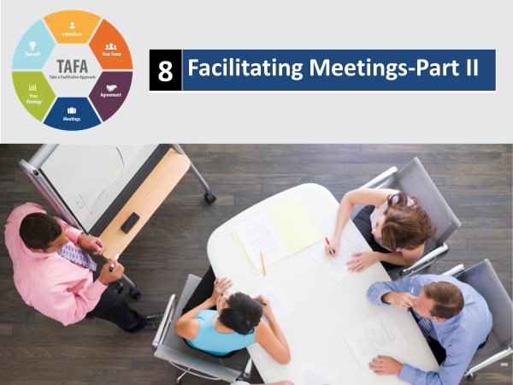 |  |  | SHOW POWERPOINT: Facilitating Agreement  SAY:  You’ll walk away with an understanding of:  - How to keep the group focused  - How to properly close a meeting  - How to prepare for excellent meetings  - How to prevent and manage dysfunction in meetings  - How to support other leaders in meetings when they aren’t going well
PPT: Checkpoint  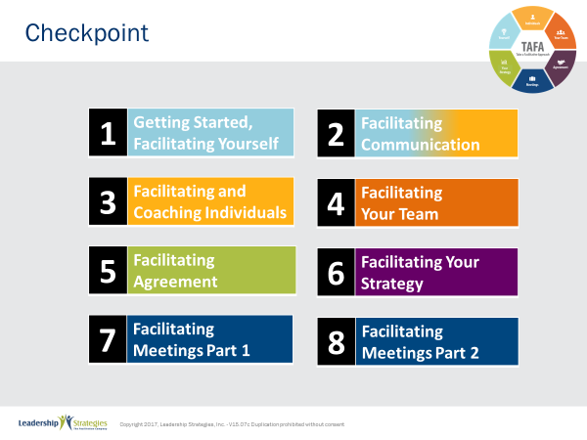 |  |  | SHOW POWERPOINT: Checkpoint  CHECKPOINT:  In our last module, we covered part one of Facilitating Meetings where we learned some meeting basics including how to prepare and start a meeting. Now we will move into how to run and close effective meetings. By the end of this module, you will be ready to facilitate masterful meetings.
PPT: TAFA  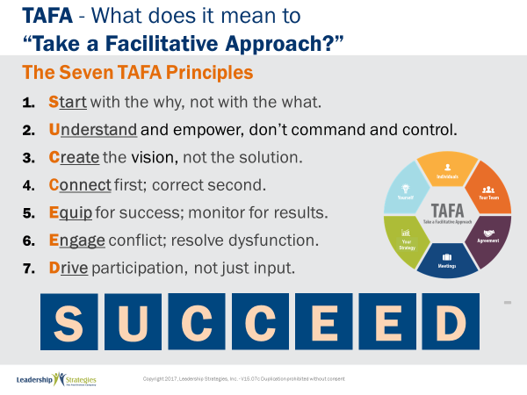 |  |  | SHOW POWERPOINT: TAFA  SAY:  Let’s review the TAFA principles:  There are 7 key TAFA principles – the principles of taking a facilitation approach. Any time you have a decision to make, a problem to solve, someone to coach or correct, we are going to be giving you tools and techniques for implementing these principles.  Let’s walk through them together.  People are often inspired when they are connected and aligned with purpose. Unfortunately, as leaders we often focus on what we want done and start there. Facilitative leaders understand the importance of why and always start any discussion, meeting, initiative kickoff, etc., with the why.  Often leaders don’t involve those impacted because they believe they need to control all aspects of what is done to achieve their desired result. They don’t take the time to understand how to adapt to the styles of their people to inspire performance because they don’t understand the relationship between engagement and results.  However, leaders who take a facilitative approach understand how to empower others by defining purpose and providing guidelines that allow teams to create recommendations that are thoughtful and innovative, but also practical and implementable. They adjust their own management styles to get the most out of their people.  One of the key roles of leaders is to set a vision of success with a clear and compelling “why” that inspires success. Facilitative leaders understand that once they set the vision they must give their people the authority, resources, support and coaching so that their people can develop and implement solutions and strategies that bring the vision into reality.  Some leaders are expert at pointing out mistakes their people make. They seem to enjoy demonstrating their superiority by identifying errors and then showing their people what they have done wrong.  Leaders who take a facilitative approach understand the importance of connecting with people first and helping them discover their own errors. They recognize the power of being the “guide on the side” rather than the “sage on the stage.” They strive to leave every interaction with the person feeling lifted rather than beaten down.  So many teams are essentially destined to fail from the start because they are not properly equipped for success. Facilitative leaders understand that teams require eight essentials and provide teams the essentials they need to accomplish their work. At the same time, many plans fall short of their desired ends due to lack of monitoring for results. For example, how often do strategic plans get written and then put on a shelf? Facilitative leaders understand the need to monitor for results every step of the way.  Leaders who don’t have the tools to effectively manage conflict and dysfunction tend to respond with either a “fight or flight” strategy when faced with a challenging situation. Those leaders who take the flight approach will avoid addressing issues and hope they go away on their own. Those employing the fight strategy tend to try to overpower situations by forcing their will without listening to or considering other alternatives.  Leaders skilled in taking a facilitative approach view disagreement as an opportunity to identify better solutions; they view dysfunction as a sign that something important is not being addressed. They understand the three reasons people disagree and have strategies for addressing each one. They fully buy-in to the dysfunction principles--conscious prevention, early detection, and clean resolution--and use appropriate techniques to prevent, detect and resolve dysfunction.  How often does a decision come down from headquarters which the people in the field know makes absolutely no sense? The idea couldn’t possibly work and everyone knows it, except the leaders. What happens? Time and energy is wasted implementing something that months later gets abandoned when the leaders finally figure out it was a bad idea. If they had only asked, the wasted time and resources could have been put to a much more productive use. If they had only asked.  Or how often, when trying to make a needed change, does the change get met with blatant rejection or subtle subterfuge simply because those expected to implement the change were not involved up front in the creation?  Leaders who take a facilitative approach recognize that you can get better decisions and achieve higher levels of buy-in when those impacted by the decision are involved in creating it.  - In the first case of a decision coming from headquarters, the involvement of those who would have to implement the decision would have likely yielded an even better solution that considered issues and situations that the workers understood but of which the leaders were unaware.  - In the case of the needed change that was met with significant opposition, involvement up front could have yielded greater buy-in and commitment to the implementation.  SUMMARIZE:  These principles outline what it means to take a facilitative approach inside an organization. As more and more leaders adopt a facilitative approach to leadership, we expect to see greater business results through higher levels of buy-in and commitment throughout the organization.
  1 | Start with the why, not with the what
  2 | Understand and empower; don’t command and control
  3 | Create the Vision, not the solution
  4 | Connect first; correct second
  5 | Equip for success; monitor for results
  6 | Engage conflict; address dysfunction
  7 | Drive participation, not just input
TRANSITION:
Just a few quick housekeeping items before we jump into the meat of today’s workshop.
PPT: Ground Rules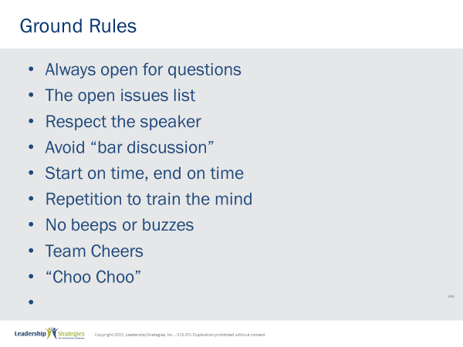 |  |  | SHOW POWERPOINT: Ground Rules (build)  SAY:  Well, as you can see, we have a very ambitious agenda over the next [two] days. To get through it smoothly, I would like us to agree on some “Ground Rules” or “Session Guidelines.”  ASK:  By a show of hands, how many of you have been in some type of training class before? [Raise your hand.]  SAY:  So, you know those things that work and don’t work. I value your time. I want this to be a productive session for you. So, what are those guidelines that we need to have in place to make this a productive session for you? Let’s look at these ground rules for how we will conduct our session for the next [two] days and reach an agreement on them.  DO:  REVIEW ground rules on slide. ASK the group if they would like to add or delete any of these ground rules.  ASK for a show of hands to adopt the ground rules as revised.
PPT: Your Materials  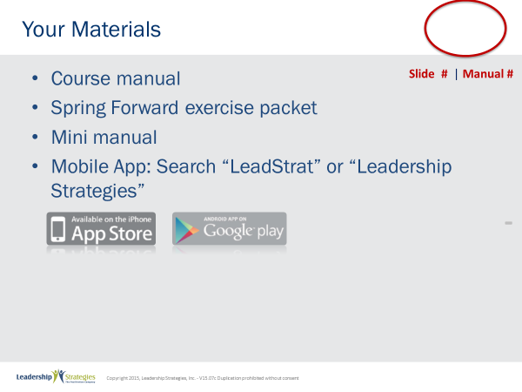 |  |  | SHOW POWERPOINT: Your Materials (build)  DO:  REVIEW the content on the slide.
PPT: Homework Review  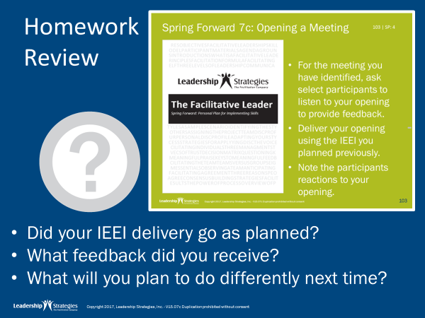 |  |  | SHOW POWERPOINT PPT: Homework Review  SAY:  Let’s pull out the Spring Forward manual so we can discuss how we applied what we learned last time.  DO:  READ through the activity to remind people… process responses for examples, have them talk at tables, have them share with one partner, have one person from each table share their view, etc.
PPT: 8 Facilitating Meetings-Part I-II  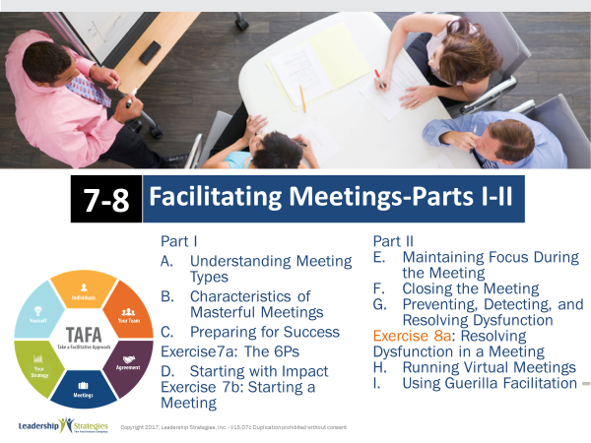 |  |  | SHOW POWERPOINT: 8 Facilitating Meetings-Part I-II  DO:  REVIEW the module agenda on the slide.  Ask:  Is there anything you were expecting to see on the agenda that isn’t there?  DO:  DISCUSS in a similar way to the personal objectives and WRITE on the Objectives flip chart if appropriate
PPT: Agenda  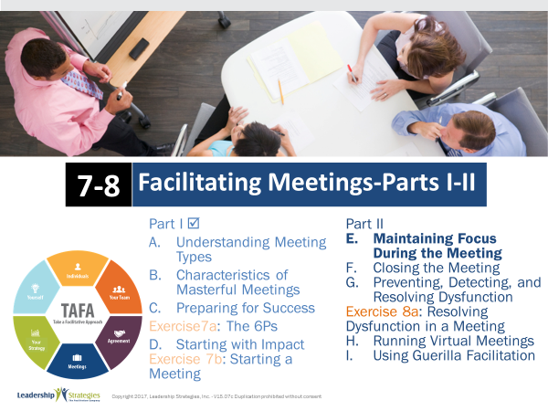 |  |  | SHOW POWERPOINT: Agenda  CHECKPOINT:  Now that we have established the course for today, let’s talk about how to keep your meetings focused. This is a commong challenge, right?
PPT: Using Checkpoints with Each Agenda Item  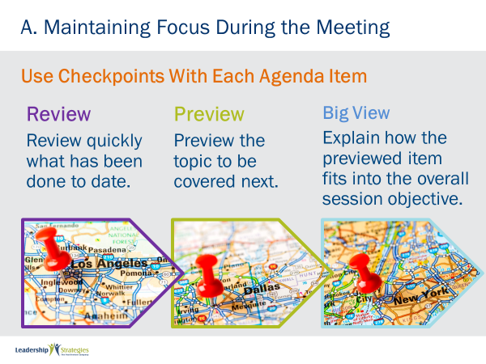 |  |  | SHOW POWERPOINT: Using Checkpoints with Each Agenda Item (build)  DAVE – the slide says “A” – but it is “E”  ASK:  How many of us have been in a meeting that just seemed to drag? [raise your hand] Have you ever wondered where you are on the agenda during a meeting? [nod your head]  SAY:  Well, we are about to share with you a great technique that allows you, as the meeting leader, to figuratively “put the participants on your shoulder” and carry them through the meeting agenda or process. We call this a Checkpoint.  A Checkpoint is comprised of three distinct parts:  - Review: a brief review of what has been done to date  - Preview: a statement about what the group is about to do and  - Big View: an explanation of how the item just Previewed fits into the overall objective of the meeting or session  What we often find when observing people conducting meetings is that they typically do the first two steps; they overlook that Big View or WHY. And, when you really think about it, it is all about the WHY. Give them the Big View and that issue is addressed as you move to every new agenda item in a meeting
PPT: Maintaining Focus During the Meeting  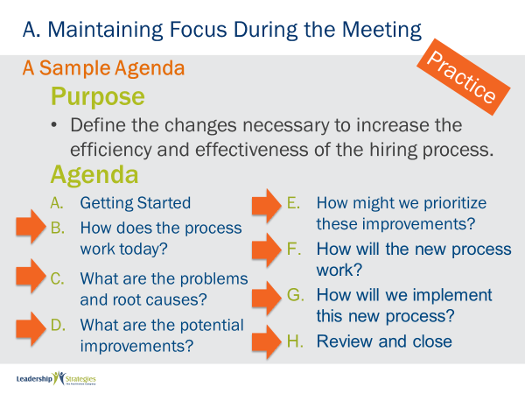 |  |  | SHOW POWERPOINT: Maintaining Focus During the Meeting  DAVE – the slide says “A” – but it is “E” (all slides this section need to be updated  DO:  ASSIGN a new team lead.  SAY:  Let’s assign each team a Checkpoint as follows:  - (purple) team; how about taking us from Agenda Item B to C  - (blue) team; how about taking us from Agenda Item C to D  - (green) team; how about taking us from Agenda Item D to E  - (red) team; how about taking us from Agenda Item E to F  Before we begin, let me do a quick example by going from Agenda Item A to B.  DO:  DELIVER the following sample checkpoint.  - Review: we have just completed our introductions where we have identified your key topics and matched them to our agenda for the session  - Preview: what we are about to do next is define the steps in the current hiring process  - Big View: and that’s important because before we start identifying problems and solutions let’s all start with a common understanding of the existing hiring process  SAY:  OK, let me allow each team 1 minute to prepare their checkpoint.  DO:  START the clock; when time is up, have each team present their checkpoint; award dots.
PPT: Give Clearn Directions  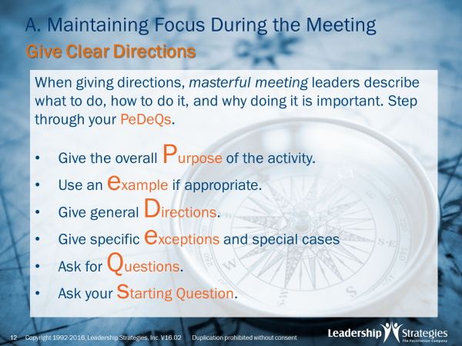 |  |  | SHOW POWERPOINT: Give Clear Directions (build)  ASK:  How many of you have provided instructions to a group on an activity you would like them to do as a part of a meeting? [raise your hand] Anyone ever had the experience where there was a lack of clarity? [nod your head] Or, in the middle of the activity, you realize the participants were not doing what you believe you instructed them to do? [nod your head]  SAY:  Using Your PeDeQs for Directions will solve this dilemma. Let’s look at what we mean by that.  DO:  REVIEW the slide; model a set of PeDeQs for the participants.
PPT: Redirect Side Issues  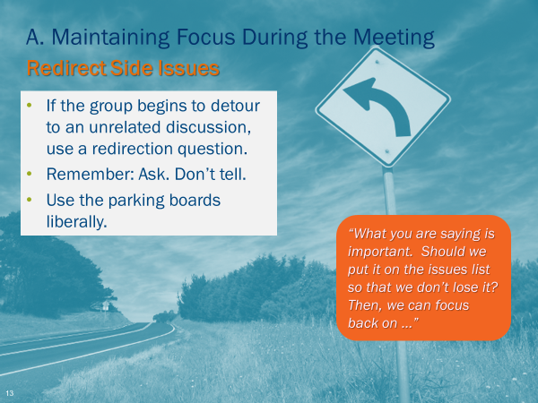 |  |  | SHOW POWERPOINT: Redirect Side Issues (build)  SAY:  Another one of my favorite people in the meetings I am a part of is Wandering Willie or Wilhelmina. You know that person that wants to take you down every bunny trail they can think of. The problem is, too many meeting leaders are not equipped or will not address that meeting hijacker. While we want to tackle this with great aplomb, the technique we would like to share with you is the Re-Directing of Side Issues.  For example, you are in the middle of identifying the steps in the current hiring process. And, Willie makes a statement like, “yes, and the problem with that step is it takes too long, etc.” Unskilled meeting leaders allow Willie to talk about that problem and take the meeting off its path or agenda. Of course, we do not want to be rude, yet there will be people in that meeting that will recognize problems will be addressed in another agenda item. And, those process oriented participants will wonder why you are jumping around.  Instead, we respond to Willie with a question such as, “Willie, that is an interesting point. It sounds like a problem and we will be getting to problems in our next agenda item. Would it be OK with you to place that on the Issues List, so we don’t forget it, and get back to identifying all the steps?”  Note, we asked, we did not tell. Our Parking Boards are great vehicles to capturing the key information throughout a meeting. Use them liberally.  ASK:  Any questions on the Re-Direction?  DO:  FACILITATE the discussion.
PPT: Record Relevant Information  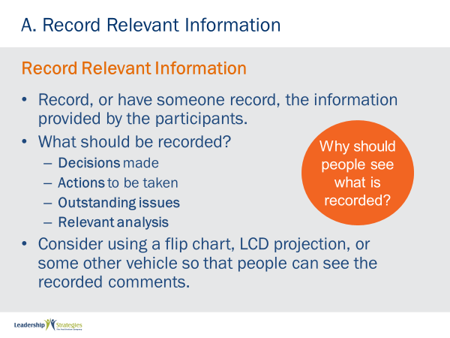 |  |  | SHOW POWERPOINT: Record Relevant Information (build)  SAY:  One of my favorite adages is, “the faintest of ink is better than the longest of memory.” Along those same lines, during a meeting, it is a good idea to ensure the salient points being discussed are captured on a flip chart, a white board or a document you may be projecting in something like a virtual meeting. At a minimum, we always record the items for our three Parking Boards (IDA) and any relevant analysis discussed during the meeting.  ASK:  [Red] team, any comments or items to add?  DO:  FACITLITATE the discussion directing items to each team.
PPT: Use, Don’t Abuse the Pen  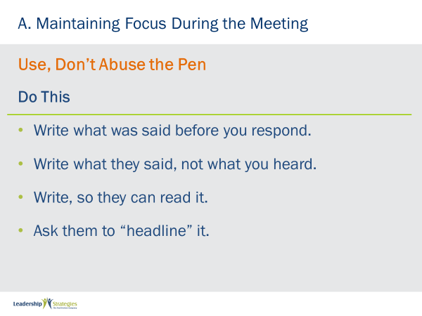 |  |  | SHOW POWERPOINT: Use, Don’t Abuse the Pen (build)  DO:  REVIEW content on the slide.
 | PPT: Use, Don’t Abuse the Pen 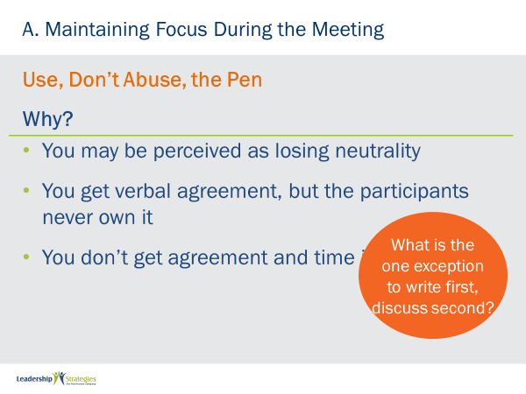 |  | SHOW POWERPOINT: Use, Don’t Abuse the Pen (build)  SAY:  We often find that meeting leaders have a propensity to “help” participants by paraphrasing their comments. In a manner of speaking, that is typically done in an attempt to help the participant. In fact, it is diminishing the ownership of that item and, in a worst-case scenario, is saying to that participant, “Hey you don’t talk so well, so let me talk for you!”  DO:  REVIEW key tips on the slide.  KEY POINT:  The exception would be the Re-Direct and, in essence, we are writing, just in another place; they may raise other items such as profanity, which, of course we would tend not to write; instead say something like, “Is that what you want me to write here?”
 | PPT: Seek Consensus Before Moving On  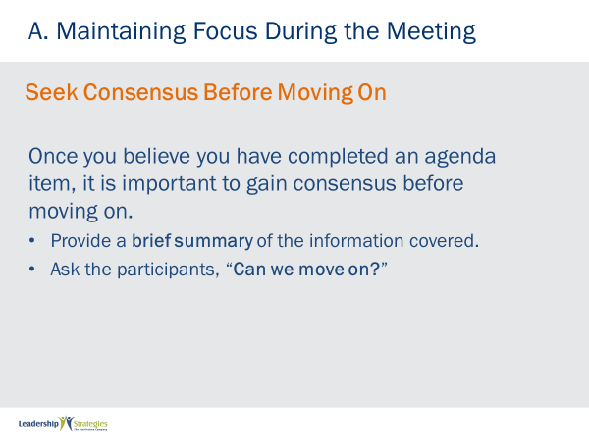 |  | SHOW POWERPOINT: Seek Consensus Before Moving On (build)  SAY:  Consensus can be like a snow ball rolling down a hill. As a meeting leader, we want to gain momentum; we want the meeting participants to know we are making progress and we are getting closer to the end of our meeting and achieving our objectives/purpose. To do that, we find the providing a brief summary and gaining the OK from the participants as we end each agenda item creates that momentum or sense or achievement.  It also allows us to become aware early of outstanding issues or disagreements when the participants are reluctant to move on and/or agree.  ASK:  Any questions on Seeking Consensus Before Moving On?  DO:  FACILITATE the discussion.
 | PPT: Track Time Against the Agenda  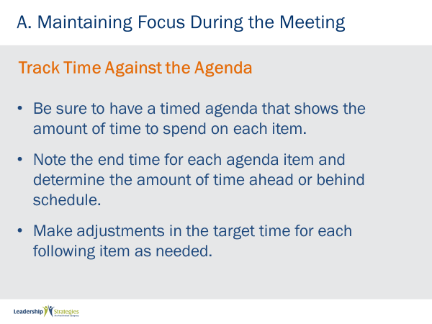 |  | SHOW POWERPOINT: Track Time Against the Agenda (build)  SAY:  As Yogi Berra once said, “when you come to a fork in the road, take it.” If we fail to track our actual times against our planned times we are relying on hope and hope is not a strategy. The tips on this slide allow us to execute that Masterful Meeting and allow us to recognize when we are running ahead or falling behind to make the necessary adjustments vs. running through the last few items in our meeting.  ASK:  Help me [green] team, what are some of the challenges with falling behind and rushing through those last few items?  DO:  FACILITATE the discussion.  KEY POINT:  Actions are typically generated at the end of a meeting and when we close with a statement like, “it’s 4 o’clock, let’s wrap this up”…we run the risk of losing a lot of the impact of our meeting.
 | PPT: Track Time Against the Agenda  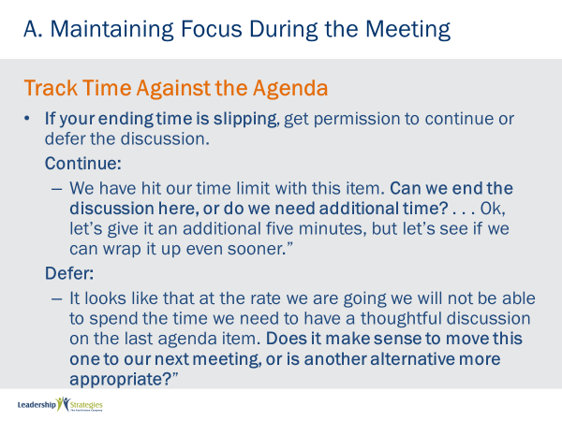 |  | SHOW POWERPOINT: Track Time Against the Agenda (build)  DO:  REVIEW the points on this slide.  NOTE: Consider assigning ½ the teams Continue and the other Defer and then facilitate the discussion.
PPT: Agenda |  |  | SHOW POWERPOINT: Agenda  CHECKPOINT:  We have reviewed several techniques you can use to keep your meeting focused. Now, let’s look at what needs to happen at the close or our meeting. This is critical point. If we skimp on the close, our entire efforts may be wasted.
 | PPT: Books Closed!  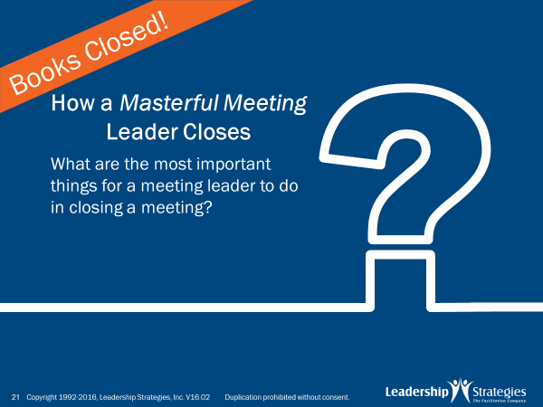 |  | SHOW POWERPOINT: Books Closed!  DO:  FACILITATE the following activity.  PURPOSE - The purpose of this next exercise is to ask each team how they believe a Masterful Meeting Leader Closes a meeting  EXAMPLE - not needed  DIRECTIONS - Each team will be recording their answers to the question I am about to ask on post-it notes. So first, let’s select a new team leader. Since this is our first activity in new teams today, let’s select our first team leader. [Select the new team leader; oldest/newest car; most/least siblings; etc..].  Our team leaders will be doing the following:  1. They will be recording the answers from their teams on the post-it notes and writing with the marker. Note the markers are pretty thick and the post-its are pretty small; so, please write accordingly.  2. Each answer will be recorded on its own, unique post-it note. So, [blue] team, if you have four answers, how many post-it notes would you have? [great, four, that’s as complicated as the math will get today]  3. Finally, I am going to set the clock for two minutes. When the clock rings, indicating time has expired, please cap your markers to keep the competition fair.  All good with that? [nod your head; answer any questions]  EXCEPTION - none  QUESTIONS - Are there any questions before I ask the question to get us started? [respond to any questions]  STARTING QUESTION - OK, think about the next meeting you are going to lead….think about how productive the meeting has been and all the things that were discussed…..you are about to close that meeting….what are all the things you will do to close that meeting to maximize that meeting?  DO:  When the clock expires, use LAST PERSON STANDING to have teams place all closing items on a flip chart titled: Closing Activities. [refer to Day 1 notes for Last Person Standing]  SAY:  Great job folks, you have actually captured many of the activities we believe are needed for that Masterful Close. Let’s take a look at the best practices/techniques we have identified that are a part of a Masterful Close.
 | PPT: Review Items Covered  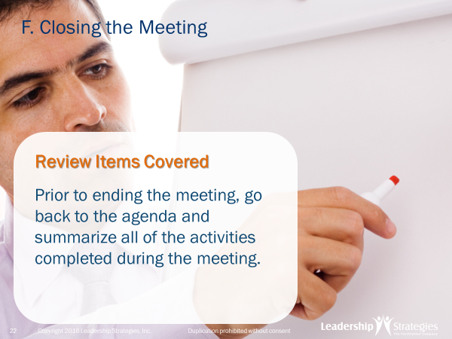 |  | SHOW POWERPOINT: Review Items Covered (build)  SAY:  Too often we rush through the close of a meeting because we do not allow sufficient time for a close. As the meeting leader, we want to close with rigor and to ensure that we maximize the impact of the meeting. We start with a review of activities performed by briefly going through the agenda and key accomplishment(s) in each agenda item. This gives a sense of accomplishment and highlights everything that was accomplished during the meeting. When we are rushed for time, it is best to reduce the scope of a meeting rather than speedily rushing through a hasty, ill performed close.
 | PPT: Review Items Covered  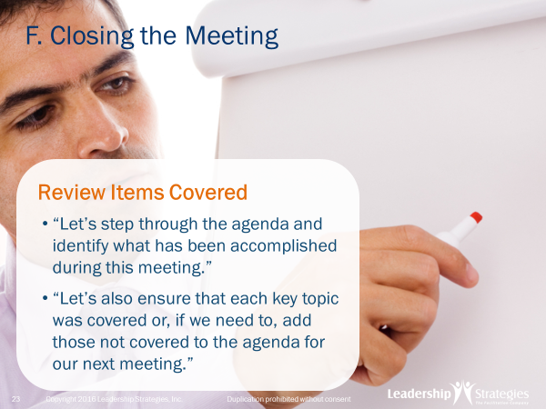 |  | SHOW POWERPOINT: Review Items Covered (build)  SAY:  Another great use of our Wall Plan and our Flip Charts to solidify all that was accomplished in the meeting. When we briefly review the items covered during a meeting we also remind people of what was accomplished in the time spent in the meeting.
 | PPT: Confirm Decisions Made  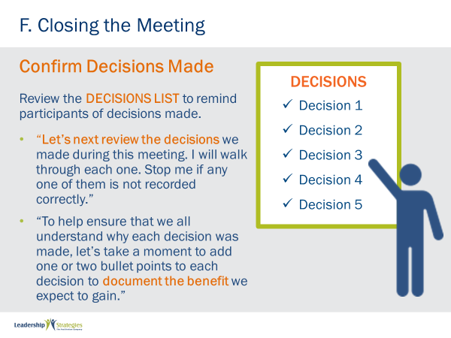 |  | SHOW POWERPOINT: Confirm Decisions Made (build)  SAY:  Next, let’s confirm each decision on our Decisions List. Review each decision with the participants and confirm their understanding of that decision. To reinforce each decision, review why the decision was made and the benefit that is anticipated by that decision – it helps ensure the appropriate level of buy-in when the benefit(s) are articulated.
 | PPT: Address Open Issues  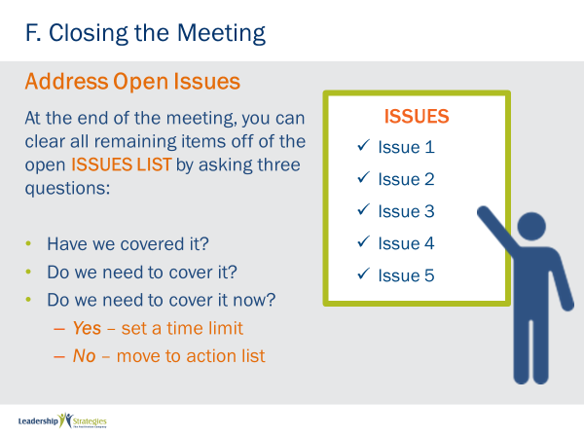 |  | SHOW POWERPOINT: Address Open Issues (build)  SAY:  Now address each issue on the Issues List; this ensures our Issues List does not become the cemetery – the place for items to die. For each issue, ask the participants a series of questions and have them respond.  DO:  REVIEW the slide points. Consider having placed some mock post-it notes on the Issues List to use as examples.
 | PPT: Assign Actions  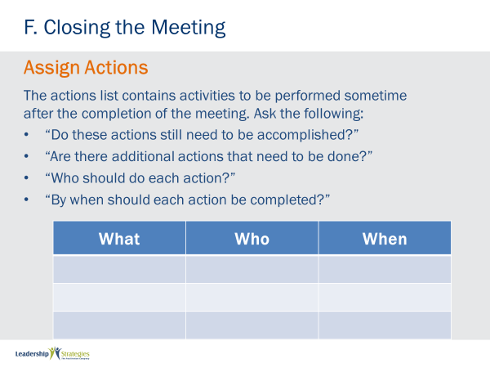 |  | SHOW POWERPOINT: Assign Actions (build)  SAY:  For our last Parking Board, the Action List, we confirm each item on the Action List by reviewing it as follows.  DO:  REVIEW slide content.  ASK:  Are there any questions on how we close our three Parking Boards?  DO:  FACILITATE the discussion.
 | PPT: Evaluate the Meeting  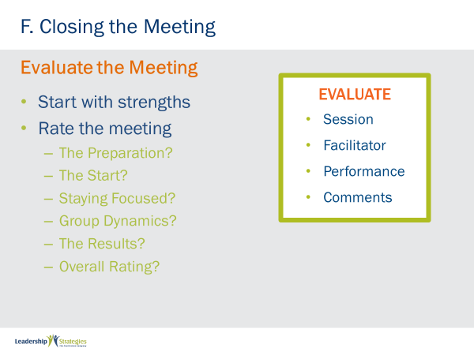 |  | SHOW POWERPOINT: Evaluate the Meeting (build)  SAY:  To get better or to hone our skills, we must use feedback as a part of that continuous improvement process. There are several key areas to evaluate.  DO:  Use the slide to address the elements and facilitate the discussion.
 | PPT: Evaluate the Meeting  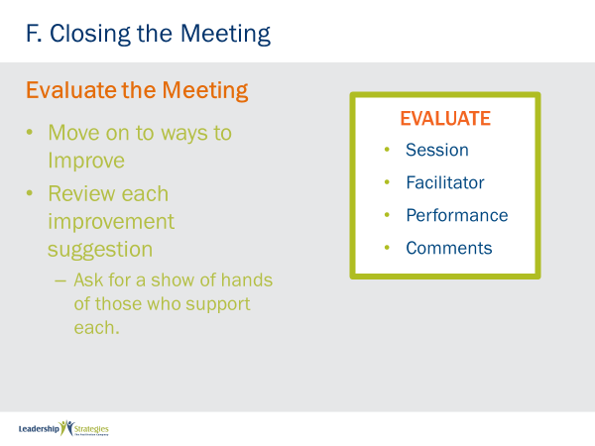 |  | SHOW POWERPOINT: Evaluate the Meeting (build)  SAY:  As we discussed during our exercises, to get better or to hone our skills, we must use feedback as a part of that process. There are 4 key areas to evaluate.  DO:  Use the slide to address the 4 elements and facilitate the discussion. Refer to the non-copyrighted page for a facilitated session feedback form.
 | PPT: Thank Participants and End  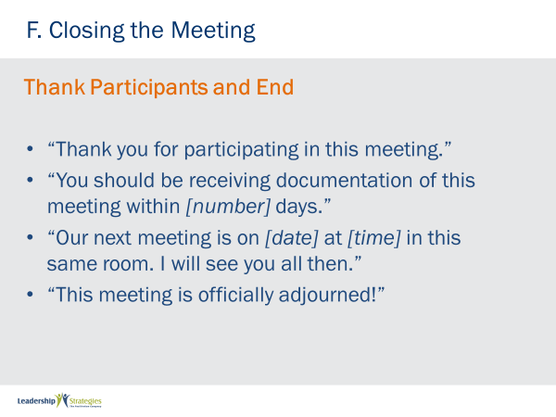 |  | SHOW POWERPOINT: Thank Participants and End (build)  ASK:  How many of you have attended a meeting in the last several months and were not thanked for investing your time? [raise your hand]  SAY:  Yes, I have as well. Your participants had other valuable things they might have been able to do; instead, they attended your meeting. By thanking them for their time and their engagement we are recognizing this. Then, ensure you are clear about follow-up documentation, any next steps and/or meetings, and then formally adjourn the meeting.
 | PPT: Distribute the Meeting Notes  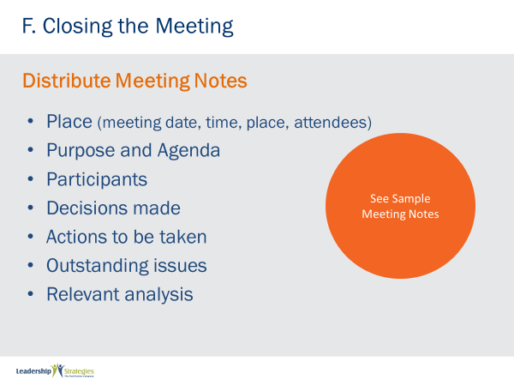 |  | SHOW POWERPOINT: Distribute the Meeting Notes  SAY:  Let’s wrap up our meeting by “putting a bow on the package.” Distribute the meeting notes to include the key elements from the meeting.  DO:  COVER POINTS on slides and provide a sample in the participant manual.  KEY POINT:  While the 3 Parking Boards are included as a part of the Distribute Meeting Notes, mention that the approach to closing the Parking Boards as described earlier is that, when closed as we outlined, all Issues are either eliminated or moved to the Action List.
 | PPT: Following Up to Hold Accountable  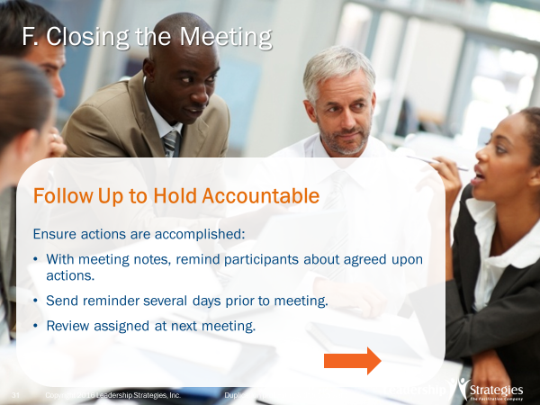 |  | SHOW POWERPOINT: Following Up to Hold Accountable (build)  SAY:  Make your meetings “stick!” Create a culture of accountability. As the meeting leader ensure you are clear about how the Action List will be tracked and by whom.  DO:  REVIEW points on the slide.  NOTE: The following slide includes additional points.
 | PPT: Following Up to Hold Accountable  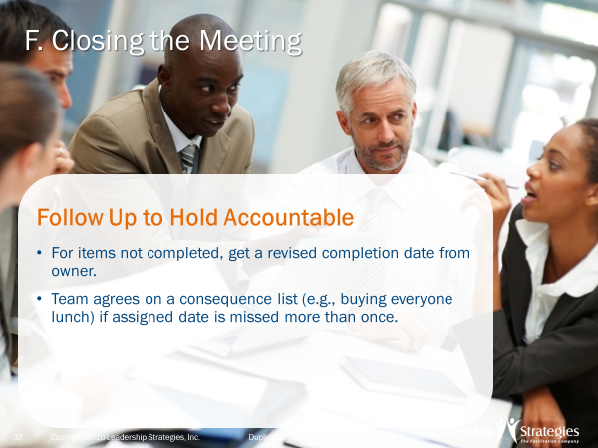 |  | SHOW POWERPOINT: Following Up to Hold Accountable (build)  DO:  REVIEW points on the slide.
 | PPT: Checklist for Closing  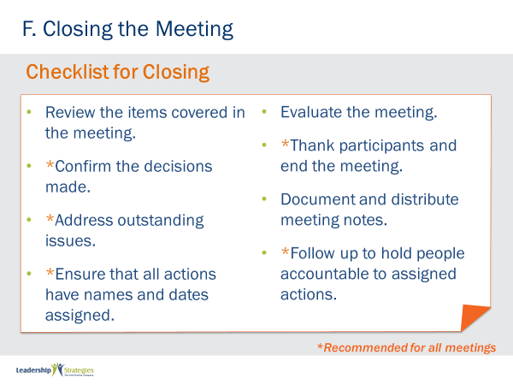 |  | SHOW POWERPOINT: Checklist for Closing  SAY:  Another great Checklist for your use – Closing. And remember, these checklists are on the www.leadstrat.com website for your use.
 | PPT: Review Slides  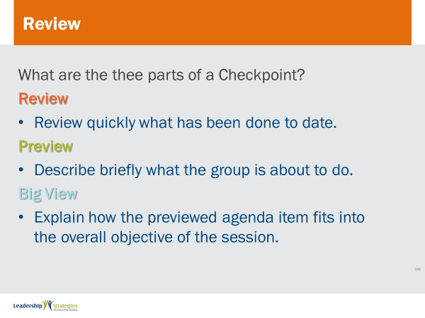 |  | SHOW POWERPOINTS: Review Slides  SAY:  Now it is time to do some review. We’ll do this by table teams, starting with the (color) team and rotating clockwise. If your team gets the answer, dots for everyone on the team.  DO:  REPEAT for all review slides.
PPT: Agenda |  |  | SHOW POWERPOINT: Agenda  CHECKPOINT:  We have discussed the key activities for a Masterful Close. What we are about to do next is look at the first of the many “what if’s” and we will start with the most fun, “what if there is dysfunction?” … and that is important because often times we encounter some type or types of dysfunctions in our meetings. While most often they are not extreme forms of dysfunction, we want to have an approach to manage the dysfunctions that will occur in a way that is least distracting to our meetings. So let’s get started.
 | PPT: Preventing, Detecting, and Resolving Dysfunction  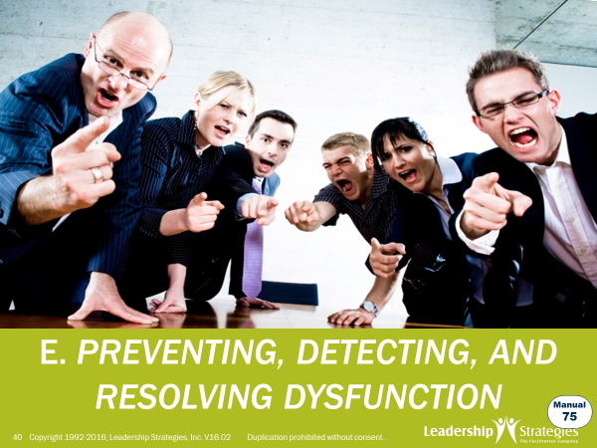 |  | SHOW POWERPOINT: Preventing, Detecting, and Resolving Dysfunction  DAVE -On the slide it should this be labeled Section G not E (for this entire section on dysfunction)  ASK:  How many of you have experienced dysfunctional behavior in the meetings you attend or conduct? (raise your hand)  SAY:  That is a challenge, isn’t it? (nod your head) Let’s take a look at managing dysfunction.  We have five best practices/techniques to address dysfunction, so let’s get started with one of our favorite engagement activities, Rotating Flip Charts.  DO:  FACILITATE the following activity.  PURPOSE - The purpose of this engagement will be to identify some of the most frequent types of dysfunctions you find in the sessions you lead or attend.  EXAMPLE - not necessary  DIRECTIONS: First, let’s select a new team leader. If you have already led your team today, you are not eligible to lead this activity. Of the remaining members of your team, will the person (who is tallest/shortest; has the most/least sibling, has the oldest/newest car, etc..) serve as the team leader. Team leaders, please take your colored marker and post-it notes with you and you and your team will each go to the flip chart nearest to you. When I ask you to start, I would like each team to make a list of the most common dysfunctions you experience or see in the meetings you attend or lead. I will give you 90 seconds to do this.  EXCEPTIONS - none  QUESTIONS - Any questions? [respond to questions]  STARTING QUESTION - Think about the meetings you have either attended or led for the last several months. Think about the behaviors you find annoying… the types of things you see participants in those meeting do that you believe are dysfunctional. What are the most common types of dysfunction you find in those meetings?  DO:  After the 90 seconds are up, begin round 2 (see below).  SAY:  OK, folks, time is up for our first round of Rotating Flip Charts. Facing forward, I would like each team to rotate 1 flip chart to the right and, team leaders, take your markets and post-it notes with you, please. [allow teams to rotate]  DIRECTIONS - Now, here are the directions for this round. Look at the list on the flip chart you are in front of now Place a check mark at the end of the dysfunctions if you had that/those dysfunction(s) on your original flip chart. Once you have completed identifying the duplicates, then, select one of the remaining dysfunctions, one that is not a duplicate, and, with your team, discuss how you would address that type of behavior if you were leading that meeting.  QUESTIONS - Any questions? [respond to questions] Great, get started and I will allow another 90 seconds.  DO:  When time runs out, have each team report out and facilitate the discussion.
 | PPT: Preventing, Detecting, and Resolving Dysfunction  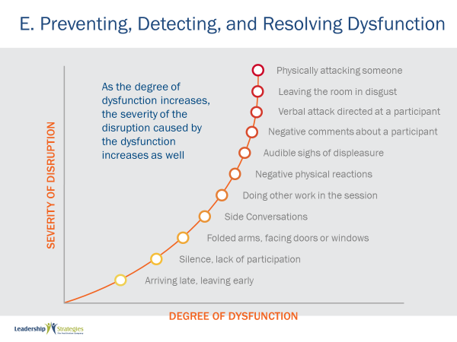 |  | SHOW POWERPOINT: Preventing, Detecting, and Resolving Dysfunction (build)  SAY:  This graph is an interesting view into dysfunction. Notice the growth in the severity as the degree of dysfunction increases.  KEYPOINT:  The key point is to deal with dysfunction while it has less of an impact or adverse effect on your session. Think of it this way, rarely, if ever, do two participants come into a meeting a “go at each other.” They typically start with something like rolled eyes or folded arms or other milder forms of dysfunction; the meeting leader ignores it and hopes it will go away, and it moves up our scale. We can help them if we understand Dysfunctional Behavior and this graphical representation depicts this and encourages us, as meeting leaders, to address it early and avoid that “ostrich theory” of dysfunction.
 | PPT: Understanding Dysfunctional Behavior  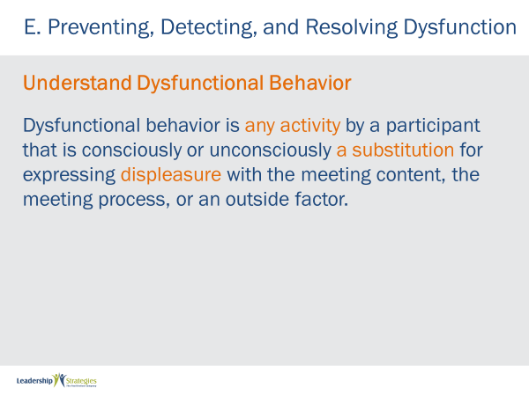 |  | SHOW POWERPOINT: Understanding Dysfunctional Behavior  SAY:  [Name] from the [red] team, would you please read our definition of dysfunctional behavior.  KEY POINTS:  Dysfunctional behavior is any activity used for expressing displeasure with one of the three things listed.  This is a substitution --- why? Because we want to create an environment in our sessions that when a participant has an issue, they are comfortable raising that issue in a non-dysfunctional manner.
 | PPT: Separate Symptom from Root Cause  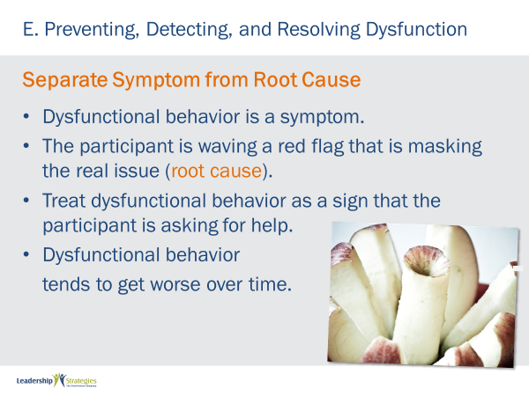 |  | SHOW POWERPOINT: Separate Symptom from Root Cause (build)  SAY:  So, as challenging as it may be to want to say something like, “Sally, did your parents not tell you it is rude to speak when someone else is speaking?” Resist. Instead, look at those symptoms of dysfunctional behavior as your ability, as a meeting leader, to help the participant by Separating the Symptom from the Root Cause.  DO:  REVIEW the key points on the slide.  SAY:  The other challenge is when we deal with the symptom, the behavior may temporarily subside; to eliminate it, we must get below the symptom down to the root cause.
 | PPT: Focus on Prevention  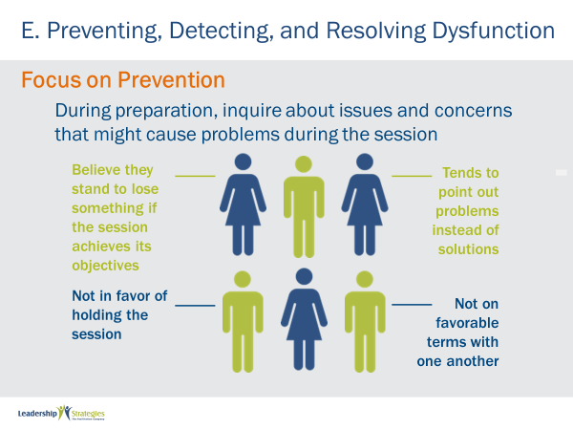 |  | SHOW POWERPOINT: Focus on Prevention (build)  SAY:  By Focusing on Prevention we are able to eliminate many types of dysfunction. Or, at least, to minimize them and their impact on our session.  DO:  REVIEW points on the slide and FACILITATE a discussion.  KEY POINT:  These are items that should have been considered as a part of our Masterful Preparation.
 | PPT: Focus on Prevention  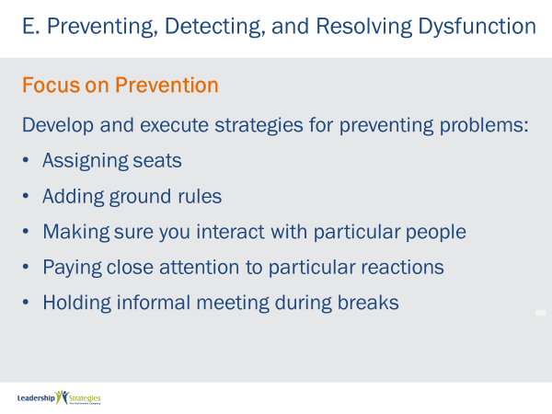 |  | SHOW POWERPOINT: Focus on Prevention (build)  SAY:  Being aware of what might happen allows us to develop strategies that Focus on Prevention. Let’s look at the five strategies we find very helpful  DO:  REVIEW points on the slide.  ASK:  Are their others some of you have found work?  DO:  FACILITATE the discussion.
 | PPT: Detect Non-Verbal Cues  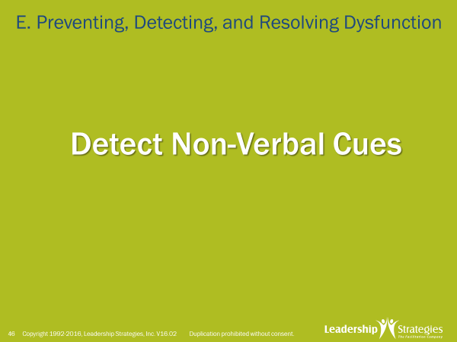 |  | SHOW POWERPOINT: Detect Non-Verbal Cues  SAY:  To detect non-verbal cues, let me ask each of you to assume a position that you could care less about anything else we did for the rest of the day  DO:  Have all people do that; then ask them to look around and see what that looks like.  SAY:  OK, you can come back now. The question is, “What do most meeting leaders do when they see some of what we just saw?” Typically, little or nothing. We refer to that as “the ostrich theory of dealing with dysfunction.” Make believe it is not happening and hope it will go away. Do not do that; it can make it much worse.  Let’s take a look at some of those non-verbal cues.
 | PPT: Not Speaking  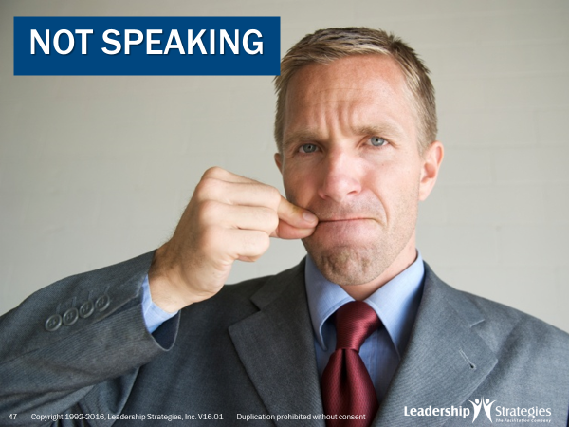 |  | SHOW POWERPOINT: Not Speaking  SAY:  People who are not speaking. Or those that typically speak that are not engaged.
 | PPT: Folded Arms  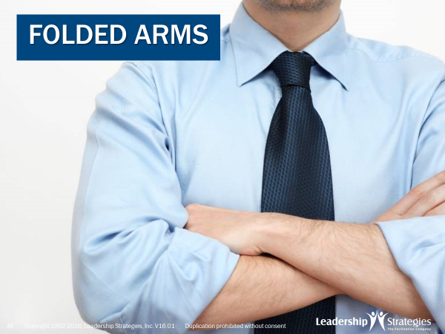 |  | SHOW POWERPOINT: Folded Arms  SAY:  Folded arms. Now be careful, that is a sign, look for corroborating evidence – that person may simply be cold.
 | PPT: Can’t wait for next break  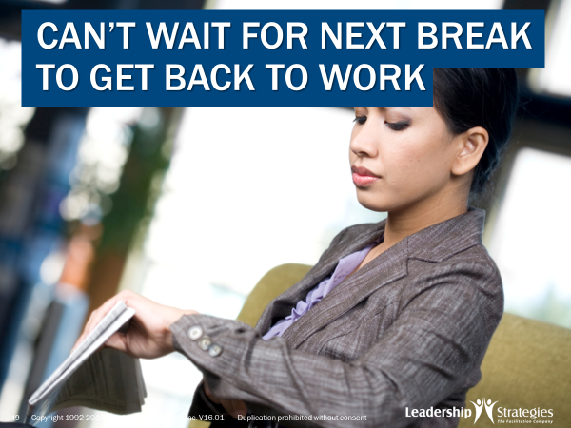 |  | SHOW POWERPOINT: Can’t wait for next break  SAY:  Those that are constantly taking care of business during every break. Make sure they are actually “tuned in” or determine if there is something going on that they may need to be addressing.
 | PPT: Side Conversations   |  | SHOW POWERPOINT: Side Conversations  SAY:  Side conversations, the “crack berry prayer” are other non-verbal signals.
 | PPT: Address Dysfunction Effectively  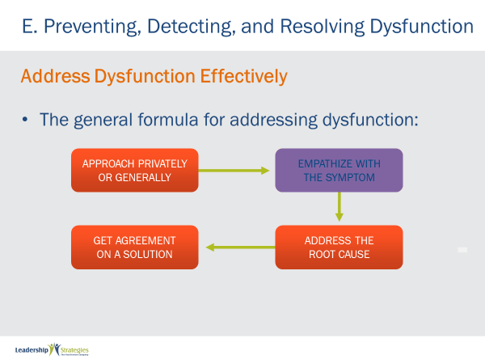 |  | SHOW POWERPOINT: Address Dysfunction Effectively (build)  SAY:  Once you have decided to address the dysfunctional behavior, you want to Address Dysfunction Effectively. We find a four-step process that is really effective:  1. Approach privately or generally. [blue], team how might we deal with it privately? [facilitate the discussion] [purple] team, how about dealing with it generally? [facilitate the discussion and remind how to use the ground rules in these situations]  2. Empathize with the symptom. Please circle or highlight that step; it is the most important step. Demonstrating empathy first shows we care about our participants and it avoids “pointing a finger” or being accusatory about the why, or root cause. The empathy is for what we are seeing; the symptom and drawing no conclusions about the why or the root cause.  3. Address the root cause. This ensures we are addressing the why and will eliminate most dysfunction from continuing  4. Get agreement on a solution. This, again, is important to moving towards elimination  ASK:  Any questions or discussion before we look at some specific examples and solutions?  DO:  FACILITATE the discussion.
 | PPT: Dealing with Dysfunction  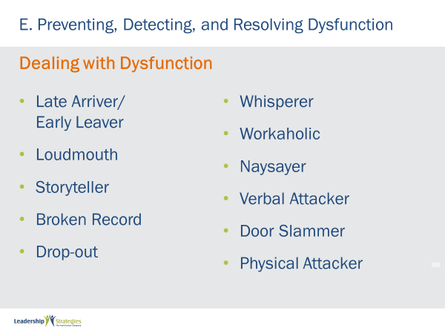 |  | SHOW POWERPOINT: Dealing with Dysfunction (build)  SAY:  Let me set the clock for sixty seconds and ask each team to look at these pages in your participant manual and select one that you would like to discuss.  DO:  FACILITATE the discussion and reflect often on how the steps outlined follow the 4-step process.  ASK:  Any other dysfunctions that we should discuss?  DO:  FACILITATE the discussion while giving many examples of demonstrating empathy for the symptom.
 | PPT: What Should You Avoid Doing?  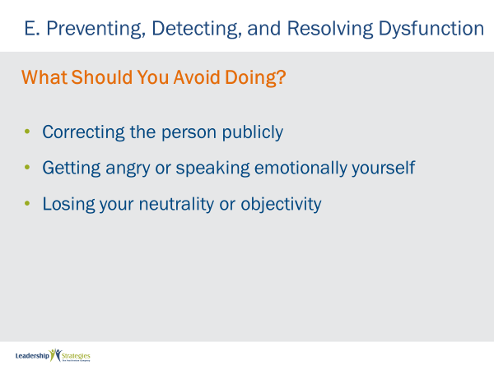 |  | SHOW POWERPOINT: What Should You Avoid Doing? (build)  SAY:  The three things to Avoid are… [cover the slide] Please make a note of these in your participant manuals. This keeps us, as the meeting leading, above the fray and allows us to mitigate the impact of dysfunction in our meetings.  DO:  REVIEW the content on the slide.
 | PPT: Confirm Resolution  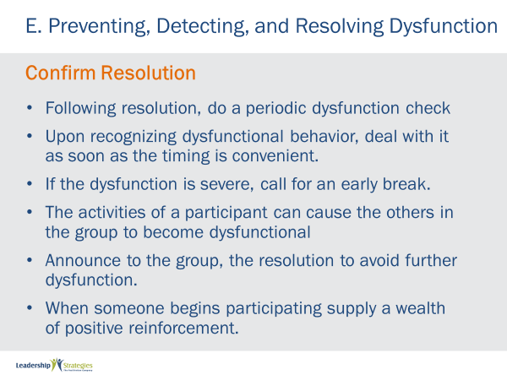 |  | SHOW POWERPOINT: Confirm Resolution (build)  SAY:  Once you have dealt with dysfunction, ensure we are “on alert” to ensure it does not occur again.  DO:  REVIEW the slide points.  ASK:  Do any of our teams have questions or comments about Confirming Resolution?  DO:  FACILITATE the discussion.
 | PPT: Checklist  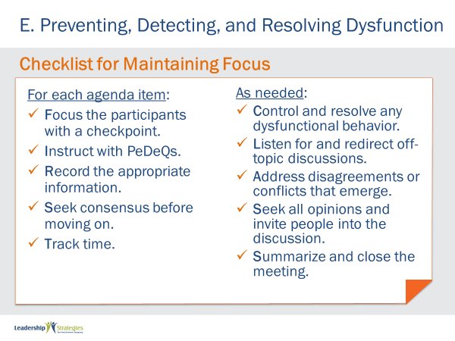 |  | SHOW POWERPOINT:  DAVE- this slide is about Maintaining Focus – it doesn’t belong here. Is there a Checklist for Dysfunction?
 | PPT: Review Slides  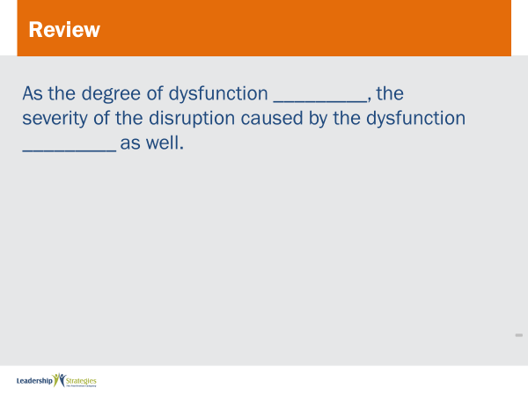 |  | SHOW POWERPOINTS: Review Slides  SAY:  Now it is time to do some review. We’ll do this by table teams, starting with the (color) team and rotating clockwise. If your team gets the answer, dots for everyone on the team.  DO:  REPEAT for all review slides.
PPT: Agenda |  |  | SHOW POWERPOINT: Agenda  CHECKPOINT:  Now that we have talked about different ways to prevent, detect and resolve conflicts, let’s do an activity to bring it home.
 | PPT: Spring Forward 8a: Resolving Dysfunction in a Meeting  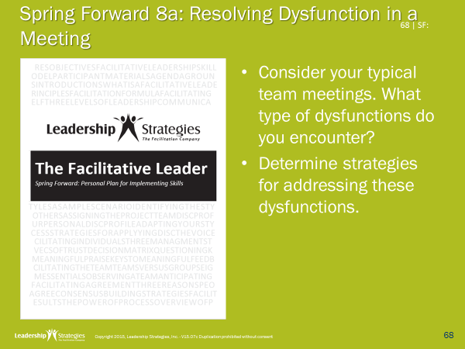 |  | SHOW POWERPOINT: Spring Forward 8a: Resolving Dysfunction in a Meeting  SAY:  In this Spring Forward exercise, you get to apply these techniques to common dysfunctions that you contend with.  DO:  FACILITATE the following activity.  PURPOSE - The purpose is to identify strategies for commonly faced dysfunctions.  EXAMPLE - not necessary  DIRECTIONS: Work individually to identify the top 3-5 dysfunctions you have in your meetings and then come up with a strategy to avoid and or manage it.  EXCEPTIONS - none  QUESTIONS - Any questions? [respond to questions]  STARTING QUESTION - Think about the meetings you have either attended or led for the last several months. Think about the behaviors you find annoying… the types of things you see participants in those meeting do that you believe are dysfunctional. What can you do to prevent or minimize those behaviors?  DO:  After they work on this, ask several participants to share one of their strategies.
PPT: Agenda |  |  | SHOW POWERPOINT: Agenda  CHECKPOINT:  We’ve been talking dysfunctions in our meetings. what we are about to do next is look at the last of our “what if’s” and we will look at one that is dramatically increasing over the last few years, “what if the meeting is virtual?” This is important because more and more all of our participants are not in the same meeting room. Some may be in another city, country or simply telecommuting. So we want to have some tools in our tool kit to assist with virtual meetings. Let’s take a look at some of those.
 | PPT: H. Running Virtual Meetings   |  | SHOW POWERPOINT: H. Running Virtual Meetings  ASK:  How many of you have participates or led a virtual meeting? (raise your hand) These present different challenges or require special techniques, do they not? (nod your head)  SAY:  We will look at this first generally and then some special considerations for planning, starting and executing virtual meetings and look at these key tips or techniques.  Let’s look at some best practices for virtual meetings.
 | PPT: What if the Meeting is Virtual?  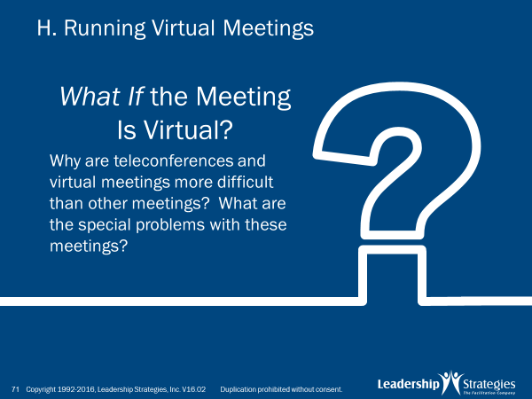 |  | SHOW POWERPOINT: What if the Meeting is Virtual?  SAY:  To get started with What if the Meeting is Virtual, let’s use our teams again.  DO:  FACILITATE the following activity.  PURPOSE - The purpose of this next exercise is to ask each team what makes virtual meetings more challenging than face-to-face meetings  EXAMPLE - not needed  DIRECTIONS - Each team will be recording their answers to the question I am about to ask on the flip charts labeled at the front of the room by using the markers on the easels. The idea is to list the key challenges with virtual meetings. Let’s assign new team leaders. [assign team leaders; someone new]  EXCEPTIONS - none  QUESTIONS - Are there any questions before I ask the question to get us started? [respond to any questions]  STARTING QUESTION - Think about the last audio conference that you attended or the last meeting you were a part of that was conducted with some or all participants who were attending virtually….from the beginning to the end of that meeting, what were some of the special challenges or problems with these virtual meetings?  DO:  When the clock expires, have team leaders report out and facilitate the discussion as needed.
 | PPT: Tips for Planning  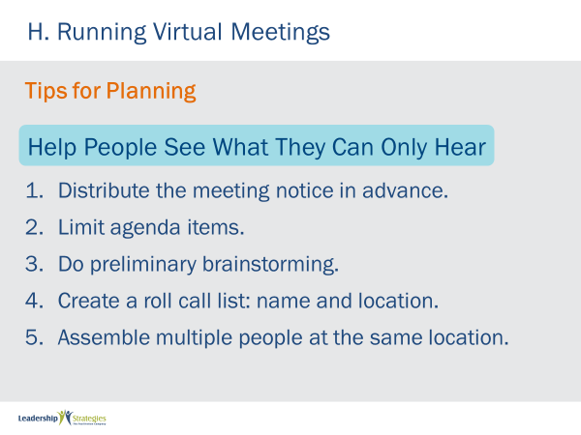 |  | SHOW POWERPOINT: Tips for Planning (build)  SAY:  One of the key points when conducting a meeting with all or some of the participants attending remotely is to Help People See What Thy Can Only Hear. Here are some of the key tips or techniques that assist in that area  DO:  REVIEW the content on the slides. Then, refer back to flip charts for teams to speak to items from their charts again.
 | PPT: Tips for Starting  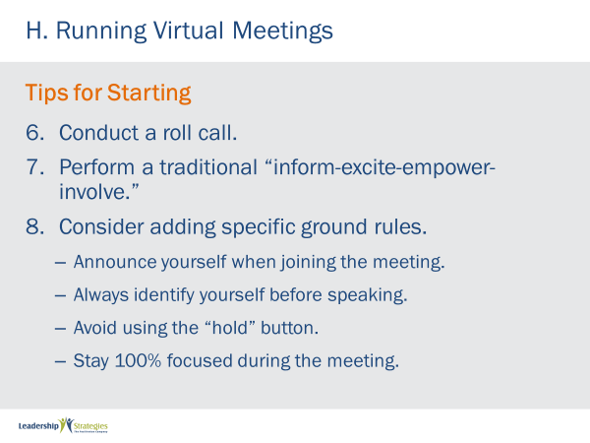 |  | SHOW POWERPOINT: Tips for Starting (build)  SAY:  As we start our virtual meetings, we want to think about the key of engaging as soon as possible and including specific ground rules that address as many of the remote challenges that are possible. Let’s do a round robin read around here [name] from the [green] team, please get us started [complete the round robin adding comments along the way]  ASK:  Any other tips or questions regarding Preparing and Starting of virtual meetings?  DO:  FACILITATE the discussion.
 | PPT: Tips for Executing  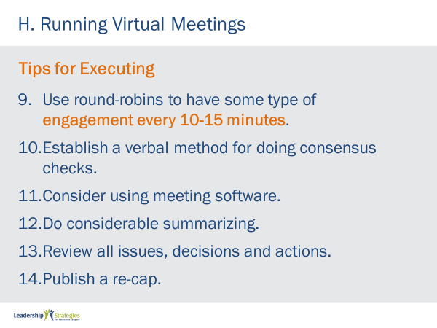 |  | SHOW POWERPOINT: Tips for Executing (build)  SAY:  For running or executing meetings with virtual participants, we have the following points to maximize engagement and results. Yes, we actually get comments in the virtual meetings that we run like, “It was like we were all in the room together!” and so can you.  DO:  REVIEW the slide.
PPT: Agenda |  |  | SHOW POWERPOINT: Agenda  CHECKPOINT:  We just finished talking about tips to facilitate better virtual meeting. But what do you do when you are not the meeting leader, and the meeting isn’t going so well? We call this guerilla facilitation. Its about artfully helping out the team, without stepping on the leader’s toes. Curious? Let’s dive in.
 | PPT: I. Using Guerilla Facilitation  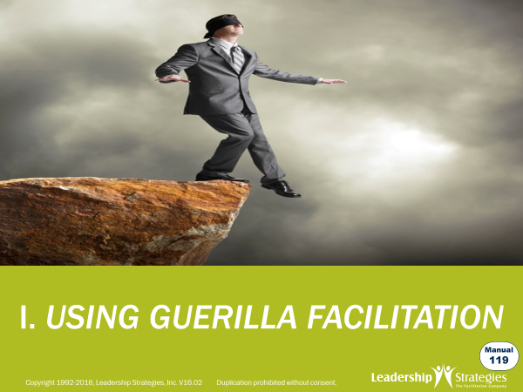 |  | SHOW POWERPOINT: I. Using Guerilla Facilitation  ASK:  Have any of you ever been a participant in a meeting and the meeting leader was not effectively leading that meeting? (raise your hand) Wouldn’t it be nice to have a few tricks up our sleeve to help in these situations? (nod your head)  SAY:  In this next section we are going to provide some key tips for us to help when that occurs.
 | PPT: Using Guerilla Facilitation  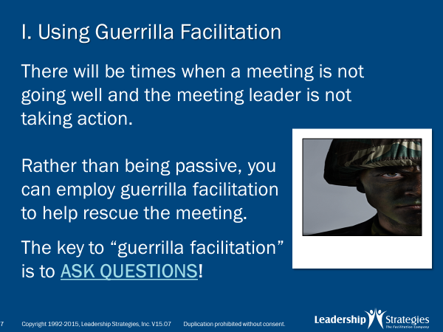 |  | SHOW POWERPOINT: I. Using Guerilla Facilitation (build)  ASK:  Let’s use a quick round robin, by teams starting with our [green] team. Would you think about a time when you were in a meeting…think about a time in one of those meetings when you were thinking to yourself, “Hey this meeting is not headed in the right direction” or “Wow, the meeting leader just missed an opportunity to do something that would have really helped move this meeting along”…..what are some of the signs the meeting leader is not leading?  DO:  CONDUCT a round robin; consider documenting on a flip chart.  SAY:  Great points, so the key when the meeting leader is not leading is to avoid being passive and just letting things go. Instead we suggest “Guerilla Facilitation” and essentially it is our desire to help the meeting leader make the meeting better. The key tool is to ASK QUESTIONS.  Let’s take a look at some specific situations and the types of questions we might ask to help improve those situations.
 | PPT: Example #1: No Purpose  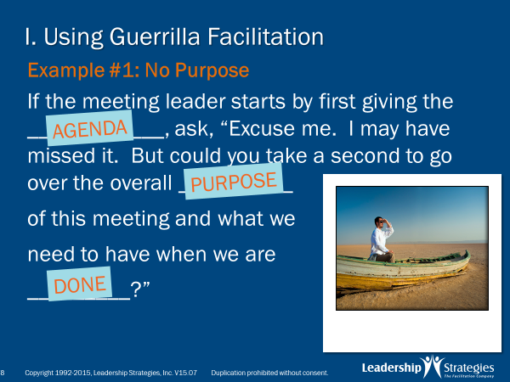 |  | SHOW POWERPOINT: Example #1: No Purpose (build)  SAY:  Folks how do many people start a meeting? That’s right they start with the agenda. When that happens, what we might do is raise our hands and say, “Excuse me, I may have the purpose of me meeting so we know what we need to have when we are done?”  DO:  GO AROUND the room, team by team, asking for their responses. INSTRUCT them to write the answers in their books. FACILITATE the conversation and add examples.
 | PPT: Example #2: Lack of Focus  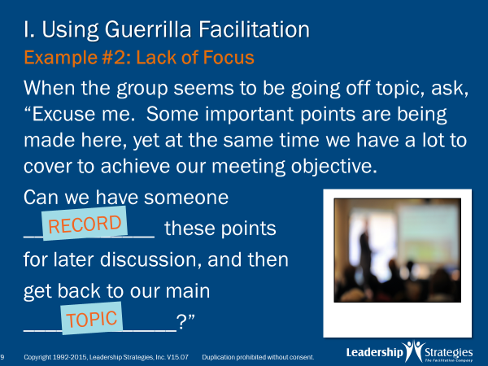 |  | SHOW POWERPOINT: Example #2: Lack of Focus (build)  ASK:  How many of us have been in a meeting with Wandering Willie or Wandering Wilhemina? [raise your hand] Me too and that’s pretty annoying, isn’t it [nod your head]  SAY:  When Willie starts talking about a topic that is not related to the current agenda item, for example we are making a list of steps in a process and Willie says, “Hey the problem with that step is……” We might offer the following…”  DO:  READ the slide or have someone read it. INSTRUCT them to write the answers in their books.
 | PPT: Example #3: No Documentation  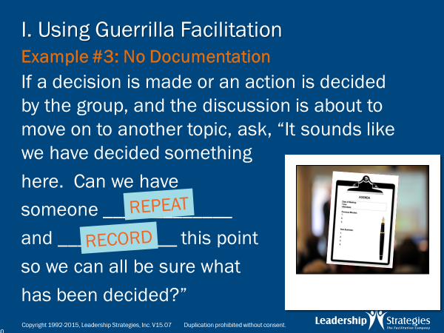 |  | SHOW POWERPOINT: Example #3: No Documentation (build)  ASK:  How about this one. Ever been in a meeting where you felt like it was second verse same as the first? [raise your hand] Again, me too. Often that is the result of the meeting leader overlooking the importance to documenting decisions as they are made. As we like to say, “the faintest of ink is better than the longest of memory.” So the next time you are attending a meeting and a decision was made but not documented, try this…”  DO:  COVER the slide or ask the next team, what the fill-in-the-blank should be.
 | PPT: Example #4: Over/Under Participation 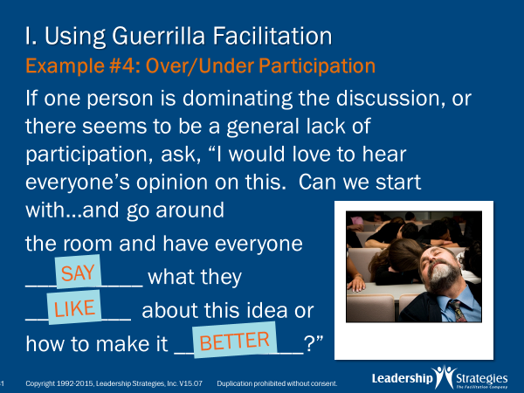 |  | SHOW POWERPOINT: Example #4: Over/Under Participation (build)  ASK:  Another one of my favorite characters in Dominating Don or Donna. You know that person or two that are always participating. Think about it…think about the meetings we something like that has happened to you as a participant…what might we try then?  DO:  FACILITATE the discussion; then cover the points on the slide.
 | PPT: Example #5: No Closure  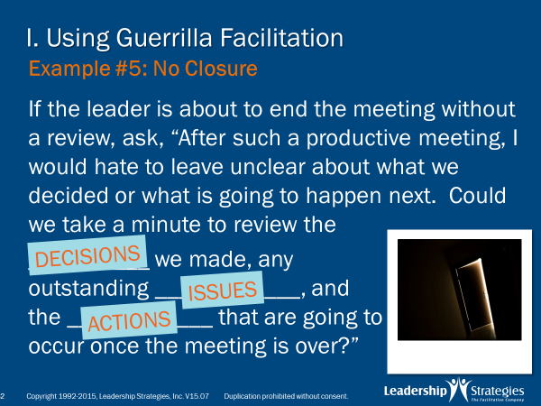 |  | SHOW POWERPOINT: Example #5: No Closure (build)  SAY:  Another one of my favorite characters in Dominating Don or Donna. You know that person or two that are always participating.  ASK:  Think about it…think about the meetings we something like that has happened to you as a participant…what might we try then?  DO:  FACILITATE the discussion; then cover the points on the slide.
 | PPT: Review Slides  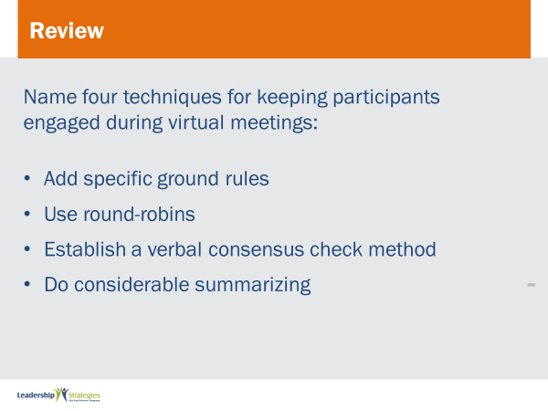 |  | SHOW POWERPOINTS: Review Slides  SAY:  Now it is time to do some review. We’ll do this by table teams, starting with the (color) team and rotating clockwise. If your team gets the answer, dots for everyone on the team.  DO:  REPEAT for all review slides.
 | PPT: Spring Forward 8b: Applying the Masterful Meeting Strategies  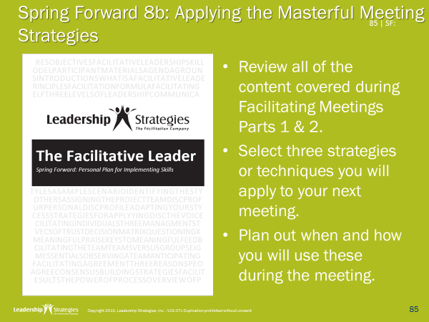 |  | SHOW POWERPOINT: Spring Forward 8b: Applying the Masterful Meeting Strategies (build)  DO:  FACILITATE the following activity.  PURPOSE – To plan three strategies to improve upcoming meetings.  EXAMPLE - not needed  DIRECTIONS – Individually answer the questions on 8b.  EXCEPTIONS - none  QUESTIONS - Are there any questions before I ask the question to get us started? [respond to any questions]  STARTING QUESTION – not needed  DO:  When the clock expires, ask three participants to share one of their strategies and facilitate the discussion as needed.
PPT: Agenda |  |  | SHOW POWERPOINT: Agenda  CHECKPOINT:  We just covered our last content piece of Facilitating Meetings, which brings us to the end of our course. Let’s review how the meeting techniques support our TAFA model.
PPT: TAFA  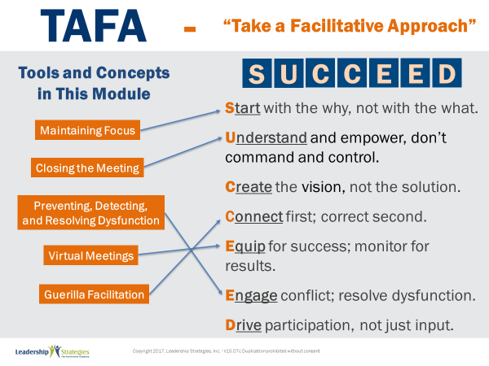 |  |  | SHOW POWERPOINT: TAFA (build)  SAY:  Let’s take a moment to look at some of the concepts we’ve learned in this module and examine how they reflect the TAFA principles.  DO:  REVIEW slide and lead discussion by asking if there are other principles that are reflected by the concepts.
PPT: Checkpoint  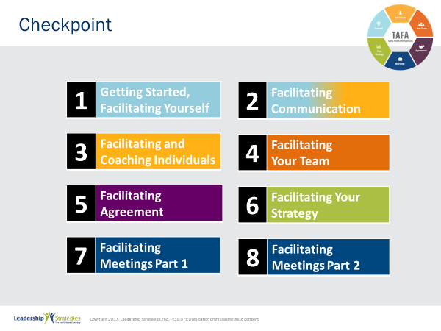 |  |  | SHOW POWERPOINT: Checkpoint  CHECKPOINT:  We have just completed the last module!
PPT: Connect with LSI  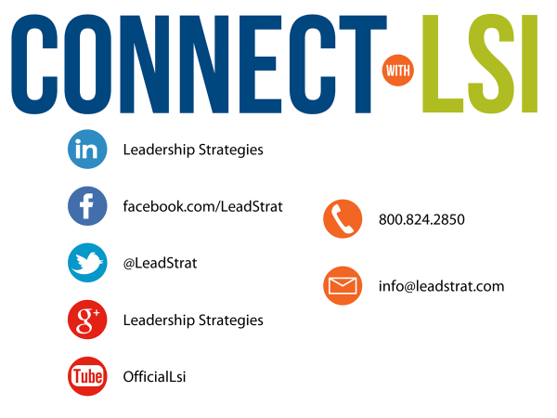 |  |  | SHOW POWERPOINT: Connect with LSI  Note to Instructor: this slide may be excluded if you are going directly into the next module. In that case, hide the slide.  SAY:  We fundamentally believe facilitation is a skill that applies in a multitude of situations. We also are confident that, in our quest to “share the power of facilitation with the world,” connecting via social media is a way for all of us to collectively share our successes, our challenges and our facilitation work. To “facilitate” that process, we want to ensure you are aware of how we can all stay connected using social media.  How many of you have found many of the skills in the class helpful? [raise your hand] I know that one of the things I did after attending was share what I learned with many of my colleagues. Have some of you already thought about that? [nod your head]  Then, one request we would like to make of you is to update your “education or classes attended” on your LinkedIn profile. That visibility will help all of us to “share the power” I have been referring to. Any questions?  FACILITATE the discussion.
 | PPT: Congratulations!  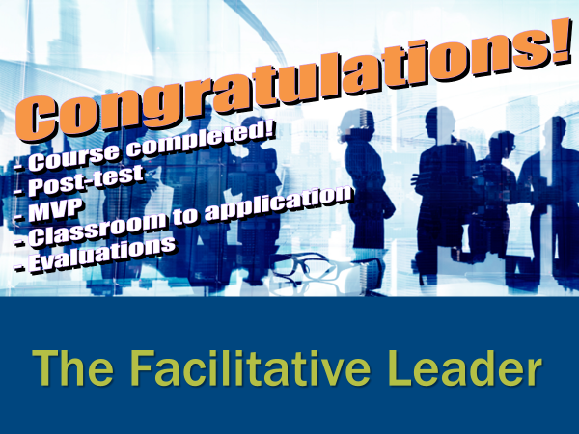 |  | SHOW POWERPOINT: Congratulations! (builds)  Note to Instructor: There are three congratulation slides. Select the correct slide depending on whether you are:  - Moving on to the next module immediately (slide 1)  - Coming back another day to do the next module and therefore need to do an evaluation (slide 2)  - Have completed the workshop and therefore need to close out the class with the post-test, evaluations, dot winner (MVP), and the From Classroom to Application sheet (slide 3)  Hide the other two congratulations slides.  DO:  REVIEW and execute the content on slide.  EXECUTE THE POST TEST:  If appropriate, handout the post-test. Give people five minutes to complete. Ask teams to give their cheer once completed.  Once completed, have team members pass their post-test clockwise to a new person. Go through each question and have the group give responses. Instruct them to place a checkmark for each correct response.  Once completed have people add up the number of check marks and place the total at the top.  Since each post-test has eight questions, place the number 8 through 0 in the first column of a two-column chart.  Before people hand the post-tests back to the owner, do a round robin and have people indicate the number the person got corrected. Place a tick mark next to that number each time that number is reported.  THANK participants and dismiss class.
 |  |  | END OF THE FACILITATIVE LEADER MODULE 8

