The Facilitative Leader
Module 7: Facilitating Meetings Part 1

Facilitator Guide

Table of Contents
Facilitator’s Information
Table of Contents 1
How to Use This Guide 2
Symbols Used in the Facilitator’s Guide 3
Participant Pre-Work 4
Materials & Equipment for Module One of The Facilitative Leader 5
The Facilitative Leader Module 7: Agenda 7
Module 7: Introduction 10
Module 7: Facilitating Meetings Part 1 Agenda 11

How to Use This Guide
This Facilitator’s Guide covers the following:
- Work you’ll need to do prior to the workshop,
- Materials and equipment you’ll need for the workshop, and
- Instructions and verbiage to conduct the workshop.
Headings
The heading for each section indicate the information that will be covered in that particular section.
Instructions Section
On the right-hand side of the workshop instructions pages you’ll find the approximate number of minutes required to complete a topic.
The format for the instructions section contains 2 columns as follows:
- Left-hand Column:  - Contains graphics, such as a copy of a slide or an icon, indicating the major aspect of the training segment. For example, a television set icon indicates that a video will be shown. The next page shows the various icons used. | - Right-hand Column  - Lists the information or instructions to be conveyed to the participants and contains possible starting questions you can ask about the topic to engage participants in a discussion or an activity.  - Describes the activity to be completed. Note that actions to be done will always be in bold.  NOTE: This Facilitator’s Guide is not intended to be used as a script. The words in this column give you one example of how to deliver the content. Part of your preparation is to review this guide and become familiar with its contents, structure, and flow. You should feel free to use your own words, adjust the delivery to your own style, while also adapting to the needs of the group you are facilitating. At all times, be sure to show enthusiasm and comfort with the material when you are presenting. This will provide a more enjoyable and meaningful session for your participants.
 | Anything in a gray box means that you will be “doing” something rather than presenting.

Symbols Used in the Facilitator’s Guide
There are a number of symbols used in this Facilitator’s Guide to serve as prompts for the type of activity occurring at that point in the program. Here is a list of those symbols and what they mean.
 | Presentation |  |  | Key Information
 | Spring Forward Exercise |  |  | Pull through previous learnings
 | Pair Discussion/Exercise |  |  | Participant Manual “Write-along”
 | Group Discussion/Exercise |  |  | UMU activity
 | Write responses on a flip chart |  |  | Checkpoint
 | Transition to next topic |  |  | Individual Activity

In some cases, an activity will transition from one type to the other (e.g. from individual to group discussion). In such cases, more than one symbol may be used in chronological order.

Participant Pre-Work
None.

Materials & Equipment for Module One of The Facilitative Leader
Following is a list of the materials to be used in this training session. Be sure to become familiar with all of them.

- Projector and Screen
- Laptop
- PowerPoint Slides – “The Facilitative Leader 7: Facilitating Meetings Part 1”
- Facilitator Guide (this document)
- Updated Participant List
- Participant Packets (one for each participant)
  - Tent Cards
  - Participant Manual
  - Spring Forward Booklet
- Flipcharts – one for Facilitator, plus one for each table group)
- Pins/tape to hang posters
- Tape
- Pens and Markers
- Post-it notes (one different color package for each table group)

Flip Charts:
- Class Objectives
- Agenda: Day 1
- Personal Objectives/Problems w/ Meetings
- Sample Agenda (Process Improvement)
  - Purpose: to identify the changes necessary to improve the efficiency and effectiveness of the hiring process
  - Agenda/Steps:
A. Getting Started
B. Define the Steps in the Current Hiring Process
C. Identify the Problems with the Current Hiring Process
D. Develop the Potential Improvements
E. Establish the Priority of Improvements
F. Develop the Implementation Plan
G. Review and Close
- Ground Rules (match slide)
  - Always open for questions
  - The open issues list
  - Respect the speaker
  - Avoid “bar discussions”
  - “Choo Choo”
  - Start on time, end on time
  - ELMO
  - nEtiquette
  - _____________
- Levels of Change (3 Flip Charts; for reference)
  - Meeting Participant
  - Meeting Leader
  - Meeting Advocate
- Parking Boards
  - Issues
  - Decision
  - Actions

The Facilitative Leader Module 7: Agenda
TIME | TOPIC
5 minutes | Workshop Introduction  - Checkpoint  - Course Objectives  - TAFA  - Ground Rules  - Your Materials
7 minutes | Homework Review
 | - Have participants share results of their homework (in pairs, table groups, and/or with the class)
2 minutes | Workshop Introduction  - Agenda (Compare to participant objectives)
4 minutes | Typical Problems with Meetings Activity
 | - Identify typical problems in meetings.
15 minutes | A. Understanding Meeting Types  - Status Meetings  - Working Meetings  - How to Avoid Having Meetings
25 minutes | B. Characteristics of Masterful Meetings  - Masterful Meeting Definition  - 18 Characteristics (four categories: Preparation, Starting, Executing and Closing)
10 minutes | How a Masterful Meeting Leader Prepares Activity
10 minutes | - Identify the important things to know in planning a meeting.
15 minutes | C. The 6 P’s of Preparation  - Purpose  - Product  - Participants  - Probably Issues  - Process  - Place
10 minutes | Sample Ways to Process Exercise
10 minutes | - Identify the best process for a meeting.
10 minutes | Spring Forward 7a. The 6 Ps Exercise
10 minutes | - Practice thinking through the 6 P’s for an upcoming meeting.
10 minutes | How a Masterful Leaders Starts Exercise
10 minutes | - Identify the most important things for a leader to do when starting a meeting.
15 minutes | D. Starting with Impact  - IEEI (Inform, Excite, Empower and Involve
7 minutes | Examples of Exciting Exercise
7 minutes | - Practice developing an excite statement.
10 minutes | D. Starting with Impact (continued)  - Confirm the Agenda  - Establish Ground Rules  - Establish the Parking Boards (Issues, Decisions, Actions)  - Make Introductions
5 minutes | What is the Recommended Order? Activity
5 minutes | - Teams put all the elements of opening a meeting in the correct order.
5 minutes | Spring Forward 7b – Starting a Meeting
5 minutes | - To practice building an IEEI.
10 minutes | Spring Forward 7c – Opening a Meeting
10 minutes | - To practice delivering and IEEI.
15 minutes | Session Close (Will vary based on FL “package” being delivered.)  - Review Agenda  - TAFA: Tools and Concepts in this Module  - Checkpoint to next module if appropriate  - Connect with LSI  - Congratulations slide with appropriate closing activities depending on whether this module is delivered as part of the four-day or as a stand-alone  - Execute Post-Test if appropriate  - Award dot winner MVP prize if appropriate  - Complete From Classroom to Application if appropriate  - Execute Evaluation if appropriate  - Formally close the session.
180 minutes  (3 hours) | Total Training Time

Module 7: Introduction
Overview
Leaders learn techniques to use while coaching individuals for high performance.
Models include the following:
- Meeting Types
- Characteristics of a Masterful Meeting
- 6 P’s of Preparation
- IEEI

Key Learnings
- How to determine the type of meeting to have.
- The 18 characteristics of a masterful meeting
- How to prepare for a meeting
- How to start a meeting

Timing: 3 hours

Module 7: Facilitating Meetings Part 1 Agenda
Exercise: Typical Problems with Meetings
- Understanding Meeting Types
- Characteristics of Masterful Meetings
Exercise: How a Masterful Meeting Leader Prepares
- The 6 P’s of Preparation
Exercise: Sample Ways to Process
Exercise: Spring Forward 7a. The 6 Ps
- Starting with Impact
Exercise: Examples of Exciting Exercise
Exercise: What is the Recommended Order?
Exercise: Spring Forward 7b – Starting a Meeting
Exercise: Spring Forward 7c – Opening a Meeting

Timing: 3 hours
PPT: Title   |  |  |  | SHOW POWERPOINT (PPT: Title Slide)  Note to Instructor: Customize your opening depending on the modules the group will be receiving in total, whether you are following a previous module, coming back from time in-between modules, or only running this workshop for this group.  SAY:  Welcome Managers to the Leadership Through Facilitation Workshop!  Introduce yourself and your background.  Have participants introduce themselves by sharing name, position, and years with the company. Ensure that each participant has signed in.
PPT: 7 Facilitating Meetings-Part I  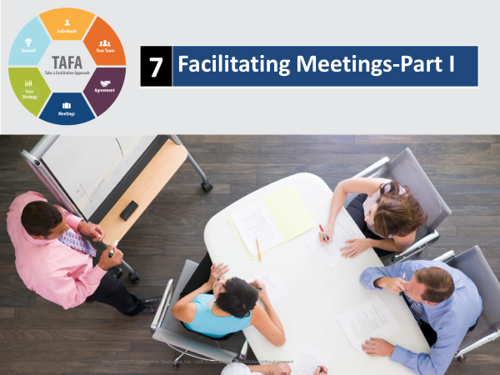 |  |  |  | SHOW POWERPOINT: 7 Facilitating Meetings-Part I  SAY:  You’ll walk away with an understanding of:  - The different types of meetings  - The characteristics of masterful meetings  - How to prepare for a meeting  - How to start a meeting
PPT: Checkpoint  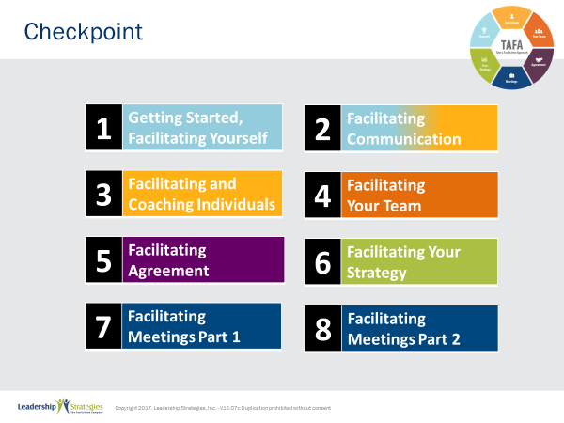 |  |  |  | SHOW POWERPOINT: Checkpoint (build)  CHECKPOINT:  In our last module, you learned about facilitating strategy. In Module 7, we are going to focus on how to facilitate meetings. You probably lead several meetings a day, so it is critical that you have skills and techniques to be sure they are run effectively.
PPT: TAFA  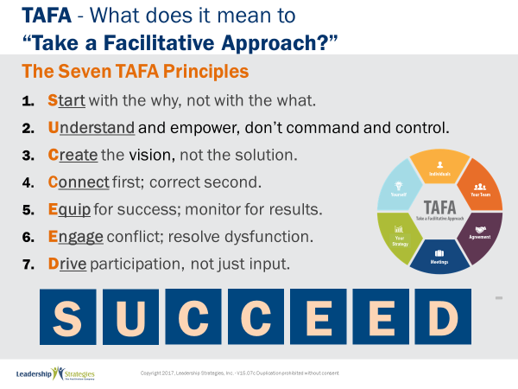 |  |  |  | SHOW POWERPOINT: TAFA  SAY:  Let’s review the TAFA principles:  There are 7 key TAFA principles – the principles of taking a facilitation approach. Any time you have a decision to make, a problem to solve, someone to coach or correct, we are going to be giving you tools and techniques for implementing these principles.  Let’s walk through them together.  People are often inspired when they are connected and aligned with purpose. Unfortunately, as leaders we often focus on what we want done and start there. Facilitative leaders understand the importance of why and always start any discussion, meeting, initiative kickoff, etc., with the why.  Often leaders don’t involve those impacted because they believe they need to control all aspects of what is done to achieve their desired result. They don’t take the time to understand how to adapt to the styles of their people to inspire performance because they don’t understand the relationship between engagement and results.  However, leaders who take a facilitative approach understand how to empower others by defining purpose and providing guidelines that allow teams to create recommendations that are thoughtful and innovative, but also practical and implementable. They adjust their own management styles to get the most out of their people.  One of the key roles of leaders is to set a vision of success with a clear and compelling “why” that inspires success. Facilitative leaders understand that once they set the vision they must give their people the authority, resources, support and coaching so that their people can develop and implement solutions and strategies that bring the vision into reality.  Some leaders are expert at pointing out mistakes their people make. They seem to enjoy demonstrating their superiority by identifying errors and then showing their people what they have done wrong.  Leaders who take a facilitative approach understand the importance of connecting with people first and helping them discover their own errors. They recognize the power of being the “guide on the side” rather than the “sage on the stage.” They strive to leave every interaction with the person feeling lifted rather than beaten down.  So many teams are essentially destined to fail from the start because they are not properly equipped for success. Facilitative leaders understand that teams require eight essentials and provide teams the essentials they need to accomplish their work. At the same time, many plans fall short of their desired ends due to lack of monitoring for results. For example, how often do strategic plans get written and then put on a shelf? Facilitative leaders understand the need to monitor for results every step of the way.  Leaders who don’t have the tools to effectively manage conflict and dysfunction tend to respond with either a “fight or flight” strategy when faced with a challenging situation. Those leaders who take the flight approach will avoid addressing issues and hope they go away on their own. Those employing the fight strategy tend to try to overpower situations by forcing their will without listening to or considering other alternatives.  Leaders skilled in taking a facilitative approach view disagreement as an opportunity to identify better solutions; they view dysfunction as a sign that something important is not being addressed. They understand the three reasons people disagree and have strategies for addressing each one. They fully buy-in to the dysfunction principles--conscious prevention, early detection, and clean resolution--and use appropriate techniques to prevent, detect and resolve dysfunction.  How often does a decision come down from headquarters which the people in the field know makes absolutely no sense? The idea couldn’t possibly work and everyone knows it, except the leaders. What happens? Time and energy is wasted implementing something that months later gets abandoned when the leaders finally figure out it was a bad idea. If they had only asked, the wasted time and resources could have been put to a much more productive use. If they had only asked.  Or how often, when trying to make a needed change, does the change get met with blatant rejection or subtle subterfuge simply because those expected to implement the change were not involved up front in the creation?  Leaders who take a facilitative approach recognize that you can get better decisions and achieve higher levels of buy-in when those impacted by the decision are involved in creating it.  - In the first case of a decision coming from headquarters, the involvement of those who would have to implement the decision would have likely yielded an even better solution that considered issues and situations that the workers understood but of which the leaders were unaware.  - In the case of the needed change that was met with significant opposition, involvement up front could have yielded greater buy-in and commitment to the implementation.  SUMMARIZE:  These principles outline what it means to take a facilitative approach inside an organization. As more and more leaders adopt a facilitative approach to leadership, we expect to see greater business results through higher levels of buy-in and commitment throughout the organization.
  1 | Start with the why, not with the what
  2 | Understand and empower; don’t command and control
  3 | Create the Vision, not the solution
  4 | Connect first; correct second
  5 | Equip for success; monitor for results
  6 | Engage conflict; address dysfunction
  7 | Drive participation, not just input
TRANSITION:
Just a few quick housekeeping items before we jump into the meat of today’s workshop.
PPT: Ground Rules  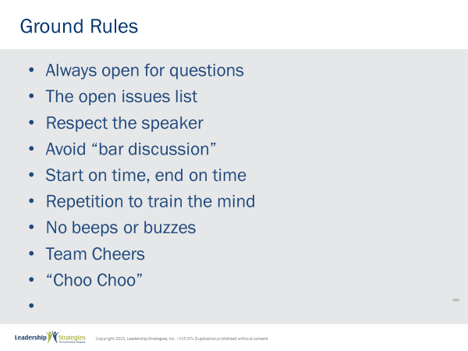 |  |  |  | SHOW POWERPOINT: Ground Rules (build)  SAY:  Well, as you can see, we have a very ambitious agenda over the next [two] days. To get through it smoothly, I would like us to agree on some “Ground Rules” or “Session Guidelines.”  ASK:  By a show of hands, how many of you have been in some type of training class before? [Raise your hand.]  SAY:  So, you know those things that work and don’t work. I value your time. I want this to be a productive session for you. So, what are those guidelines that we need to have in place to make this a productive session for you? Let’s look at these ground rules for how we will conduct our session for the next [two] days and reach an agreement on them.  DO:  REVIEW ground rules on slide. ASK the group if they would like to add or delete any of these ground rules.  ASK for a show of hands to adopt the ground rules as revised.
PPT: Your Materials  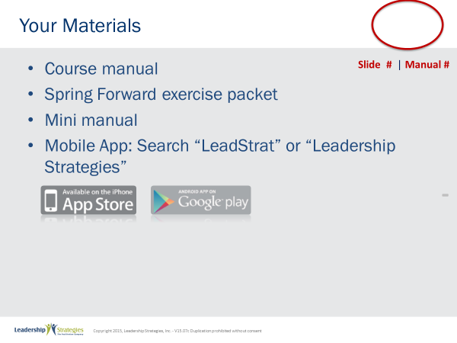 |  |  |  | SHOW POWERPOINT: Your Materials (build)  DO:  REVIEW the content on the slide.
PPT: Homework Review  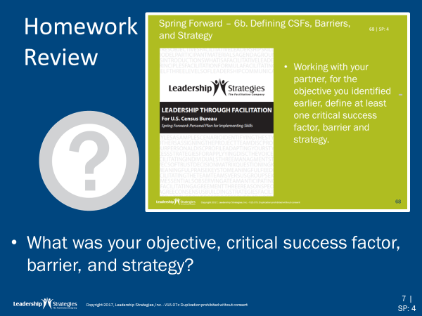   |  |  |  | SHOW POWERPOINT: Homework Review  DO:  REVIEW the homework assignment following the questions on the slide.
PPT: 7 Facilitating Meetings-Part I |  |  |  | SHOW POWERPOINT: 7 Facilitating Meetings-Part I  SAY:  At LSI we facilitate all kinds of neat stuff ---- Strategic Planning, Process Improvement, Issue Resolution, etc. And, often this requires us to prepare for and conduct meetings. Our clients often tell us how different the meetings we conduct are from their experiences; how they are more energetic, well thought out and typically driven towards an action orientation. That’s great to hear and I can tell you first hand at LSI we “eat our own cooking.” We prepare for and run our internal meetings exactly the same way. Why? Because we have found over the 20+ years that we have been doing this that it makes a difference. It leads to results, and at the end of the day, isn’t it all about being productive and getting results?  ASK:  How many of you did not attend a meeting last month? [raise your hand]  How about last week? [nod your head]  SAY:  Well, that is just about right. Based on studies by the AMA, most of us that are at a second level of management or above spend over 50% of our time in meetings. But, that is not what is most interesting about their research! What is most interesting is that more than half of those people believe that those meetings are not a good use of their time! Think about it – that is more than a day a week. What more could you get done each week with another day +?  In Modules 7 and 8, we are going to look at how we can turn our meetings into masterful meetings – meetings with a purpose, that deliver results, meetings that people will look forward to because they are well done and deliver a return for their investment.
TRANSITION:
Before we dive into the agenda, let’s find out what types of typical problems you experience with meeting.
PPT: Typical Problems with Meetings  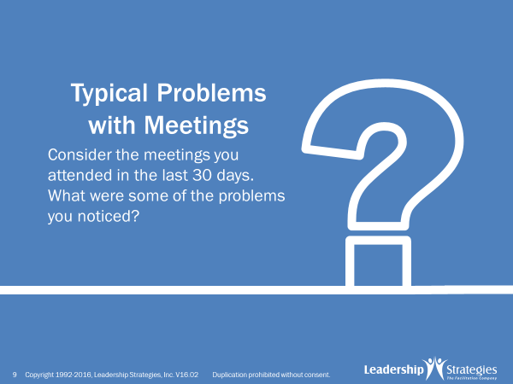 |  |  |  | SHOW POWERPOINT: Typical Problems with Meetings  SAY:  Why don’t we begin by making a list of the typical problems with meetings that we currently experience? Let’s start with the [Blue] Team and go around the room while I put the items on a flip chart [or you may use teams and post-it notes]. We will start with [name].  So, let’s reflect for just a moment.  ASK:  Think about the meetings you have attended in the last 30 days…remember those things that bothered you about those meetings. …those things that made you think about how they could have been better…. the things that frustrated you and made you say, “There is a better way….” (Name – from above), please get me started  DO:  COLLECT and GROUP the key problems on a flip chart. PROBE with reacting questions, encourage, praise, etc..
TRANSITION:
Let’s look at the agenda and make sure we are covering your challenges.
PPT: 7-8 Facilitating Meetings-Part I-II  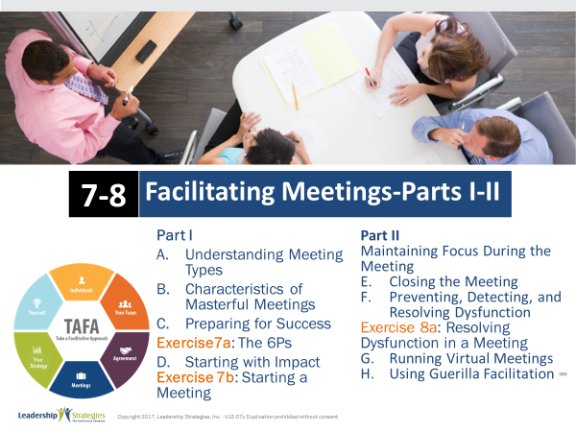 |  |  |  | SHOW POWERPOINT: 7-8 Facilitating Meetings-Part I-II  DO:  REVIEW the agendas for modules 7 and 8.  Go back to the chart with problems, and put the corresponding Agenda letter beside each problem. If there is not a corresponding Agenda item, put it in Open Issues.
PPT: Agenda  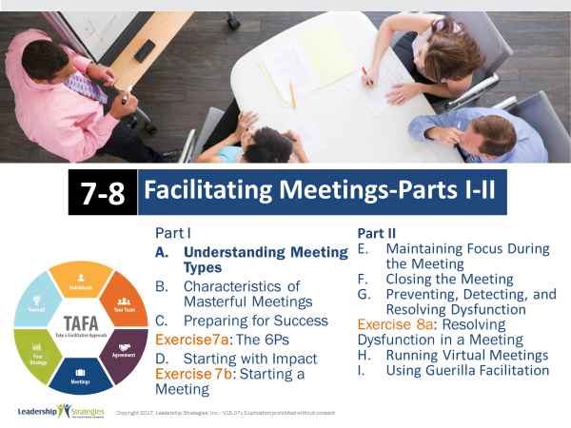 |  |  |  | SHOW POWERPOINT: Agenda  CHECKPOINT:  Now we know where the hot issues are in the room and you know when we will address yours. Let’s begin by discussing the different types of meetings. It is important to know what type of meeting you need to have because we often confuse these… which can be a reason for some of the challenges you shared.
PPT: A. Understanding Meeting Types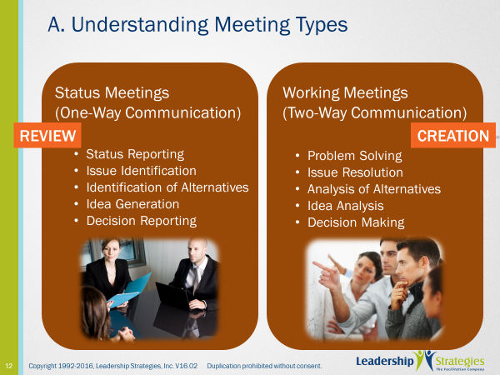 |  |  |  | SHOW POWERPOINT: A. Understanding Meeting Types (build)  SAY:  When we look at all the meetings we have led or participated in, we can typically categorize them into two major camps.  First, we have Status Meetings. [Red] team, think about the term status meetings; think about the things that come to mind, the types of status meetings you have led or participated in…. What are the types of topics or discussions you consider to be a part of a Status Meeting?  DO:  Facilitate discussion and cover key points on the slide including the one-way flow of communication in a Status Meeting.  SAY:  On the other side of our types of meetings are Working Meetings. Green team, what types of meetings come to your mind when you think about Working Meetings?  DO:  FACILITATE the discussion and cover the key points on the slide including the two-way communications in a Working Meeting; provide examples such as design meetings, process improvement, and issue resolution meetings.
PPT: A. Understanding Meeting Types  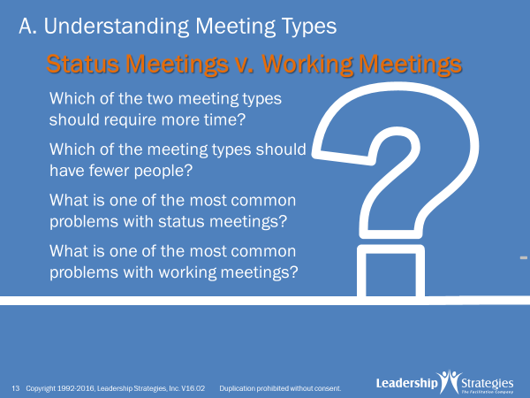 |  |  |  | SHOW POWERPOINT: A. Understanding Meeting Types (build)  ASK:  Let’s use our teams to take a look at the questions on this slide. Let me start with the [blue] team. Think about the two meeting types….status meeting and working meeting…think about your experience with the two meeting types…..which of the meeting types do you believe require more time and why? [facilitate the discussion]  Nice job [blue] team. Let’s move on to our [green] team.  DO:  GO through the next three questions in the same manner facilitating the discussion focusing on the “why” part of the teams’ answers.  KEY POINTS:  - Generally, status meetings require less time and working meetings require more time. One-way vs. two-way communication  - Generally working meetings have fewer people; the RIGHT people but fewer and we will be covering how to determine the right people later today  - One of the most common problems with status meetings is they turn in to working meetings. And, often times, the right people are not in the room  - One of the most common problems with working meetings is they lose focus. The meeting leader allows the conversations to wander/drift without taking corrective action. Again, a technique we will be discussing later.
PPT: How to Avoid Having Meetings  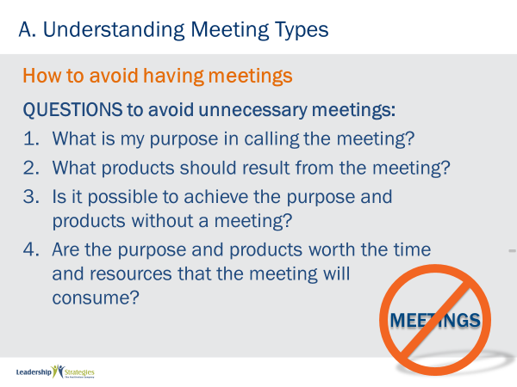 |  |  |  | SHOW POWERPOINT: How to Avoid Having Meetings (build)  ASK:  How many of us have heard about the cost/benefit balance? Or ROI?  SAY:  Often, we can avoid unnecessary meetings; but how? Let’s take a look at the key questions on this slide. [name] on our [blue] team, read the first point for me.  DO:  ADD comments and FACILITATE through the four key points on the slide.
 | PPT: How to Avoid Having STATUS Meetings 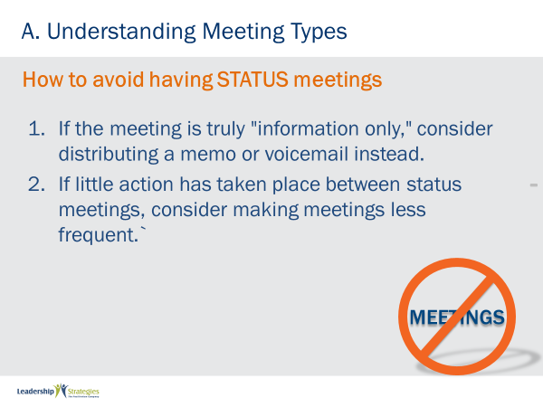 |  |  | SHOW POWERPOINT: How to Avoid Having STATUS Meetings (build)  SAY:  Here are some additional points to consider to avoid unnecessary Status Meeting. Any comments or questions?  DO:  FACILITATE the discussion.
 | PPT: How to Avoid Having WORKING Meetings  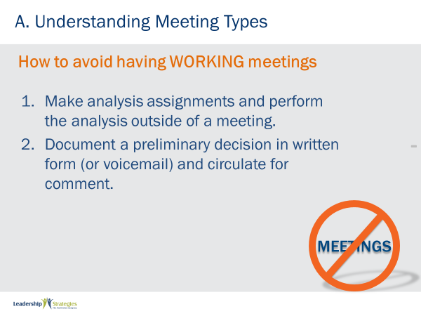 |  |  | SHOW POWERPOINT: How to Avoid Having WORKING Meetings (build)  SAY:  Here are some additional points to consider to avoid unnecessary Working Meeting. Any comments or questions?  DO:  FACILITATE the discussion.
 | PPT: Review  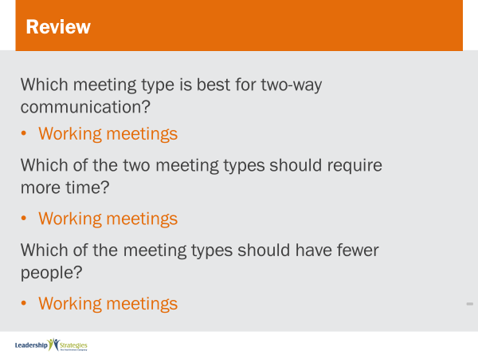 |  |  | SHOW POWERPOINT: Review  SAY:  Let’s review what we have covered so far today.  DO:  READ the questions on the slide and ask for a raised hand if they know the answer. Call on the first person who raises their hand. If they get the answer correct, award them a dot. If they do not answer correctly (or completely) ask someone else to help them out. Continue for all review slides.
PPT: Agenda |  |  |  | SHOW POWERPOINT: Agenda  CHECKPOINT:  We’ve talked about the different types of meetings, now let’s review the Characteristics of Masterful Meetings… or what happens during meetings to ensure they are effective.
 | PPT: Masterful Meetings Definition  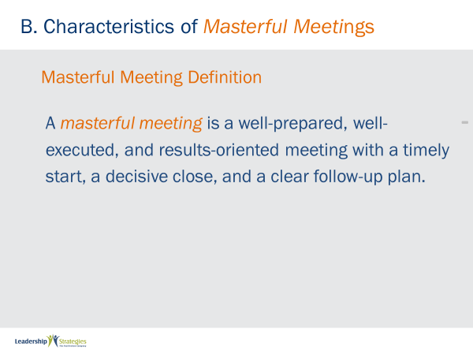 |  |  | SHOW POWERPOINT: Masterful Meetings Definition  SAY:  Well done folks. Let’s take a look at the LSI crisp and concise definition of a Masterful Meeting. [name], can you read this for us, please?  DO:  FACILITATE a discussion around the content stressing each component: well-prepared, well-executed, results-oriented, timely start, decisive close and clear follow-up plan.
 | PPT: 18 Characteristics 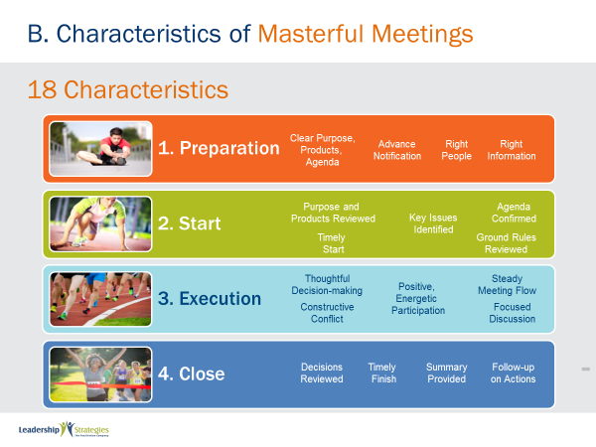 |  |  | SHOW POWERPOINT: 18 Characteristics (build)  SAY:  With that definition in mind, this diagram depicts the eighteen elements of a Masterful Meeting in four distinct categories of:  - Preparation  - Starting  - Executing and  - Closing  Let’s take a more detailed look at each of these eighteen characteristics.
 | PPT: Preparation  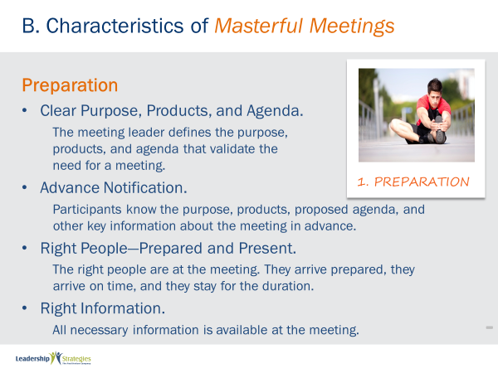 |  |  | SHOW POWERPOINT: Preparation (build)  SAY:  [Name], get us stared with the first characteristic of Preparation.  DO:  Use a READ AROUND for all four points on the slide, making a comment occasionally and at least at the end of each of the four categories.
 | PPT: Start 1 of 2  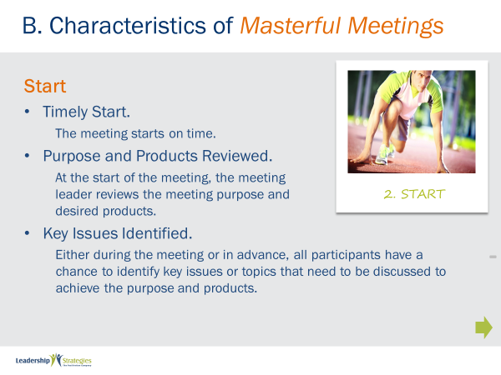 |  |  | SHOW POWERPOINT: Start 1 of 2 (build)  DO:  Continue use a read around the five START characteristics, making a comment occasionally and at least at the end of each of the four categories.  NOTE: START continues onto the next slide.
 | PPT: Start 2 of 2  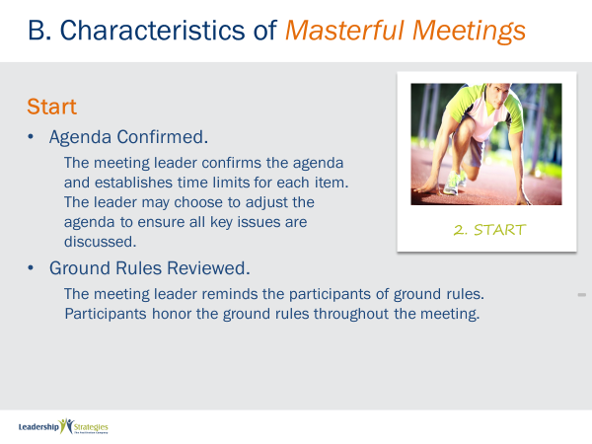 |  |  | SHOW POWERPOINT: Start 2 of 2 (build)  DO:  [Continue from previous slide.]
 | PPT: Execution 1 of 2  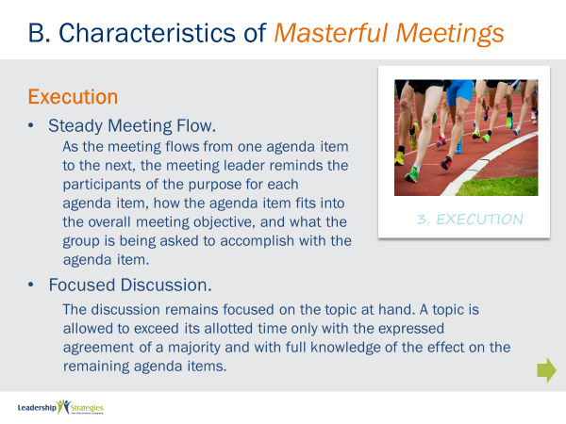 |  |  | SHOW POWERPOINT: Execution 1 of 2 (build)  DO:  Continue use a read around the five EXECUTION characteristics, making a comment occasionally and at least at the end of each of the four categories.  NOTE: EXECUTION continues onto the next slide.
 | PPT: Execution 2 of 2  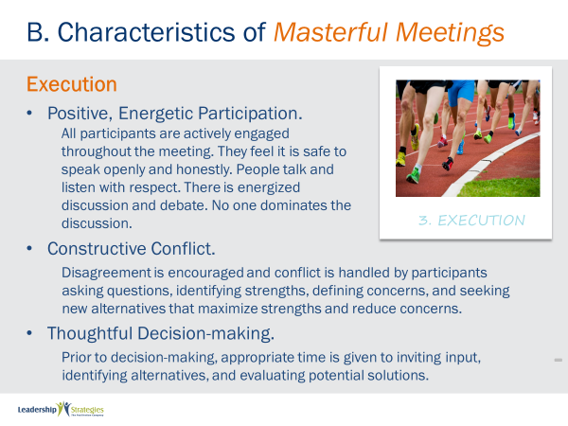 |  |  | SHOW POWERPOINT: Execution 2 of 2 (build)  DO:  [Continue from previous slide.]
 | PPT: Close and Follow-up 1 of 2  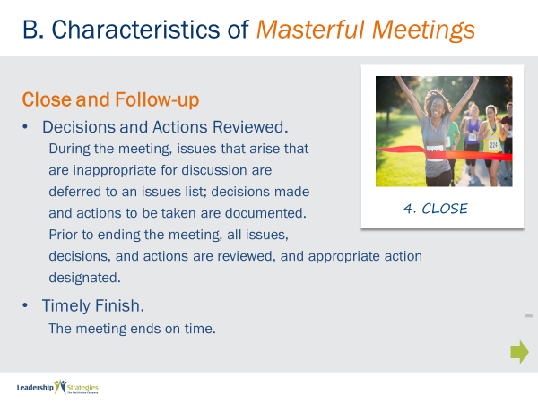 |  |  | SHOW POWERPOINT: Close and Follow-up 1 of 2 (build)  DO:  Continue use a read around the four CLOSE and FOLLOW UP characteristics, making a comment occasionally and at least at the end of each of the four categories.  NOTE: CLOSE AND FOLLOW UP continues onto the next slide.
 | PPT: Close and Follow-up 2 of 2  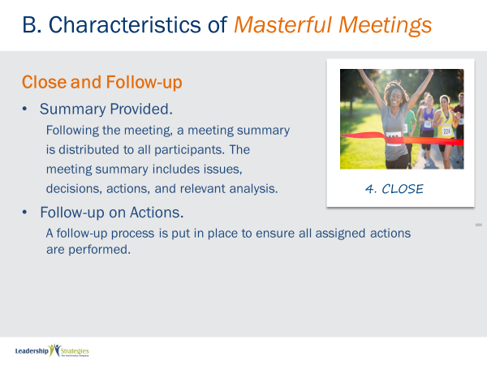 |  |  | SHOW POWERPOINT: Close and Follow-up 2 of 2 (build)  DO:  [Continue from previous slide.]  KEY POINTS:  Running any meeting without considering these 18 characteristics is likely what many people do. That is a key reason we hear/read so much about bad meetings – let’s commit to ending those types of meetings and being a catalyst of conducting masterful meeting in our organizations.
PPT: Agenda |  |  |  | SHOW POWERPOINT: Agenda  CHECKPOINT:  You now know the 18 characteristics of masterful meetings. It’s time to unpack them in more detail. We’ll begin with how to prepare for success. If we don’t get this part right, nothing else matters.
 | PPT: Books Closed!  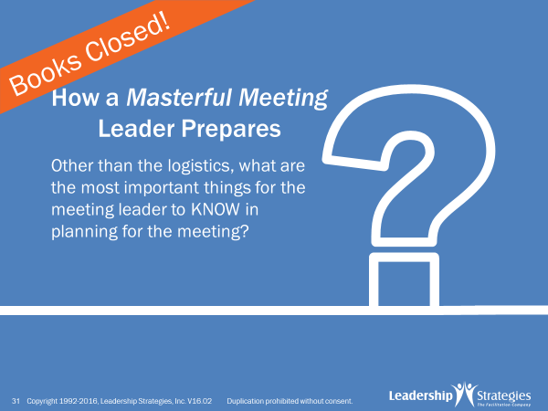 |  |  | SHOW POWERPOINT: Books Closed!  SAY:  To get started with preparation, let’s use our teams.  DO:  FACILITATE the activity described below.  PURPOSE - The purpose of this next exercise is to ask each team what they believe is a part of Masterful Meeting preparation  EXAMPLE - not needed  DIRECTIONS - Each team will be recording their answers to the question I am about to ask on post-it notes. So first, let’s select a new team leader. If you have already been a team lead, you are not eligible. Of the remaining team members [select the new team leader; oldest/newest car; most/least siblings; etc.]. Our new team leaders will be doing the following:  - They will be recording the answers from their teams on the post-it notes and writing with the marker. Note the markers are pretty thick and the post-its are pretty small; so, please write accordingly.  - Each answer will be recorded on its own, unique post-it note. So, [blue] team, if you have four answers, how many post-it notes would you have? [great, four, that’s as complicated as the math will get today]  - Finally, I am going to set the clock for two minutes. When the clock rings, indicating time has expired, please cap your markers to keep the competition fair.  EXCEPTIONS - none  QUESTIONS - All good with that? [nod your head; answer any questions] are there any questions before I ask the question to get us started? [respond to any questions]  STARTING QUESTION - OK, think about the last meeting you led or the next meeting you are planning to lead…think about all the things you would need to do from the time you were aware of the need for that meeting until that meeting gets started……what are the most important things for the Meeting Leader to KNOW in planning for the meeting?  DO:  When the clock expires, COLLECT the post-it notes and GROUP them on a flip chart at the front of the room; model the grouping technique; consider referring this grouped list to the next slide to encourage the sharing of experiences around each topic.
 | PPT: The 6 P’s of Preparation  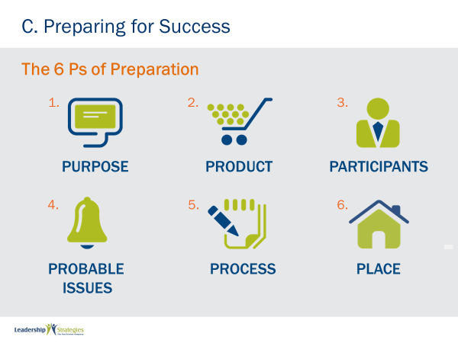 |  |  | SHOW POWERPOINT: The 6 P’s of Preparation (build)  SAY:  I am sure many of you have heard about the more common Ps of Preparation: prior planning prevents poor performance. Well, while those P’s tell you about the importance of preparing, the 6 Ps on this slide tell you what you really need to do to prepare well for your meetings. These 6 Ps are:  - Purpose  - Product  - Participants  - Probable issues  - Process and  - Place  TRANSITION:  Let’s take a look in a little more detail about each of these 6 Ps.
 | PPT: Purpose  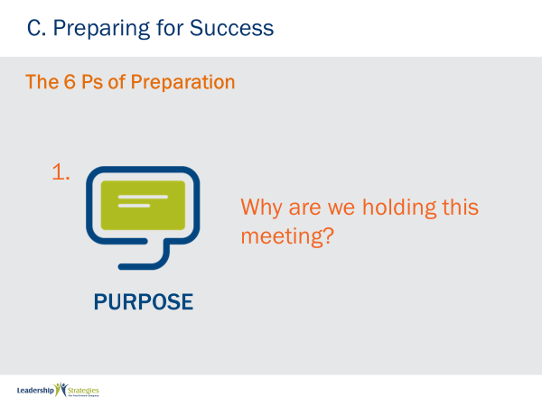 |  |  | SHOW POWERPOINT: Purpose  SAY:  To define the Purpose of our meeting, we really need to know why we are having this meeting and why the meeting is important. May I ask someone on our [green] team to think about a recent meeting you led….think about the reason you had the meeting….the goal you were trying to achieve….what was the “why” for conducting that meeting?  DO:  ASK if anyone else have a different example; FACILITATE the discussion referring back to the two types or meetings – status and working - and defining the purpose(s) of each; reinforce the 1-way vs. 2-way communication that contrasts the two types of meetings.
 | PPT: Product  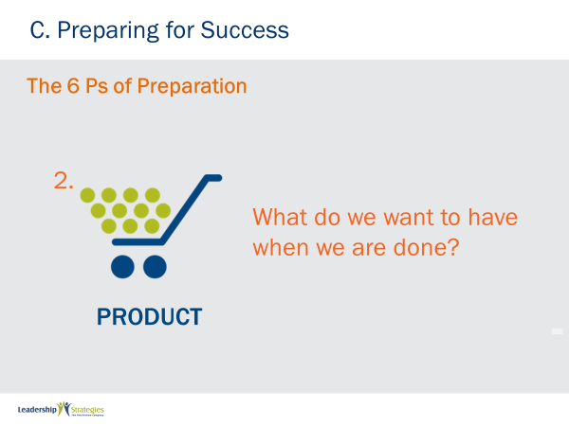 |  |  | SHOW POWERPOINT: Product  SAY:  Next, we would want to define Product. What will we have at the end of the meeting. We find it very helpful to look at this Product across the three dimensions listed:  - Hand: What is the tangible deliverable when we are done with this meeting?  - Head: What will we have in our heads, what will we know at the end of the meeting?  - Heart: What will we have in our hearts: what will we believe at the end of the meeting?  TRANSITION:  As a part of our preparation, think about how these first two Ps take our meetings to a higher level.
 | PPT: Purpose and Product Answers  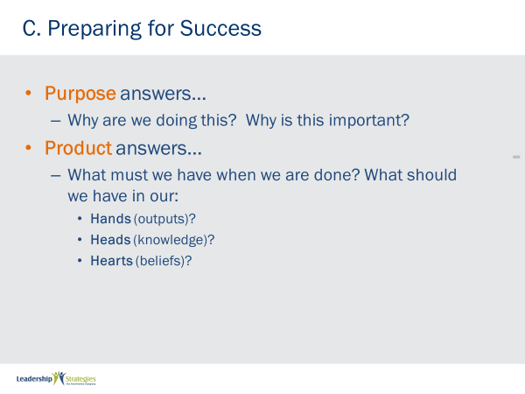 |  |  | SHOW POWERPOINT: Purpose and Product Answers (build)  SAY:  These two points focus on the purpose, or why’s of the meeting and the key dimensions of the outcome or the product of the meeting. Can you imagine the difference you can make when you use the paradigm in preparing for your future meetings? Wouldn’t this take the meetings in your organization or team to a different level? (nod your head)
 | PPT: Purpose and Product Examples  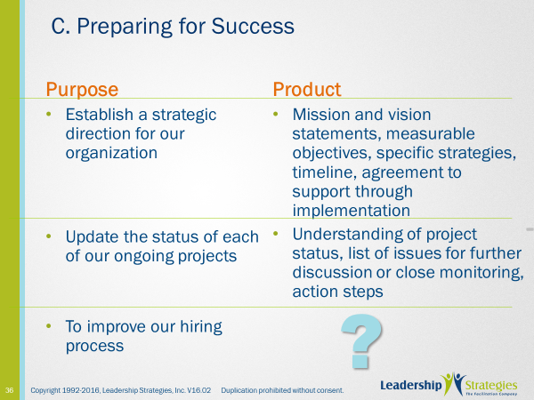 |  |  | SHOW POWERPOINT: Purpose and Product Examples (build)  SAY:  On this slide we have two examples, one for the strategic direction and the other for a status meeting. Can everybody see the key product for each of these two meetings? [raise your hand]  What about our third example regarding the hiring process. Let me ask each team, starting with our [red] team to help identify the product or products for that meeting.  DO:  FACILITATE that discussion.  NOTE: the key products would be a list.
 | PPT: Participants  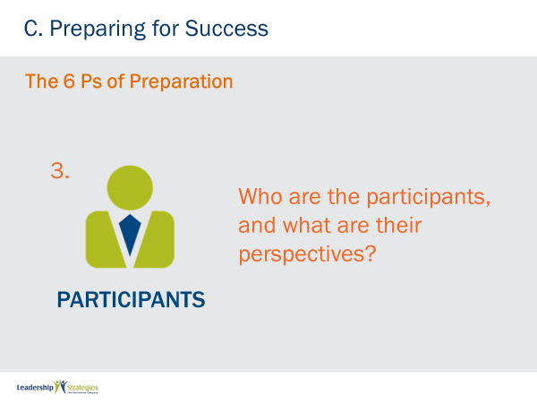 |  |  | SHOW POWERPOINT: Participants  SAY:  The third P is Participants. Note, it is not only who are the best participants to achieve the session purpose and product; but also, WHERE are they coming from? Who are your prisoners (people who don’t want to attend), who are your vacationers (who look at meetings as a place to relax), and who are your seekers?  We will be talking about this tomorrow, but we start managing the behaviors we want to encourage as well as the behaviors we want to prevent right here.
 | PPT: Participants – Status Meeting  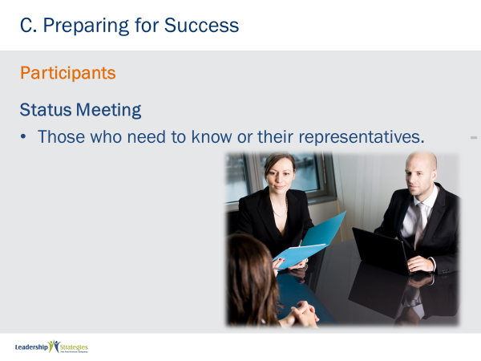 |  |  | SHOW POWERPOINT: Participants – Status Meeting  SAY:  For a Status Meeting the right participants are those who need to know or their representatives. [blue] team, can you share an example from one of your member’s status meetings?  DO:  FACILITATE that discussion.
 | PPT: Participants – Working Meeting  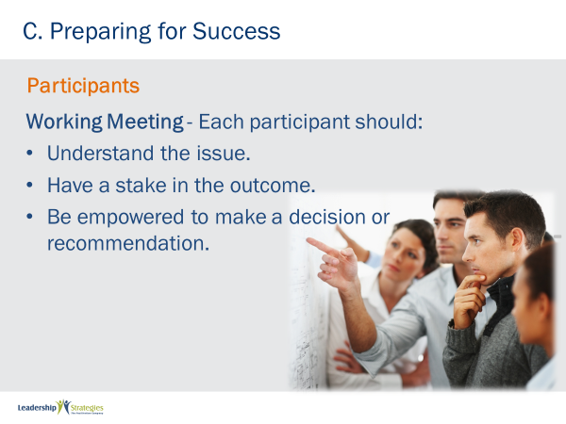 |  |  | SHOW POWERPOINT: Participants – Working Meeting (build)  SAY:  For our other type of a meeting, the Working Meeting, we have the three key attributes for identifying the right participants listed on this slide. After going through the three requirements.  ASK:  What happens if each of the requirements is missing?  DO:  FACILITATE that discussion.  KEY POINTS:  If they do not understand the issue, you will have to educate them as part of the meeting; if they do not have a stake in the outcome, they may be indifferent if they do not have to live with the results; and if they are not empowered to make a decision, we may be in the information sharing vs. decision making meeting and will not get the results we want to achieve.
 | PPT: Working Meeting - As a Group  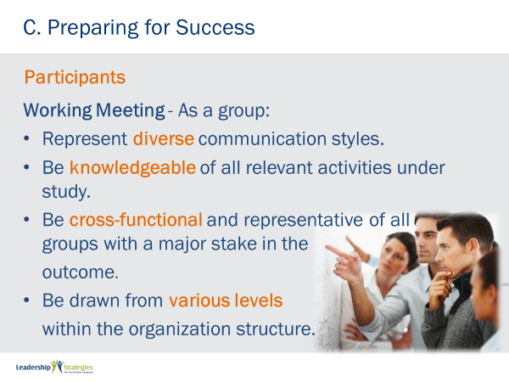 |  |  | SHOW POWERPOINT: Working Meeting – As a Group (build)  SAY:  Think about a meeting regarding a design of a new IT system or a lead flow discussion. Think about an audience of all functional people in the IT meeting or all sales/marketing people in the lead flow meeting. We might have selected each individual participant correctly, yet we might not have the audience we need when we look at all the participants in their entirety. So, as a part of identifying the Right Participants, we want to consider several other criteria.  DO:  Review key points from the slide; facilitating the discussion.
 | PPT: Probable Issues  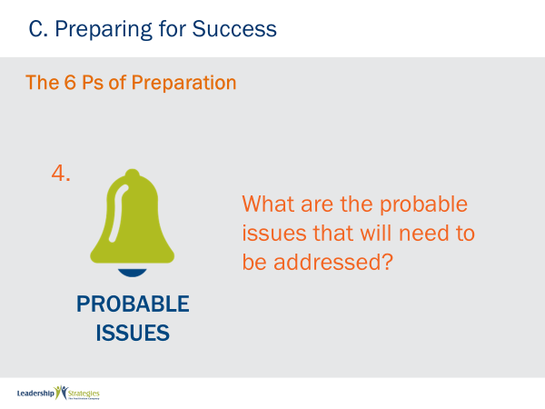 |  |  | SHOW POWERPOINT: Probable Issues  SAY:  The fourth P, is Probable issues.  ASK:  Given those participants coming together to achieve your intended purpose and build the intended product, what are the Probable issues that will arise? And, what will your strategies be for tackling those issues?  DO:  FACILITATE that discussion.
 | PPT: Probable Issues – Questions to Answer  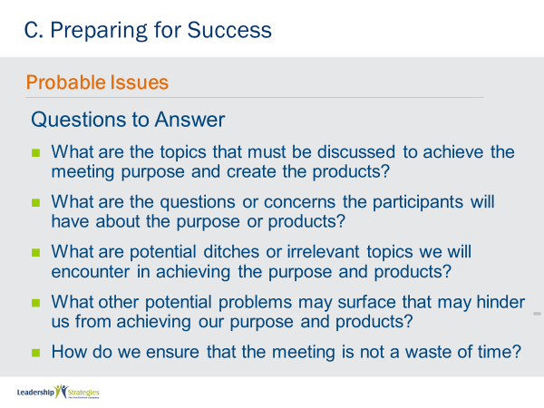 |  |  | SHOW POWERPOINT: Probable Issues – Questions to Answer (build)  SAY:  Here are some Questions to Answer that will help you, as a meeting leader, identify Probable Issues as a part of preparing for your meetings.  DO:  FACILITATE the discussion of the key questions on the slide; ask for some recent examples to highlight an area or two.
 | PPT: Process  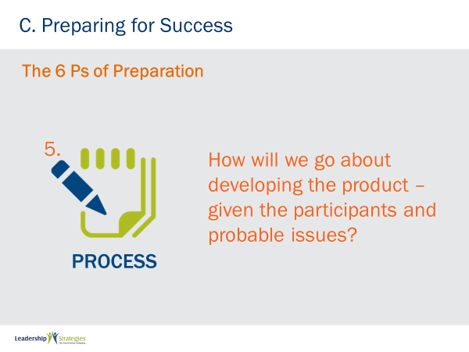 |  |  | SHOW POWERPOINT: Process  SAY:  The fifth P is Process.  ASK:  What is the process that will get you from Purpose to Product? Do you know the process? Have you done this before? Or, are you building a new process to achieve the purpose?  DO:  FACILITATE the discussion around the importance or process.
 | PPT: Process – Develop the Agenda  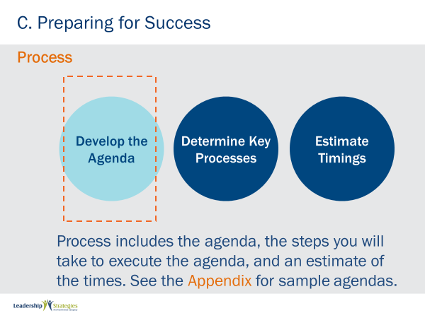 |  |  | SHOW POWERPOINT: Process – Develop the Agenda  SAY:  The fifth P or Process includes three distinct steps: the agenda, the key processes and an estimate of the timing for each item on the agenda. Let’s take a look at each.  Many meeting leaders often stop at the preparation of the steps for the meeting or the agenda. Then they just “wing” it or plan to run their meeting based on this summary type agenda. Instead, to make your meeting more masterful, you will want to tackle that fifth P of preparation: Process. To do that requires three steps. The first is the agenda item. When all of the agenda items are pulled together, we have our steps to conduct the meeting. Let’s take a look at a sample of the steps for a meeting to improve the hiring process.  As a part of the course, you will find in the Appendix several of the most common meetings LSI conducts. For each we have provided you a starting point for each of these meeting types. Of course, this would serve as a starting point. You would want to adjust or customize those agendas to ensure your meetings are more targeted. As you look at any meeting, we would typically find a “diverge then converge” model. By that we mean early agenda items are typically for context and possibilities while later agenda items are for action planning.
 | PPT: Process – Determine Key Processes 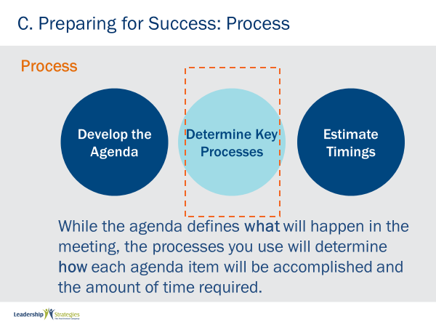 |  |  | SHOW POWERPOINT: Process – Determine Key Processes  SAY:  As meeting leaders, we want our meetings to “seem like they fly by.” Participants toward the end of a meeting have two polar opposites in terms of how they will feel about that meeting. On one extreme, it is like, “wow, another hour until we get out of here.” On the other end of that continuum, the meeting participant reacts more like, “wow, where di the day go?” The difference is often in how we design the key processes during our preparation for a meeting.  Too many meetings are presentation followed by Q&A; then another presentation followed by Q&A; and then again. That is not only boring but it makes the meeting or day drag on. Instead by varying the key processes to engage our participants we make our meetings more interactive; we gain buy-in or commitment to decisions because participants are a part of making decisions, they have been engaged and are more committed to the results they agreed to during the meeting.  ASK:  Any questions on Determining Key Processes as a part of preparation?  DO:  FACILITATE that discussion.  SAY:  Once we have identified the key processes then, for each agenda item and key process, we must provide an estimate of the time it will take to complete that agenda item. It is a question of moving from a WAG (wild ass guess) to a SWAG. We only bet better by preparing estimates and then tracking our actual times against our estimates.  ASK:  Does someone on the [green] team share how they do that today?  DO:  FACILITATE that discussion.
 | PPT: Sample Ways to Process  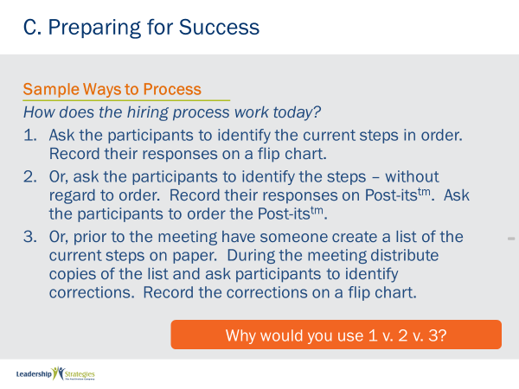 |  |  | SHOW POWERPOINT: Sample Ways to Process (build)  DO:  FACILITATE the activity using the instructions below.  PURPOSE - Let’s take a look at three different ways to process a step in a process improvement meeting agenda. For the agenda item where we would ask the participants to identify the way the process works today, this slide depicts three different ways to complete this agenda item – the Process for the meeting to identify the steps in the current hiring process.  EXAMPLE - none needed  DIRECTIONS - To do this, I would like to assign each of our teams one of the options and ask that team to identify circumstances for using that particular options. Let me ask the [purple] team to discuss when, where and why you might use choice 1. [red] team, you take choice 2 and [blue] team, you take choice 3. I will set the clock for 2 minutes for your team to discuss the option assigned to your team. Our new team leader, who will serve as the spokesperson for your team for this exercise, will be [assign different team leader]  EXCEPTIONS - none  QUETSION - Before we begin, are there any questions?  STARTING QUESTION - not necessary  DO:  Start the clock and FACILITATE the discussion when time expires.
 | PPT: Common Processes  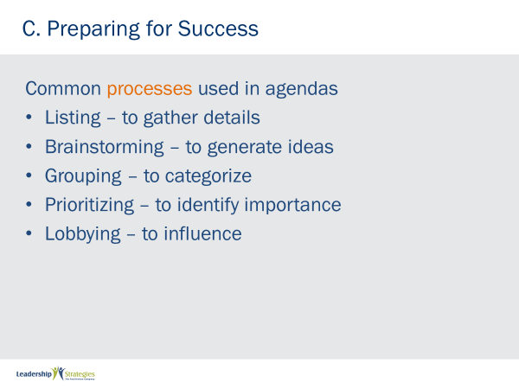 |  |  | SHOW POWERPOINT: Common Processes (build)  SAY:  There are a multitude of ways to Process agenda items during a meeting. The key is to vary the methods and engage the participants to make meetings more interesting. This slide lists several of the process types which we will be covering in more detail in Section F of the course. As you can see, the slide lists the common process and the “why” or “what” that process might be use for.  ASK:  Are there any questions or comments on this list?  DO:  FACILITATE that discussion.
 | PPT: C. Preparing for Success  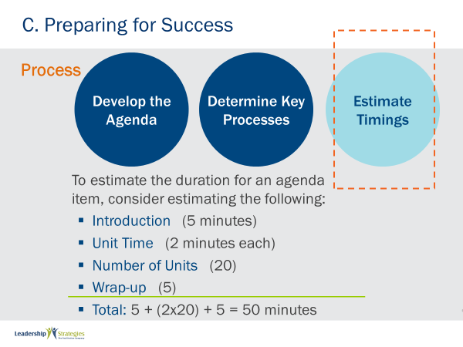 |  |  | SHOW POWERPOINT: C. Preparing for Success (build)  SAY:  Here is a good example of the way we can develop estimates of each agenda item. Notice it follows a basic format of:  - Introduction; what will it take to start that agenda item  - Unit Time: the time it will take to identify, discuss, order, etc. each unit included in that agenda item  - Number of units: the anticipated number of units in that agenda item (e.g. we estimate there are between 10 to 12 total steps in the current hiring process)  - Wrap-up the time it will take to summarize and conclude that agenda item  This is a great template for us to use to Estimate Timings for each agenda item in our meeting.  ASK:  Does anyone use something like this today?  DO:  FACILITATE that discussion.
 | PPT: Place  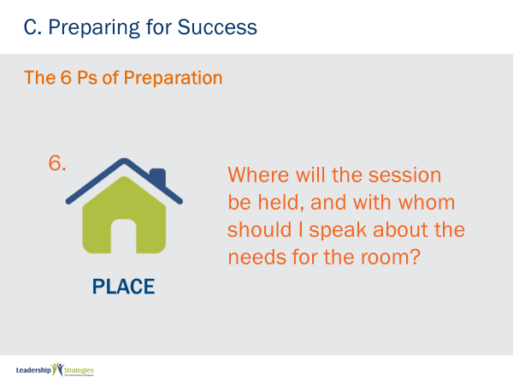 |  |  | SHOW POWERPOINT: Place  SAY:  Our last P, Place. Where will the session be conducted? (Is it VIRTUAL?) Have arrangements been made? Who will your contact be for administrative items?  Although not a difficult P, how many of you have meeting rooms in your organization waiting for meetings? That’s right, we have to plan for our meetings well in advance to ensure we can book that meeting room or Place.
 | PPT: Place  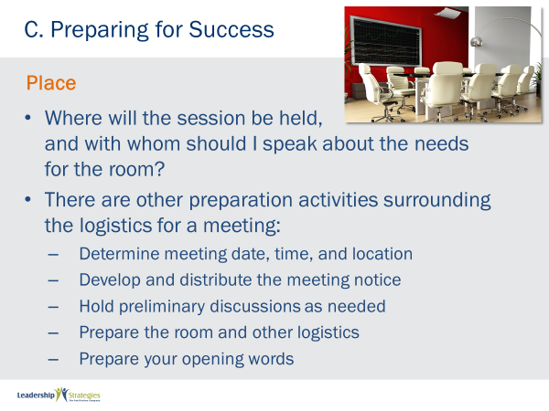 |  |  | SHOW POWERPOINT: Place (build)  ASK:  How many of you are aware of Murphy’s Law? [raise your hand] How many of us have experienced Murphy’s Law? [nod your head]  SAY:  When it comes to the Logistics of our meeting, it seems this is often where Murphy lives. When we remember to cover these items, they always go well. When we overlook or rush through our preparation, the item we forget or overlook always seems to go the wrong way.  ASK:  [Green] team, any Murphy’s Law examples you might share with us?  DO:  FACILITATE the discussion.  KEY POINT:  “Life is often in the details”; the difference between a good meeting and a great meeting is not doing any one thing so much better but doing a lot of little things just a little bit better.
 | PPT: Checklist for Preparing  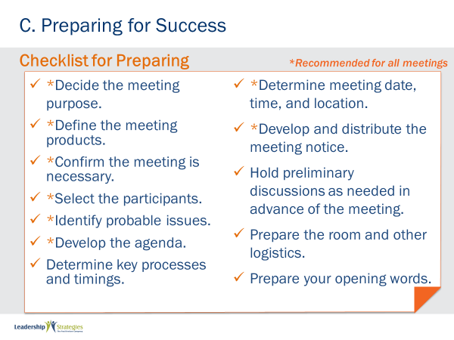 |  |  | SHOW POWERPOINT: Checklist for Preparing  SAY:  Here is the first of several Checklists for assisting us in making our meetings more Masterful. You will notice that all steps may not be necessary for all meetings and those that are recommended for all meetings are identified by an asterisk by that item on the checklist. These checklists are included on the LSI website along with other key meeting tools such as the countdown time we have been using. You may want visit that web site and check for updates occasionally.  ASK:  Before we move on, are there any questions on Masterful Preparation?  DO:  FACILITATE the discussion.
 | PPTS: Review Slides  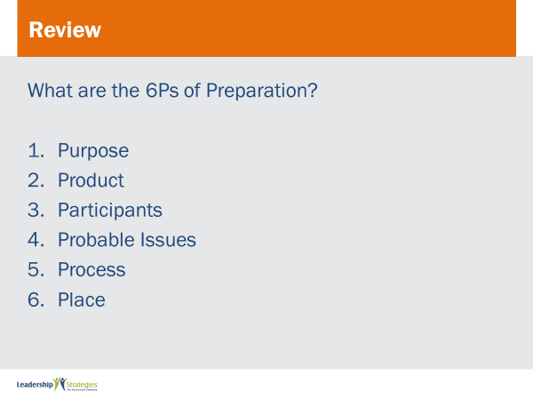 |  |  | SHOW POWERPOINT: Review Slides  SAY:  Let’s review what we have covered so far today.  DO:  READ the questions on the slide and ask for a raised hand if they know the answer. Call on the first person who raises their hand. If they get the answer correct, award them a dot. If they do not answer correctly (or completely) ask someone else to help them out. Continue for all review slides.
PPT: Agenda |  |  |  | SHOW POWERPOINT: Agenda  CHECKPOINT:  You now know how to thoroughly prepare for any meeting using the 6 P’s of Preparation. Let’s do an exercise so you can practice using this technique.
 | PPT: Spring Forward 7a. The 6 Ps  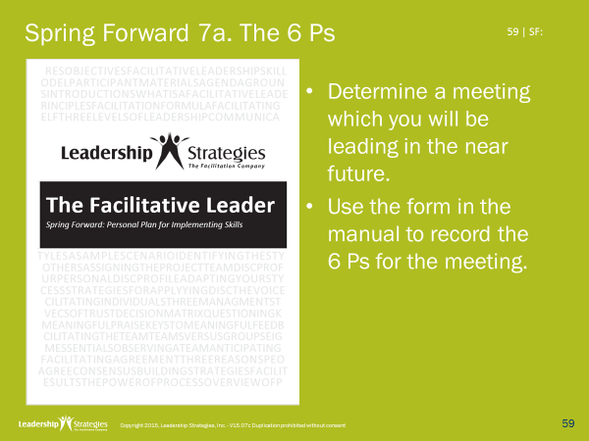 |  |  | SHOW POWERPOINT: Spring Forward 7a. The 6 Ps (build)  DO:  Instruct the group to complete the exercise.  PURPOSE - To plan for an upcoming meeting.  EXAMPLE – not needed  DIRECTIONS - Take 5 minutes to individually plan your meeting. Then, share with a partner.  EXCEPTIONS - none  QUESTIONS - What questions do you have?
 | PPT: Agenda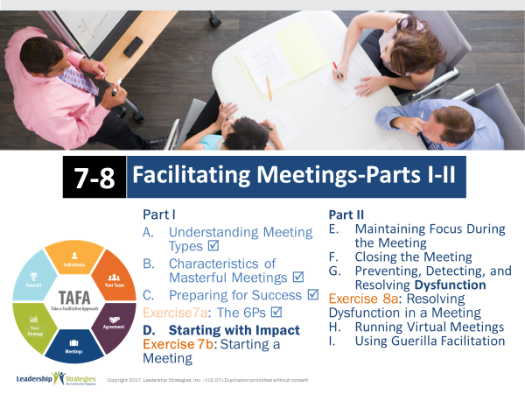 |  |  | SHOW POWERPOINT: Agenda  CHECKPOINT:  We have just completed our agenda items on Getting Started, a vision of a Masterful Meeting and Masterful Preparation. We covered the 6 Ps of Preparation, how to avoid unnecessary meetings as well as several other best practices/techniques. [consider some backward build up] What we are about to do next is how to start with impact. This is important because, as we all know, we get one chance to make that first impression and we want to start our meetings by “grabbing their attention,” by converting our prisoners and vacationers into seekers and to get them engaged early so they “will be there when we need them to be there.” Let’s take a look at the best practices/techniques associated with Masterful Starting.
 | PPT: Sample Meeting Notice  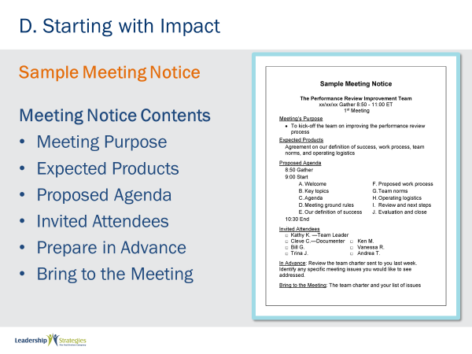 |  |  | SHOW POWERPOINT: Sample Meeting Notice  DO:  REVIEW the slide.
 | PPT: Books Closed!  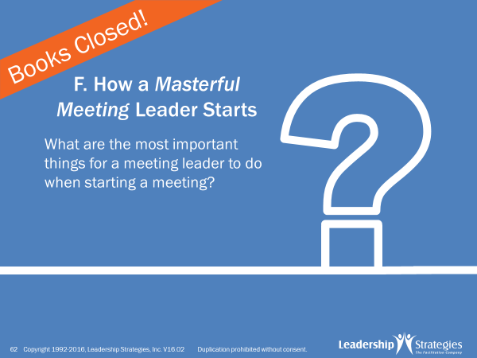 |  |  | SHOW POWERPOINT: Books Closed!  SAY:  To get started with starting, let’s use our teams and do one of my favorite meeting engagements, Last Person Standing.  PURPOSE - The purpose of this next exercise is to have each team identify as many unique items in starting a session and determining which team can identify the most unique items  EXAMPLE - not needed  DIRECTIONS - Each team will be recording their answers to the question I am about to ask on post-it notes. So first, let’s select a new team leader. If you have already been a team lead, you are not eligible. Of the remaining team members [select the new team leader; oldest/newest car; most/least siblings; etc.]. Our new team leaders will be doing the following:  - They will be recording the answers from their teams on the post-it notes and writing with the marker. Note the markers are pretty thick and the post-its are pretty small; so, please write accordingly.  - Each answer will be recorded on its own, unique post-it note. So, [blue] team, if you have four answers, how many post-it notes would you have? [great, four, that’s as complicated as the math will get today]  - Finally, I am going to set the clock for two minutes. When the clock rings, indicating time has expired, please cap your markers to keep the competition fair.  All good with that? [nod your head; answer any questions]  EXCEPTION - none  QUESTIONS - Are there any questions before I ask the question to get us started? [respond to any questions]  STARTING QUESTIONS - Think about the last meeting you attended where the meeting leader just blew you away as they started that meeting….think about the things she/he did…..the way they kicked off that meeting in a way that figuratively grabbed you by the shirt and shook you…..you knew it was going to be a great meeting…what are the most important things a meeting leader does to start a meeting in that way?  (ADDITIONAL) DIRECTIONS - Now what we are going to do is ask each team leader to select one of their post-it notes, read that post-it note to the audience, place it on the flip chart and move to the back of the line; then the next team leader will do the same thing  As participants, your job in the audience is to listen for a duplicate. When you hear a duplicate, you must cross your hands above your head and “honk’; let’s give that a try [have audience do it once with vigor]; great job, that’s what we need you to do. Now, when we get the first duplicate for a team, that team lead will continue to the back of the line and continue in the competition. However, when any team has a second duplicate, which we will recognize by the second post-it note of that color, that team leader will join their team at the table. Which team will win the completion? That’s right the Last Person Standing.  Continue with the Last Person Standing engagement
 | PPT: D. Starting with Impact  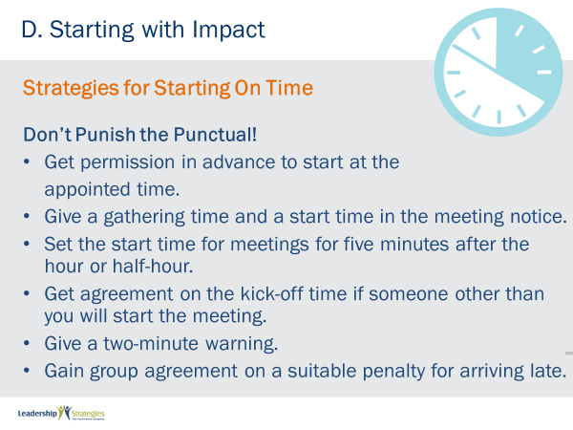 |  |  | SHOW POWERPOINT: D. Starting with Impact (build)  ASK:  How many of your meetings start late? [raise your hand] That’s what we typically find; many or most meetings start late. And, [green] team who are the people that arrive late? Are they the junior participants or the more senior participants? [typically get the senior as an example; if so, follow-up with] That’s what we are often told, the more senior folks. Let me ask you, do you think senior people got where they are by coming in late and leaving early? [nod your head, no]  SAY:  Of course not, so why are they arriving to meetings late? I believe they know meetings will likely start late so they stay in their office or their last meeting and have that last conversation or respond to that one more email, etc. Knowing the meeting they are about to go to will not start on time. Stop that. As at the conclusion of the next meeting if you might have a minute to two to share an observation.  When you are asked about that observation simple ask, “Has anyone else noticed that our meetings are not starting on time? Does anyone see that as a problem?” And, be ready to offer some solutions – you should have several by the end of tomorrow. That senior executive in that meeting will likely remember that comment. And, in a good way.  DO:  REVIEW the key points on the slide facilitating the discussion.  KEY POINT:  DO NOT PUNISH THE PUNCTUAL and get them to guesstimate what the total cost of all meetings in an organization starting just three to five minutes late is in terms of wasted payroll expense.
 | PPT: Set the Stage  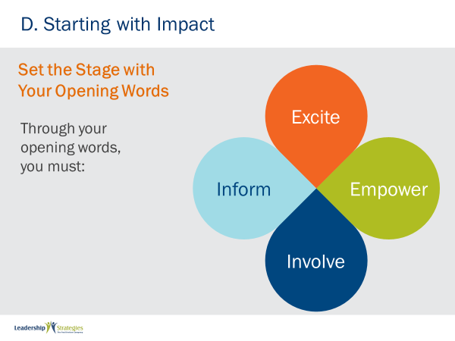 |  |  | SHOW POWERPOINT: Set the Stage  ASK:  Now that we know how to get our meeting started in a timely manner, let’s turn our attention on how to open with impact. How many of you have heard the adage, “You get one chance to make a good impression?” [raise your hand] How about the key point in opening a meeting or making a presentation the need to ‘hook” them? [nod your head]  SAY:  Me, too. But until I learned from Leadership Strategies how to do that it was a continuing challenge. So, in order to start with impact, in order to figuratively grab them by their shirt collars and grab their attention, you want to IEEI.
 | PPT: Inform  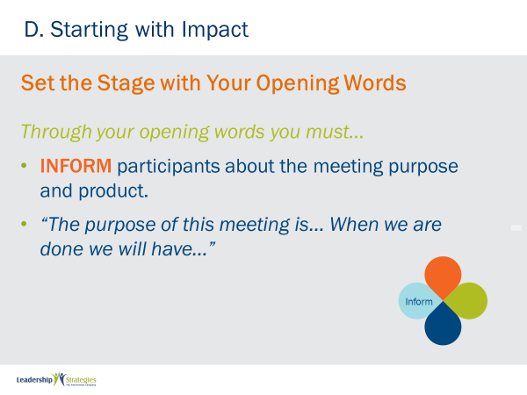 |  |  | SHOW POWERPOINT: Inform  SAY:  Start by Informing them of purpose and product. Why, start with this? It scopes the meeting!
 | PPT: Excite  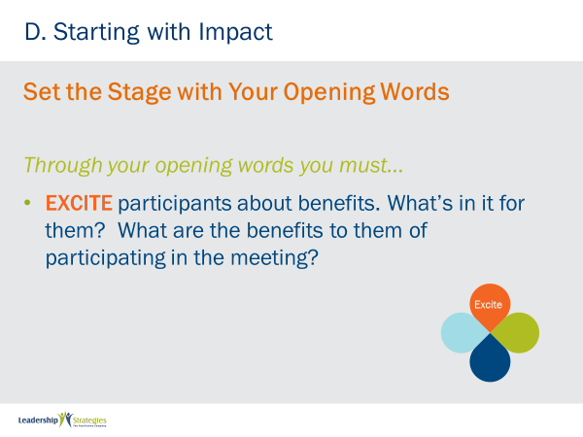 |  |  | SHOW POWERPOINT: Excite  SAY:  Next Excite them. Put yourselves in the seat of a participant and ask yourself, WII-FM; what’s in it for me. If you selected your participants using our 5 Ps of Preparation, we have the answer to that WII-FM or they would likely not have been included as a participant in our meeting. Give them the BENEFITS to them. This converts your prisoners and vacationers to seekers because they are tuned into radio station WII-FM
 | PPT: Empower  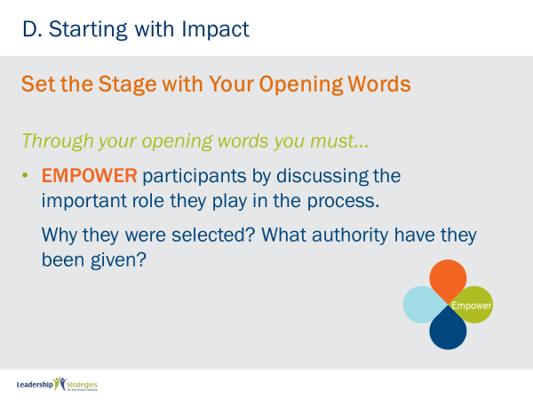 |  |  | SHOW POWERPOINT: Empower  SAY:  Now, as Alfred E. Neuman used to say in Mad Magazine, answer the question, “Why me?” In other words, whey were they selected and what authority have they been given. Are they being asked to provide a recommendation or make a decision. Again, if you followed the prescribed 6 Ps of preparation, you know the answer to this; tell them!
 | PPT: Involve  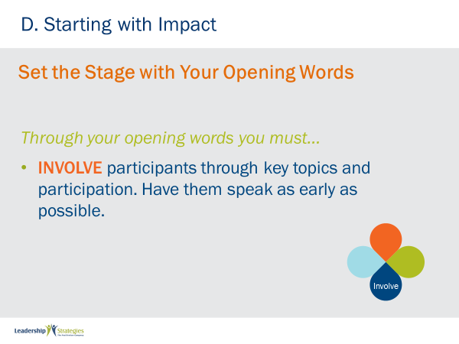 |  |  | SHOW POWERPOINT: Involve  SAY:  Now, change that meeting from one-way flow of information to a dialogue; Ask them their personal objectives or key topics they need to have addressed to accomplish the purpose and product you Informed them about in the IEEI!!  In our experience, we find most times participants aren’t involved in the meeting early enough. By involving them early they know their input is desired they will more likely be there for you when you need them to be there throughout the meeting.
 | PPT: Best/Worst  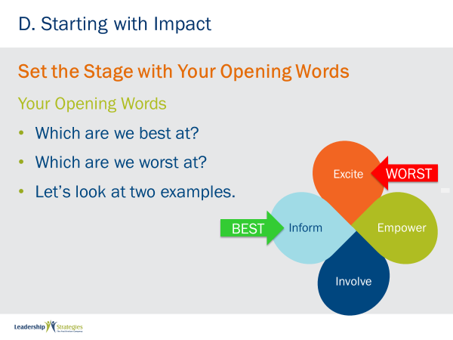 |  |  | SHOW POWERPOINT: Best/Worst (build)  SAY:  Over the course of our 20+ years, we ask many people what they are best at and what they are worst at. Let’s see what this group thinks.  DO:  HAND POLL the group about the best and worst and announce the group results]  SAY:  Typically, what we have found is meeting leaders find they are best at Inform and worst at Excite. Let’s see if we and spend about ten minutes to work on Excite statements for either meetings you are planning to do in the near future or one of the meeting identified in the next slide.
 | PPT: Examples  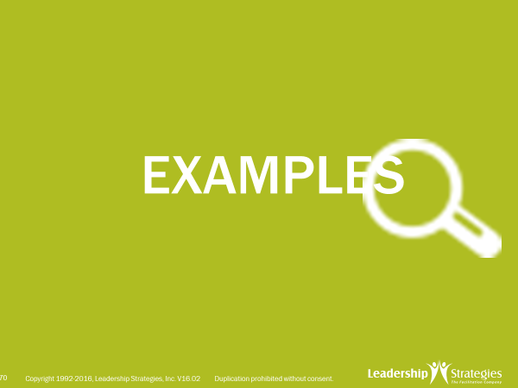 |  |  | SHOW POWERPOINT: Examples  SAY:  Let’s look at a couple of Excite statements and identify a few tips on how to build better Excite statements.
 | PPT: Excite Example #1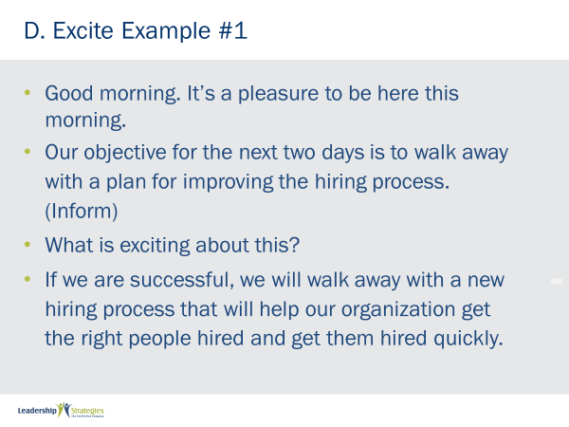 |  |  | SHOW POWERPOINT: Excite Example #1 (build)  ASK:  (Name), would you please read Example #1?  SAY:  Thank you, pretty good don’t you think folks? [nod your head] Probably better than most Excite statement I have heard. Let’s compare that to the next example.
 | PPT: Excite Example #2  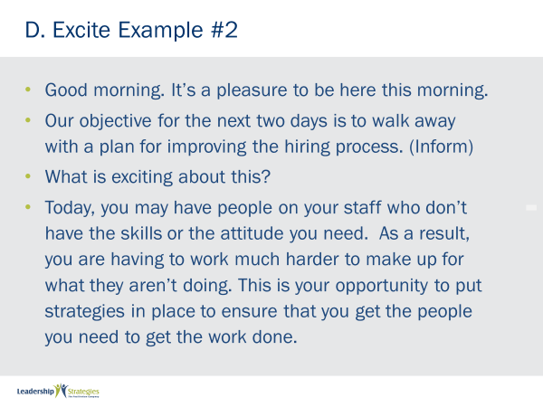 |  |  | SHOW POWERPOINT: Excite Example #2 (build)  ASK:  (Name), would you please read Example #2?  ASK:  OK, show of hands, how many of you think this Example, #2, is better?  DO:  ANNOUNCE the # or %.  SAY:  Yes, this one is more about THEM. While the first one is good it is not as directly tied to the participants.
 | PPT: Which is Better? Why?  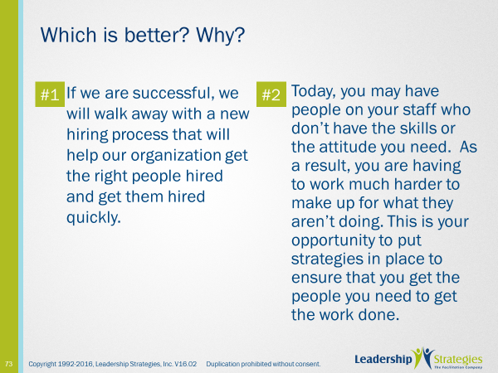 |  |  | SHOW POWERPOINT: Which is Better? Why? (build)  ASK:  Looking at them side-by-side there is one really neat tip that will help us build better Excite statements. Can anyone see differences that appeal to them?  DO: FACILITATE the discussion.
 | PPT: Which is Better? Why?  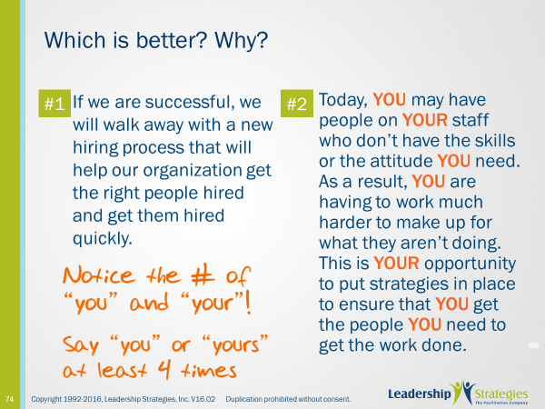 |  |  | SHOW POWERPOINT: Which is Better? Why? (build)  SAY:  Some really good points. We also find that by using the words “you” ore “your” at least 4 times it makes that Excite statement more like the WII-FM that is so important about our Excite statements.  ASK:  Are there any questions about the Excite statement?  DO:  FACILITATE the discussion.
 | PPT: Examples of Exciting  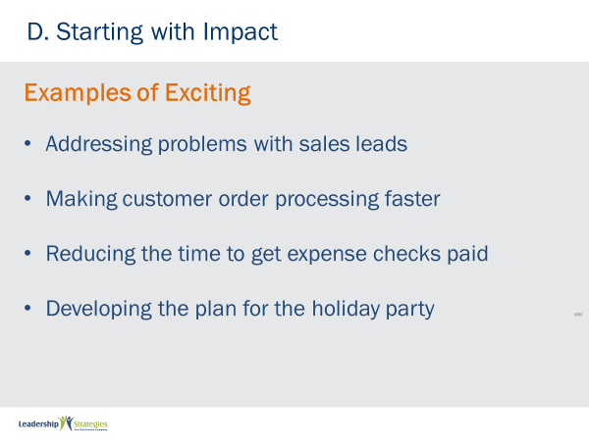 |  |  | SHOW POWERPOINT: Examples of Exciting (build)  DO:  FACILITATE the activity using the instructions below.  PURPOSE - The purpose of this exercise is to have each team develop an Excite statement for an upcoming session or one of the options provided on this slide.  EXAMPLE - Let me provide you an example of a great Excite statement. “This is exciting because as we all know, when we hire the wrong people our jobs get…..[open your arms and get the group to say “harder”] That’s right; and, when we hire the right people, our jobs get….[as before, get them to say “easier”] Did you see how powerful that can be. Another tip that we find helpful to develop a great Excite statement is to use the words “you” and “your” OR “we” and “our” at least four times.  DIRECTIONS - The way we are going to do this is in our teams. So, let’s start by selecting a new team lead [assign team lead]. Our team leaders will serve as their team scribe and spokesperson. We will give you [2-3] minutes for each team to prepare their Excite statement.  EXCEPTIONS - none  QUESTIONS - Any questions? [respond to the questions]  STARTING QUESTION - not needed  DO:  When the clock expires facilitate the REVIEW each Excite statement; consider asking the things they liked and the ways to make each statement better.
 | PPT: Confirm the Agenda  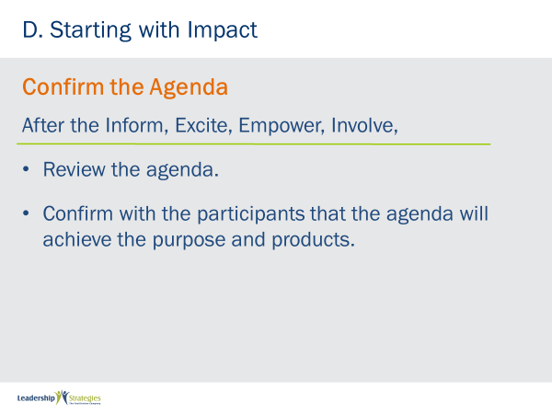 |  |  | SHOW POWERPOINT: Confirm the Agenda (build)  SAY:  Once we have completed our IEEI and have collected the participants personal objectives/key topics, we move to a review of the agenda. After the agenda review, we map the personal objectives to the agenda to ensure we have a meeting plan that addresses the participant needs. And, of course, if there is a personal objective/key topic that will not be addressed by the agenda, we have an opportunity to determine how and when to best cover that item.  ASK:  Any questions on Confirming the Agenda?  DO:  FACILITATE the discussion.
 | PPT: Establish the Ground Rules  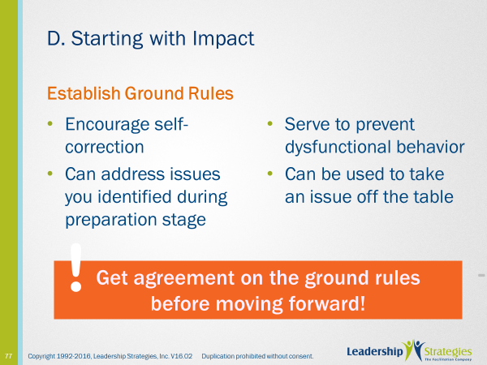 |  |  | SHOW POWERPOINT: Establish the Ground Rules (build)  SAY:  After the review of the agenda, we move to Establish the Ground Rules.  ASK:  How many of you use ground rules in your meetings today? [raise your hand] Do you find them helpful? [nod your head] So, [name], I see you find them helpful, would you share with us how they work for you?  DO:  FACILITATE the discussion.  KEY POINTS:  For follow-up meetings with the same participants, there might be a “standard set of ground rules” that are referred to and only ask if there are any special ground rules needed for a particular session.  To make the ground rules the overall responsibility of the group, we ask for agreement or consensus on the ground rules to have the group adopt the ground rules to be used as a means of self-correction with the group and by the group.
 | PPT: Establish the Parking Boards  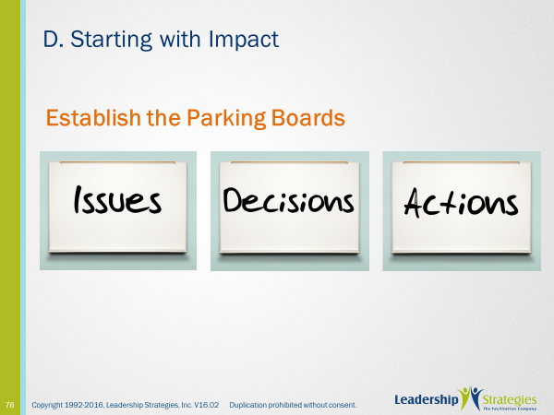 |  |  | SHOW POWERPOINT: Establish the Parking Boards  SAY:  After Ground Rules, we want to Establish the Parking Boards.  DO:  REVIEW the slide and facilitate a discussion on who currently uses Parking Boards, etc.  KEY POINT:  The Parking Boards are a great tool to ensure our meetings remain focused, that we do not fail to record decisions that are made and actions that are assigned.
 | PPT: Decision List  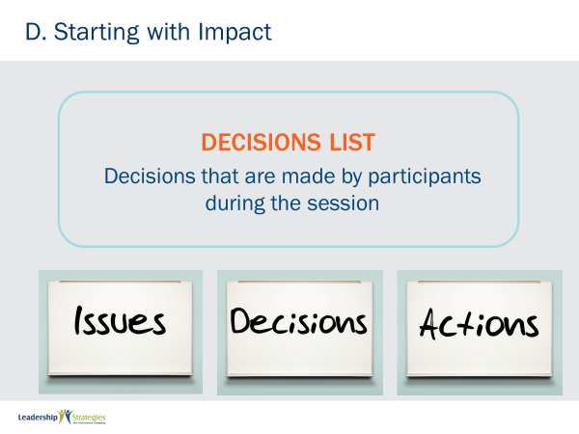 |  |  | SHOW POWERPOINT: Decisions List  SAY:  The Decisions List is where all decisions are captured throughout the session.
 | PPT: Actions List  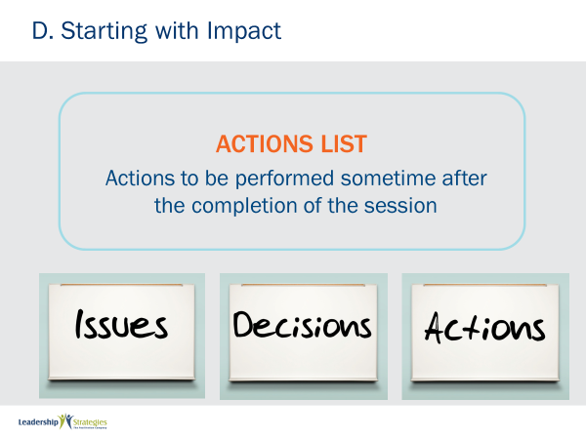 |  |  | SHOW POWERPOINT: Actions List  SAY:  The actions list includes any action (big or small) that needs to be competed.
TRANSITION:
After the Parking Boards have been reviewed, we move to introductions, should they be needed.
 | PPT: Make Introductions  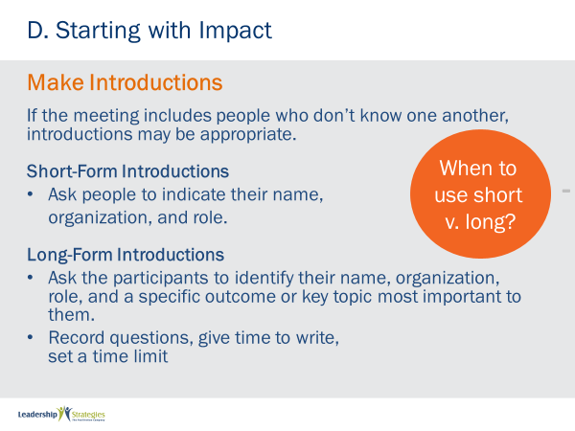 |  |  | SHOW POWERPOINT: Make Introductions (build)  SAY:  And the last part to the Masterful Start is to Make Introductions. Depending upon the participants, their familiarity with one another and the length of time for the meeting we may elect to use the Short Form or the Long Form Introductions.  ASK:  Who in the room has used the Short Form?  How about the Long Form?  Any questions on Making Introductions?  DO:  FACILITATE the discussion.
 | PPT: Close Books!  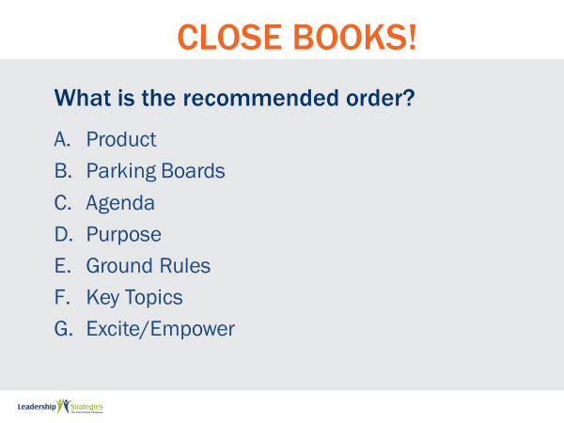 |  |  | SHOW POWERPOINT: Close Books!  SAY:  Let me ask each team to order the steps in our Masterful Start. I will set the clock to two minutes.  DO:  When time expires, have each team read their order and post to a flip chart with a column for each team.
 | PPT: What is the recommended order?  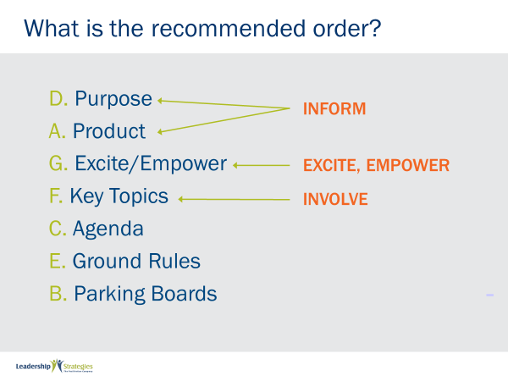 |  |  | SHOW POWERPOINT: What is the recommended order? (build)  DO:  REVEAL the solution to the team exercise. FACILITATE a discussion if any teams did not get the order correct.
 | PPT: Checklist for Starting 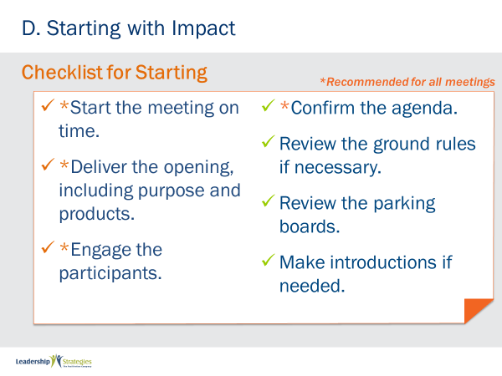 |  |  | SHOW POWERPOINT: Checklist for Starting (build)  SAY:  Once again, here is a great checklist to use for ensuring you have addressed all of the key components of Starting a meeting.
 | PPT: Agenda  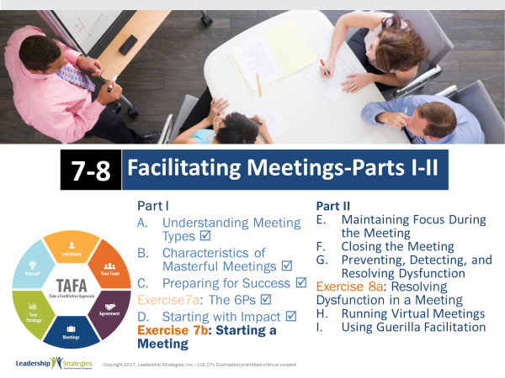 |  |  | SHOW POWERPOINT: Agenda  CHECKPOINT:  In this module, we have covered the different types of meetings, the 18 characteristics of masterful meetings, how to prepare for and start meeting. What we are about to do next is an exercise to practice starting a meeting. That is important because we want to provide an opportunity for you to practice some of these new meeting skills so that you will be able to apply them in your future meetings.
 | PPT: Spring Forward 7b: Starting a Meeting  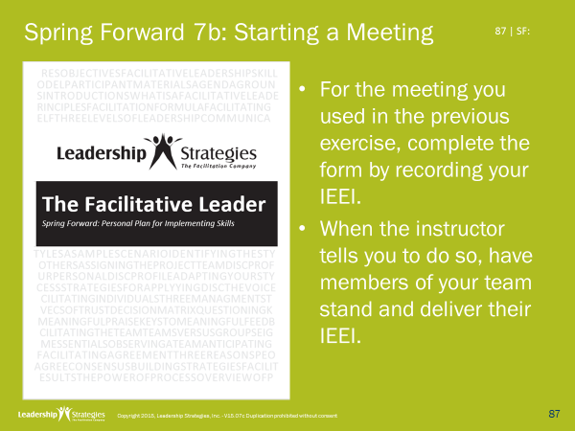 |  |  | SHOW POWERPOINT: Spring Forward 7b: Starting a Meeting (build)  SAY:  Let’s all pull out our Spring Forward Exercise Packet and turn to Exercise 7b on page 19.  DO:  INSTRUCT them using the following instructions.  PURPOSE - To practice building an IEEI.  EXAMPLE – not needed  DIRECTIONS - Take 5 minutes to individually develop your IEEI. Then, share with a partner.  EXCEPTIONS - If you don’t have a direct report, think of someone you work with  QUESTIONS - What questions do you have?
 | PPT: Review Slides  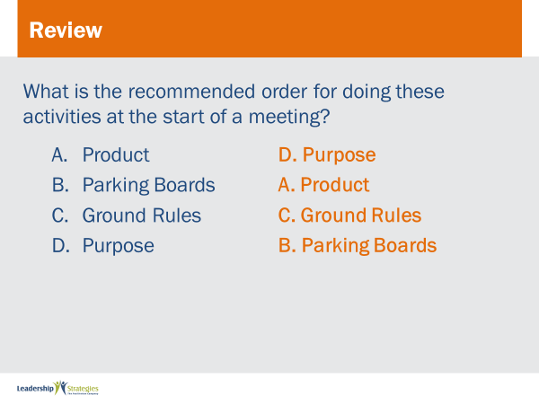 |  |  | SHOW POWERPOINT: Review Slides  DO:  Post each review slide up and ask for someone to raise their hand to answer the question. If they get it correct, award them a dot.  REPEAT for all review slides.
 | PPT: Spring Forward 7c: Opening a Meeting  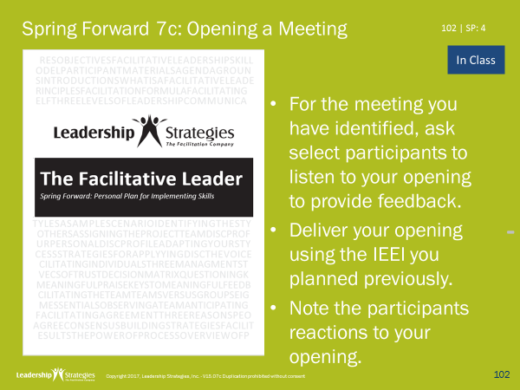 |  |  | SHOW POWERPOINT: Spring Forward 7c: Opening a Meeting (build)  DO:  INSTRUCT them using the following instructions if they will complete this activity in class.  PURPOSE - To practice delivering an IEEI.  EXAMPLE – not needed  DIRECTIONS – Take turns delivering your IEEIs in your table teams. Provide each other with feedback.  EXCEPTIONS - none  QUESTIONS - What questions do you have?
 | PPT: Spring Forward 7c: Opening a Meeting  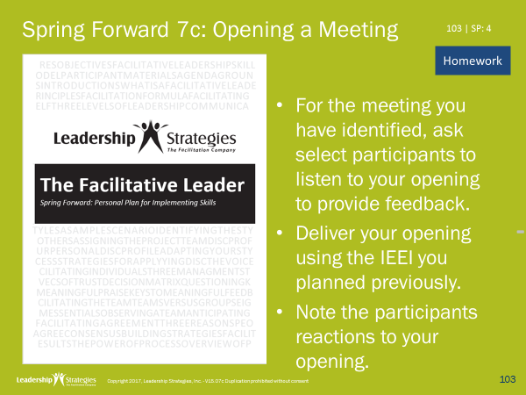 |  |  | SHOW POWERPOINT: Spring Forward 7c: Opening a Meeting (build)  DO:  INSTRUCT them using the following instructions if they will complete this activity for homework.  PURPOSE - To practice delivering an IEEI.  EXAMPLE – not needed  DIRECTIONS – Deliver your IEEI at a meeting.  EXCEPTIONS - none  QUESTIONS - What questions do you have?
 | PPT: Agenda |  |  | SHOW POWERPOINT: Agenda  CHECKPOINT:  We’ve completed our last exercise for this module, it’s time for us to move into our close.
 | PPT: TAFA  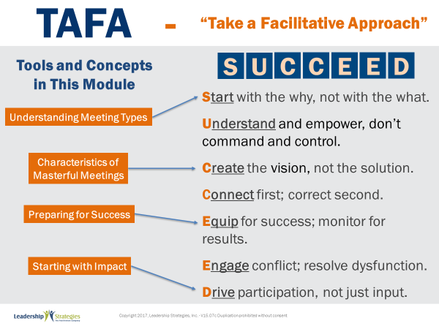 |  |  | SHOW POWERPOINT: TAFA (build)  SAY:  Let’s take a moment to look at some of the concepts we’ve learned in this module and examine how they reflect the TAFA principles.  DO:  REVIEW slide and lead discussion by asking if there are other principles that are reflected by the concepts.
 | PPT: Checkpoint |  |  | SHOW POWERPOINT: Checkpoint (build)  CHECKPOINT:  We have completed the Facilitating Meetings part 1. In the next module we will cover how to keep the group focused and manage dysfunction. These are additional elements needed to ensure you lead masterful meetings.
 | PPT: Connect with LSI  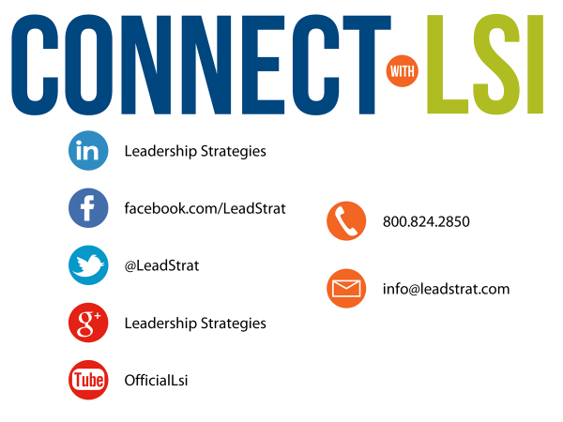 |  |  | SHOW POWERPOINT: Connect with LSI  Note to Instructor: this slide may be excluded if you are going directly into the next module. In that case, hide the slide.  SAY:  We fundamentally believe facilitation is a skill that applies in a multitude of situations. We also are confident that, in our quest to “share the power of facilitation with the world,” connecting via social media is a way for all of us to collectively share our successes, our challenges and our facilitation work. To “facilitate” that process, we want to ensure you are aware of how we can all stay connected using social media.  How many of you have found many of the skills in the class helpful? [raise your hand] I know that one of the things I did after attending was share what I learned with many of my colleagues. Have some of you already thought about that? [nod your head]  Then, one request we would like to make of you is to update your “education or classes attended” on your LinkedIn profile. That visibility will help all of us to “share the power” I have been referring to. Any questions?
 | PPT: Congratulations!  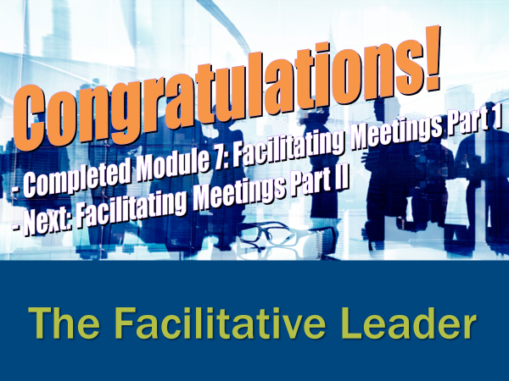  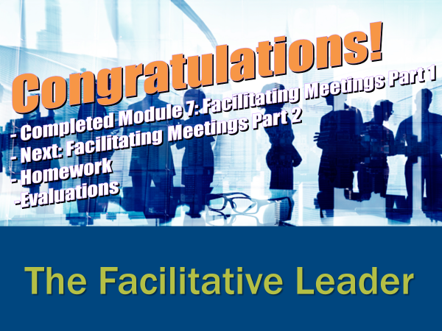  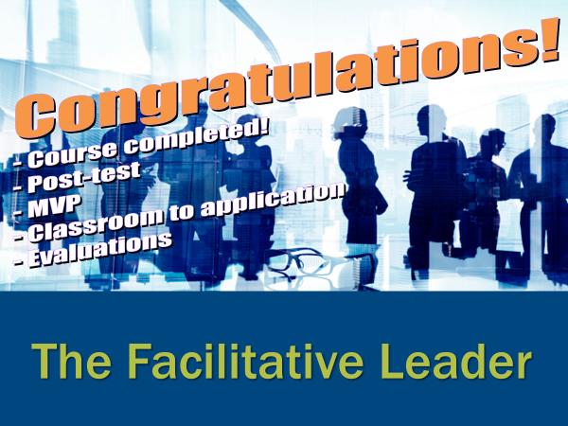 |  |  | SHOW POWERPOINT: Congratulations! (builds)  Note to Instructor:  There are three congratulation slides. Select the correct slide depending on whether you are:  - Moving on to the next module immediately (slide 1)  - Coming back another day to do the next module and therefore need to do an evaluation (slide 2)  - Have completed the workshop and therefore need to close out the class with the post-test, evaluations, dot winner (MVP), and the From Classroom to Application sheet (slide 3)  Hide the other two congratulations slides.  DO:  REVIEW and execute the content on slide.  EXECUTE THE POST TEST:  If appropriate, handout the post-test. Give people five minutes to complete. Ask teams to give their cheer once completed.  Once completed, have team members pass their post-test clockwise to a new person. Go through each question and have the group give responses. Instruct them to place a checkmark for each correct response.  Once completed have people add up the number of check marks and place the total at the top.  Since each post-test has eight questions, place the number 8 through 0 in the first column of a two-column chart.  Before people hand the post-tests back to the owner, do a round robin and have people indicate the number the person got corrected. Place a tick mark next to that number each time that number is reported.  THANK participants and dismiss class.
 |  |  | END | END OF THE FACILITATIVE LEADER MODULE 7

