The Facilitative Leader
Module 6: Facilitating Strategy

Facilitator Guide

Table of Contents
Facilitator’s Information
Table of Contents 1
How to Use This Guide 2
Symbols Used in the Facilitator’s Guide 3
Participant Pre-Work 4
Materials & Equipment for Module Six of The Facilitative Leader 5
Leadership Through Facilitation Module 6: Agenda 6
The Facilitative Leader Module Six: Agenda 9
Module 6: Introduction 10

How to Use This Guide
This Facilitator’s Guide covers the following:
- Work you’ll need to do prior to the workshop,
- Materials and equipment you’ll need for the workshop, and
- Instructions and verbiage to conduct the workshop.
Headings
The heading for each section indicate the information that will be covered in that particular section.
Instructions Section
On the right-hand side of the workshop instructions pages you’ll find the approximate number of minutes required to complete a topic.
The format for the instructions section contains 2 columns as follows:
- Left-hand Column:  - Contains graphics, such as a copy of a slide or an icon, indicating the major aspect of the training segment. For example, a television set icon indicates that a video will be shown. The next page shows the various icons used. | - Right-hand Column  - Lists the information or instructions to be conveyed to the participants and contains possible starting questions you can ask about the topic to engage participants in a discussion or an activity.  - Describes the activity to be completed. Note that actions to be done will always be in bold.  NOTE: This Facilitator’s Guide is not intended to be used as a script. The words in this column give you one example of how to deliver the content. Part of your preparation is to review this guide and become familiar with its contents, structure, and flow. You should feel free to use your own words, adjust the delivery to your own style, while also adapting to the needs of the group you are facilitating. At all times, be sure to show enthusiasm and comfort with the material when you are presenting. This will provide a more enjoyable and meaningful session for your participants.
 | Anything in a gray box means that you will be “doing” something rather than presenting.

Symbols Used in the Facilitator’s Guide
There are a number of symbols used in this Facilitator’s Guide to serve as prompts for the type of activity occurring at that point in the program. Here is a list of those symbols and what they mean.
 | Presentation |  |  | Key Information
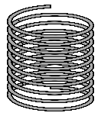 | Spring Forward Exercise |  |  | Pull through previous learnings
 | Pair Discussion/Exercise |  |  | Participant Manual “Write-along”
 | Group Discussion/Exercise |  |  | UMU activity
 | Write responses on a flip chart |  |  | Checkpoint
 | Transition to next topic |  |  | Individual Activity

In some cases, an activity will transition from one type to the other (e.g. from individual to group discussion). In such cases, more than one symbol may be used in chronological order.

Participant Pre-Work

Materials & Equipment for Module Six of The Facilitative Leader
Following is a list of the materials to be used in this training session. Be sure to become familiar with all of them.
- Projector and Screen
- Laptop
- PowerPoint Slides – “The Facilitative Leader 6: Facilitating Your Strategy”
- Facilitator Guide (this document)
- Updated Participant List
- Participant Packets (one for each participant)
  - Tent Cards
  - Participant Manual
  - Spring Forward Booklet
- Flipcharts – one for Facilitator, plus one for each table group)
- Pins/tape to hang posters
- Tape
- Pens and Markers
- Post-it notes (one different color package for each table group)

Flip Charts:
- Course Objectives (posted, if appropriate)
- Ground Rules (posted)
- Coming Attractions (posted)
- Module 6 Agenda
- Post Test

Leadership Through Facilitation Module 6: Agenda
TIME | TOPIC
5 minutes | Workshop Introduction  - Checkpoint  - Course Objectives  - TAFA  - Ground Rules  - Your Materials
7 minutes | Homework Review
 | - Have participants share results of their homework (in pairs, table groups, and/or with the class)
2 minutes | Workshop Introduction  - Agenda (Compare to participant objectives)
15 minutes | A. Strategic Planning: The Drivers Model  - What Strategic Plans Often Look Like  - The 4 Strategic Questions  - The Drivers Model  - 5 Key Points
15 minutes | B. Sample Strategic Plan Part 1: Mission, Vision, Goals and Objectives  - Definitions  - Sample Strategic Plan  - Action Plans  - Mission and Vision  - Goals and Objectives
15 minutes | Spring Forward 6a. Defining Goals and Objectives
15 minutes | - Participants goals and objectives for their teams.
15 minutes | C. Sample Strategic Plan Part 2: CSFs, Barriers, Strategies and Actions  - Critical Success Factors  - Action Plans  - Dividing the Plan
7 minutes | D. The Strategy Process  - The Phases
10 minutes | E. Why Most Plans Fail  - Why Most Plans Fail  - Covey Urgency/Importance Matrix  - How Do You Increase Accountability for Implementations?  - Monthly
5 minutes | F. Three-Step Monitoring Process  - Sample Dashboard Summary  - Three-Step Monitoring Process
10 minutes | G. The Leadership Briefing  - What is it?  - The Benefits and Key Products
10 minutes | H. The 10 Pitfalls to Avoid  - The 10 Pitfalls to Avoid
15 minutes | I. Special Application of the Drivers Model  - Managing Your Boss  - Change Management  - Coaching  - Having a Coaching Conversation
13 minutes | Spring Forward 6b. Defining CSFs, Barriers, and Strategy
13 minutes | - Participants practice determining critical success factors, barriers and strategies.
13 minutes | Spring Forward 6c. 6c. Documenting Your Monitoring Process
13 minutes | - Participants practice documenting a three-step monitoring process for the strategy.
8 minutes | Review
8 minutes | - Numerous review slides to test understanding and learning.
15 minutes | Session Close (Will vary based on FL “package” being delivered.)  - Review Agenda  - TAFA: Tools and Concepts in this Module  - Checkpoint to next module if appropriate  - Connect with LSI  - Congratulations slide with appropriate closing activities depending on whether this module is delivered as part of the four-day or as a stand-alone  - Execute Post-Test if appropriate  - Award dot winner MVP prize if appropriate  - Complete From Classroom to Application if appropriate  - Execute Evaluation if appropriate  - Formally close the session.
180 minutes  (3 hours) | Total Training Time

The Facilitative Leader Module Six: Agenda
- Strategic Planning: The Drivers Model
- Sample Strategic Plan Part 1: Mission, Vision, Goals, Objectives
Exercise: 6a: Defining Goals
- Sample Strategic Plan Part 2: CSFs, Barriers, Strategies, Actions
- The Strategy Process
- Why Most Plans Fail
- Three-Step Monitoring Process
- The Leadership Briefing
- The 10 Pitfalls to Avoid
- Special Applications of the Drivers Model
Exercise 6b: Defining CSFs, Barriers and Strategy
Exercise 6c: Facilitating Your Strategy

Module 6: Introduction
Overview
Leaders learn techniques to use while facilitating teams.
Modules include the following:
- The Drivers Model
- The Strategy Process
- Why Most Plans Fail
- Three-Step Monitoring Process
- The Leadership Briefing
- 10 Pitfalls to Avoid
- Special Applications of the Drivers Model
Key Learnings
- The Drivers Models
- The components of a Strategic Plan
- How to execute and monitor a Strategic Plan.
Facilitation Tips/Background Information
- Post on the wall ahead of time three flip chart pages with the following titles
  - Objectives
  - Agenda
  - Coming Attractions
- Accommodate participant objectives where possible, but do not be tempted into shoe-horning their objectives into the planned activities. If it’s not going to be covered, explain why it is out of the parameters of this workshop. If appropriate, consider covering out-of-scope objectives over lunch, on breaks, or in some other way.
- Be familiar with the DISC communication styles.

Timing: 3 hours

Timing: 3 hours
PPT: Title   |  |  |  |  | SHOW POWERPOINT: Title Slide  Note to Instructor: Customize your opening depending on the modules the group will be receiving in total, whether you are following a previous module, coming back from time in-between modules, or only running this workshop for this group.  SAY:  Welcome Managers to the Leadership Through Facilitation Workshop!  Introduce yourself and your background.  Have participants introduce themselves by sharing name, position, and years with the company. Ensure that each participant has signed in.
PPT: 6 Facilitating Your Strategy  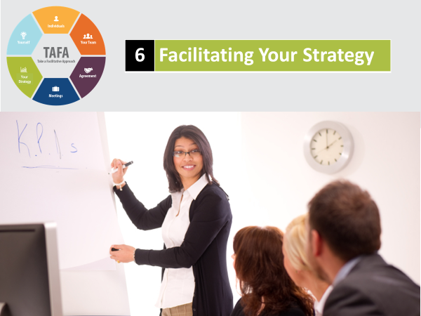 |  |  |  |  | SHOW POWERPOINT: 6 Facilitating Your Strategy  SAY:  You’ll walk away with an understanding of:  - The Drivers Models  - The components of a Strategic Plan  - How to execute and monitor a Strategic Plan.
PPT: Checkpoint  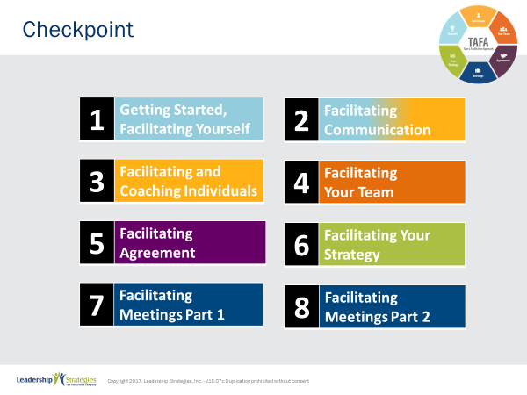 |  |  |  |  | SHOW POWERPOINT: Checkpoint (build)  CHECKPOINT:  In our last module, you learned about facilitating strategy. In Module 7, we are going to focus on how to facilitating meetings. You probably lead several meetings a day, so it is critical that you have skills and techniques to be sure they are run effectively.
PPT 3: TAFA - What does it mean to  “Take a Facilitative Approach?”  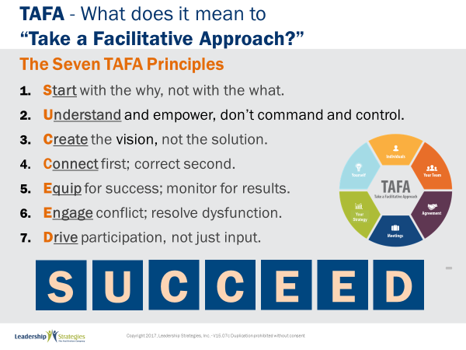 |  |  |  |  | SHOW POWERPOINT: TAFA (build)  SAY:  Let’s review the TAFA principles:  There are 7 key TAFA principles – the principles of taking a facilitation approach. Any time you have a decision to make, a problem to solve, someone to coach or correct, we are going to be giving you tools and techniques for implementing these principles.  Let’s walk through them together.  People are often inspired when they are connected and aligned with purpose. Unfortunately, as leaders we often focus on what we want done and start there. Facilitative leaders understand the importance of why and always start any discussion, meeting, initiative kickoff, etc., with the why.  Often leaders don’t involve those impacted because they believe they need to control all aspects of what is done to achieve their desired result. They don’t take the time to understand how to adapt to the styles of their people to inspire performance because they don’t understand the relationship between engagement and results.  However, leaders who take a facilitative approach understand how to empower others by defining purpose and providing guidelines that allow teams to create recommendations that are thoughtful and innovative, but also practical and implementable. They adjust their own management styles to get the most out of their people.  One of the key roles of leaders is to set a vision of success with a clear and compelling “why” that inspires success. Facilitative leaders understand that once they set the vision they must give their people the authority, resources, support and coaching so that their people can develop and implement solutions and strategies that bring the vision into reality.  Some leaders are expert at pointing out mistakes their people make. They seem to enjoy demonstrating their superiority by identifying errors and then showing their people what they have done wrong.  Leaders who take a facilitative approach understand the importance of connecting with people first and helping them discover their own errors. They recognize the power of being the “guide on the side” rather than the “sage on the stage.” They strive to leave every interaction with the person feeling lifted rather than beaten down.  So many teams are essentially destined to fail from the start because they are not properly equipped for success. Facilitative leaders understand that teams require eight essentials and provide teams the essentials they need to accomplish their work. At the same time, many plans fall short of their desired ends due to lack of monitoring for results. For example, how often do strategic plans get written and then put on a shelf? Facilitative leaders understand the need to monitor for results every step of the way.  Leaders who don’t have the tools to effectively manage conflict and dysfunction tend to respond with either a “fight or flight” strategy when faced with a challenging situation. Those leaders who take the flight approach will avoid addressing issues and hope they go away on their own. Those employing the fight strategy tend to try to overpower situations by forcing their will without listening to or considering other alternatives.  Leaders skilled in taking a facilitative approach view disagreement as an opportunity to identify better solutions; they view dysfunction as a sign that something important is not being addressed. They understand the three reasons people disagree and have strategies for addressing each one. They fully buy-in to the dysfunction principles--conscious prevention, early detection, and clean resolution--and use appropriate techniques to prevent, detect and resolve dysfunction.  How often does a decision come down from headquarters which the people in the field know makes absolutely no sense? The idea couldn’t possibly work and everyone knows it, except the leaders. What happens? Time and energy is wasted implementing something that months later gets abandoned when the leaders finally figure out it was a bad idea. If they had only asked, the wasted time and resources could have been put to a much more productive use. If they had only asked.  Or how often, when trying to make a needed change, does the change get met with blatant rejection or subtle subterfuge simply because those expected to implement the change were not involved up front in the creation?  Leaders who take a facilitative approach recognize that you can get better decisions and achieve higher levels of buy-in when those impacted by the decision are involved in creating it.  - In the first case of a decision coming from headquarters, the involvement of those who would have to implement the decision would have likely yielded an even better solution that considered issues and situations that the workers understood but of which the leaders were unaware.  - In the case of the needed change that was met with significant opposition, involvement up front could have yielded greater buy-in and commitment to the implementation.  SUMMARIZE:  These principles outline what it means to take a facilitative approach inside an organization. As more and more leaders adopt a facilitative approach to leadership, we expect to see greater business results through higher levels of buy-in and commitment throughout the organization.
  1 | Start with the why, not with the what
  2 | Understand and empower; don’t command and control
  3 | Create the Vision, not the solution
  4 | Connect first; correct second
  5 | Equip for success; monitor for results
  6 | Engage conflict; address dysfunction
  7 | Drive participation, not just input
TRANSITION:
Just a few quick housekeeping items before we jump into the meat of today’s workshop.
PPT: Ground Rules  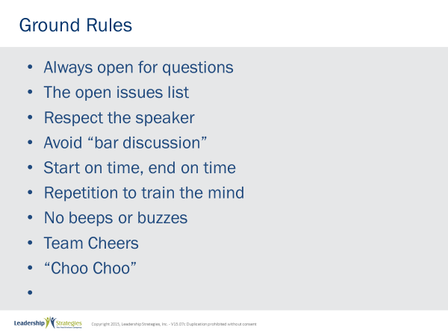 |  |  |  |  | SHOW POWERPOINT: Ground Rules (build)  SAY:  Well, as you can see, we have a very ambitious agenda over the next [two] days. To get through it smoothly, I would like us to agree on some “Ground Rules” or “Session Guidelines.”  ASK:  By a show of hands, how many of you have been in some type of training class before? [Raise your hand.]  SAY:  So, you know those things that work and don’t work. I value your time. I want this to be a productive session for you. So, what are those guidelines that we need to have in place to make this a productive session for you? Let’s look at these ground rules for how we will conduct our session for the next [two] days and reach an agreement on them.  DO:  REVIEW ground rules on slide. ASK the group if they would like to add or delete any of these ground rules.  ASK for a show of hands to adopt the ground rules as revised.
PPT: Your Materials  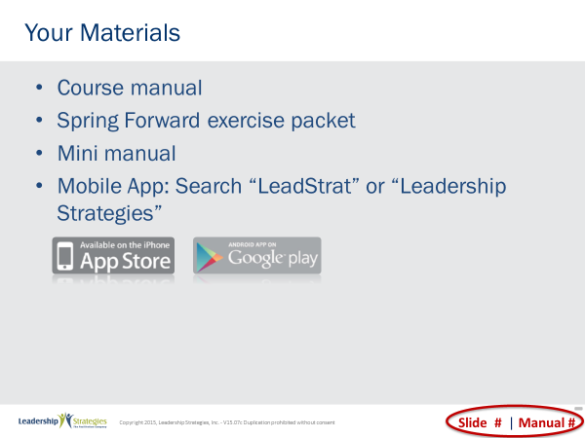 |  |  |  |  | SHOW POWERPOINT: Your Materials (build)  DO:  REVIEW the content on the slide.
PPT: Homework Review  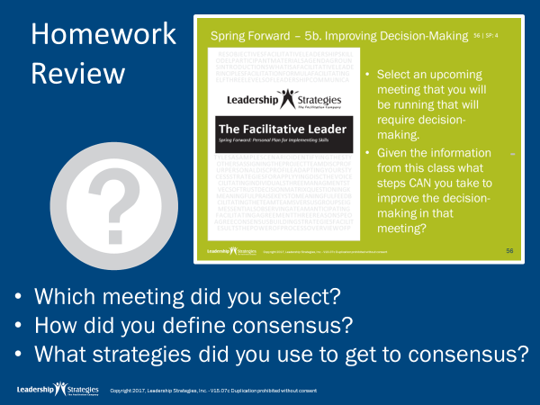   |  |  |  |  | SHOW POWERPOINT: Homework Review (build)  DO:  REVIEW the homework assignment following the questions on the slide.
PPT: 6 Facilitating Your Strategy  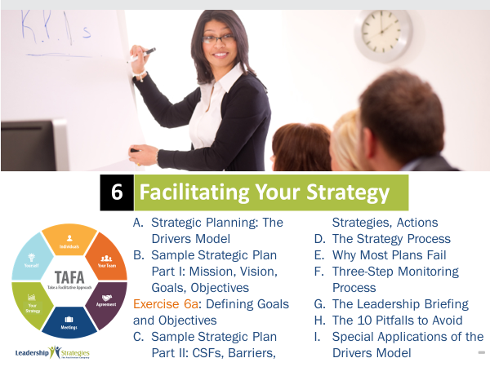 |  |  |  |  | SHOW POWERPOINT: 6 Facilitating Your Strategy (build)  Review each agenda item briefly.  Ask:  Is there anything you were expecting to see on the agenda that isn’t there?  DO:  DISCUSS in a similar way to the personal objectives and WRITE on the Objectives flip chart if appropriate  SAY:  As we go through this course, you will see that the development of the strategic plan is not quite a linear process. You will see that with some components we start in the middle and work backwards (e.g., goals-to-mission-to vision). In other cases, we will move forward but find that we have to go back and make changes to something we thought was already done (e.g., objectives can cause changes to the goal statements). There is no need to walk through the flow chart now. We just wanted you to have a place where the complete picture appears and we will break down the components as we go.
PPT: Agenda  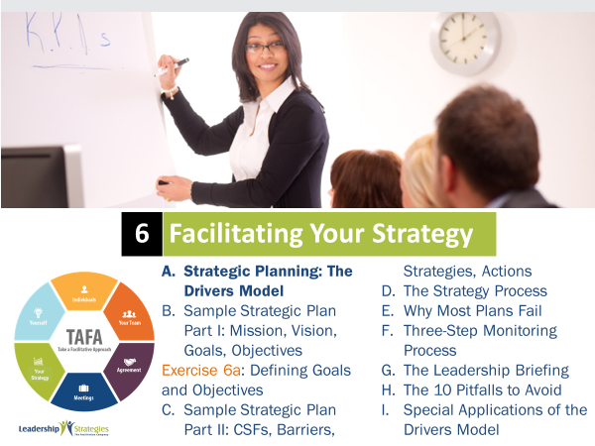 |  |  |  |  | SHOW POWERPOINT: Agenda  CHECKPOINT:  Now that we are have overviewed this module, I’d like to introduce you to the Drivers Model. This model will be our focal point today.
PPT: What Strategic Plans Often Look Like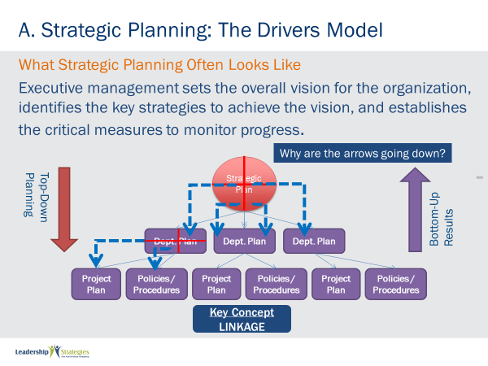 |  |  |  |  | SHOW POWERPOINT: What Strategic Plans Often Look Like (build)  SAY:  Let’s start by discussing the three levels of strategic planning. Through  strategic planning, the organization’s executive management sets the  overall vision for the organization, identifies the key strategies to achieve  the vision, and establishes the critical measures to monitor progress.  The strategic plan is then executed through various department plans,  and the department plans are executed through the various project plans,  policies and procedures. We call this top-down planning, but bottom-up  implementation. Notice the direction of the arrows in the diagram.  ASK:  Why do you think the arrows are going down, not up?  SAY:  There are many good reasons, but one great reason.  KEY POINTS:  Good reasons:  - Strategies start from the top.  - Management is responsible for setting the direction.  - Department’s activities and project plans must stem from the original strategic plan  - Department plans must contribute to the strategic plan.  SAY:  So, there are lots of very good reasons why the arrows are going down. But we say that there is one great reason for the arrows to go down, and that is linkage.  Imagine what would happen if the arrows were going up. If the arrows were going up, that would mean that the project plans, policies and  procedures contribute to the department plans and that all of the department plans would be contributing to the strategic plan. Now what that would mean is that every department could be successful, but the entire strategic plan could fail. Why? Because all the departments were simply contributing to the strategic plan.  Think of the strategic plan as being divided into several pieces. Each department is responsible for one or more pieces of the strategic plan. Likewise, think of each department plan as being divided into pieces. Each piece of the department plan is accomplished through a particular project, policy, or procedure. So, if all the projects and policies and procedures are successful, that is, if we’re successful at the bottom level, then automatically all the department plans are successful. And if all the department plans are successful, that means the strategic plan would be successful. So, literally, the key is linkage. All of the objectives and strategies of the strategic plan need to be linked to a specific department or organization unit.
PPT: The 4 Strategic Questions  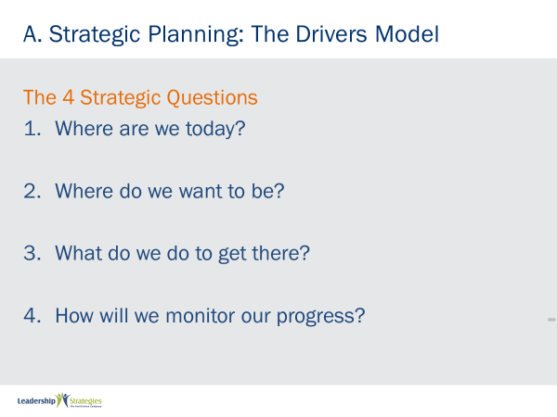 |  |  |  |  | SHOW POWERPOINT: The 4 Strategic Questions (build)  DO:  REVIEW the content on the slide.
PPT: The Drivers Model  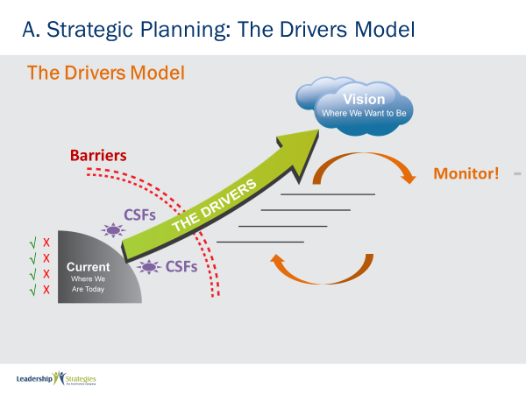 |  |  |  |  | SHOW POWERPOINT: The Drivers Model (build)  SAY:  The Drivers Model is designed to address linkage in a strategic planning. The Drivers Model starts with answering the question, where are we now?  In many organizations, there are people who constantly focus on, “Here’s what’s wrong with today.” We call them naysayers. They love telling you all the things that are wrong with the organization. Yet, they never do anything about it. And of course, there are some things that are not quite right with any organization, but that’s not the full picture, is it? There are also some strengths to the organization, so we want to balance that picture to understand both our strengths and our weaknesses.  There’s another group in most organizations – the dreamers, if you will. These folks draw nice rosy pictures of what the organization can be. They’re much more fun to be around, of course, but what they have in common with the naysayers is that they talk about what should happen but often don’t do anything about it.  The key to actually achieving the vision is to understand your drivers – the things that drive you from where you are today, to where you want to be. These are the strategies that you use – the things you end up doing – in order to achieve your vision. And the drivers have to do two important things. First, they must address the barriers that are preventing you from getting where you want to be. They also have to address the critical success factors, which are the things that must go right in order for you to achieve your vision.
PPT: Purchasing a House  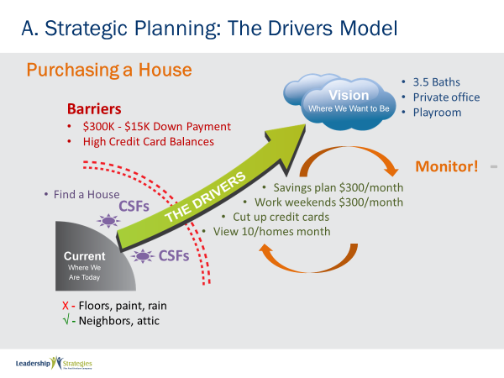 |  |  |  |  | SHOW POWERPOINT: Purchasing a House (build)  SAY:  Let me break this down with a simple example. Let’s say my wife and I  decide we need to buy a new house. So, we start by looking at the  strengths and weaknesses of the house we were in. First the strengths.  It’s in a nice neighborhood. Great. What else is a strength? Well, it’s got  a big attic. OK. If the best thing you can say about a house is it has a big  attic, it’s time to move. Then came the weaknesses. The floorboards are  warped. Everywhere you step you hear the creaks. The paint is peeling  from the plaster. And every time it rains, “Let’s get the buckets!” Okay, so  now we have a full picture. Next, we look at where do we want to be.  Where did we want to be? My wife grew up in a family of seven with one  bathroom. You can imagine the first words out of her mouth, “Four  bathrooms. We’re going to have four bathrooms.” It might not have  anything else, but if we have four bathrooms my wife will be happy. Then  it was my turn. “I want my house to have my office, with the operative  word being “my.” It doesn’t have to double as a guest bedroom, it doesn’t  have to be a place where the kids play when it’s raining outside. It’s “my  office.” What did the kids want? A huge playroom, over the garage. So  you can imagine this house, with four bathrooms, private office, and a  playroom over the garage. Where I come from, that’s not an inexpensive house.  Now we have our vision, but there are certain barriers to achieving that  vision. First of all, we needed $15,000 for a down payment. We’d never  saved more than $5,000 in our lives. So that looked like a major barrier to  achieving that vision. Well, there’s another barrier isn’t there? For  someone to loan us the rest of the money, we had to have pretty good  credit. And let’s just say that credit card debt was high and getting higher  … definitely another barrier.  There was also a critical success factor. In order for us to achieve this  vision, we had to find a house that someone wanted to sell, that had the  features we desired, in a neighborhood where we wanted to live, at a price we could afford. Pretty critical, wouldn’t you say?  Now, it’s time to talk about the drivers. What were we going to do to get there? Well, let’s take that first barrier. We needed an extra $10,000 to  make the down payment. Well, you might say borrow money from our  parents. But keep in mind that my wife came from a family of seven with  one bathroom and I didn’t do much better, so borrowing from the parents was not an option. We decided to save money. We decide to stop eating out twice a week, stop going to those department store sales, and I decide I’m going to take peanut butter and jelly sandwiches for lunch every day.  We figured if we did all of these things, we could save $300.00 a month.  Well, do the math. That’s like three years. There’s no way I was going to  eat peanut butter and jelly for three years. So, we needed another  strategy.  We decide to get weekend jobs, so that gives us another $300.00 a  month. Now we’re down to a year and a half. But there was another  barrier: credit card debt. We cut up those credit cards, and begin paying  off a little of the remaining debt each month. Well, there’s a critical  success factor, remember? We have to find the right house. How do we  do that? We get a realtor and we set a target of looking at twenty homes  a month. We actually looked at over 200 homes before we bought. That  sounds like a lot, but we had plenty of time!  There’s one more driver we had to put in place – more important than any of the others. That driver is the monitoring driver. So, the first Sunday of every month, at 6pm, everything in our house stops. We ask ourselves a series of questions. First, how much money did we save this month. Great! $350. How much did we get from the extra jobs? Another $300. Wonderful! How’s the credit card debt doing? It’s going down.  Fantastic! How many homes did we look at? Only five? What’s the  problem? The real estate agent wasn’t available? It sounds like we may  need to…  So, every month, we do our monitoring.
PPT: 5 Key Points  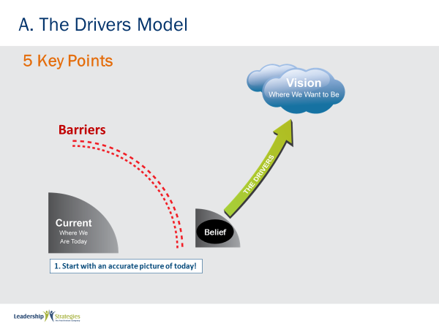 |  |  |  |  | SHOW POWERPOINT: 5 Key Points (build)  SAY:  There are five key points to remember about the Drivers Model.  Because you may think you’ve overcome certain barriers when you really  haven’t.  Let me make this example a little more graphic for you. Let’s say you  wanted to get from Atlanta to Los Angeles – in what direction would you  have to drive? West. But what if you thought you were in Atlanta but you  really were in Seattle. What happens when you drive west? Let’s just say  you might end up a little wet, which probably was not part of your vision.  So, you need to be clear on where you are today or you may end up  taking the wrong steps.  KEY POINT #1:  You need to create a shared vision. Not just a vision, but a shared  vision. If everyone has a different vision of where the organization needs  to be, imagine the chaos when each department goes off in a different  direction. The key to strategy and strategic thinking is for all parties  involved to have a shared vision of where they want to be.  There is a statement that businesses suffer from a lack of vision. We  think that businesses suffer from having too many visions. If they had just  one, that would be great.  TRANSITION  Let’s go back to the house example…
 | PPT: 5 Key Points  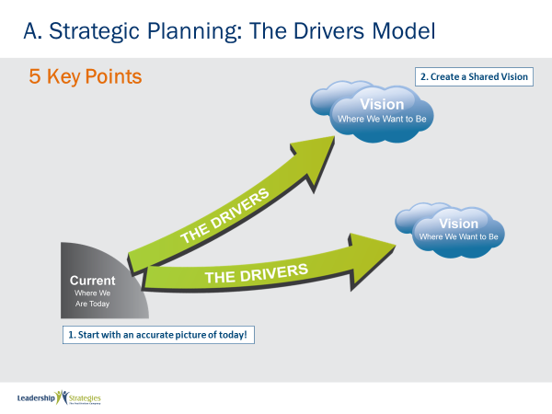 |  |  |  | SHOW POWERPOINT: 5 Key Points (build)  SAY:  You can probably imagine what would have happened if my wife and I had different visions of the type of home we wanted.  Yes, that’s right, we would end up getting the house my wife wanted!  But can you imagine the conflict and struggle along the way? Because we  would want different things and pull in different directions, many of the  decisions we needed to make along the way would have resulted in major  fights over whose vision would prevail. By creating a shared vision up  front, we have the “fight” only once. Once the vision was created, we  would be able to make decisions together in line with achieving that vision.  KEY POINT #2:  Point number two is to create a vision, and make sure it is shared  throughout the organization.
 | PPT: 5 Key Points  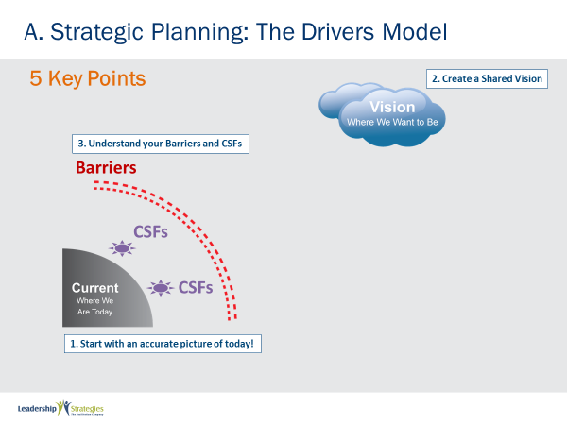 |  |  |  | SHOW POWERPOINT: 5 Key Points (build)  KEY POINT #3:  Once you have that shared vision, you need to understand the major  barriers to achieving that vision. What’s keeping us where we are today?  Then, you must understand what’s critical to getting you where you want  to be. What are the key conditions that, if you create them, will drive  achievement of the vision?  If the Drivers are the rocket that gets you to your vision, then these critical success factors are the fuel that lets the rocket blast off and keep going.
 | PPT: 5 Key Points  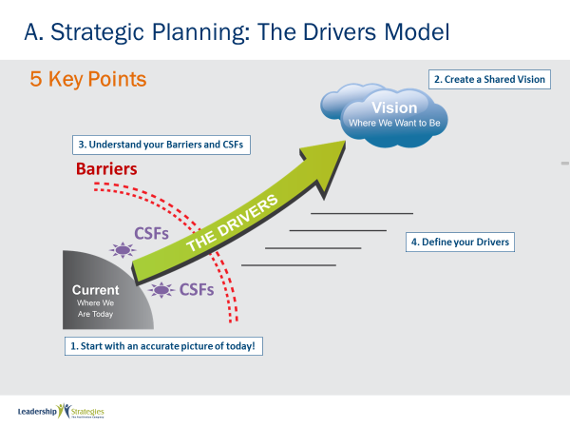 |  |  |  | SHOW POWERPOINT: 5 Key Points (build)  KEY POINT #4:  Once we identify our barriers and critical success factors, key point  number four is to define our drivers. What are the key strategies that are  going to get us there? Remember the strategies have to address the  barriers and critical success factors.
 | PPT: 5 Key Points  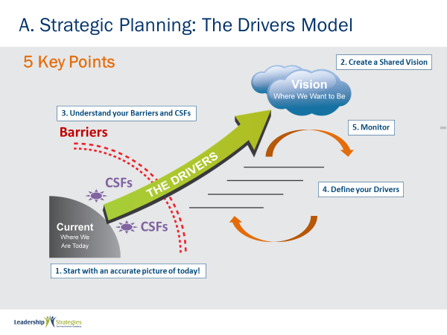 |  |  |  | SHOW POWERPOINT: 5 Key Points (build)  KEY POINT #5:  Finally, Monitoring. You must monitor your progress to keep on track  and stay motivated to achieve your vision.
TRANSITION:
Now that we have looked at the Drivers Model conceptually, let’s focus on the primary document that results from the Drivers Model process.
 | PPT: Agenda  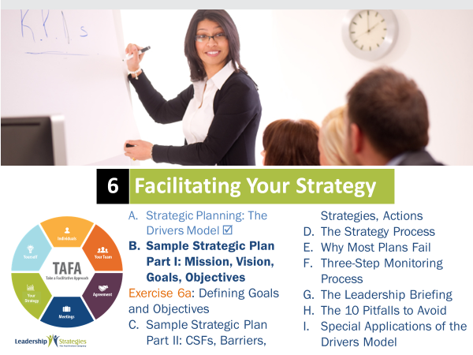 |  |  |  | SHOW POWERPOINT: Agenda  CHECKPOINT:  We have just overviewed the Drivers Model. Now we will talk more about the specific components that go into Strategic Planning. It’s important to understand they “what” and “why” for each component.
 | PPT: Sample Strategic Plan 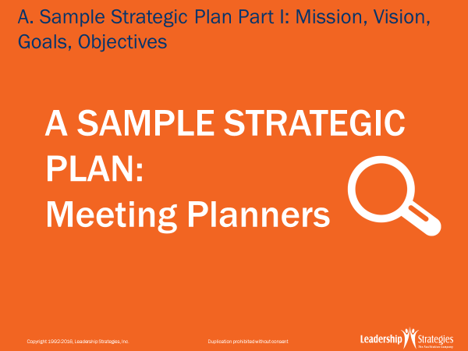 |  |  |  | SHOW POWERPOINT: Sample Strategic Plan  SAY:  Let’s walk through a sample strategic plan.
 | PPT: Definitions  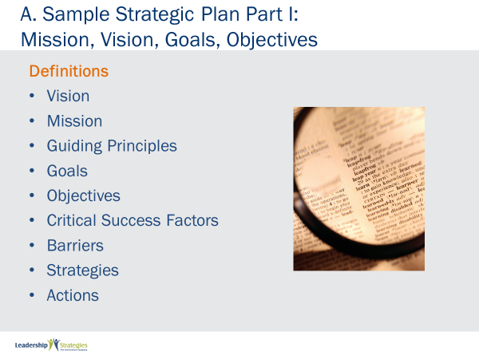 |  |  |  | SHOW POWERPOINT: Definitions (build)  DO:  REVIEW the definitions on the slide by using a round robin to have participants read definitions from the participant guide. Answer any questions.
 | PPT: Sample Strategic Plan  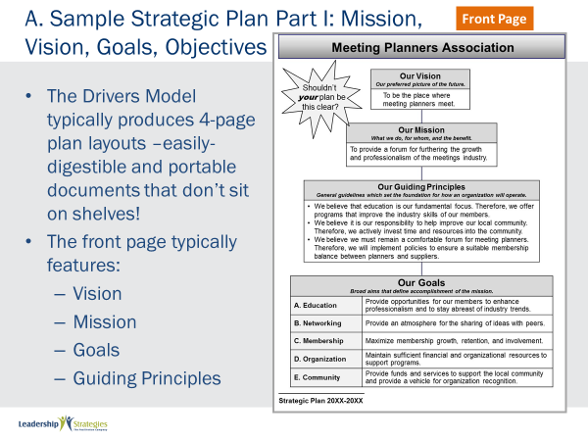 |  |  |  | SHOW POWERPOINT: Sample Strategic Plan (build)  SAY:  The Strategy Layout serves as the primary strategy document. It is  typically an 11x17 page folded in half and contains the core components  of the strategic plan.  The front page of the strategy layout contains the organizations vision,  mission, guiding principles and goals.  Notice there are five goals for this meeting planner’s association includes:  education, networking, membership, organization, and community.
TRANSITION:

Let’s open the front page and look at the two inside pages.
 | PPT: Sample Strategic Plan  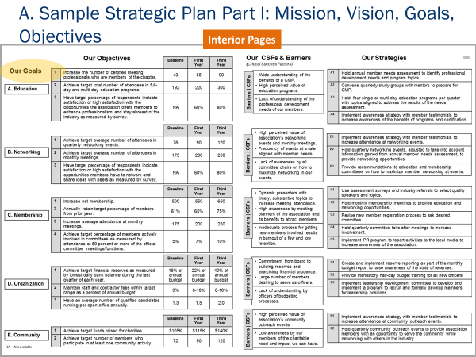 |  |  |  | SHOW POWERPOINT: Sample Strategic Plan  SAY:  On the left side, you once more see the five goals. But next to each goal  is a set of specific measurable targets that show baseline, first year  milestone and where this organization wants to be in three years.  On the right side, for each goal, you see the critical success factors,  barriers and strategies needed to accomplish that goal.  With this format, you can easily see the alignment from goals all the way  through to strategies.
TRANSITION:

Let’s look at the back page.
 | PPT: Sample Strategic Plan  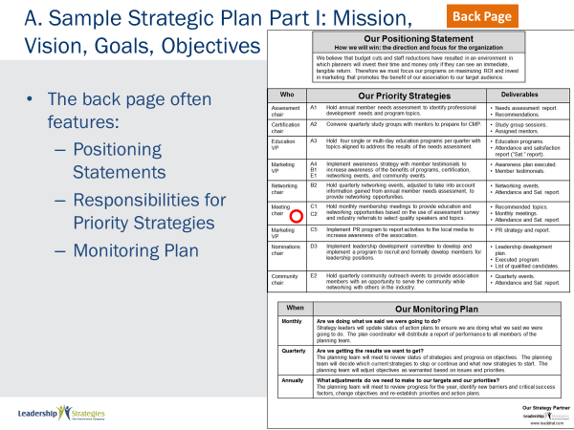 |  |  |  | SHOW POWERPOINT: Sample Strategic Plan (build)  SAY:  The back page gives the organization’s broad positioning statement, the  priorities and the monitoring plan.  You will note that one of the priorities is circled. Notice, for each strategy  there is the person responsible along with the deliverables for the strategy.  So, along with the four-page strategy layout that we just looked at, each  priority has a detailed action plan.
TRANSITION:

Let’s take a look any sample action plan.
 | PPT: Action Plans  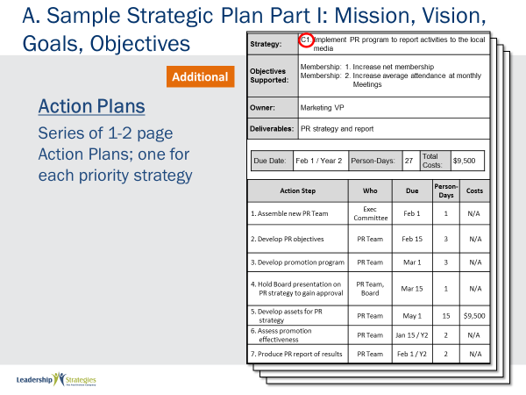 |  |  |  | SHOW POWERPOINT: Action Plans (build)  SAY:  Each action plan is 1 to 2 pages that documents the steps necessary, the  people responsible, the due date, the out of pocket costs, as well as the  resources needed, to implement the strategy.
TRANSITION:

We talked about the deliverable for the Drivers Model, now let’s take a
look in a little more detail at each component.
 | PPT: Mission and Vision  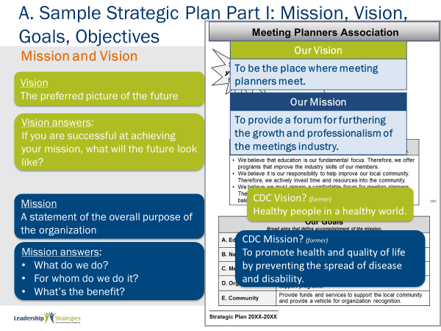 |  |  |  | SHOW POWERPOINT: Mission and Vision (build)  DO:  ASK someone read the mission statement.  SAY:  Now that’s a great mission statement. Why? Because a mission statement only does three things: It explains what you do, for whom you do it and the benefits. What do they do? Provide a forum. What’s the benefit? Furthering growth and professionalism. Who benefits? The meetings industry. A mission statement is a statement of the overall purpose of the organization, describing what you do, for whom you do it and the benefit.  Now, let’s take a look at their vision statement: The place where meeting  planners meet. Well, based on these words, what’s the difference  between a vision and mission? The mission explains the overall purpose  of the organization: what you do, for whom you do it, and the benefit. A  vision, however, is a picture of the preferred future; a statement that  describes how the future will look if the organization is successful at  achieving its mission. That’s the difference between the vision and  mission statements. Let’s look at another example of what we mean.  The CDC – the Centers for Disease Control – a US government health  agency, has a mission statement that reads: To promote health and  quality of life by preventing and controlling disease, injury and disability.  Their vision statement is: Healthy people in a healthy world. Do you see  the distinction? A mission is what you do, for whom you do it and the  benefit. It’s a statement of the overall purpose. A vision statement is what  the future will look like if you are successful at achieving your mission.  Guiding principles are general guidelines that set the foundation for how  an organization will operate.  When organizations define their values, it isn’t unusual to hear statements similar to the following: We focus on the customer. We respect the individual. Integrity is non-negotiable. Our people are our most critical resource.  While values such as these are important, organizations using the Drivers  Model gain greater benefit by transforming their values into guiding  principles. Guiding principles define the value and describe the behaviors  that the organization believes support that value. To ensure that you focus on both the value and the behavior, the Drivers Model uses the following format for guiding principles: “We believe… (value). Therefore, we will … (behaviors).”  Take a look at this organization’s third guiding principle. We believe we  must remain a comfortable forum for meeting planners. Therefore, we will  implement policies to ensure a suitable membership balance between  planners and suppliers. The members of this association were not only the  people who plan meetings, but also all the suppliers to that industry such  as resorts, limousine companies, audio-visual companies, and all the  organizations that recognize that meeting planners are their customers.  The association was concerned that they easily could become an  association overrun by suppliers. So, from this guiding principle they  implemented policies to prevent that from happening. For example, one  of their policies was that in order for a supplier to join, a planner had to  join as well.
 | PPT: Goals and Objectives  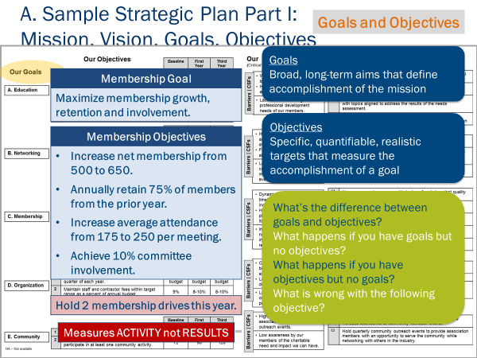 |  |  |  | SHOW POWERPOINT: Goals and Objectives (build)  SAY:  Take a look at the goals for the organization. What are goals? We define  them as broad long-term aims that define accomplishment of the mission.  For this meeting planning organization to achieve its mission, it realized it  had to be successful in six areas: Education, community outreach,  membership and so on. As you look at the words, notice that they are  very broad, general statements.  Look at that membership goal: maximize membership growth, retention  and involvement. Of course, many membership-based organizations  would have this as a goal? So, goals are very broad statements. But  what’s key is that these statements define the six areas where this  organization must succeed in order to achieve their mission. Even more  important is what follows each one of these goals. We call these  objectives.  Let’s look at the objectives for the membership goal. These were 3-year  objectives.  DO:  READ the objectives on the slide.  There are four specific objectives that define accomplishment of this  goal called membership. While we only show the membership objectives,  you can imagine that each of their six goals would have objectives tied to  them.  ASK:  What’s the difference between goals and objectives?  SAY:  While goals are broad, objectives are specific and measurable targets to  be reached. You need to have both goals and objectives, no matter what  you call them. We call them goals and objectives; you might call them  objectives and goals, or key performance areas and key performance  indicators. Or strategic intent and strategic outcomes. It doesn’t matter  what you call them. The key is that you need both: something broad that  defines your aims and something specific and measurable that sets  targets for a specific time period.  ASK:  So why do you need both? Suppose you just had goals and no objectives. What’s the problem with just having broad aims and no measurable targets?  ASK:  Well, how would you know whether or not you’ve been successful?  SAY:  Suppose this organization just had the goal of maximizing membership  growth, but no specific targets? At the end of three years they’d ask  themselves did we maximize membership growth? Well, uh, let’s see, uh,  well yeah, yeah, we did. How do you know? Well, without targets, you  really don’t.  ASK:  If objectives are so important, then why not just have objectives? For what reason do you need goals?  SAY:  Think of it this way. What if the meeting planners just set objectives to increase net membership to 650, achieve average attendance and so on?  Then next year, some different objectives. And the next year, even more objectives. Well, the problem is that you’re just setting targets. But what are the targets for? What are you trying to achieve? Are your targets covering everything that is important to you? This is what goals are for. The goals tell you what’s important to you. Your goals tell you the areas  for which you need to have objectives. All that the objectives do is tell you  one final point. What is wrong with this objective: “Hold two membership  drives this year.” What would be wrong with that objective? Is it specific?  Yes. Membership drives. Is it measurable? Yes. We want to have two of  them. Is it time-bound? Yes, one year. So, what is wrong with the  objective?  The problem is that it doesn’t measure the goal. It doesn’t measure  whether or not you’re maximizing membership growth, retention or  involvement. Let me clarify.  The problem is that an objective such as “Hold two membership drives” is  measuring activity not results. Let’s say we had our two membership  drives but didn’t get any new members. At the end of the year we would  congratulate ourselves for achieving the objective, but we would not have  achieved the goal of maximizing membership growth. That’s the danger  of having objectives that measure activity instead of objectives focused on results. If we don’t measure outcomes, we can get so caught up in the  activity, that we lose sight of the real goal. So, we must be careful when  we create objectives to avoid measuring activity (such as holding  membership drives) but focus on the true desired outcome (increasing  members).  The final mistake that people make around objectives is that after defining their objectives they jump straight to strategies. Don’t do it.  You have two important steps first. You must identify your critical success  factors to achieving those objectives. And you must identify the major  barriers standing in your way.  These will lead you to the right strategies that will help you overcome the  barriers and create the critical conditions to achieve your objectives.
 | PPT: Agenda |  |  |  | SHOW POWERPOINT: Agenda  CHECKPOINT:  We have just defined and discussed the key components of a solid strategic plan. Now, you get to apply this knowledge to your own work. Let’s do an activity so you can think about your goals and objectives.
 | PPT: Spring Forward 6a. Defining Goals and Objectives  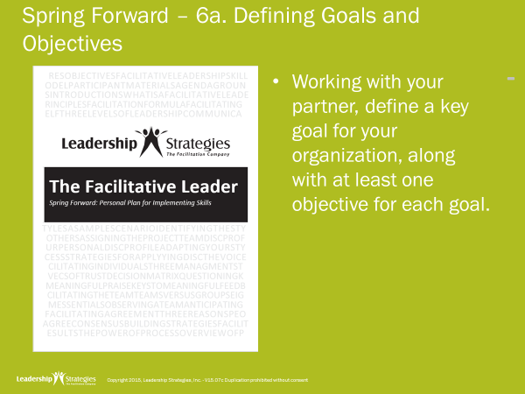 |  |  |  |  | SHOW POWERPOINT: Spring Forward 6a. Defining Goals and Objectives  DO:  Instruct the group to complete the exercise.  PURPOSE - To define goals and objectives for your work area.  EXAMPLE – not needed  DIRECTIONS - Take 5 minutes to identify three goals and at least one objective for each goal. Then, share with a partner.  EXCEPTIONS - none  QUESTIONS - What questions do you have?  DO:  ASK 2-3 participant to share what they wrote and discuss.
 | PPT: Agenda |  |  |  | SHOW POWERPOINT: Agenda  CHECKPOINT:  Great job working through your own goals and objectives. The next step in the process is to identify Critical Success Factors. Let’s review what they are now.
 | PPT: Critical Success Factors  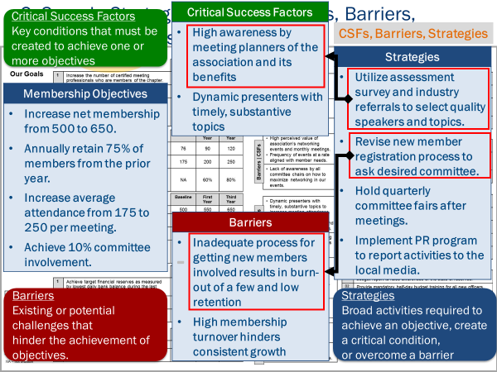 |  |  |  |  | SHOW POWERPOINT: Critical Success Factors (build)  ASK:  Once you’ve determined your goals and objectives, what should you do  next?  SAY:  You should then identify your critical success factors and barriers for your  objectives. In our meeting planners example, they identified two critical  success factors for the membership goal. First, they needed dynamic  presenters with timely substantive topics to increase meeting attendance. Second, they needed high awareness to attract new members.  Now look at those barriers: They had an inadequate process for getting  new members involved, and high membership turnover was hindering  consistent growth.
 | PPT: Critical Success Factors  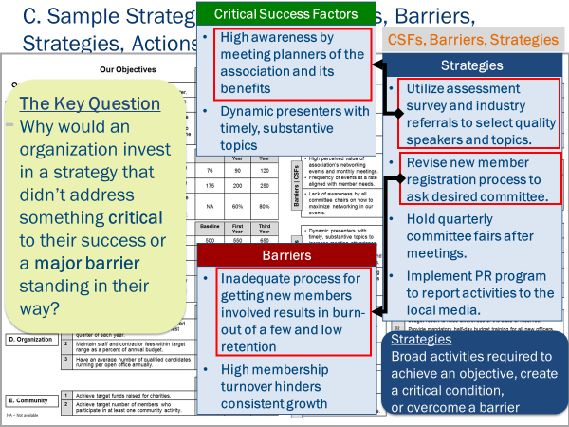 |  |  |  |  | SHOW POWERPOINT: Critical Success Factors (build)  SAY:  Let’s examine the strategies. These are the drivers, the things you’re  going to actually do. Their first strategy is to utilize an assessment survey  and industry referrals to select quality speakers and topics.  ASK:  What’s that strategy trying to achieve?  SAY:  It’s trying to meet that first critical success factor, getting dynamic  presenters. What about the second strategy: revise new membership  registration process to find out the committees that members would like to work on.  ASK:  What’s that strategy trying to do?  SAY:  You’ve got it. It’s addressing that first barrier: an inadequate process for  getting new members involved. In fact, if you take a look at each of those  strategies, you’ll notice that each one is addressing a critical success  factor, or a barrier, or both.  ASK:  Given that all organizations have scarce resources, why would any  organization invest in a strategy that wasn’t addressing a critical success  factor or a barrier? Why would an organization do that? And, by the way,  organizations do it all the time. But why would they invest in a strategy  that wasn’t addressing what was most critical to their success or a major  barrier standing in their way?  SAY:  The primary reason, we found, is that they never asked the question.  They have never asked what their critical success factors and barriers  are. So, one of the keys to effective strategic planning is to think through  what is critical to achieving your objectives, and to identify the barriers that are standing in your way. Only then can you make sure you invest in the most important strategies.
 | PPT: Action Plans  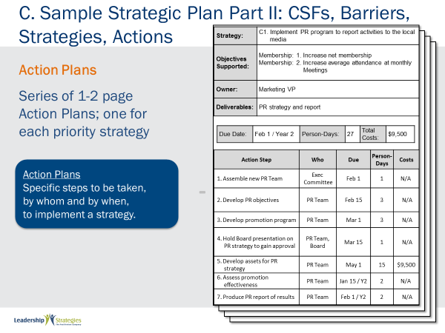 |  |  |  |  | SHOW POWERPOINT: Action Plans (build)  SAY:  In the Meeting Planners example, there are six goals and five strategies  for the goal area called membership. If each goal had five strategies, then  this plan would generate thirty strategies. Can you do thirty strategies all  at once? Of course not. So that’s why you prioritize. You go through an  activity of prioritizing the most important strategies to start on first. Most  often, 6-10 strategies are chosen.  Then, you write action plans for each of those priority strategies. What  you see here is a shortened form of an action plan that says what are you  going to do, who’s going to do it and by when it is going to be done.
TRANSITION:
Let’s take a full look at an action plan.
 | PPT: Dividing the Plan  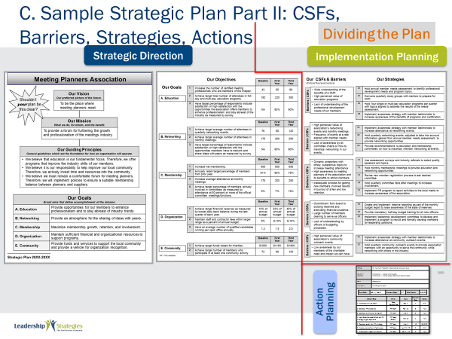 |  |  |  |  | SHOW POWERPOINT: Dividing the Plan (build)  SAY:  Take a look at this action plan.  ASK:  What would you say is the purpose of action plans?  SAY:  Action Plans allow you to monitor the activity to see if you’re getting the  strategies done.  An action plan provides the details for how a priority strategy will be  implemented. The action plan describes what will be done, by whom and  by when. The action plan also estimates both the people resources and  the out-of-pocket dollars required.  We have looked at the individual components of the strategic plan, now  let’s focus on how you actually develop the plan. This will get us one level  deeper toward facilitating strategy.  KEY POINTS:  We break the strategy development activity into three major sessions.  - In strategic direction setting, you cover vision, mission, guiding  - principles, goals, and objectives.  - In implementation planning, you cover critical success factors, barriers, strategies.  - In the action planning session, the team develops the action plans.  For larger organizations  - Strategic direction setting is typically performed by executive management: typically, 8-20 people.  - The executives then bring in middle managers (20-40) to review the plan, provide comments and work with executives to develop the implementation plan. set priorities, and select strategy leaders from among the executive and middle managers.  - Strategy leaders then select workers to form teams to develop the action plans for approval by executive management.  For smaller organizations  - Strategic direction setting and implementation planning are typically performed by the same group and strategy leaders are selected from among them. With the priority strategies established, the strategy leaders select workers to form work teams to develop the action plans for approval by executive management.
 | PPT: Agenda |  |  |  | SHOW POWERPOINT: Agenda  CHECKPOINT:  Just as there are there are three distinct strategy sessions, there are also  three distinct phases to the overall strategy process. Let’s take a look at  each of these to provide an overall foundation for our work.
 | PPT: The Phases  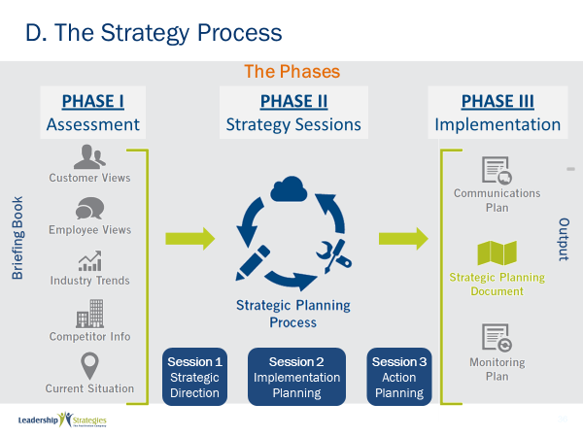 |  |  |  |  | SHOW POWERPOINT: The Phases (build)  DO:  REVIEW the key points below as you follow along with the slide:  KEY POINTS:  Phase I is the assessment phase. Recall that the first key point of the  Drivers Model is to start with an accurate picture of today. Accordingly,  during this phase, we want to compile the information that will give all  planning team members a common understanding of where the  organization is today.  This is necessary because people in operations only see the company  from their view, while people in marketing and sales see the company  from their view, and those in the field have their own view. By compiling a document that contains all these views, everyone on the planning team  gets a full view of the current situation.  We divide the assessment into six components.  The information from these components is compiled into a briefing book  that is distributed to all planning team members typically 1 or 2 weeks  prior the session.  Phase II is the strategy session phase. During the three sessions, the  team develops the strategic direction, the implementation plan, and the  action plans.  There are three major outputs from the strategy sessions, the strategic  plan, the communications plan and the monitoring plan which indicates  how we are going to monitor the process.  Phase III is the implementation phase in which we implement the strategic plan, the communications plan and the monitoring plan.
 | PPT: Agenda |  |  |  | SHOW POWERPOINT: Agenda  CHECKPOINT:  We’ve talked about the three phases of strategic planning. Now let’s ask  the big question: Why do most plans fail?
 | PPT: E. Why Most Plans FAIL  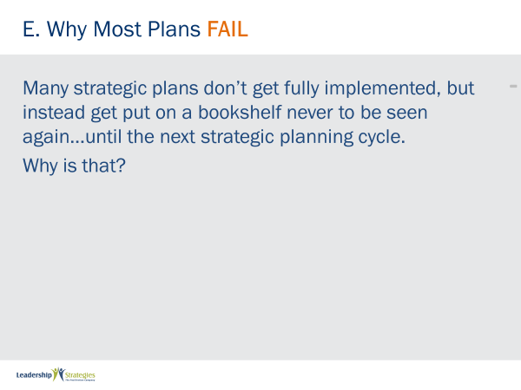 |  |  |  |  | SHOW POWERPOINT: E. Why Most Plans FAIL  SAY:  We all know that most strategic plans get put up on a shelf and never get implemented? But why does that happen?  By understanding why it happens we can put things in place to make sure  it doesn’t happen with this plan.
 | PPT: E. Why Most Plans FAIL  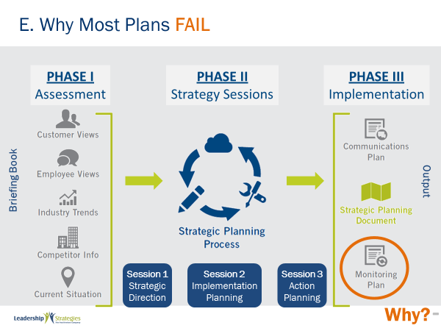 |  |  |  |  | SHOW POWERPOINT: E. Why Most Plans FAIL (build)  ASK:  - Does failure happen during Phase I: Assessment? (No)  - Does failure happen during Phase II: Strategy Sessions? (No)  - Does failure happen during Phase III: Implement?  SAY:  Yes. And we find it happens during the monitoring phase.  ASK:  Why?  DO:  FACILITATE a discussion.
 | PPT: Covey Urgency/Importance Matrix  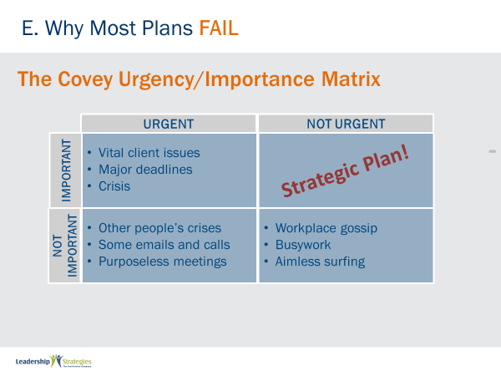 |  |  |  |  | SHOW POWERPOINT: Covey Urgency/Importance Matrix (build)  SAY:  In The Seven Habits of Highly Effective People Stephen Covey presented  the Urgency/Importance Matrix. In the matrix, activities can have high or  low importance and high or low urgency.  Things that are high importance and high urgency, such as a directive  from your boss that requires immediate action, always get done.  Things that are low importance and low urgency, like junk mail, should  never get done.  Things that are low importance and high urgency, like the telephone  ringing, often get done because of their urgency.  But the final box is special. These are the things that are high importance,  but low urgency. We find that most things in the strategic plan fall into this category. Why? – They must be highly important otherwise they wouldn’t be in the strategic plan. And they must be low urgency, otherwise they would be done already.  Unfortunately, it is human nature to do the urgent, NOT the important. So, we are much more likely to get things done that are highly urgent with low importance, and we let the important but not urgent items “get put on the shelf” and never get done.
KEY POINT:
The secret to successful strategy implementation is to move the items in
the strategic plan from low urgency to high urgency.
 | PPT: How Do You Increase Accountability for Implementation?  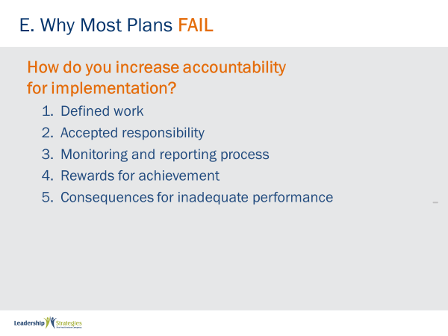 |  |  |  |  | SHOW POWERPOINT: How Do You Increase Accountability for Implementation? (build)  SAY:  We have worked with organizations on strategic initiatives for nearly two decades. Over this period, we have seen organizations that have been highly successful and we have seen other organizations that have failed to get out of the starting gate.  Why does this happen? We believe, more times than not, the answer is accountability, or more specifically, the lack thereof. We believe effective accountability has five critical components.  - Clear identification and articulation of the work to be done, the expectations and timelines surrounding it and a plan for achieving it.  This first step is often where the breakdown of accountability starts. How often is it that work is not clearly defined or expectations and timelines not clearly articulated or a plan not delineated for achieving the work?  - Accepted responsibility.  Once the work is defined, someone has to accept responsibility for getting it done. Please note, assigned responsibility is not the same as accepted responsibility. Has the person been simply assigned it or has the person accepted that it is his/her responsibility for accomplishing it?  - Monitoring and reporting.  Accountability comes from the Latin word that literally means “to give an account.” We may have accepted the responsibility for clearly defined work. However, without a monitoring and reporting process (i.e., without a process for people to give an account), there is essentially no accountability.  - Reward for accomplishment.  A key to effective accountability is to have a reward for accomplishing the item for which we are being held accountable. In the workplace, rewards can take a variety of forms, including recognition, time off, gift certificates, convenient parking space, etc.  - Consequences for lack of performance.  Consequences are necessary to ensure that there is both a “carrot” for performance and a “stick” for lack of performance. While many organizations avoid the stick, we find it is an essential component for letting people know they have let down the team.  While sometime the lack of performance is so significant and so severe that it requires “freeing up the person’s future,” in most cases, a less severe consequence is more appropriate. One of the strategies we have seen helpful is having the team define consequences in advance. Simple consequences such as cleaning up the break room or taking another person’s team out to lunch may be suitable. (Consider using the accountability dice fully described in a Leadership Strategies article titled with that same name.)  What happens if one or more of the accountability components is missing?  - If any one of the components is missing, you will likely have a significant breakdown in accountability.  - If two or more components are missing, the level of accountability is so low, for most situations you can pretty much say that accountability is non-existent. The work may still get done, but most likely due to the sheer will and desire of those involved and in spite of, not with the support of, any process, oversight, or leadership.  Make sure your team delivers on your strategic initiatives. Consider implementing effective accountability strategies.
 | PPT: Monthly  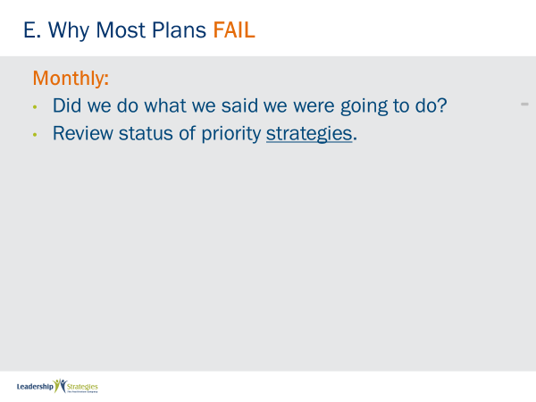 |  |  |  |  | SHOW POWERPOINT: Monthly (build)  ASK:  How do you move items in the strategic plan from low urgency to high  urgency?  SAY:  Through our work with hundreds of organizations in strategic initiatives,  we have designed the monitoring process in the Drivers Model specifically to address this.  The monitor process includes 3 stages: monthly, quarterly and annual.  During monthly monitoring, the question to ask is, “Are we doing what we said we were going to do?” Focus on whether the action steps are getting done.  Each action plan indicates what steps are to be done when. Therefore  each month, the strategy teams indicate the progress they have made.  This information is then recorded in a strategy scoreboard.
 | PPT: Agenda |  |  |  | SHOW POWERPOINT: Agenda  CHECKPOINT:  We’ve just discussed important actions you take to increase your strategic success. We touched on the monitoring process. I’d like to show you a more detailed example of how we do this at LSI.
 | PPT: Sample Dashboard Summary  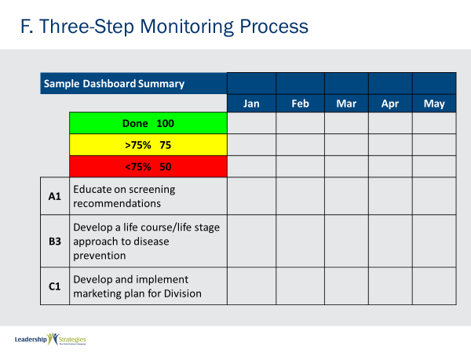 |  |  |  |  | SHOW POWERPOINT: Sample Dashboard Summary  SAY:  Here is an example of a dashboard.
 | PPT: Sample Dashboard Summary  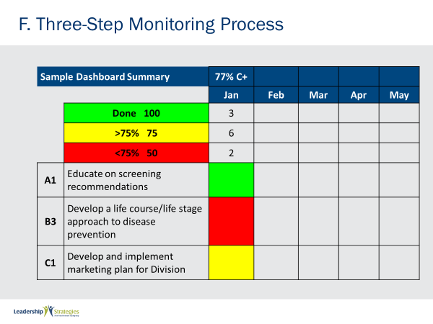 |  |  |  |  | SHOW POWERPOINT: Sample Dashboard Summary  SAY:  The strategy dashboard shows those strategies on track (green), those  that have fallen slightly behind (yellow), and those that have fallen well  behind (red). The team receives an overall grade for the month, based on  the performance.  As you can see 3 strategies are on track (green), six have fallen slightly  behind (yellow), and two have fallen well behind (red). The team’s overall  grade is a C+ for the month.
 | PPT: Sample Dashboard Summary 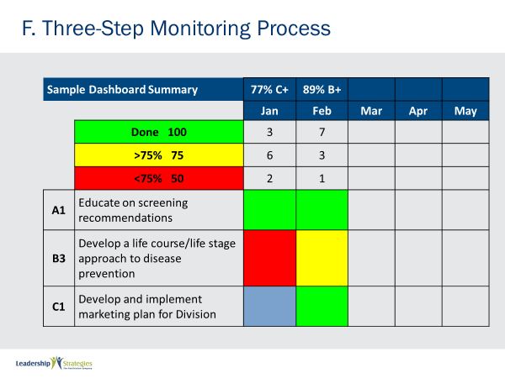   |  |  |  |  | SHOW POWERPOINT: Sample Dashboard Summary  KEY POINTS:  In the following month they did better and had a B+ grade for the month.  Notice that the color for C1 in January is blue. You may remember that in the prior month is was yellow. But in the month of February it got completed. The blue color indicates that the activity is done, but it wasn’t done on time.  You may also note that the B3 strategy is still red for January, because it is still not complete.
 | PPT: Sample Dashboard Summary 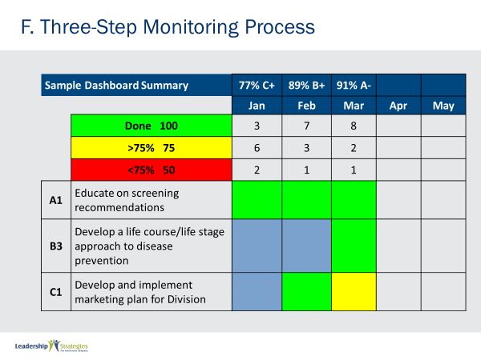 |  |  |  |  | SHOW POWERPOINT: Sample Dashboard Summary  SAY:  March was even better.
 | PPT: Sample Dashboard Summary 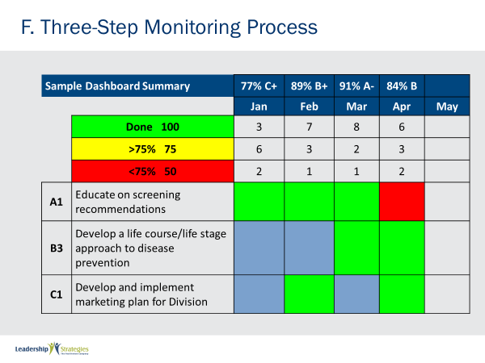 |  |  |  |  | SHOW POWERPOINT: Sample Dashboard Summary  SAY:  They had a small set back in April resulting in a lower grade than March.
 | PPT: F. Three-Step Monitoring Process  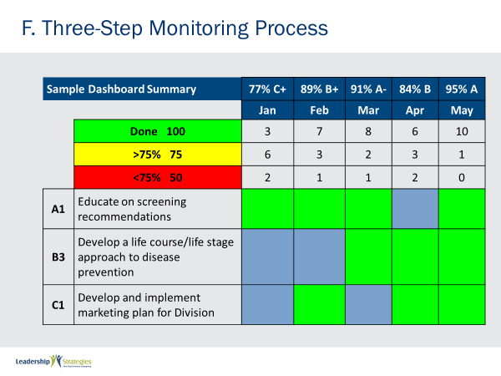 |  |  |  |  | SHOW POWERPOINT: Sample Dashboard Summary  SAY:  But by May they were back on track.
 | PPT: Three-Step Monitoring Process  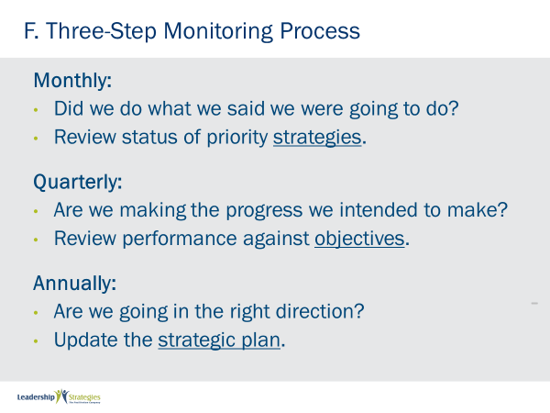 |  |  |  |  | SHOW POWERPOINT: Three-Step Monitoring Process (build)  SAY:  So monthly the question is, “Did we do what we said we were going to  do?” and the focus is on strategies.  Quarterly, we ask a different question, “Are we making the progress we  intended to make?” In this case we focus on objectives and we measure  performance against the objectives. We make adjustments to our  strategies as needed to ensure we are staying on track.  So, while monthly we focus on activities, quarterly we focus on results.  Annually, we ask a different question, “Are we going in the right direction?”  As Covey explained, we may be moving up the ladder, but is the ladder  against the right wall? We don’t want to get the top of the ladder and  realize we have made progress, but in a direction, that doesn’t matter any  more.  So once a year we reassess the direction, look at new issues in the  environment, reset our targets and reprioritize as needed.
 | PPT: Agenda |  |  |  | SHOW POWERPOINT: Agenda  CHECKPOINT:  Can you see how important is to get the three-step monitoring process right? There is more to learn about strategy. You also need to debrief leadership. This creates opportunities to calibrate or re-calibrate as needed.
 | PPT: The Leadership Briefing  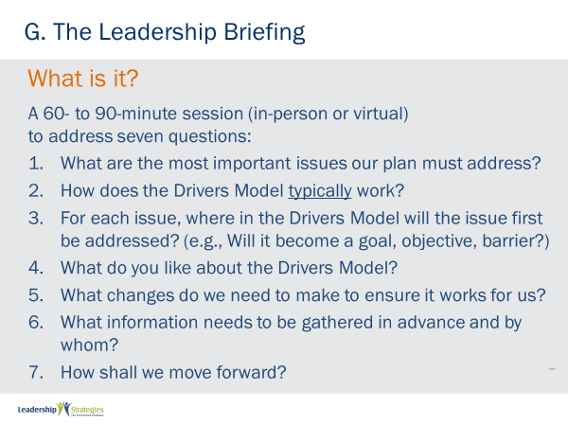 |  |  |  |  | SHOW POWERPOINT: The Leadership Briefing (build)  SAY:  In undertaking a strategic planning effort, have you ever found the team arguing over definitions, or wanting to complete the strategic plan in a half-day or a day, or disinterested because they don’t see how strategic planning will have impact on their day-to-day?  We believe many of these issues can be resolved quickly up-front by holding a carefully crafted management briefing.  The management briefing is a 90-minute interactive session in which the planning team becomes laser-focused on the most important issues impacting the organization. This is step one.  Once there is agreement on the issues, and this takes very little time, they are now ready to listen and have you take step two and describe a process for addressing the issues. You walk them through the Drivers Model, just as I have done for you today.  But it is the next step that is critical. You ask them to indicate where in the Drivers Model will there issue first be addressed. As an example, some issues will become goals, others will become objectives, barriers, critical success factors, etc.  Then do a round robin to have each person say what he/she likes about the Drivers Model.  Then open it up for recommendations for how to improve it.  If time permits, you identify the information needed to be gathered in advance.  And then ask, how shall we move forward. You might be surprised how excited people might be about taking the next step because they can see the benefit.
 | PPT: The Benefits and Key Products  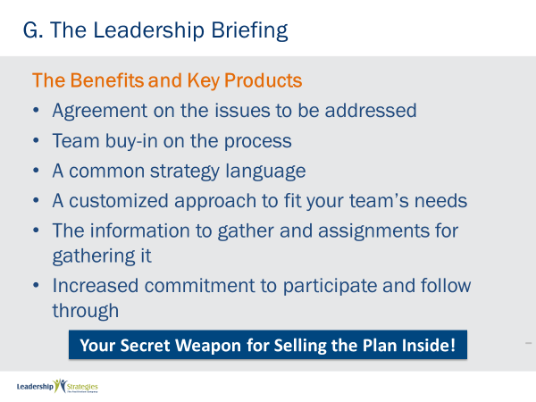 |  |  |  |  | SHOW POWERPOINT: The Benefits and Key Products (build)  ASK:  What are the benefits of and the key products produced in the Leadership briefing?  SAY:  Let’s take a look…  DO:  REVIEW the content on the slide.
 | PPT: Agenda |  |  |  | SHOW POWERPOINT: Agenda  CHECKPOINT:  We just covered the leadership briefing section. Now, I’m going to tell you about the ten pitfalls to avoid during strategic plans. Hopefully, this will save you some time and energy, as you learn from our mistakes.
 | PPT: The 10 Pitfalls to Avoid  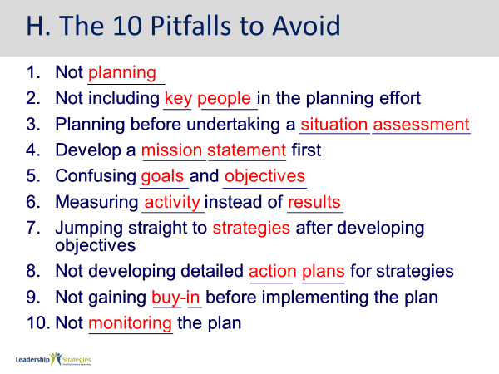 |  |  |  |  | SHOW POWERPOINT: The 10 Pitfalls to Avoid (build)  DO:  REVIEW the content on the slide. REMIND them to complete the fill-in-the-blanks in their workbooks.
 | PPT: Agenda |  |  |  | SHOW POWERPOINT: Agenda  CHECKPOINT:  Now you know what NOT to do! Our last section today addresses special applications of the Drivers Model.
 | PPT: Managing Your Boss  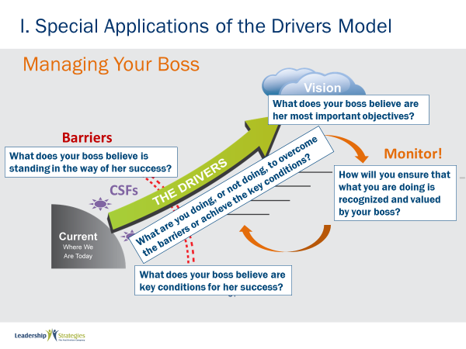 |  |  |  |  | SHOW POWERPOINT: Managing Your Boss (build)  SAY:  You can use the Drivers Model to manage your boss. In this case the drivers model starts in a different place. You start by identifying what your boss believes are her most important objectives. The key is understanding your boss’ perception.  Next, identify which a boss believes are her barriers and critical success factors. To be of value to your boss you should be doing things that move barriers and create critical conditions for her to be successful. If you’re not addressing what is important to your boss or worse, if your boss believes you are creating barriers or preventing critical conditions from being put in place, your boss may view you as a liability instead of an asset!  So, use the drivers model to ensure that you all well aligned with what your boss as her critical success factors and barriers.
 | PPT: Change Management  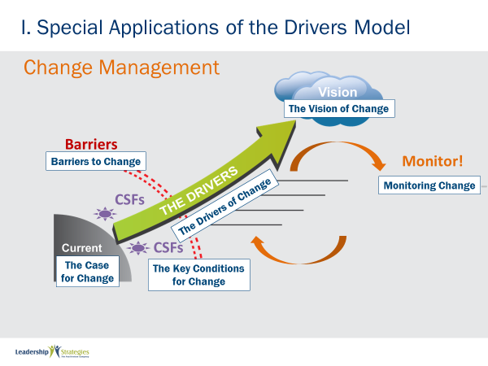 |  |  |  |  | SHOW POWERPOINT: Change Management (build)  SAY:  There are 3 special applications of the Drivers Model that I would like to highlight.  First, when you are introducing a major change into your organization, you might consider taking these steps.  Start by building your case for change. Why should the organization change? Why is it necessary?  Once you have the case for change, create the vision for change. What will the organization look like with the change in place? What are the benefits to making the change?  Then, identify the barriers to change, the things standing in the way. As well, identify the key conditions that have to be created if the change is going to be successful.  The next step is to identify the drivers for change, what are the things we’re going to do to create the vision by overcoming the barriers and by creating the key conditions for change.  Finally, it is critical to monitor change on a consistent basis, keeping in mind the five C’s to accountability.
 | PPT: Coaching  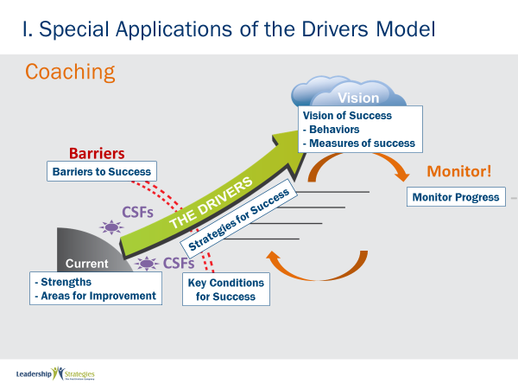 |  |  |  |  | SHOW POWERPOINT: Coaching (build)  SAY:  The Drivers Model is also very effective in the coaching context. Let me show you what I mean. The Drivers model starts with answering the question where are we today? In the coaching context this means what are you doing well, what are your strengths? What is not going so well? what do you see as your weaknesses?  The second question is where you want to be? 3 years from now, five years from now, ten years from now, where do you want to be in your career? Or, it could be a coaching session based on improvement, where the person is trying to improve a certain area, so the question might be what is your vision of improvement?  Next, we want to understand what are the barriers standing in the way what are the things that are today preventing you from getting there. And then, what are the key conditions that if we create them will be like the fuel that gets you to where you want to go? And then the drivers. What are the things that you can begin doing to overcome the barriers, create critical conditions, and drive you to your vision.  Finally, it is critical to monitor on a consistent basis.
 | PPT: Having a Coaching Conversation  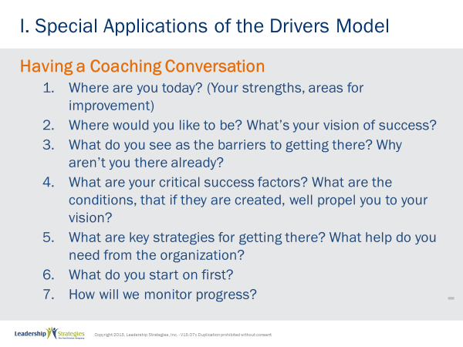 |  |  |  |  | SHOW POWERPOINT: Having a Coaching Conversation (build)  DO:  REVIEW the content on the slide.
 | PPT: Review Slides  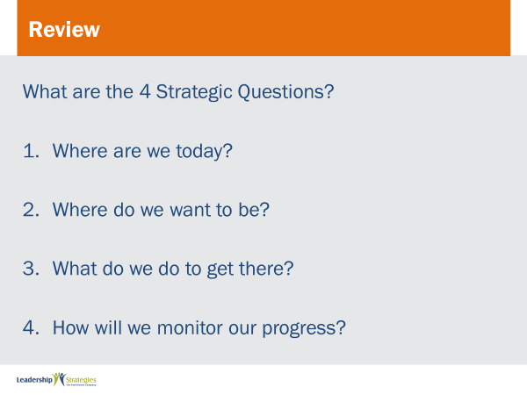 |  |  |  |  | SHOW POWERPOINT: Review Slides (build)  DO:  Post each review slide up and ask for someone to raise their hand to answer the question. If they get it correct, award them a dot.  REPEAT for all review slides.
 | PPT: Spring Forward – 6b. Defining CSFs, Barriers, and Strategy  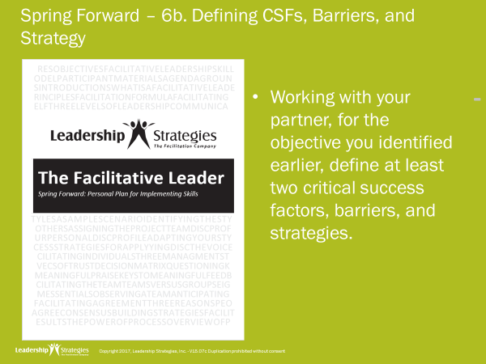 |  |  |  |  | SHOW POWERPOINT: Spring Forward – 6b. Defining CSFs, Barriers, and Strategy (build)  DO:  INSTRUCT them using the following instructions if they will complete this activity in class.  PURPOSE - To practice determining critical success factors, barriers and strategies.  EXAMPLE – not needed  DIRECTIONS – Individually answer the questions in the Spring Forward workbook.  EXCEPTIONS - none  QUESTIONS - What questions do you have?  DO:  ASK 2-3 participants to share what they wrote.
 | PPT: Spring Forward – 6c. Documenting Your Monitoring Process  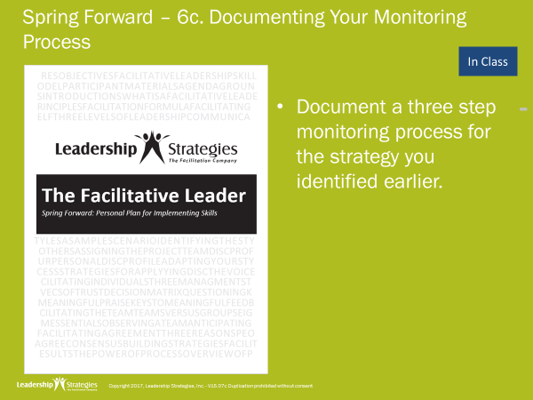 |  |  |  |  | SHOW POWERPOINT: Spring Forward – 6c. Documenting Your Monitoring Process (build)  DO:  INSTRUCT them using the following instructions if they will complete this activity in class.  PURPOSE - To practice documenting a three-step monitoring process for the strategy.  EXAMPLE – not needed  DIRECTIONS – Individually answer the questions in the Spring Forward workbook.  EXCEPTIONS - none  QUESTIONS - What questions do you have?  DO:  ASK 2-3 participants to share what they wrote.
 | PPT: Agenda |  |  |  | SHOW POWERPOINT: Agenda  CHECKPOINT:  We just completed our last exercises for the day. Let’s go back to the TAFA Model and see how facilitating strategy connects.
 | PPT: TAFA  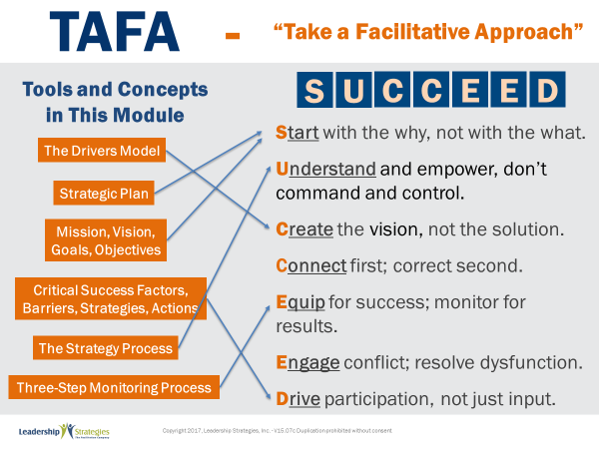 |  |  |  |  | SHOW POWERPOINT: TAFA (build)  SAY:  Let’s take a moment to look at some of the concepts we’ve learned in this module and examine how they reflect the TAFA principles.  DO:  REVIEW slide and lead discussion by asking if there are other principles that are reflected by the concepts.
 | PPT: Checkpoint |  |  |  |  | SHOW POWERPOINT: Checkpoint (build)  CHECKPOINT:  We have completed the Facilitating Strategy. In the next module we will talk about how to facilitate masterful meetings.
 | PPT: Connect with LSI  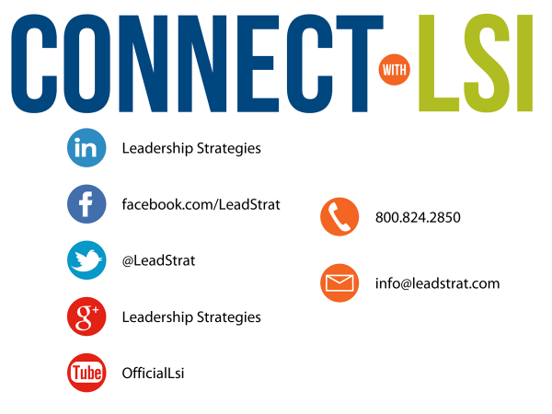 |  |  |  |  | SHOW POWERPOINT: Connect with LSI  Note to Instructor: this slide may be excluded if you are going directly into the next module. In that case, hide the slide.  SAY:  We fundamentally believe facilitation is a skill that applies in a multitude of situations. We also are confident that, in our quest to “share the power of facilitation with the world,” connecting via social media is a way for all of us to collectively share our successes, our challenges and our facilitation work. To “facilitate” that process, we want to ensure you are aware of how we can all stay connected using social media.  How many of you have found many of the skills in the class helpful? [raise your hand] I know that one of the things I did after attending was share what I learned with many of my colleagues. Have some of you already thought about that? [nod your head]  Then, one request we would like to make of you is to update your “education or classes attended” on your LinkedIn profile. That visibility will help all of us to “share the power” I have been referring to. Any questions?
PPT: Congratulations  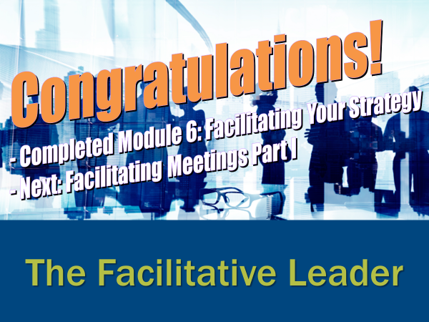  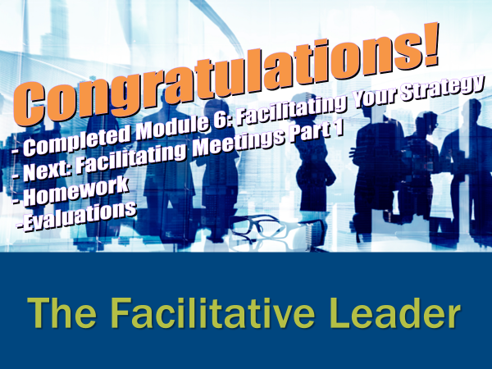  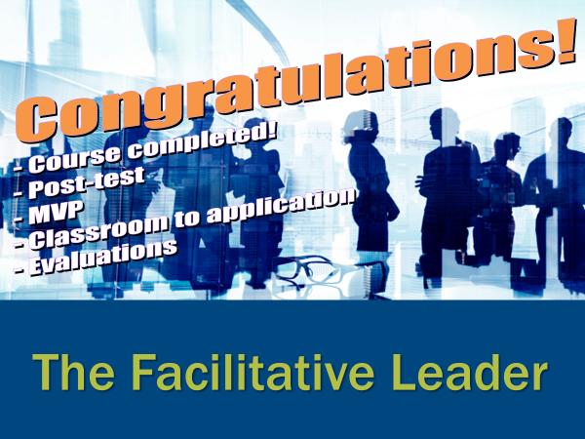 |  |  |  | SHOW POWERPOINT: Congratulations! (builds)  Note to Instructor:  There are three congratulation slides. Select the correct slide depending on whether you are:  - Moving on to the next module immediately (slide 1)  - Coming back another day to do the next module and therefore need to do an evaluation (slide 2)  - Have completed the workshop and therefore need to close out the class with the post-test, evaluations, dot winner (MVP), and the From Classroom to Application sheet (slide 3)  Hide the other two congratulations slides.  DO:  REVIEW and execute the content on slide.  EXECUTE THE POST TEST:  If appropriate, handout the post-test. Give people five minutes to complete. Ask teams to give their cheer once completed.  Once completed, have team members pass their post-test clockwise to a new person. Go through each question and have the group give responses. Instruct them to place a checkmark for each correct response.  Once completed have people add up the number of check marks and place the total at the top.  Since each post-test has eight questions, place the number 8 through 0 in the first column of a two-column chart.  Before people hand the post-tests back to the owner, do a round robin and have people indicate the number the person got corrected. Place a tick mark next to that number each time that number is reported.  THANK participants and dismiss class.
 |  |  | END |  | END OF THE FACILITATIVE LEADER MODULE 5

