The Facilitative Leader
Module 5: Facilitating Agreement

Facilitator Guide

Table of Contents
Facilitator’s Information
Table of Contents 1
How to Use This Guide 2
Symbols Used in the Facilitator’s Guide 3
Materials & Equipment for Module 5 of The Facilitative Leader 4
Leadership Through Facilitation Module 5: Agenda 5
Module 3: Introduction 7
Module 3: Facilitating and Coaching Individuals Agenda 8

How to Use This Guide
This Facilitator’s Guide covers the following:
- Work you’ll need to do prior to the workshop,
- Materials and equipment you’ll need for the workshop, and
- Instructions and verbiage to conduct the workshop.
Headings
The heading for each section indicate the information that will be covered in that particular section.
Instructions Section
On the right-hand side of the workshop instructions pages you’ll find the approximate number of minutes required to complete a topic.
The format for the instructions section contains 2 columns as follows:
- Left-hand Column:  - Contains graphics, such as a copy of a slide or an icon, indicating the major aspect of the training segment. For example, a television set icon indicates that a video will be shown. The next page shows the various icons used. | - Right-hand Column  - Lists the information or instructions to be conveyed to the participants and contains possible starting questions you can ask about the topic to engage participants in a discussion or an activity.  - Describes the activity to be completed. Note that actions to be done will always be in bold.  NOTE: This Facilitator’s Guide is not intended to be used as a script. The words in this column give you one example of how to deliver the content. Part of your preparation is to review this guide and become familiar with its contents, structure, and flow. You should feel free to use your own words, adjust the delivery to your own style, while also adapting to the needs of the group you are facilitating. At all times, be sure to show enthusiasm and comfort with the material when you are presenting. This will provide a more enjoyable and meaningful session for your participants.
 | Anything in a gray box means that you will be “doing” something rather than presenting.

Symbols Used in the Facilitator’s Guide
There are many symbols used in this Facilitator’s Guide to serve as prompts for the type of activity occurring at that point in the program. Here is a list of those symbols and what they mean.
 | Presentation |  |  | Key Information
 | Spring Forward Exercise |  |  | Pull through previous learnings
 | Pair Discussion/Exercise |  |  | Participant Manual “Write-along”
 | Group Discussion/Exercise |  |  | UMU activity
 | Write responses on a flip chart |  |  | Checkpoint
 | Transition to next topic |  |  | Individual Activity
In some cases, an activity will transition from one type to the other (e.g. from individual to group discussion). In such cases, more than one symbol may be used in chronological order.

Materials & Equipment for Module 5 of The Facilitative Leader
Following is a list of the materials to be used in this training session. Be sure to become familiar with all of them.
- Projector and Screen
- Laptop
- PowerPoint Slides – “The Facilitative Leader 5: Facilitating Agreement”
- Facilitator Guide (this document)
- Updated Participant List
- Participant Packets (one for each participant)
  - Tent Cards
  - Participant Manual
  - Spring Forward Booklet
- Flipcharts – one for Facilitator, plus one for each table group)
- Pins/tape to hang posters
- Tape
- Pens and Markers
- Post-it notes (one different color package for each table group)

Flip Charts:
- Course Objectives (posted, if appropriate)
- Ground Rules (posted)
- Coming Attractions (posted)
- Module 5 Agenda
- Post Test

Leadership Through Facilitation Module 5: Agenda
TIME | TOPIC
5 minutes | Workshop Introduction  - Checkpoint  - Course Objectives  - TAFA  - Ground Rules  - Your Materials
7 minutes | Homework Review
 | - Have participants share results of their homework (in pairs, table groups, and/or with the class)
2 minutes | Workshop Introduction  - Agenda (Compare to participant objectives)
13 minutes | A. Decision Making Alternatives
15 minutes | B. Understanding Disagreements Activity
 | - Participants discuss examples of things people disagree about at work.
15 minutes | - 8 Team Essentials  - Understanding Disagreements
20 minutes | C. The 3 Reasons People Disagree
20 minutes | D. Identify and Resolving Level 3  - Identify and Resolving Level 3 Examples  - Justin and Avery Scenario
10 minutes | E. Using Delineation to Resolve Level 1  - Using Delineation to Resolve Level 1  - Continue Justin and Avery Scenario
15 minutes | F. Using Strengths and Weaknesses and Merge to Resolve Level 2  - Using Strengths, Weaknesses and Merge to Resolve Level 2  - Continue Justin and Avery Scenario
10 minutes | G. Five Finger Consensus  - Using Five Finger Consensus  - What if Consensus Continues to Be a Problem?
15 minutes | Spring Forward 5a. Resolving a Disagreement
15 minutes | - Participants identify the types of disagreements that occur in their organizations and think through strategies to work through them.
8 minutes | Review
8 minutes | - Numerous review slides to test understanding and learning.
10 minutes | Homework or In-Class Assignment: Spring Forward 5b. Improving Decision Making
10 minutes | - Participants plan for an upcoming meeting, thinking about how the decision will be made.
15 minutes | Session Close (Will vary based on FL “package” being delivered.)  - Review Agenda  - TAFA: Tools and Concepts in this Module  - Checkpoint to next module if appropriate  - Connect with LSI  - Congratulations slide with appropriate closing activities depending on whether this module is delivered as part of the four-day or as a stand-alone  - Execute Post-Test if appropriate  - Award dot winner MVP prize if appropriate  - Complete From Classroom to Application if appropriate  - Execute Evaluation if appropriate  - Formally close the session.
180 minutes  (3 hours) | Total Training Time

Module 3: Introduction
Overview
Leaders learn techniques to use while coaching individuals for high performance.
Modules include the following:
- Decision-Making Alternatives
- The 3 Reasons Why People Disagree
- Identifying and Resolving Level 3
- Using Delineation to Resolve Level 1
- Using Strengths, Weaknesses and Merge to Resolve Level 2
- 5-Finger Consensus

Key Learnings
- Be able to determine which decision-making alternative is ideal for each situation
- Apply techniques to address disagreement based on the type of disagreement it is
- Facilitate team through 5-Finger Consensus

Facilitation Tips/Background Information
- Post on the wall ahead of time three flip chart pages with the following titles
  - Objectives
  - Agenda
  - Coming Attractions
- Accommodate participant objectives where possible, but do not be tempted into shoe-horning their objectives into the planned activities. If it’s not going to be covered, explain why it is out of the parameters of this workshop. If appropriate, consider covering out-of-scope objectives over lunch, on breaks, or in some other way.
- Be familiar with the DISC communication styles.

Timing: 3 hours

Module 5: Facilitating and Coaching Individuals Agenda
- Decision-Making Alternatives
- The 3 Reasons People Disagree
- Identifying and Resolving Level 3
- Using Delineation to Resolve Level 1
- Using Strengths, Weaknesses and Merging to Resolve Level 2
- 5-Finger Consensus
Exercise 5a. – Resolving a Disagreement

Timing: 3 hours
PPT: Facilitative Leader  |  | SHOW POWERPOINT: Facilitative Leader  Note to Instructor: Customize your opening depending on the modules the group will be receiving in total, whether you are following a previous module, coming back from time in-between modules, or only running this workshop for this group.  SAY:  Welcome Managers to the Leadership Through Facilitation Workshop!  Introduce yourself and your background.  Have participants introduce themselves by sharing name, position, and years with the company. Ensure that each participant has signed in.
PPT: Facilitating Agreement  |  | SHOW POWERPOINT: Facilitating Agreement  SAY:  You’ll walk away with an understanding of:  - Decision making alternatives you can choose from.  - The 3 reasons people disagree.  - Techniques to use for resolving different types of conflicts.
PPT: Checkpoint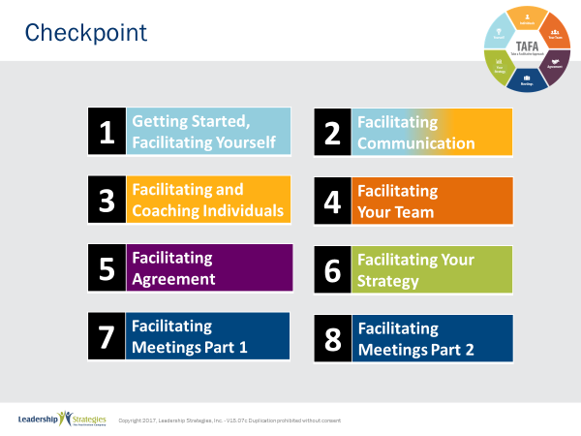 |  | SHOW POWERPOINT: Checkpoint  CHECKPOINT:  In Module 4, we covered how to facilitate your team. Now, we will move into facilitating agreements with your team. This is the next level of facilitating teams, and it can be more complicated. As a leader it is critical that you can effectively guide your team to resolve conflicts.
PPT: TAFA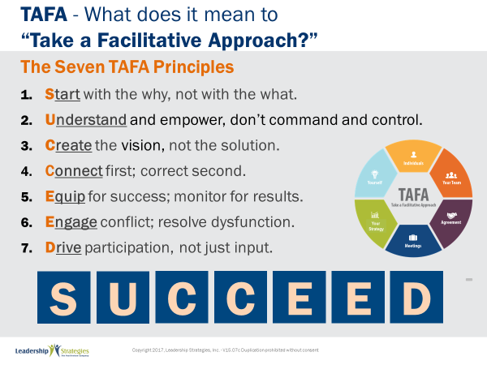 |  | SHOW POWERPOINT: TAFA  SAY:  Let’s review the TAFA principles:  There are 7 key TAFA principles – the principles of taking a facilitation approach. Any time you have a decision to make, a problem to solve, someone to coach or correct, we are going to be giving you tools and techniques for implementing these principles.  Let’s walk through them together.  People are often inspired when they are connected and aligned with purpose. Unfortunately, as leaders we often focus on what we want done and start there. Facilitative leaders understand the importance of why and always start any discussion, meeting, initiative kickoff, etc., with the why.  Often leaders don’t involve those impacted because they believe they need to control all aspects of what is done to achieve their desired result. They don’t take the time to understand how to adapt to the styles of their people to inspire performance because they don’t understand the relationship between engagement and results.  However, leaders who take a facilitative approach understand how to empower others by defining purpose and providing guidelines that allow teams to create recommendations that are thoughtful and innovative, but also practical and implementable. They adjust their own management styles to get the most out of their people.  One of the key roles of leaders is to set a vision of success with a clear and compelling “why” that inspires success. Facilitative leaders understand that once they set the vision they must give their people the authority, resources, support and coaching so that their people can develop and implement solutions and strategies that bring the vision into reality.  Some leaders are expert at pointing out mistakes their people make. They seem to enjoy demonstrating their superiority by identifying errors and then showing their people what they have done wrong.  Leaders who take a facilitative approach understand the importance of connecting with people first and helping them discover their own errors. They recognize the power of being the “guide on the side” rather than the “sage on the stage.” They strive to leave every interaction with the person feeling lifted rather than beaten down.  So many teams are essentially destined to fail from the start because they are not properly equipped for success. Facilitative leaders understand that teams require eight essentials and provide teams the essentials they need to accomplish their work. At the same time, many plans fall short of their desired ends due to lack of monitoring for results. For example, how often do strategic plans get written and then put on a shelf? Facilitative leaders understand the need to monitor for results every step of the way.  Leaders who don’t have the tools to effectively manage conflict and dysfunction tend to respond with either a “fight or flight” strategy when faced with a challenging situation. Those leaders who take the flight approach will avoid addressing issues and hope they go away on their own. Those employing the fight strategy tend to try to overpower situations by forcing their will without listening to or considering other alternatives.  Leaders skilled in taking a facilitative approach view disagreement as an opportunity to identify better solutions; they view dysfunction as a sign that something important is not being addressed. They understand the three reasons people disagree and have strategies for addressing each one. They fully buy-in to the dysfunction principles--conscious prevention, early detection, and clean resolution--and use appropriate techniques to prevent, detect and resolve dysfunction.  How often does a decision come down from headquarters which the people in the field know makes absolutely no sense? The idea couldn’t possibly work and everyone knows it, except the leaders. What happens? Time and energy is wasted implementing something that months later gets abandoned when the leaders finally figure out it was a bad idea. If they had only asked, the wasted time and resources could have been put to a much more productive use. If they had only asked.  Or how often, when trying to make a needed change, does the change get met with blatant rejection or subtle subterfuge simply because those expected to implement the change were not involved up front in the creation?  Leaders who take a facilitative approach recognize that you can get better decisions and achieve higher levels of buy-in when those impacted by the decision are involved in creating it.  - In the first case of a decision coming from headquarters, the involvement of those who would have to implement the decision would have likely yielded an even better solution that considered issues and situations that the workers understood but of which the leaders were unaware.  - In the case of the needed change that was met with significant opposition, involvement up front could have yielded greater buy-in and commitment to the implementation.  SUMMARIZE:  These principles outline what it means to take a facilitative approach inside an organization. As more and more leaders adopt a facilitative approach to leadership, we expect to see greater business results through higher levels of buy-in and commitment throughout the organization.
  1 | Start with the why, not with the what
  2 | Understand and empower; don’t command and control
  3 | Create the Vision, not the solution
  4 | Connect first; correct second
  5 | Equip for success; monitor for results
  6 | Engage conflict; address dysfunction
  7 | Drive participation, not just input
TRANSITION:
Just a few quick housekeeping items before we jump into the meat of today’s workshop.
PPT: Ground Rules 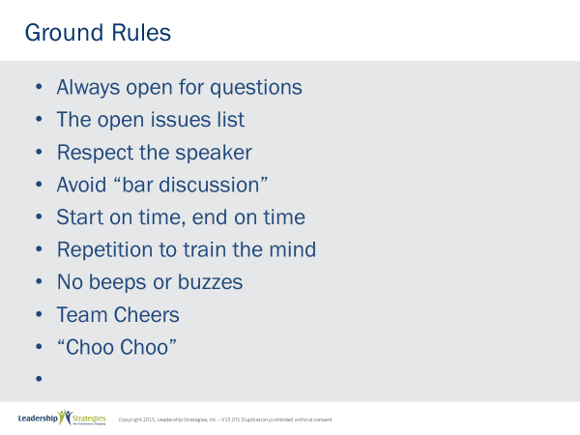 |  | SHOW POWERPOINT: Ground Rules (build)  SAY:  Well, as you can see, we have a very ambitious agenda over the next [two] days. To get through it smoothly, I would like us to agree on some “Ground Rules” or “Session Guidelines.”  ASK:  By a show of hands, how many of you have been in some type of training class before? [Raise your hand.]  SAY:  So, you know those things that work and don’t work. I value your time. I want this to be a productive session for you. So, what are those guidelines that we need to have in place to make this a productive session for you? Let’s look at these ground rules for how we will conduct our session for the next [two] days and reach an agreement on them.  DO:  REVIEW ground rules on slide. ASK the group if they would like to add or delete any of these ground rules.  ASK for a show of hands to adopt the ground rules as revised.
PPT: Your Materials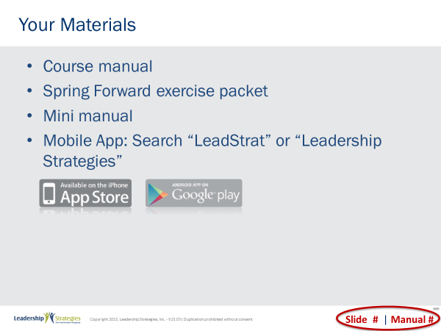 |  | SHOW POWERPOINT: Your Materials (build)  DO:  REVIEW the content on the slide.
PPT: Homework Review 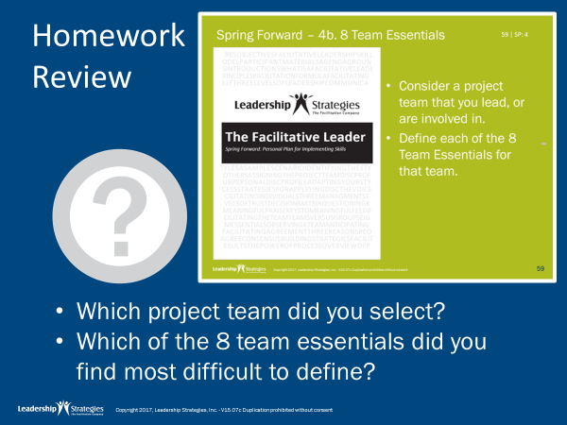 |  | SHOW POWERPOINT PPT: Homework Review  SAY:  Let’s pull out the Spring Forward manual so we can discuss how we applied what we learned last time.  DO:  READ through the activity to remind people …process responses for examples, have them talk at tables, have them share with one partner, have one person from each table share their view, etc.  NOTE: Given this exercise, have the next slide up so people can see the eight team essentials.
PPT: 8 Team Essentials 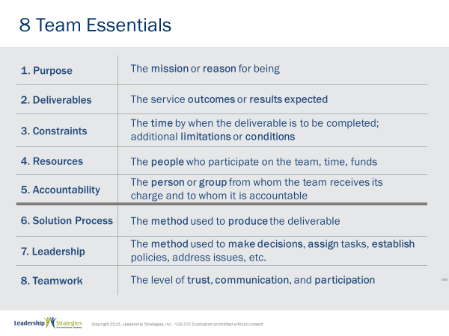 |  | SHOW POWERPOINT PPT: 8 Team Essentials  DO:  SHOW this slide while people are doing the previous exercise.
PPT: Agenda 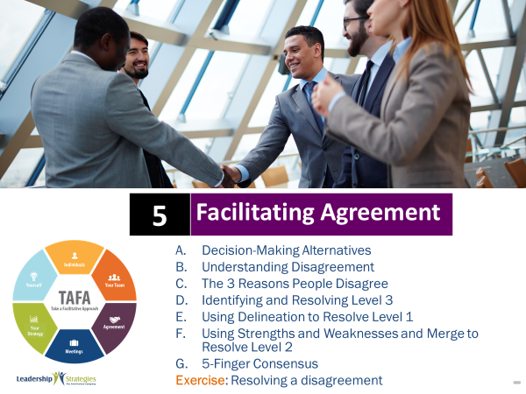 |  | SHOW POWERPOINT: Agenda  DO:  REVIEW the module agenda on the slide.
PPT: Agenda 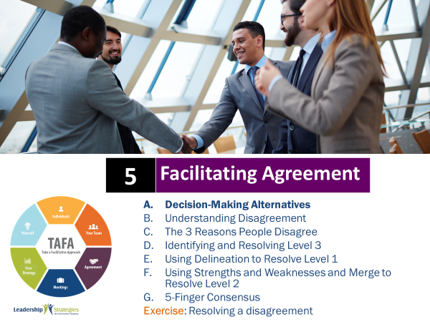 |  | SHOW POWERPOINT: Agenda  CHECKPOINT:  We have reviewed your homework about the 8 Essentials, so let’s jump in to facilitating agreements. We’ll start by looking at the alternative you have for defining consensus. It’s important to be aware of your options and select the best one for each situation.
PPT: Decision Making Alternatives 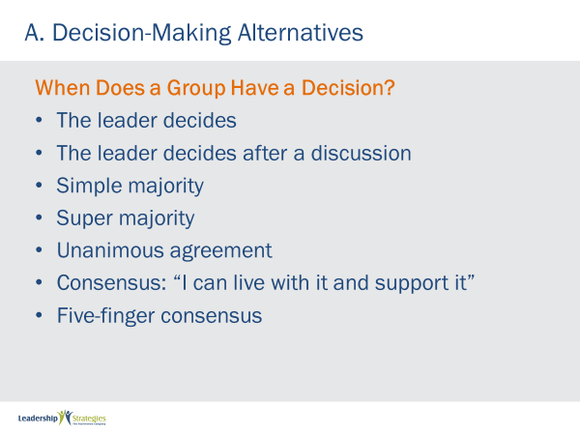 |  | SHOW POWERPOINT PPT: Decision Making Alternatives (build)  DO:  REVIEW the content on the slide, describing each alternative.  NOTE: Refer to The Secrets of Facilitation book for more detail.  POINT OUT:  Your trust level will likely impact how much authority you give your group.  Also, you need to communicate how the consensus will be reached well before it is time to make the decision.
PPT: Facilitating Agreements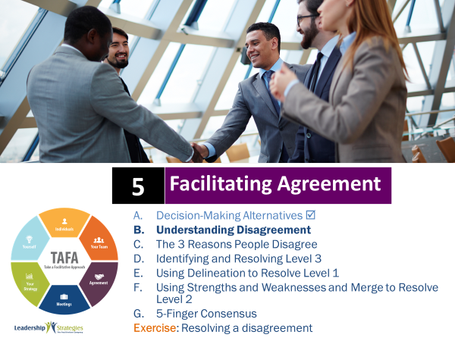 |  | SHOW POWERPOINT: Facilitating Agreements  CHECKPOINT:  So now you are aware of the options you have to make decisions. Let’s explore more about how disagreements come to be. Disagreements are often what makes getting a group to a decision so challenging.
PPT: Understanding Disagreements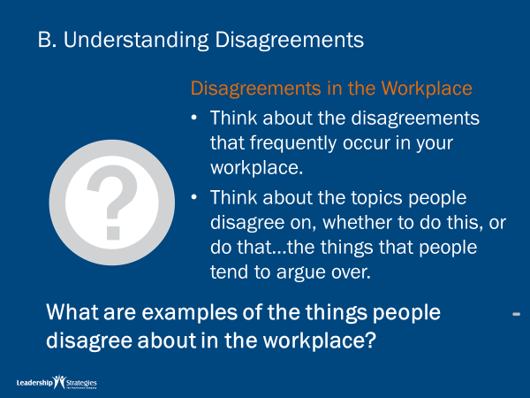 |  | SHOW POWERPOINT: Understanding Disagreements  DO:  LEAD a group discussion following the question on the slide.
PPT: 8 Team Essentials 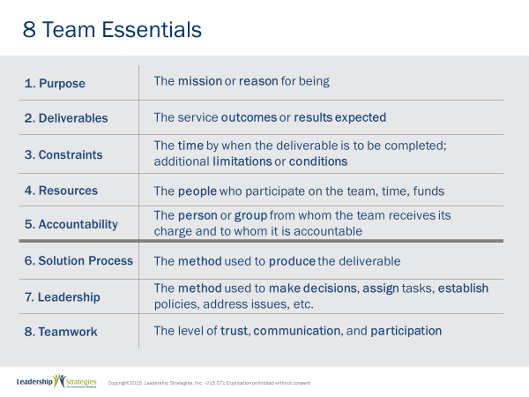 |  | SHOW POWERPOINT: 8 Team Essentials  POINT OUT:  As you will see this section on consensus building focuses on helping you with team essentials number seven, the method used to make decisions.
 | PPT: Understanding Disagreements 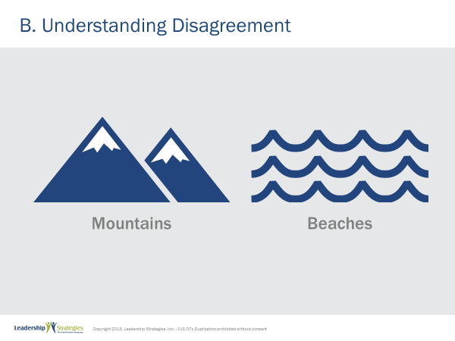 | SHOW POWERPOINT: Understanding Disagreements  SAY:  Think about this situation. You finally have your vacation planned – two years of hard work with no vacation, and your significant other wants to go as well because he/she has not had a vacation in that time period as well. So, you both agree that you desperately need a vacation. The problem is that one definitely wants to go to the mountains and the other definitely wants to go to the beach. The conversation goes back and forth with, “Mountains, beaches, etc.”  ASK:  Looking at this choice of vacations, as long as we remain at mountains vs. beaches, the key question is this: Are we talking about issues or have we staked out positions? [ask the teams]  SAY:  That’s right, we are talking about positions. And, in a positions disagreement in a best-case scenario there is a win-lose conclusion. In a worst case, there can be a lose-lose (OK, we won’t go on vacation --- I’ll take my ball and go home rather than play).
The key here is to get below positions down to issues.

Whether it is mountains vs. beaches or something else, whenever you have people, you have passion. After a period, no matter how much you like an individual, we are bound to disagree on something. We use our consensus building model, Mountains vs. Beaches, to help explain this principle. So, we are in obvious disagreement.

TRANSITION:
There are only 3 reasons people disagree and there are 3 techniques to help us start with a consensus-focused process and 5 alternative methods for guiding a group to consensus when there are disagreements.
Let’s take a look at why people disagree and Understand Disagreement.

 | PPT: Understanding Disagreements 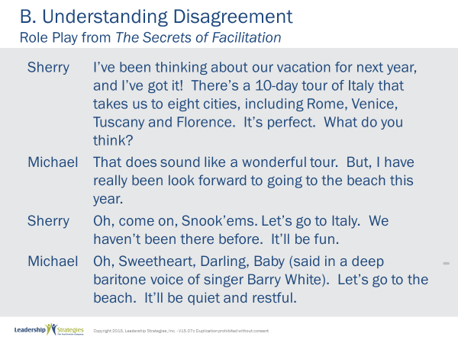 | SHOW POWERPOINT: Understanding Disagreements  DO:  ASK two volunteers to read the script. Try to choose people on opposite sides of the room.
 | PPT: Understanding Disagreements 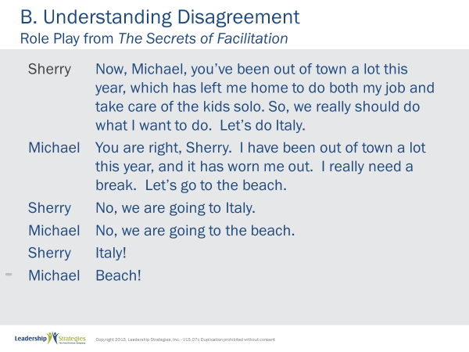 | SHOW POWERPOINT: Understanding Disagreements (cont)
 | PPT: Understanding Disagreements 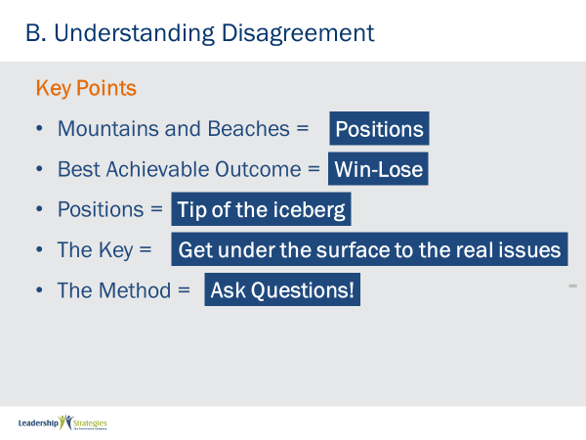 | SHOW POWERPOINT: Understanding Disagreements (build)  DO:  REVIEW the content on the slide and following the script below.  POINT OUT:  There are several key points that I would like for you to pick up from this example. First, mountains and beaches are equivalent to positions. Second, when people take positions, the best achievable outcome is win lose. Someone is going to win… and someone is going to lose. Sometimes you get lose-lose where both people end up losing. In the case of the example they may choose to go on different vacations separately and lose the benefits of each other’s company. Third, positions represent the tip of the iceberg; the real issues, the bulk of the disagreement, is under the positions. So, the key is getting under the surface to the real issues. And as facilitative leaders we know only one way to do that, and that is to ask questions.
 | PPT: Agenda 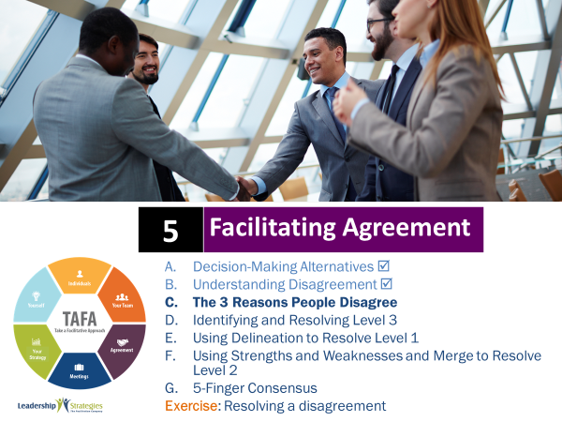 | SHOW POWERPOINT: Agenda  CHECKPOINT:  In order to get to the bottom of the real issue, it is helpful to first understand the three reasons why people disagree. Then, we can use this information to listen for clues as to what is happening. When we understand why there is a disagreement, we then know how to resolve it… but more on that later.
 | PPT: The 3 Reasons People Disagree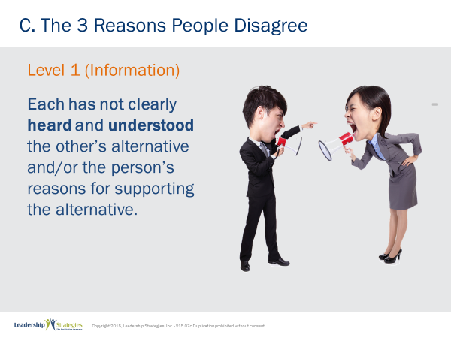 | SHOW POWERPOINT: The 3 Reasons People Disagree  SAY:  A Level 1 disagreement is about information. It occurs when the people in the disagreement have not clearly heard and understood each other’s alternative and/or their reasons for supporting the alternative.  NOTE: Consider presenting or asking about someone else’s experience with a Level 1; for an example, use The Secrets of Facilitation book
TRANSITION:
Let’s check out another scenario where two people are disagreeing…
 | PPT: The 3 Reasons People Disagree 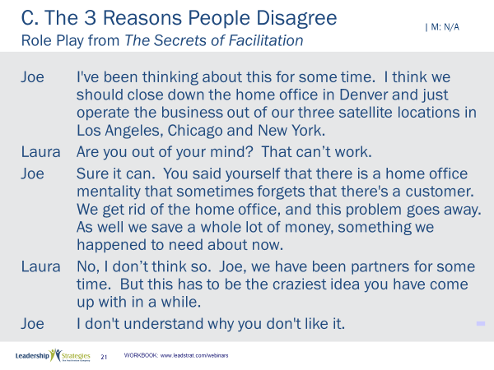 | SHOW POWERPOINT: The 3 Reasons People Disagree  DO:  ASK two different volunteers to read the script. Try to choose people on opposite sides of the room.
 | PPT: The 3 Reasons People Disagree 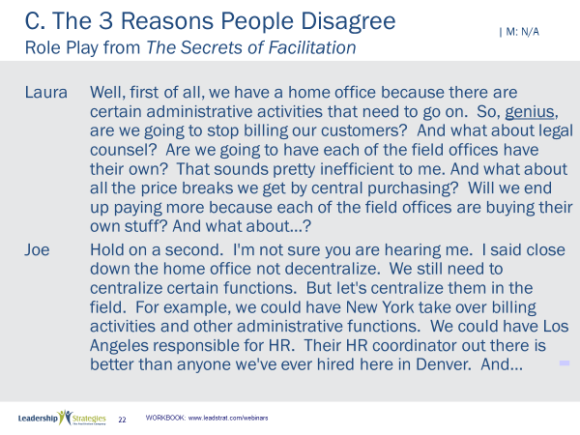 | SHOW POWERPOINT: The 3 Reasons People Disagree (cont)
 | PPT: The 3 Reasons People Disagree 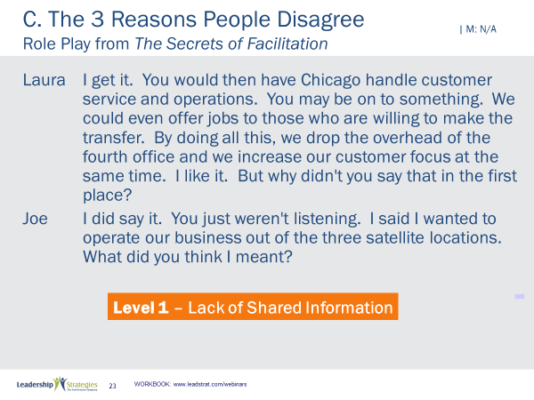 | SHOW POWERPOINT: The 3 Reasons People Disagree (cont)  DO:  After the script has been read, emphasize that is a Level 1 disagreement because it is based on a lack of shared information.
 | PPT: The 3 Reasons People Disagree 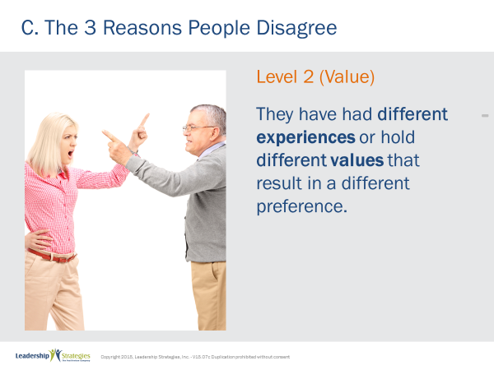 | SHOW POWERPOINT: The 3 Reasons People Disagree  SAY:  A Level 2 disagreement is different. In this case, we hear and understand but the people in the disagreement have different experiences or hold different values that result in different preference(s). [provide or ask for examples; sales vs. marketing with leads; the Republicans and the Democrats; etc.]
TRANSITION:
Ready for another scenario?
 | PPT: The 3 Reasons People Disagree 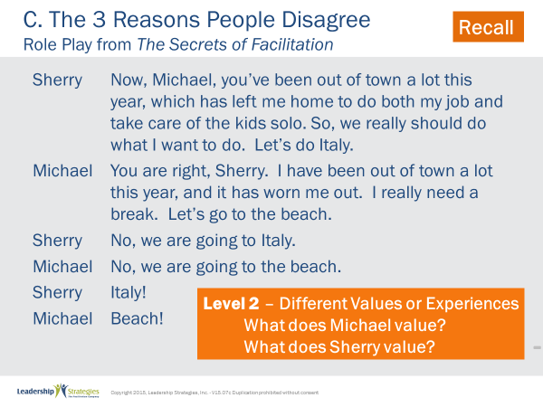 | SHOW POWERPOINT: The 3 Reasons People Disagree  DO:  ASK two different volunteers to read the script. Try to choose people on opposite sides of the room.  After the script has been read, emphasize that is a Level 2 disagreement because it is based on different values.  READ the questions on the slide and let the group respond.
 | PPT: The 3 Reasons People Disagree 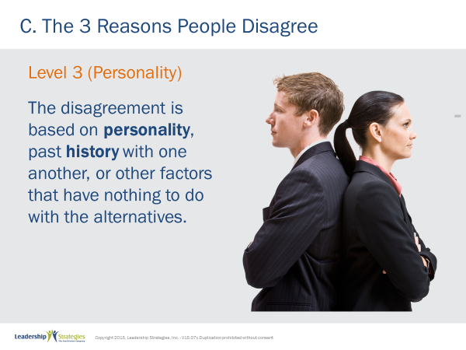 | SHOW POWERPOINT: The 3 Reasons People Disagree  SAY:  And our last type of disagreement, a Level 3 is based on personality or past history with one another. The disagreement has nothing to do with information or the alternatives being discussed. These people just want to disagree. If one says stop, the other says go. If one says up, the other says no.  DO:  DISCUSS or ask someone to share an example.
 | PPT: Agenda 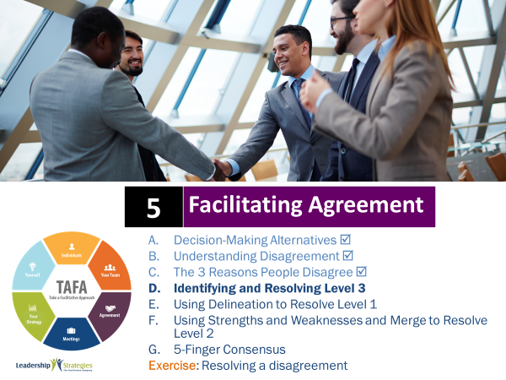 | SHOW POWERPOINT: Agenda  CHECKPOINT:  Isn’t it interesting how all disagreements typically fall into one of three reasons? The most difficult type of disagreement is the Level 3 – because it is so irrational and often personal. It’s important to know how to respond to Level 3 disagreements when they occur in team meetings.
 | PPT: Identifying and Resolving Level 3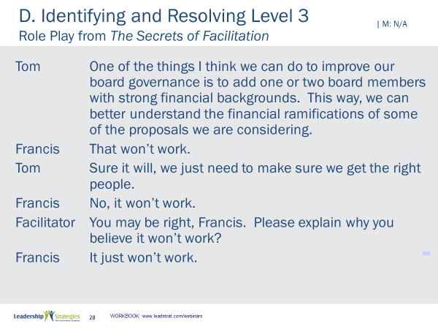 | SHOW POWERPOINT: Identifying and Resolving Level 3 (build)  DO:  ASK two different volunteers to read the script. Try to choose people on opposite sides of the room.
 | PPT: Identifying and Resolving Level 3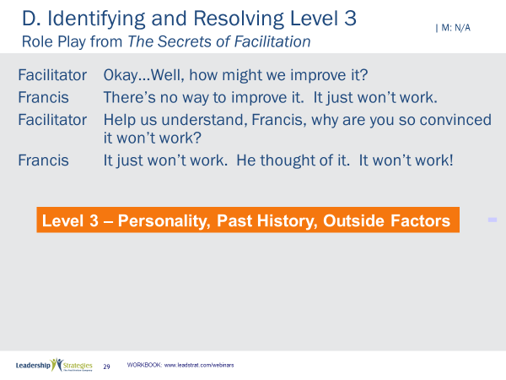 | SHOW POWERPOINT: Identifying and Resolving Level 3 (cont) (build)  DO:  After the script has been read, emphasize that is a Level 3 is based on personality, past history or an outside factor.
 | PPT: Identifying and Resolving Level 3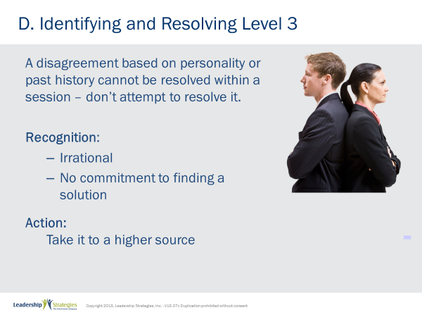 | SHOW POWERPOINT: Identifying and Resolving Level 3 (build)  SAY:  Level 3s have two distinct characteristics:  1) They are irrational  2) There is no commitment to finding a solution by either party involved  Consequently, a disagreement based on personality or past history cannot be resolved within a group meeting – don’t attempt to resolve it. Facilitators that do are wasting everybody’s time.  DO:  Provide an example or ask for one to highlight a time when trying to address Level 3 in a group setting was futile.  SAY:  So, what do you do when a Level 3 disagreement breaks out? Take a break, if necessary, and gain agreement to put it on the Issues List for the time being and take it to a higher source at a later time.
 | PPT: Identifying and Resolving Level 3 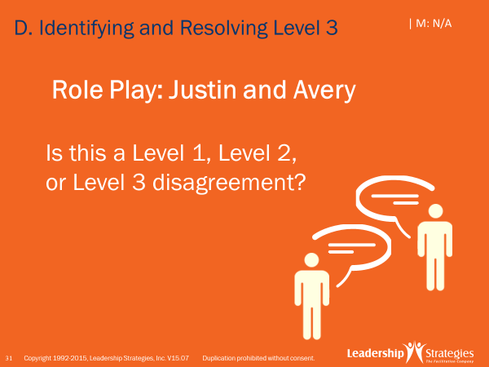 | SHOW POWERPOINT PPT: Identifying and Resolving Level 3  DO:  Use the following instructions:  PURPOSE: to apply the points we just covered and then carry this disagreement through to demonstrate some of the techniques we are about to cover  EXAMPLE: not needed  DIRECTIONS: I need 2 brave volunteers. Can I have 1 from the (purple) team and another from the (red)? Thanks. [award dots] I am going to ask (name) to play the role of Jason and (name) to be Avery. Everyone else will listen to what is going on in this discussion and I will ask the 2 volunteers to stop at a certain point. At that point, I would like each team to take 45 seconds to decide what level of disagreement they think Jason and Avery are having here.  EXCEPTIONS: none  QUESTIONS: Are there any questions about what we are about to do?  SAY:  Let’s try a quick role play. Avery, get us started [at the first role of the facilitator, stop the role play and facilitate the discussion around lever 1, 2 or 3; make relevant points including:  - Is this argument headed north or south?  - What tells us that?  - If we can rule out level 3 – because if it is we will not try to solve it, then assume it is a level 1 and proceed to…
 | PPT: Identifying and Resolving Level 3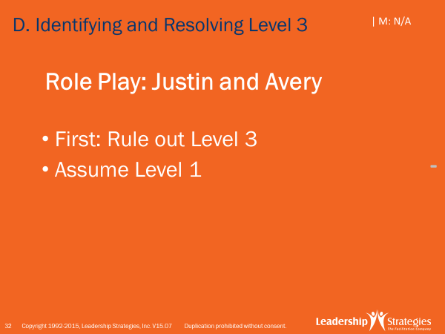 | SHOW POWERPOINT: Identifying and Resolving Level 3  DO:  REVIEW the content on the slide.
 | PPT: Agenda 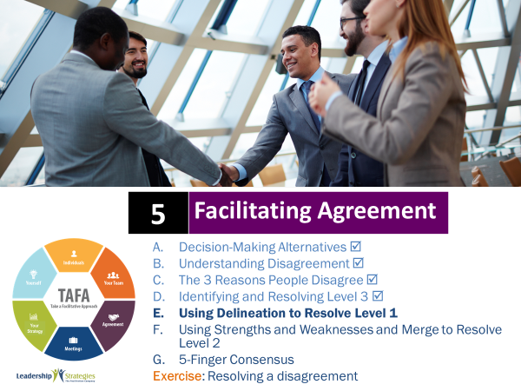 | SHOW POWERPOINT: Agenda  CHECKPOINT:  Are you feeling comfortable identifying the reason for the conflict? Once you know the reason, you can use the best technique to work through out. I’m going to show you a technique called Delineation that can be used to address a Level 1 disagreement.
 | PPT: Using Delineation to Resolve Level 1 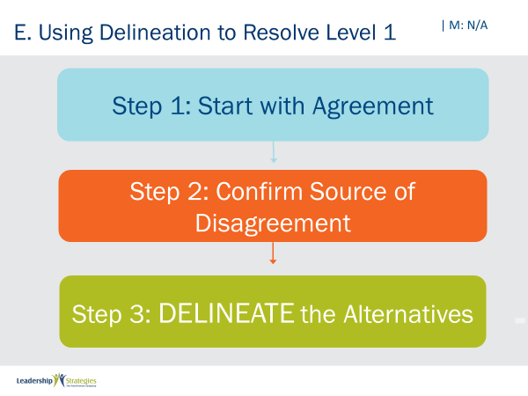 | SHOW POWERPOINT: Using Delineation to Resolve Level 1  DO:  REVIEW the content on the slide.  POINT OUT:  Remember, often times disagreement helps us arise at more Effective Decisions. Why? Because ED = RD x CD!
 | PPT: Using Delineation to Resolve Level 1 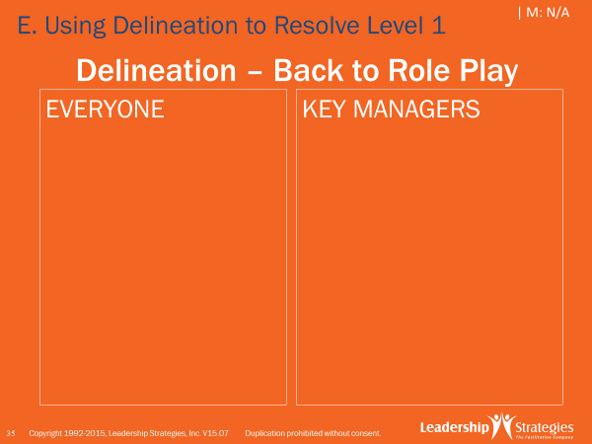 | SHOW POWERPOINT: Using Delineation to Resolve Level 1  SAY:  Let’s review how to delineate alternatives. A good metaphor here, once we decide to help the group achieve consensus, would be two people on a see-saw or teeter totter. As the facilitator, everything we do is either moving each party further out on the see-saw or moving them closer to the fulcrum. One makes it worse the other better.  The first words might sound something like this, “Whoa, let’s hold on for a second here [turn the attention from the parties that are disagreeing to you, the facilitator], I would like to try something different here.”  [Then start with agreement] Sounds like we are talking about important stuff here [they nod in agreement] and it appears we both agree the training has been good [2 points of agreement; and position yourself in front of the flip chart]  [now, acknowledge, the disagreement] It sounds like were we disagree is, Avery, you want to train? [have a flip chart with a T; Avery replies, “Everyone;” you title that part of the flip chart, “Everyone.]  And Justin, you want to train? [and he replies, “Just Managers;” label other side of the T with “Managers”]
 | PPT: Using Delineation to Resolve Level 1 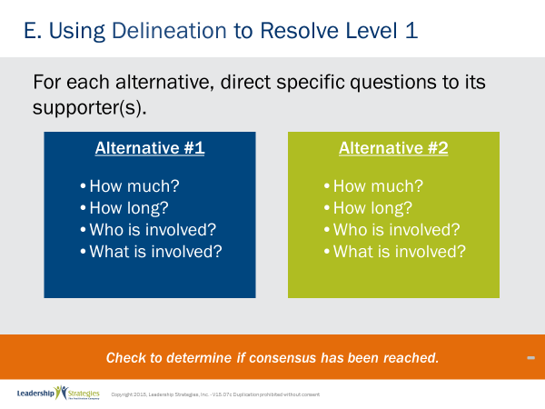 | SHOW POWERPOINT: Using Delineation to Resolve Level 1 (build)  SAY:  Now, you ask a series of questions that allows the group to answer 4 questions:  - How much will this alternative cost?  - How long will this alternative take?  - Who is involved with this alternative?  - What is involved in this alternative?  That may sound easier than it sounds. So, let me set the clock for 2 minutes and ask each team to determine the questions we will have to ask both Avery and Justin to answer the 4 questions on the slide; just list the questions so you can refer to them. Any questions? OK, let’s get started.  DO:  SET CLOCK and when time is up, facilitate the discussion to the questions; then, proceed with the role play by directing the questions first at Avery and then Justin.  POINT OUT:  Now, let’s look at what is on the flip charts. Are these opinions or are these facts? [get responses] yes, they are facts. So, in Delineation we are “playing Dragnet. Give me the facts ma'am, just the facts.” Notice I collected the facts on both sides of the T before I answered the four questions below. Why? We don’t want the participants favoring the 2nd option to be able to contrive their answers to “win.”  Once we have calculated the answer to the key 4 questions for all the alternatives, we check to see if we had consensus. If we did, (green) team, what type of a disagreement was it likely to have been? That’s right a level 1. Once the information is out, a level 1 disagreement is solved.  Let’s assume there was not consensus.
 | PPT: Using Delineation to Resolve Level 1  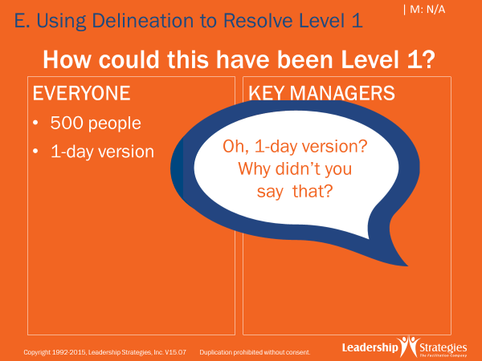 | SHOW POWERPOINT: Using Delineation to Resolve Level 1  SAY:  Often delineation will bring out facts that will lead to consensus.
 | PPT: Agenda 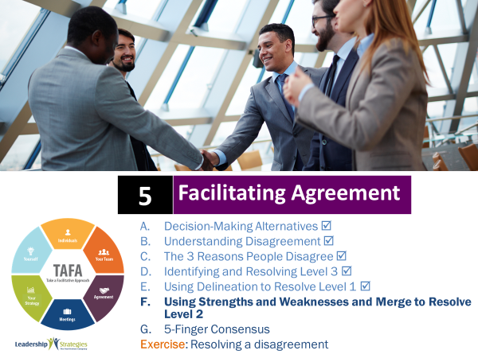 | SHOW POWERPOINT: Agenda  CHECKPOINT:  So, now that we have delineated the facts, if we don’t have agreement we can move to Strengths and Weaknesses.
 | PPT: Using Strengths and Weaknesses and Merge to Resolve Level 2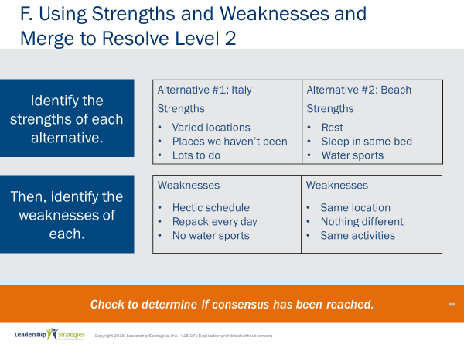 | SHOW POWERPOINT: Using Strengths and Weaknesses and Merge to Resolve Level 2  SAY:  We itemize the strengths of one alternative, then the strengths of the second alternative, followed by the weaknesses of each alternative if needed. Typically, we ask the questions of the group. Should, however, the group not engage, avoid asking a supporter of an alternative to advocate for the strengths of their alternative; it further polarizes them; remember the see-saw metaphor?  DO:  Return to the role play and now ask the group to identify the +’s of each alternative and then the –’s; once that is on the flip chart ask them if these are facts or values/opinions; things like expensive is relative rather than absolutely factual such as $10K; also show how often, not always the + of one alternative can be the – of the other.
 | PPT: Using Strengths and Weaknesses and Merge to Resolve Level 2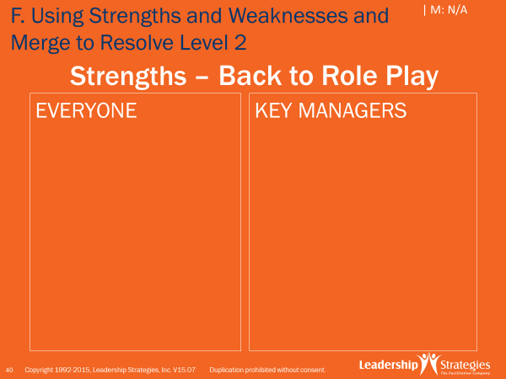 | SHOW POWERPOINT: Using Strengths and Weaknesses and Merge to Resolve  DO:  DEMONSTRATE facilitating Strengths and Weaknesses.  SAY:  Once the Strengths and Weaknesses are completed, check to see if there is consensus. If so, great; if not, proceed to the next step.
TRANSITION:
The next step is to Merge Alternatives.
 | PPT: Using Strengths and Weaknesses and Merge to Resolve Level 2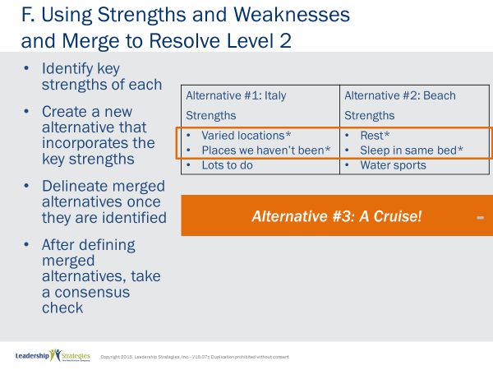 | SHOW POWERPOINT: Using Strengths and Weaknesses and Merge to Resolve Level 2  SAY:  To merge, we are guiding the group towards developing a 3rd or new alternative that combines the strengths of the existing alternatives. To do that we ask the group, “If we had to choose the key strength of this alternative, what would it be?” Then, move to each of the other alternatives and ask the group to identify the top 1 or 2 strengths of each. Once key strengths are identified, circle all of them and ask the group, “Is there another alternative, that we have not identified yet, that combines the strengths of all of the existing alternatives?” [Essentially, we are moving from Dragnet to Lt. Colombo.]  Often, when this is done, this new merged alternative should be delineated to ensure it is clear to all the participants.
 | PPT: Using Strengths and Weaknesses and Merge to Resolve Level 2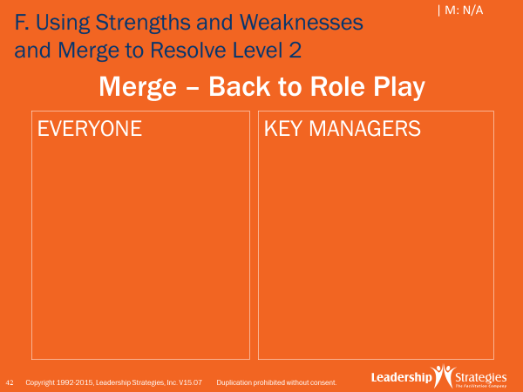 | SHOW POWERPOINT: Using Strengths and Weaknesses and Merge to Resolve Level 2  DO:  Return to Jason and Avery and get group to identify key strength or two of each alternative. Guide group to new option such as train the trainer.
 | PPT: Agenda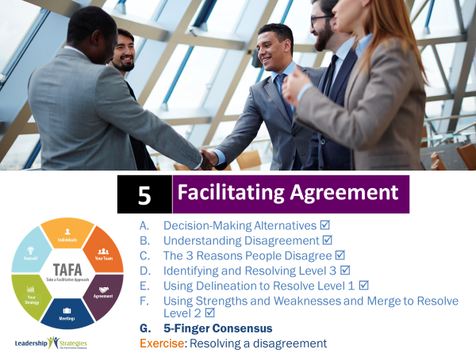 | SHOW POWERPOINT: Agenda  CHECKPOINT:  We just learned some more complex techniques for addressing conflict and working to consensus. Now, I’ll share a simplified approach that allows everyone to express themselves, yet saves time.
 | PPT: 5 Finger Consensus 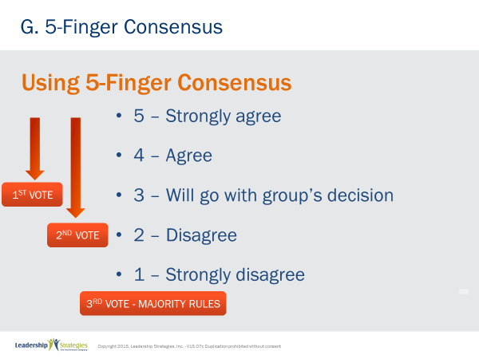 | SHOW POWERPOINT: 5 Finger Consensus (build)  SAY:  I’m going to teach you a technique called 5 Finger Consensus. In this case, we delineate to ensure all participants are dealing with the same set of facts. Then, we typically call for a vote. And the way we call for that vote is as follows…. First, we ask all participants to put their hands in the air, in a fist.  Why a fist? Because if the senior person puts up 5 fingers, it is difficult for others to show 1 or 2 fingers. The leader will influence the other voters.  In the first round: if all participants have 3, 4 or 5 fingers up, we have consensus. If in the first round, we have any 1s or 2s, we ask one of the people that does not support the decision to discuss their concerns. Then we have someone speak to the alternative. We ask for other comments, further discussion. When the discussion is over, we ask, “Before we call for the 2nd vote, are there any changes we want to make to this proposed alternative?” If so, we are back to Round 1 since it is a new proposal. If not, we move the Round 2.  In Round 2, if there are all 2s, 3s, 4s, and 5s, we have arrived at consensus. Why, we have agreed to this Decision Process earlier in the session. In this round if there are any 1’s we repeat the process from Round 1 with dissenters and supporters  With all this said, there will be times when we will not arrive at consensus.  NOTE: Refer to The Secrets of Facilitation book for more detail.
 | PPT: What if consensus continues to be a problem?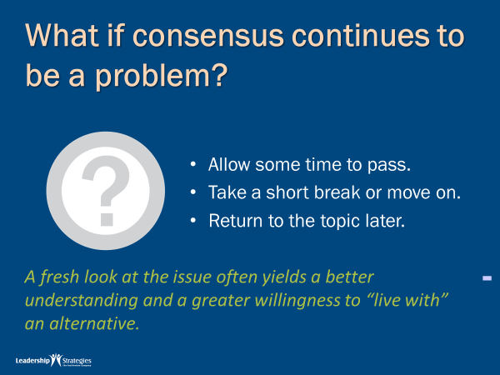 | SHOW POWERPOINT: What if consensus continues to be a problem?  SAY:  If we can not get to consensus, we move on.  DO:  REVIEW the content on the slide.
 | PPT: Agenda 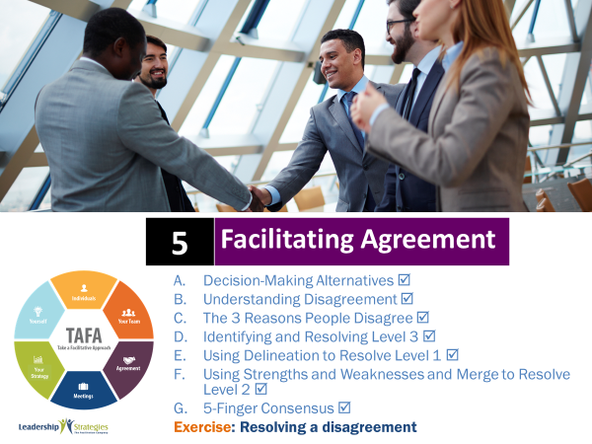 | SHOW POWERPOINT: Agenda  CHECKPOINT:  Five Finger Consensus is the last technique in our Facilitating Agreements Modules. I encourage you to try it with your team. Start with less significant issues so everyone can get the hang of it. Applying this information as soon as you can will help you learn and retain it. So, let’s discuss your next homework assignment.
 | PPT: 5a. Resolving a Disagreement 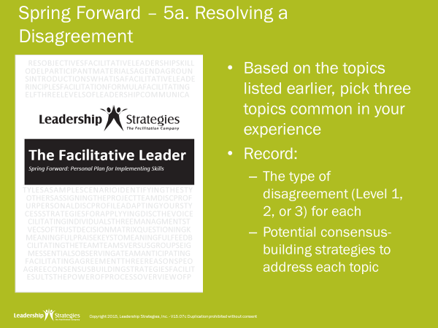 | SHOW POWERPOINT: 5a. Resolving a Disagreement  DO:  Use the following instructions:  PURPOSE: To assess the types of disagreements that occur in your organization and think of strategies to work through them.  EXAMPLE: not needed  DIRECTIONS: Individually complete the table on 5a. When you are done, share with a partner or your table team.  EXCEPTIONS: none  QUESTIONS: Are there any questions about what we are about to do?  DEBRIEF by asking some volunteers to report out.
 | PPT: Review 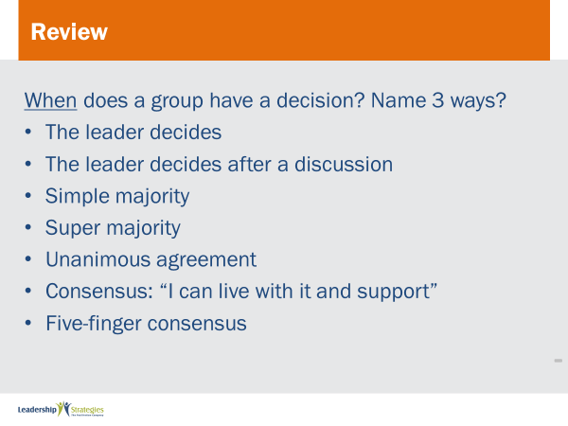 | SHOW POWERPOINTS: Review Slides  SAY:  Now it is time to do some review. We’ll do this by table teams, starting with the (color) team and rotating clockwise. If your team gets the answer, dots for everyone on the team.
 | PPT: 5b Improving Decision Making 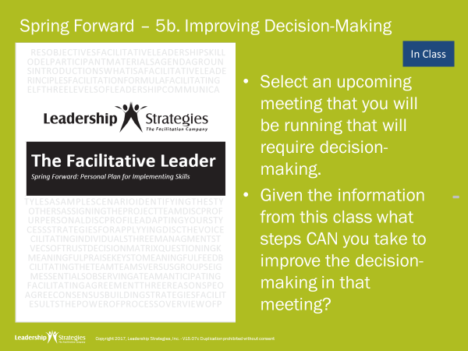 | SHOW POWERPOINT: 5b Improving Decision Making  Note to Instructor: This will either be an in-class activity (if another module follows or it is the last module for the client) or it will be homework because the participants will be coming back at another time. Use the appropriate slide.  IN-CLASS ACTIVITY-  SAY:  Let’s pull out the Spring Forward manual so we can focus on applying what we just learned.  DO:  READ through the activity. ALLOW 10 minutes. PROCESS responses as time allows. For example, have them share with one partner, have them talk at tables, have one person from each table share their view, etc.
 | PPT: 5b Improving Decision Making 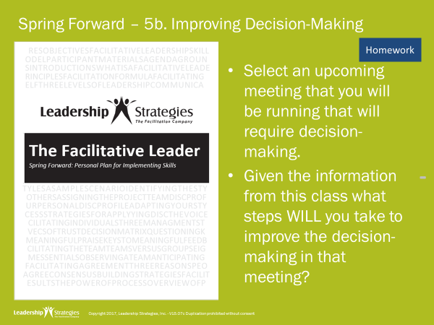 | SHOW POWERPOINT: 5b Improving Decision Making  Note to Instructor: This will either be an in-class activity (if another module follows or it is the last module for the client) or it will be homework because the participants will be coming back at another time. Use the appropriate slide.  DESCRIBE HOMEWORK-  SAY:  Before closing out, let’s talk about homework that will help put application to what we’ve learned today.  DO:  READ the first two bullets.
 | PPT: Agenda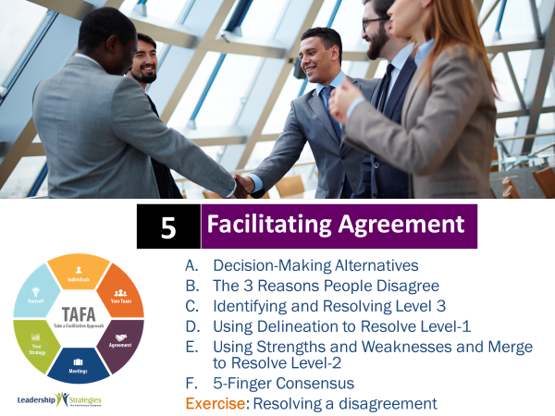 | SHOW POWERPOINT: Agenda  CHECKPOINT:  That was our final exercise for Module 5. We have covered a lot of techniques to help you resolve disagreements within your team. Let’s take a look at how all of the techniques connect to TAFA.
 | PPT: TAFA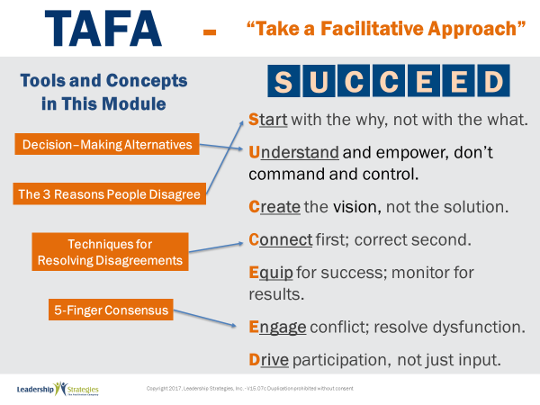 | SHOW POWERPOINT: TAFA (build)  SAY:  Let’s take a moment to look at some of the concepts we’ve learned in this module and examine how they reflect the TAFA principles.  DO:  REVIEW slide and lead discussion by asking if there are other principles that are reflected by the concepts.
 | PPT: Checkpoint | SHOW POWERPOINT: Checkpoint  CHECKPOINT:  We are over half way through the course! Next, we will cover Facilitating Your Strategy which is another important skill for a leader to develop.
 | PPT: LSI Connect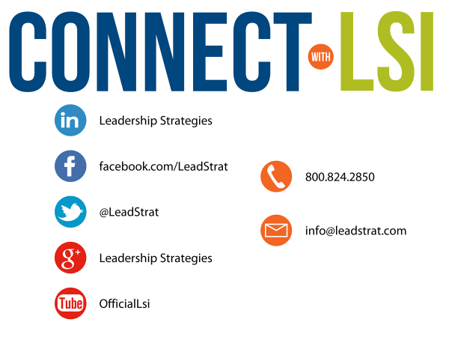 | SHOW POWERPOINT: Connect with LSI  Note to Instructor: this slide may be excluded if you are going directly into the next module. In that case, hide the slide.  SAY:  We fundamentally believe facilitation is a skill that applies in a multitude of situations. We also are confident that, in our quest to “share the power of facilitation with the world,” connecting via social media is a way for all of us to collectively share our successes, our challenges and our facilitation work. To “facilitate” that process, we want to ensure you are aware of how we can all stay connected using social media.  How many of you have found many of the skills in the class helpful? [raise your hand] I know that one of the things I did after attending was share what I learned with many of my colleagues. Have some of you already thought about that? [nod your head]  Then, one request we would like to make of you is to update your “education or classes attended” on your LinkedIn profile. That visibility will help all of us to “share the power” I have been referring to. Any questions?  FACILITATE the discussion.
 | PPT: Congratulations 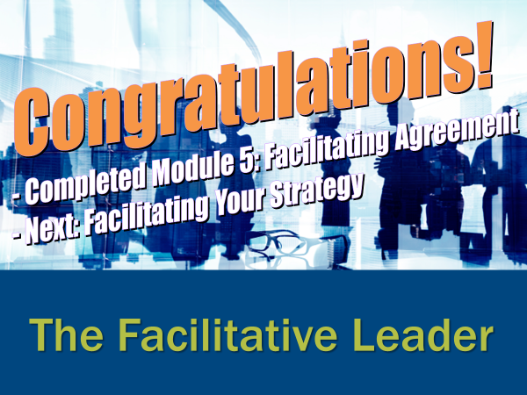  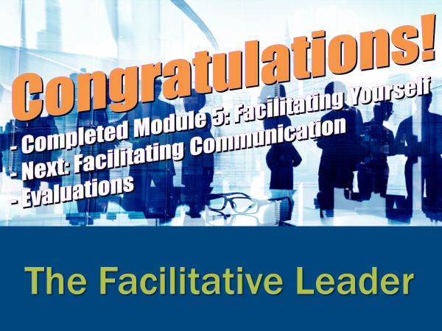   | SHOW POWERPOINT: Congratulations! (builds)  Note to Instructor: There are three congratulation slides. Select the correct slide depending on whether you are:  - Moving on to the next module immediately (slide 1)  - Coming back another day to do the next module and therefore need to do an evaluation (slide 2)  - Have completed the workshop and therefore need to close out the class with the post-test, evaluations, dot winner (MVP), and the From Classroom to Application sheet (slide 3)  Hide the other two congratulations slides.  DO:  REVIEW and execute the content on slide.  EXECUTE THE POST TEST:  If appropriate, handout the post-test. Give people five minutes to complete. Ask teams to give their cheer once completed.  Once completed, have team members pass their post-test clockwise to a new person. Go through each question and have the group give responses. Instruct them to place a checkmark for each correct response.  Once completed have people add up the number of check marks and place the total at the top.  Since each post-test has eight questions, place the number 8 through 0 in the first column of a two-column chart.  Before people hand the post-tests back to the owner, do a round robin and have people indicate the number the person got corrected. Place a tick mark next to that number each time that number is reported.  THANK participants and dismiss class.
 |  | END OF THE FACILITATIVE LEADER MODULE 5

