The Facilitative Leader
Module 4: Facilitating Your Team

Facilitator Guide

Table of Contents
Facilitator’s Information
Table of Contents 1
How to Use This Guide 2
Symbols Used in the Facilitator’s Guide 3
Participant Pre-Work 4
Materials & Equipment for Module 4 of The Facilitative Leader 5
The Facilitative Leader Module 4: Agenda 6
Module 4: Introduction 8
Module 4: Facilitating Your Team Agenda 9
Module 4: Facilitating Your Team 10

How to Use This Guide
This Facilitator’s Guide covers the following:
- Work you’ll need to do prior to the workshop,
- Materials and equipment you’ll need for the workshop, and
- Instructions and verbiage to conduct the workshop.
Headings
The heading for each section indicate the information that will be covered in that particular section.
Instructions Section
On the right-hand side of the workshop instructions pages you’ll find the approximate number of minutes required to complete a topic.
The format for the instructions section contains 2 columns as follows:
- Left-hand Column:  - Contains graphics, such as a copy of a slide or an icon, indicating the major aspect of the training segment. For example, a television set icon indicates that a video will be shown. The next page shows the various icons used. | - Right-hand Column  - Lists the information or instructions to be conveyed to the participants and contains possible starting questions you can ask about the topic to engage participants in a discussion or an activity.  - Describes the activity to be completed. Note that actions to be done will always be in bold.  NOTE: This Facilitator’s Guide is not intended to be used as a script. The words in this column give you one example of how to deliver the content. Part of your preparation is to review this guide and become familiar with its contents, structure, and flow. You should feel free to use your own words, adjust the delivery to your own style, while also adapting to the needs of the group you are facilitating. At all times, be sure to show enthusiasm and comfort with the material when you are presenting. This will provide a more enjoyable and meaningful session for your participants.
 | Anything in a gray box means that you will be “doing” something rather than presenting.

Symbols Used in the Facilitator’s Guide
There are many symbols used in this Facilitator’s Guide to serve as prompts for the type of activity occurring at that point in the program. Here is a list of those symbols and what they mean.
 | Presentation |  |  | Key Information
 | Spring Forward Exercise |  |  | Pull through previous learnings
 | Pair Discussion/Exercise |  |  | Participant Manual “Write-along”
 | Group Discussion/Exercise |  |  | UMU activity
 | Write responses on a flip chart |  |  | Checkpoint
 | Transition to next topic |  |  | Individual Activity

In some cases, an activity will transition from one type to the other (e.g. from individual to group discussion). In such cases, more than one symbol may be used in chronological order.

Participant Pre-Work
Participants will have completed Spring Forward Exercise 3b. A Trust Discussion.

Materials & Equipment for Module 4 of The Facilitative Leader
Following is a list of the materials to be used in this training session. Be sure to become familiar with all of them.
- Projector and Screen
- Laptop
- PowerPoint Slides – “The Facilitative Leader 4: Facilitating Your Team”
- Facilitator Guide (this document)
- Updated Participant List
- Participant Packets (one for each participant)
  - Tent Cards
  - Participant Manual
  - Spring Forward Booklet
- Flipcharts – one for Facilitator, plus one for each table group)
- Pins/tape to hang posters
- Tape
- Pens and Markers
- Post-it notes (one different color package for each table group)

Flip Charts:
- Course Objectives (posted, if appropriate)
- Ground Rules (posted)
- Coming Attractions (posted)
- Module 4 Agenda
- Post Test

The Facilitative Leader Module 4: Summary Agenda
TIME | TOPIC
5 minutes | Workshop Introduction  - Checkpoint  - Course Objectives  - TAFA  - Ground Rules  - Your Materials
7 minutes | Homework Review
 | - Have participants share results of their homework (in pairs, table groups, and/or with the class)
2 minutes | Workshop Introduction  - Agenda (Compare to participant objectives)
20 minutes | A. Teams v. Groups
20 minutes | B. 8 Team Essentials  - 8 Team Essential  - Team Essentials and DISC
10 minutes | C. Anticipating Team Issues
10 minutes | D. Team Norms
15 minutes | E. Accountability: 5 Crucial Elements
18 minutes | F. Solution Processes  - Strategic Planning  - Project Planning  - Issue Resolution  - Process Improvement  - Process Reengineering
18 minutes | 6. Which Solution Process?
20 minutes | G. Managing Change Resistance  - Why Do People Change?  - Connect First, Correct Second
20 minutes | 3. Resistance by DISC Style
10 minutes | H. Developing Recommendations
15 minutes | Spring Forward – 4a. Chartering a Team
8 minutes | Review Activity
8 minutes | - Instruct teams that you will take turns asking each team the questions. Award dots as appropriate.
5 minutes | Homework - Spring Forward 4b – 8 Team Essentials
5 minutes | - Participants develop the 8 essentials for their team.
15 minutes | Session Close (Will vary based on FL “package” being delivered.)  - Review Agenda  - TAFA: Tools and Concepts in this Module  - Checkpoint to next module if appropriate  - Connect with LSI  - Congratulations slide with appropriate closing activities depending on whether this module is delivered as part of the four-day or as a stand-alone  - Execute Post-Test if appropriate  - Award dot winner MVP prize if appropriate  - Complete From Classroom to Application if appropriate  - Execute Evaluation if appropriate  - Formally close the session.
180 minutes  (3 hours) | Total Training Time

Module 4: Introduction
Overview
Leaders learn techniques to use while facilitating teams.
Modules include the following:
- Teams v. Groups
- 8 Team Essentials
- Anticipating Team Issues
- Team Norms
- Accountability: 5 Critical Elements
- Solution Processes
- Managing Change Resistance
- Developing Recommendations

Key Learnings
- Identify the essential elements in chartering a team.
- Understand the value of and how to develop team norms.
- Establish the five critical elements to encourage accountability.
- Describe how to lead people through change based on their individual fears and needs.
- Describe the elements in a clear recommendation.

Facilitation Tips/Background Information
- Post on the wall ahead of time three flip chart pages with the following titles
  - Objectives
  - Agenda
  - Coming Attractions
- Accommodate participant objectives where possible, but do not be tempted into shoe-horning their objectives into the planned activities. If it’s not going to be covered, explain why it is out of the parameters of this workshop. If appropriate, consider covering out-of-scope objectives over lunch, on breaks, or in some other way.
- Be familiar with the DISC Communication Styles.
Timing: 3 hours

Module 4: Facilitating Your Team Agenda
- Teams v. Groups
- 8 Team Essentials
- Anticipating Team Issues
- Team Norms
- Accountability: 5 Critical Elements
- Solution Processes
- Managing Change Resistance
- Developing Recommendations
Exercise: Chartering a Team

Module 4: Facilitating Your Team

Timing: 3 hours
PPT: Title Slide   |  | SHOW POWERPOINT: Title Slide  Note to Instructor: Customize your opening depending on the modules the group will be receiving in total, whether you are following a previous module, coming back from time in-between modules, or only running this workshop for this group.  SAY:  Welcome Managers to The Facilitative Leader Workshop!  Introduce yourself and your background.  Have participants introduce themselves by sharing name, position, and years with the company. Ensure that each participant has signed in.
PPT: Facilitating Your Team |  | SHOW POWERPOINT: Facilitating Your Team  SAY:  You’ll walk away with an understanding of:  - The essential elements in chartering a team.  - The value of and how to develop team norms.  - The five critical elements to encourage accountability.  - How to lead people through change based on their individual fears and needs.  - The elements of a clear recommendation.
PPT: Checkpoint 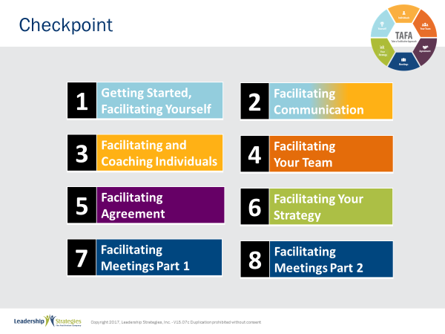 |  | SHOW POWERPOINT: Checkpoint (build)  CHECKPOINT:  In the last module, we reviewed techniques for coaching individuals. Next, we are going to explore leading the team as a whole. You’ll walk away with specific techniques you can use to lead teams.
PPT: TAFA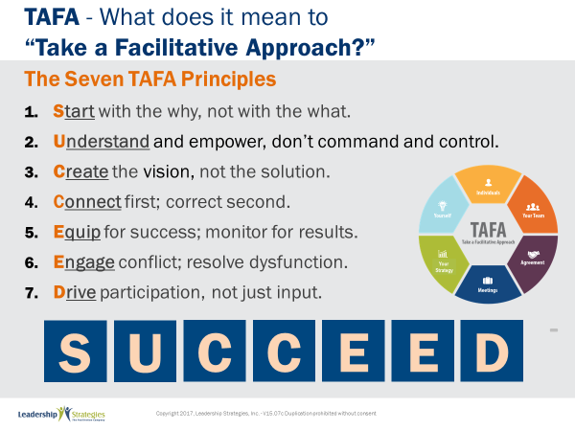 |  | SHOW POWERPOINT: TAFA (build)  SAY:  Let’s review the TAFA principles:  There are 7 key TAFA principles – the principles of taking a facilitation approach. Any time you have a decision to make, a problem to solve, someone to coach or correct, we are going to be giving you tools and techniques for implementing these principles.  Let’s walk through them together.  People are often inspired when they are connected and aligned with purpose. Unfortunately, as leaders we often focus on what we want done and start there. Facilitative leaders understand the importance of why and always start any discussion, meeting, initiative kickoff, etc., with the why.  Often leaders don’t involve those impacted because they believe they need to control all aspects of what is done to achieve their desired result. They don’t take the time to understand how to adapt to the styles of their people to inspire performance because they don’t understand the relationship between engagement and results.  However, leaders who take a facilitative approach understand how to empower others by defining purpose and providing guidelines that allow teams to create recommendations that are thoughtful and innovative, but also practical and implementable. They adjust their own management styles to get the most out of their people.  One of the key roles of leaders is to set a vision of success with a clear and compelling “why” that inspires success. Facilitative leaders understand that once they set the vision they must give their people the authority, resources, support and coaching so that their people can develop and implement solutions and strategies that bring the vision into reality.  Some leaders are expert at pointing out mistakes their people make. They seem to enjoy demonstrating their superiority by identifying errors and then showing their people what they have done wrong.  Leaders who take a facilitative approach understand the importance of connecting with people first and helping them discover their own errors. They recognize the power of being the “guide on the side” rather than the “sage on the stage.” They strive to leave every interaction with the person feeling lifted rather than beaten down.  So many teams are essentially destined to fail from the start because they are not properly equipped for success. Facilitative leaders understand that teams require eight essentials and provide teams the essentials they need to accomplish their work. At the same time, many plans fall short of their desired ends due to lack of monitoring for results. For example, how often do strategic plans get written and then put on a shelf? Facilitative leaders understand the need to monitor for results every step of the way.  Leaders who don’t have the tools to effectively manage conflict and dysfunction tend to respond with either a “fight or flight” strategy when faced with a challenging situation. Those leaders who take the flight approach will avoid addressing issues and hope they go away on their own. Those employing the fight strategy tend to try to overpower situations by forcing their will without listening to or considering other alternatives.  Leaders skilled in taking a facilitative approach view disagreement as an opportunity to identify better solutions; they view dysfunction as a sign that something important is not being addressed. They understand the three reasons people disagree and have strategies for addressing each one. They fully buy-in to the dysfunction principles--conscious prevention, early detection, and clean resolution--and use appropriate techniques to prevent, detect and resolve dysfunction.  How often does a decision come down from headquarters which the people in the field know makes absolutely no sense? The idea couldn’t possibly work and everyone knows it, except the leaders. What happens? Time and energy is wasted implementing something that months later gets abandoned when the leaders finally figure out it was a bad idea. If they had only asked, the wasted time and resources could have been put to a much more productive use. If they had only asked.  Or how often, when trying to make a needed change, does the change get met with blatant rejection or subtle subterfuge simply because those expected to implement the change were not involved up front in the creation?  Leaders who take a facilitative approach recognize that you can get better decisions and achieve higher levels of buy-in when those impacted by the decision are involved in creating it.  - In the first case of a decision coming from headquarters, the involvement of those who would have to implement the decision would have likely yielded an even better solution that considered issues and situations that the workers understood but of which the leaders were unaware.  - In the case of the needed change that was met with significant opposition, involvement up front could have yielded greater buy-in and commitment to the implementation.  SUMMARIZE:  These principles outline what it means to take a facilitative approach inside an organization. As more and more leaders adopt a facilitative approach to leadership, we expect to see greater business results through higher levels of buy-in and commitment throughout the organization.
  1 | Start with the why, not with the what
  2 | Understand and empower; don’t command and control
  3 | Create the Vision, not the solution
  4 | Connect first; correct second
  5 | Equip for success; monitor for results
  6 | Engage conflict; address dysfunction
  7 | Drive participation, not just input
TRANSITION:
Just a few quick housekeeping items before we jump into the meat of today’s workshop.
PPT: Ground Rules 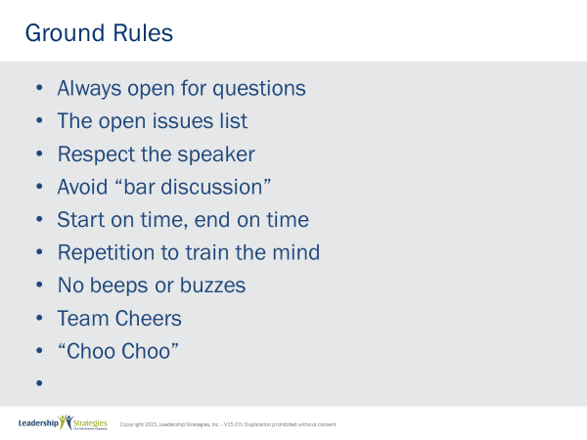 |  | SHOW POWERPOINT PPT: Ground Rules (build)  SAY:  Well, as you can see, we have a very ambitious agenda over the next [two] days. To get through it smoothly, I would like us to agree on some “Ground Rules” or “Session Guidelines.”  ASK:  By a show of hands, how many of you have been in some type of training class before? [Raise your hand.]  SAY:  So, you know those things that work and don’t work. I value your time. I want this to be a productive session for you. So, what are those guidelines that we need to have in place to make this a productive session for you? Let’s look at these ground rules for how we will conduct our session for the next [two] days and reach an agreement on them.  DO:  REVIEW ground rules on slide. ASK the group if they would like to add or delete any of these ground rules.  ASK for a show of hands to adopt the ground rules as revised.
PPT: Your Materials 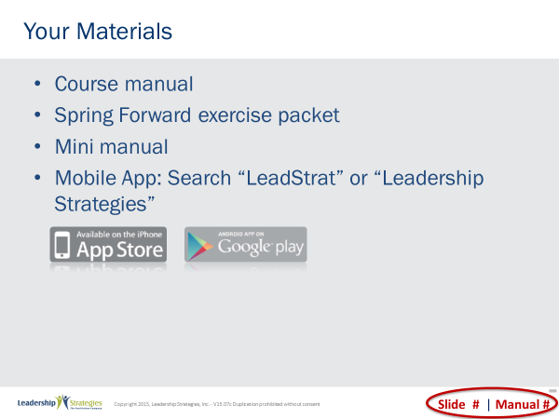 |  | SHOW POWERPOINT: Your Materials (build)  DO:  REVIEW the content on the slide.
PPT: Homework Review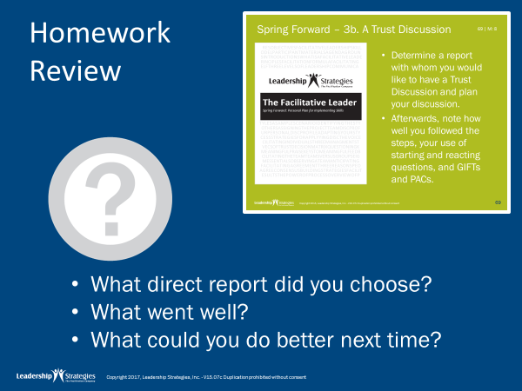 |  | SHOW POWERPOINT: Homework Review  DO:  REVIEW homework, following the questions on the slide.
PPT: Agenda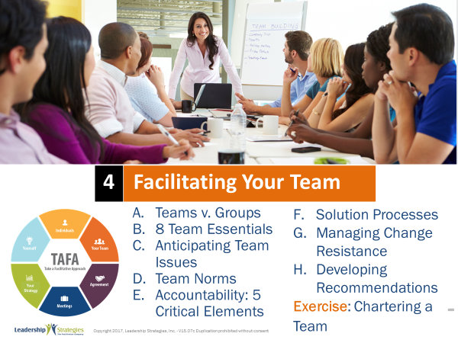 |  | SHOW POWERPOINT: Agenda  DO:  REVIEW the Module 4 agenda.  CHECKPOINT:  Now we’ve gotten ready for this module and discussed the homework. Are you ready to dive into Facilitating Your Team? We’ll begin by comparing and contrasting teams and groups.
PPT: Teams Vs. Groups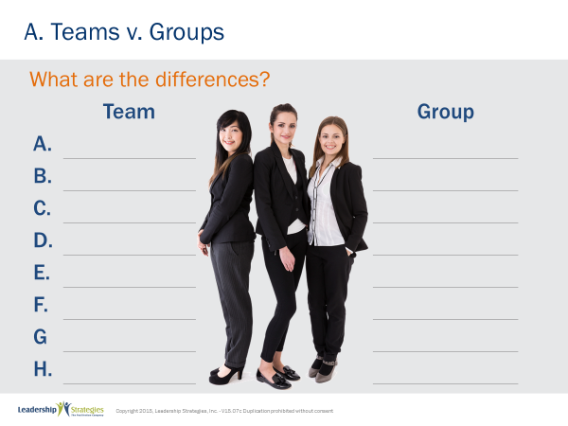 |  | SHOW POWERPOINT: Teams Vs. Groups  SAY:  Any project team, even the strongest ones, can fall into dysfunctional patterns. As one of the critical activities in our team building workshops, we ask participants to define the difference between a team and a group in a polarity form. For example, if we were talking about the difference between a pencil and a pen, we might say a pencil contains lead, while a pen contains _____. Or while lead from a pencil is easy to erase, ink from a pen is ______. What else might be a difference between a pen and a pencil?  Great, in the same way let’s build a list of the differences between a team and a group. Think about the differences you have seen between a well working team and just a group of people who happen to be in the same place. Think about what makes a team a team and a group, just a group. Who can get me started? While a team is this, a group is that…  BACKGROUND NOTE FOR INSTRUCTOR:  For preparation purposes, here is a sample of how participants might respond when you facilitate this exercise:
   | Team | Group
  A. | Common goal or purpose | Self-interests, individual goals
  B. | Defined responsibilities | No role definitions
  C. | Works together | Acts independently
  D. | Has a leader | Doesn’t have a leader
  E. | Communicates continuously | Communicates if necessary
  F. | Takes responsibility | Blames others
  G. | Relies on one another | Relies on self
PPT: Teams Vs. Groups 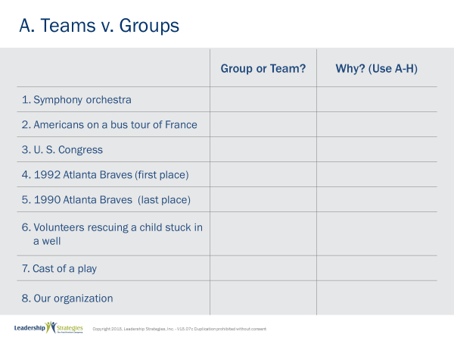 |  | SHOW POWERPOINT PPT: Teams Vs. Groups  DO:  Select team leaders and INSTRUCT teams to complete the table in their workbook. Complete first item as a group, or use another example.  NOTE: The teams are then faced with a list of items to classify as a team or group. There are relatively easy items, like a “symphony orchestra.” There are also more difficult items such as “volunteers rescuing a child out of a well” and “the U.S. Congress.” For each item, the participants work in teams to decide if the item is a team or a group and they have to justify their decision by indicating one or more of the reasons A-G from the Team/Group Difference.  The last item on the list: “Your Organization.” The teams have to indicate whether they believe their organization is a team or a group.  To process the information, have team leaders give their answers for each of the eight items. Using the pen color of the team responding, write “T” or “G” in the chart matrix for each of the eight items as reported by that team. Then do the same for the next team, using a pen with that team’s color, and so.  Once complete, circle the items where there is disagreement. Go through each of the items where there is disagreement and ask team leaders to indicate the reason the team gave (Letters A-G) for their decision.  [Note that common disagreements are U.S. Congress and 1990 Braves.]  Indicate that we will see in a minute why there is disagreement.
PPT: PPT: Teams Vs. Groups 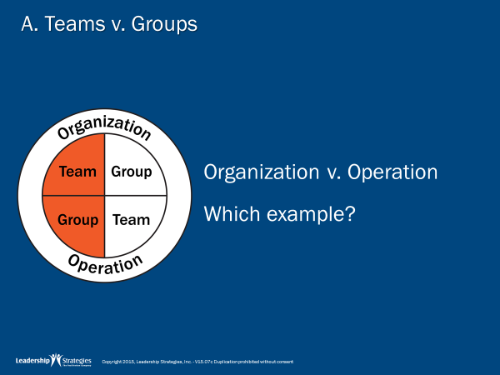 |  | SHOW POWERPOINT: Teams Vs. Groups  DO:  REVIEW the following information using your own words.  SAY:  The discussion also often leads to a deeper understanding of how teams are organized and how teams operate. For example, some people are organized as a team, but operate as a group.  ASK: Which of the eight items might fall in this category (U.S. Congress)  While our forefathers organized Congress to have a common purpose to work together on behalf of the country, unfortunately Congress all too often operates based on self-interests, acting independently, blaming one another.
 | PPT: Teams Vs. Groups 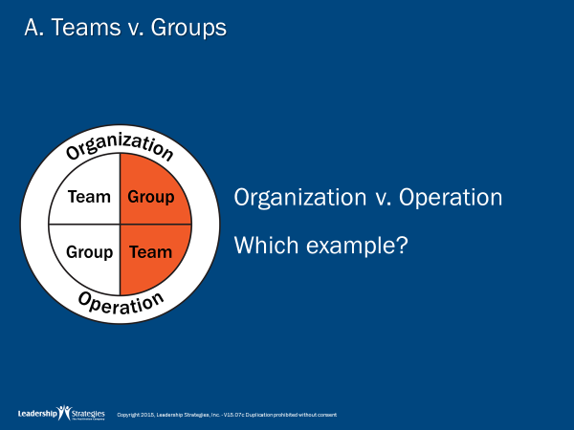 | SHOW POWERPOINT: Teams Vs. Groups  DO:  REVIEW the content on the slide.  SAY:  Contrast this with the diagram to the left that portrays a team that is organized as a group, but operates as a team.  ASK: Which of the eight items might fall in this category (neighborhood volunteers)  Prior to coming together, they had no common goal and no defined responsibilities. However, to save a child stuck in a well, they begin operating collectively to achieve the goal.
 | PPT: Teams Vs. Groups 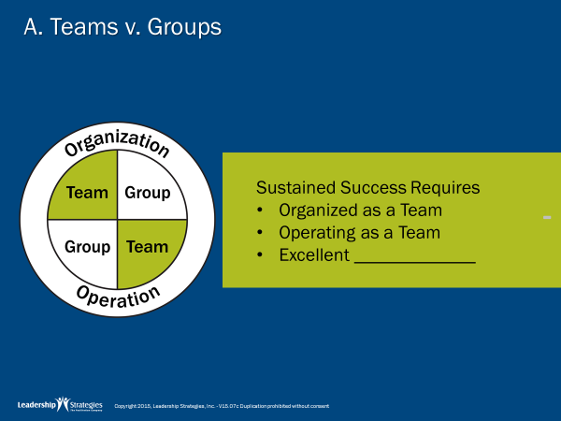 | SHOW POWERPOINT: Teams Vs. Groups  REVIEW the content on the slide.  POINT OUT:  The most effective teams are those that are organized as a team and operate a team.  ASK: Which of the eight items might fall in this category (symphony orchestra)  They have a common purpose. They have a leader and defined responsibilities. Though the leader is the only one perceived to be communicating continuously during performances, the orchestra works together to create an amazing blend of sounds that results in beautiful music.  However, recognize that you can be organized as a team AND operate as a team, but still not achieve your ultimate goals. There is a third major component. As an example, the 1992 Atlanta Braves, as good as they were, still lost the world series. Why? The third component is excellent strategy and strategy execution.  How about your organization? Is it organized as a team? Does it operate as a team? It is not unusual for an organization to be composed of a “group of teams.” Each team works independently of the other teams, with no common purpose or vision. (This is a common pitfall for government agencies and large businesses where individual departments can have their own agendas without working for the good of the whole.) We have also seen a “team of groups.” The leadership team is strong, but each of the individual operating units is plagued with self-interests and conflict.
 | PPT: Agenda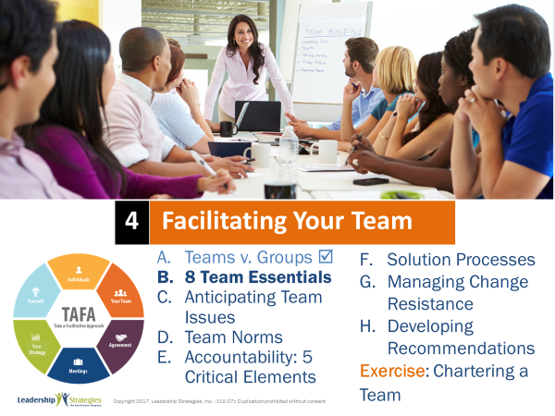 | SHOW POWERPOINT: Agenda  CHECKPOINT:  We’ve defined the differences between groups and teams. Next, let look at the eight team essentials. Every team should have these essentials to align the team and have great execution.
 | PPT: Team Essentials 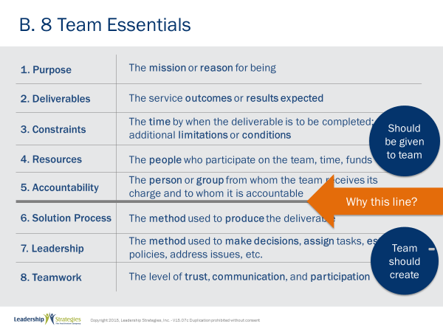 | SHOW POWERPOINT: Team Essentials (build)  SAY:  Does each of the teams with which you are involved have the essentials for success? At Leadership Strategies, we are called in from time to time to work with teams at various stages in the team cycle.  - Often, we are called in at the beginning to help charter the team and get the team started moving together in a consistent direction.  - Other times, we become involved while the team is engaged in the work. This frequently occurs with teams that are experiencing difficulties in achieving goals due to issues within the team.  - And still other times, we are asked to take a team through a debriefing exercise to document their success strategies and areas for improvement.  POINT OUT:  Through experiences like these with a variety of teams, we have identified what we believe are the “eight essentials” – that is, the eight things every team needs to be successful. We have found that a team missing one of the essentials can still be successful through persistence and strength of the team members, but it is just more difficult. A team missing two essentials is severely handicapped and our experience has been that the chances of success are very low. However, for a team missing three of the essentials, the likelihood of success is so low, one can predict with high probability that failure is imminent!  You will note the bold line separating the first five essentials from the last three. The line is significant in that the top five are different from the bottom three in a number of ways.  ASK: What might be the difference between the top five and the bottom three?  This last point is critical. In most cases, the top five should be given to the team. A team that is not given the top five essentials may be poorly chartered. Once a team is chartered, they need to focus on ensuring they develop the bottom three. In our work with teams, we have found teams that failed because they were poorly chartered (missing one or more of the top five) as well as teams that failed because they executed poorly (missing one or more of the bottom three).  ASK:  As you look at the teams with which you are involved, do they have the eight essentials?
  Top Five | Bottom Three
  How the team is organized | How the team operates
  What the team is trying to do | How the team will get it done
  Should be given to the team | Should be created by the team
 | PPT: Team Essentials & DISC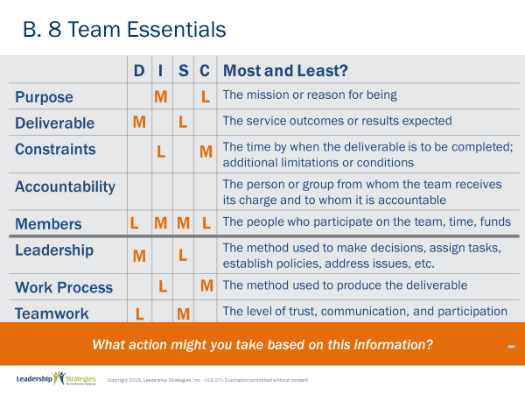 | SHOW POWERPOINT: Team Essentials & DISC (build)  Note to Instructor: You may have to provide a quick reminder of the four DISC communication styles.  SAY:  Let’s do the “D” column together. If you have a Hi-D leading a team, what might be one of the two essentials the Hi-D might be most focused on? (show response)  And what might one of the two essentials the Hi-D leader might be least focused on? (show response)  DO:  Assign one of the columns to each team to identify one of the most and one of the least for each of the other styles.  REVIEW the content on the slide which points out which DISC styles will most or least be impacted by each essential.
 | PPT: Agenda 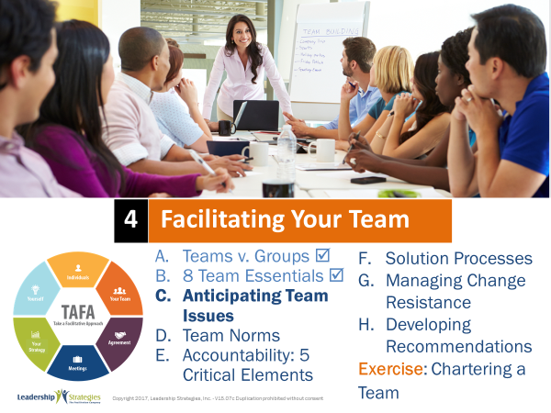 | SHOW POWERPOINT: Agenda  CHECKPOINT:  As we discussed, the 8 Essentials are critical for success. And we have identified which essential a leader with each DISC style might be most and least concerned about. Now let’s apply that learning. What would you do with this information to help set the leader up for success?
 | PPT: Anticipating Team Issues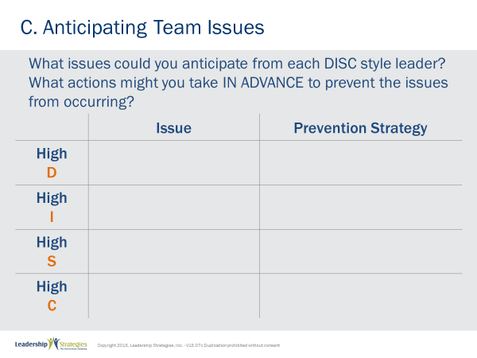 | SHOW POWERPOINT: Anticipating Team Issues  DO:  ASSIGN each table team a DISC style. INSTRUCT them to identify an issue and a prevention strategy.  Tell them if they have extra time to work on the other styles too.  REVIEW their responses as a large group, asking questions to encourage thinking.
 | PPT: Agenda 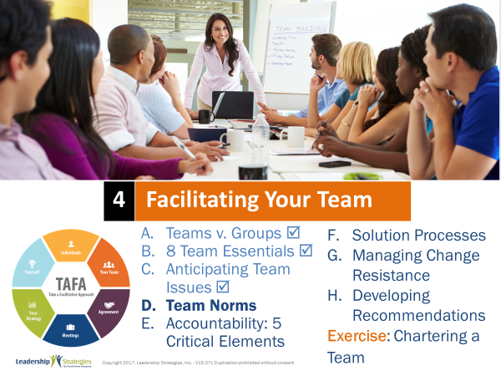 | SHOW POWERPOINT: Agenda  CHECKPOINT:  Great job applying the DISC styles. Another important element in establishing a well functioning team is developing team norms. These norms are a guideline that establishes how the group wants to interact with each other. In many ways, team norms prevent issues from surfacing.
 | PPT: Team Norms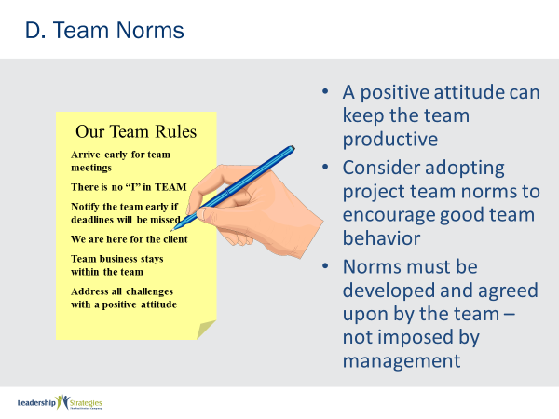 | SHOW POWERPOINT: Team Norms (build)  DO:  REVIEW the content on the slide.  Tell a personal story about a time where team norms helped a team you worked with.
 | PPT: Team Norms 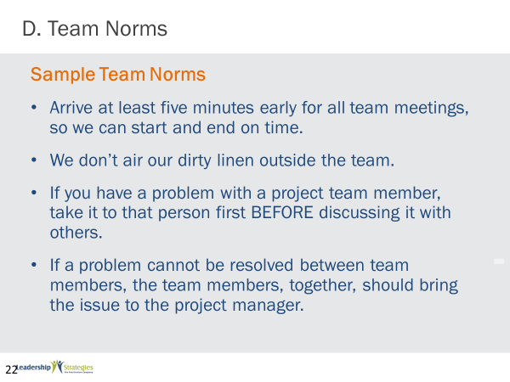 | SHOW POWERPOINT: Team Norms (build)  DO:  REVIEW the content on the slide.
 | PPT: Agenda  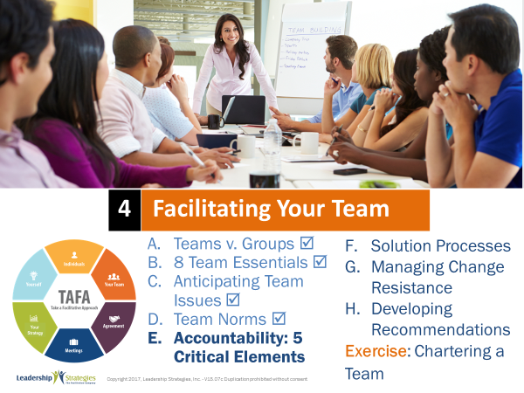 | SHOW POWERPOINT: Agenda  CHECKPOINT:  Do you see the value of team norms? Another element of strong teams is accountability. I’d like to introduce you to the five crucial elements of accountability. If you want to have a strong culture of accountability, we believe it is important to put in place five crucial elements.
 | PPT: Accountability: 5 Crucial Elements 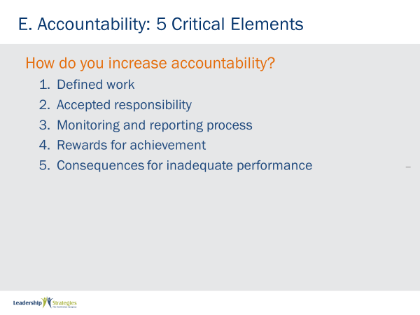 | SHOW POWERPOINT: Accountability: 5 Crucial Elements (build)  DO:  REVIEW the content on the slide.
TRANSITION:
Let’s think through accountability a little more…
 | PPT: Questions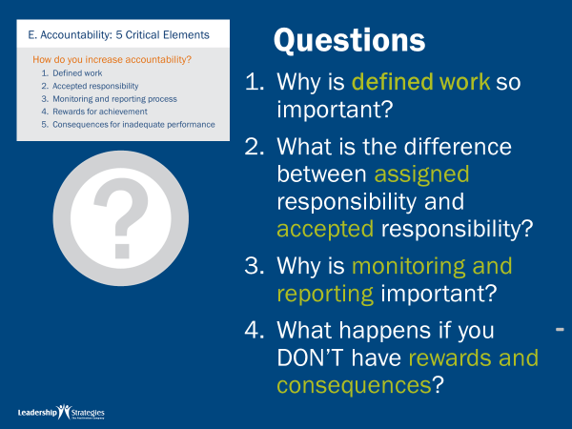 | SHOW POWERPOINT: Questions (build)  DO:  REVIEW the questions on the slide and assign each team to discuss and prepare to report out an answer to one of the questions. Allow 3 minutes. Ask teams to report out and discuss.  Alternatively, lead a group discussion.
 | PPT: Agenda  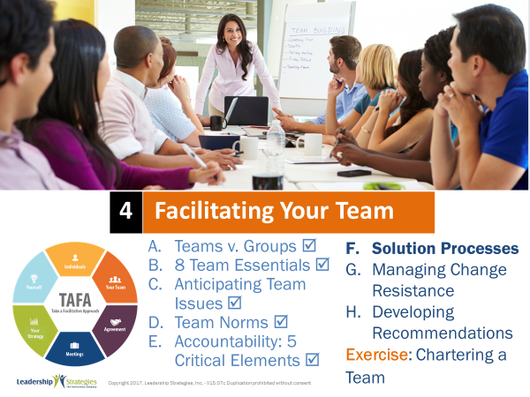 | SHOW POWERPOINT: Agenda  CHECKPOINT:  Recall that we said the three team essentials that a team must create for themselves are teamwork, a work process, and a decision process. We’ve talked about team norms and accountability around teamwork, now I would like for us to focus on the work process. By this I mean, the steps the team goes through to get its work done to accomplish tasks and solve problems. In this next section we introduce several generic solution processes that your team can adapt as its own work process.
 | PPT: Solution Process 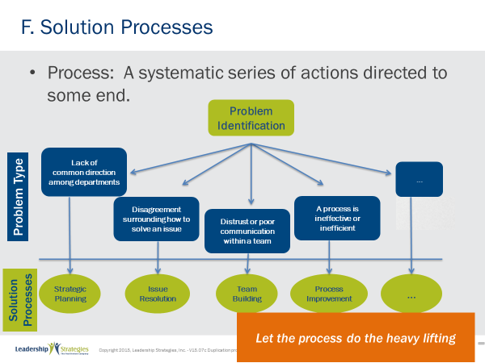 | SHOW POWERPOINT: Solution Process (build)  SAY:  As we said, while our clients have many unique issues or challenges, many problems can be classified into a Problem Type. As an example, one organization may be having issues with their hiring process, and another organization having problems with their event registration process, and another with their customer order process. These are indeed 3 different problems, but they are the same problem type: an inefficient or ineffective process. In this chart you can see, once we have identified the problem type, we can then select the appropriate solution process for addressing that problem type. The solution process provides us with a “generic” starting point for creating our team’s work process to solve that problem.  In the manual, we provide you with # generic solution processes to use in creating work processes. Let’s take a brief look at the Solution Processes section of your participant manual…this will allow us to see the similarities and differences among the solution process models in your manual... (NOTE: review each Solution Process including the following below.)  - Strategic Planning… (review the purpose and tasks)  - Project Plan…a lot more detail/specific than the Strategic Plan…strategic planning may identify projects that need to be done to accomplish goals and objectives to achieve our strategy…project planning is the approach for each project to be undertaken…  - Issue Resolution… here we would be evaluating alternatives…here the result is likely a project that will have to be planned (i.e., the above solution process)  - Management Review…while Issue Resolution is looking at a specific issue…a management review is a broader look all around the organization to identify potential problems that may exist……
 | PPT: Introduce Strategic Planning 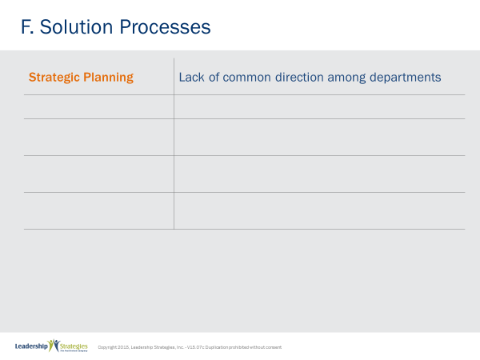   | SHOW POWERPOINT: Introduce Strategic Planning  SAY:  The first process is Strategic Planning.  DO:  READ the slide.
 | PPT: Strategic Planning Process 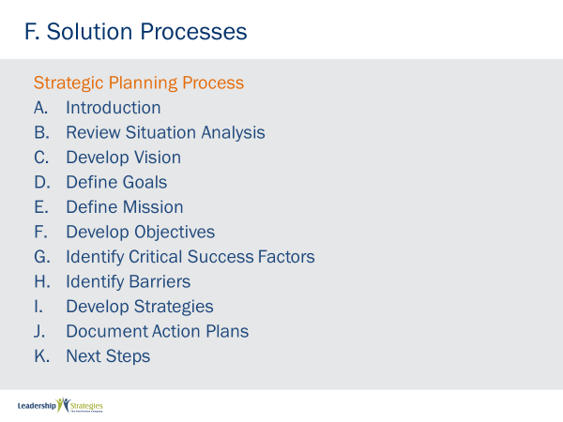 | SHOW POWERPOINT: Strategic Planning Process  DO:  REVIEW the content on the slide.
 | PPT: Introduce Project Planning 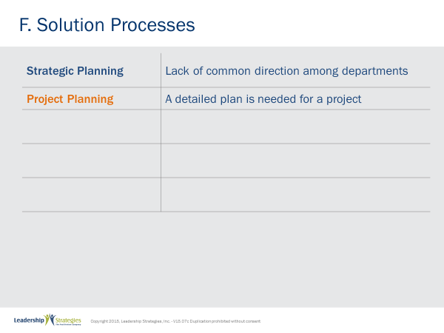 | SHOW POWERPOINT: Introduce Project Planning  SAY:  The second process is Project Planning. Project Planning involves lot more detail/specific than the Strategic Planing. Strategic planning may identify projects that need to be done to accomplish goals and objectives to achieve our strategy… and project planning is the approach for each project to be undertaken.  DO:  REVIEW the content on the slide.
 | PPT: Project Planning 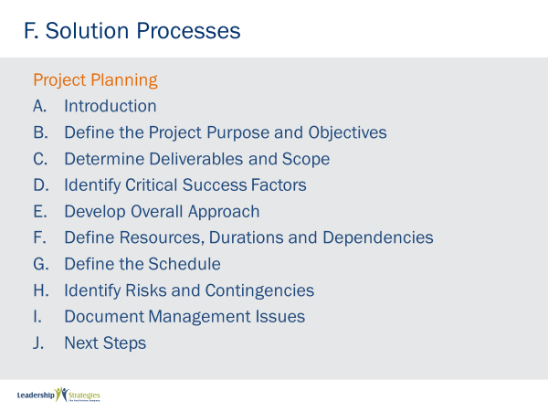 | SHOW POWERPOINT: Project Planning  DO:  REVIEW the content on the slide.
 | PPT: Introduce Issue Resolution 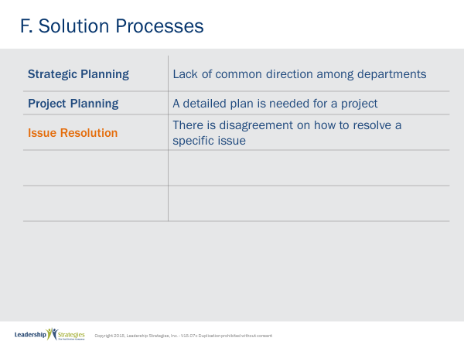 | SHOW POWERPOINT: Introduce Issue Resolution  SAY:  The third process is Issue Resolution. Here we would be evaluating alternatives. With this process the result is likely a project than will have to be planned (using Solution Process)  DO:  REVIEW the content on the slide.
 | PPT: Issue Resolution 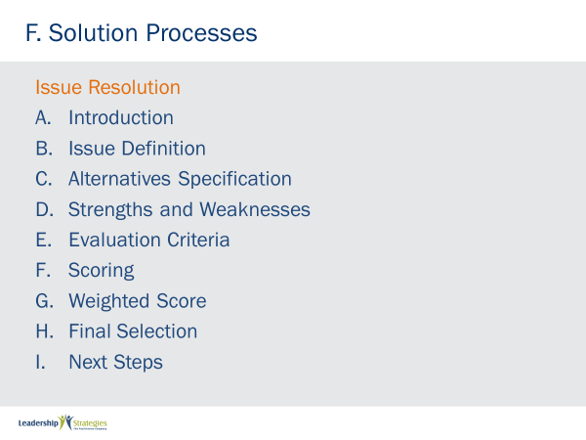 | SHOW POWERPOINT PPT: Issue Resolution  REVIEW the content on the slide.
 | PPT: Process Improvement  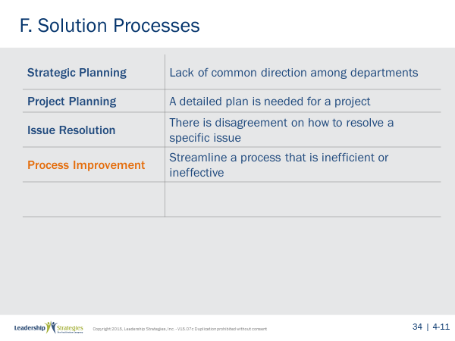 | SHOW POWERPOINT: Process Improvement  SAY:  The fourth process is Process Improvement. Here we would be examining an existing process to identify problems and implement solutions for them. With this process the result is likely an implementation plan for the solutions idenitified.  DO:  REVIEW the content on the slide.
 | PPT: Process Improvement 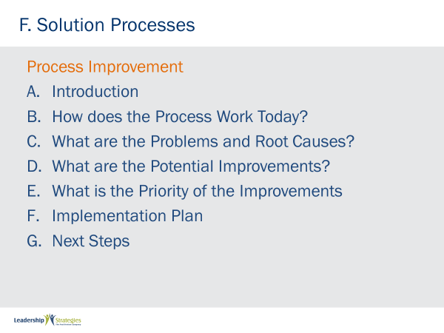 | SHOW POWERPOINT: Process Improvement  SAY:  The fourth process is Process Improvements. This is for basic Improvements. It typically addresses a process for incremental change. Tweaks.  REVIEW the content on the slide.
 | PPT: Introduce Process Reengineering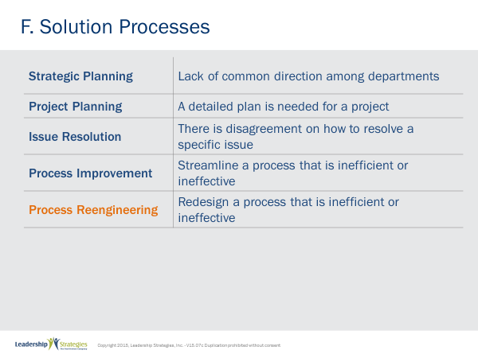 | SHOW POWERPOINT: Introduce Process Reengineering  SAY:  The fifth process is Process Reengineering. Process Reengineering involves more than a tweak. In Process Reengineering we are looking at a major overhaul or wholesale change of a process. Here we take the existing and throw it out, bringing in the new. It’s like starting with a clean slate.  DO:  REVIEW the content on the slide.
 | PPT: Proceess Reengineering 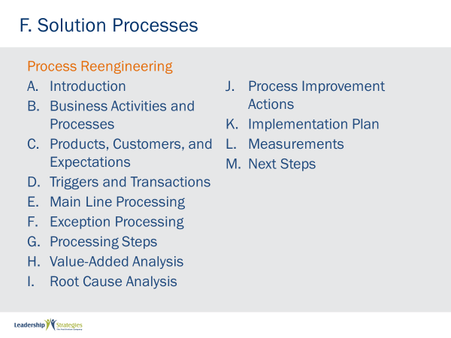 | SHOW POWERPOINT: Process Reengineering  DO:  REVIEW the content on the slide.
TRANSITION:
Now that we have reviewed several different solution processes, I want to give you a chance to build your skills in applying them.
 | PPT: Which Solution Process ?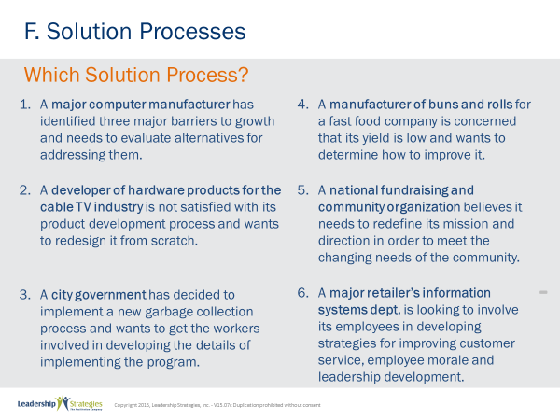 | SHOW POWERPOINT: Which Solution Process? (build)  DO:  INSTRUCT teams to complete the activity.  PURPOSE - In your teams, let’s see if you can use the problem description on Section X of your manuals to identify the key or operative words that lead us to use one of our Solution Processes in Section X.  EXAMPLE - For example, (name), would you read the first problem description for us?... Thanks. OK, (blue) team, what do you think the key or operative words are in that description? ...good… “evaluate alternatives”… that’s right.so, if we are going to evaluate alternatives. (Green) team, what Solution Process would you think we would turn to? … That’s it, Issue Resolution…  DIRECTIONS - To complete this activity, let’s first select a new team leader…good…now in your teams I am going to set the clock to 4 minutes…. I want to give your teams an opportunity to evaluate all of the examples. However, you might run out of time, and so to make sure each one is covered, I am going to ask each team to start with a different one. I would like the (red) team to start with our 2nd row….the (green) team to start with the 3rd row…..etc. You are to identify the operative words and the Solution Process your team would use to address that problem.  EXCEPTIONS - Please note…don’t overanalyze these cases…select your best Solution Process and note some may be used more than once and others may not be used at all.  QUESTIONS- Any questions? OK, I am starting the clock.  (Start the clock.)  To DEBRIEF - Facilitate the discussion when the time is up using round robin by teams, etc.)
 | PPT: Identifying Solution Process 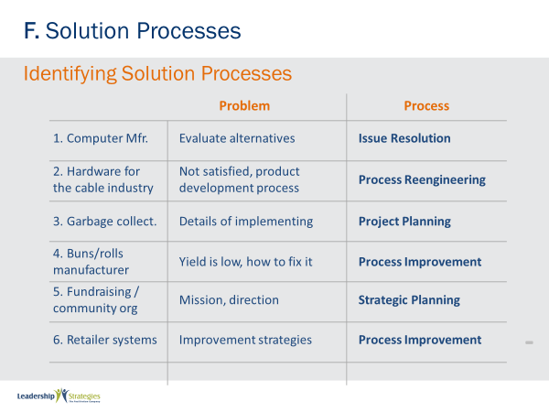 | SHOW POWERPOINT: Identifying Solution Process  SAY:  Let’s review the answers for each one. The first one is…Teams what did you say?  DO:  REVIEW each one, answering questions that arise.
 | PPT: Agenda 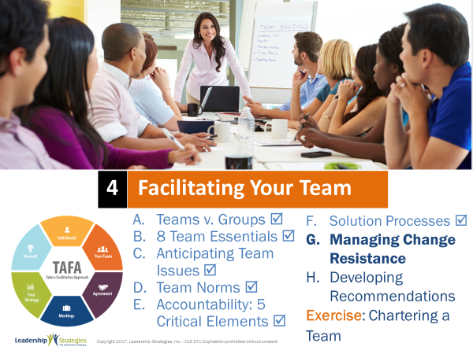 | SHOW POWERPOINT: Agenda  CHECKPOINT:  We have just completed looking at several different solution processes. Next we will talk about overcoming change resistance. Because even the best solutions can be met by resistance from those who are resistant to change.  As leaders, we often encounter change resistance, times when a decision has been made and yet one or more people in the organization are not moving with the change. How do you handle this? As you will see, how people resist has a lot to do with DISC styles.
 | PPT: Managing Change Resistance 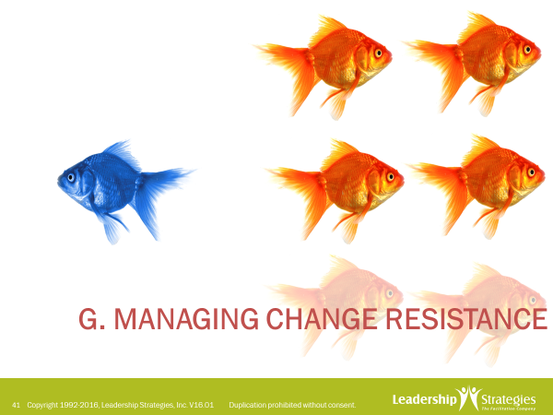 | SHOW POWERPOINT: Managing Change Resistance  SAY:  So, let’s look at strategies for managing change resistance.
 | PPT: Managing Change Resistance 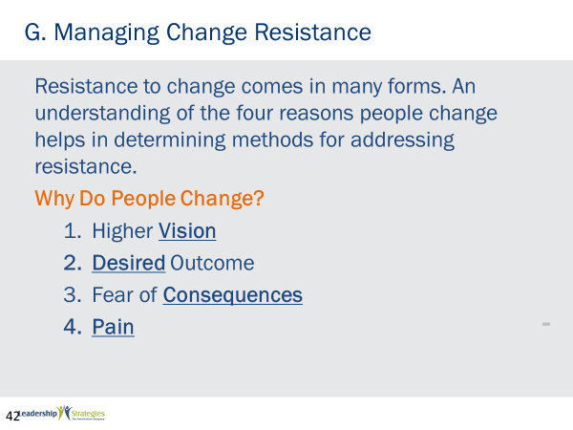 | SHOW POWERPOINT: Managing Change Resistance (build)  SAY:  We have found that there are 4 key reasons people change…  - Higher vision - Can anyone think of an example? (Name), share that with us…. Examples to consider would be Gates and Allen with the PC…a computer on every desk…. Jobs with the mouse or the music revolution.  - Desired outcome – Does anyone have an example of this? (Allow them to share.) OK, what about an individual that wants to improve their fitness, lose weight or stop a bad habit such as smoking.  - Fear of consequences – Who has a good example? (Have another participant share.) Again, we can go back to the person that wants to stop smoking…. he/she may fear poor health, cancer, etc.  - Pain - (Ask another potential participant share.) Has anybody ever lost a filling or had a bad toothache…. that forces change surfaced by pain.  ASK:  - Which the style is most likely to respond to a higher vision?  (High-I)  - How about desired outcomes? (High-D)  - Fear of consequences? (High-C)  - Pain? (High-S)  POINT OUT:  Remember for a High-S change is a four-letter word; they don’t like change, it’s very destabilizing. So how do you put a High-S in pain? We often find that the way to put a High-S in pain is what we call the surround strategy. Where people around the S are telling him how much his lack of movement or lack of support is hurting them. When everyone is saying that the High-S tends to be more open to taking action.
 | PPT: Managing Change Resistance 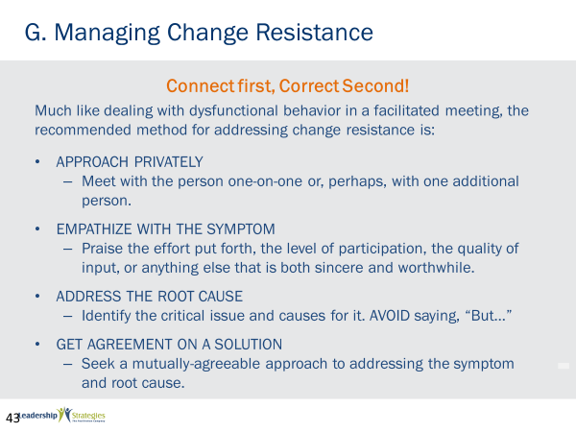 | SHOW POWERPOINT: Managing Change Resistance (build)  SAY:  So how do you address a situation where there’s resistance to change? We say it’s much like dealing with dysfunctional behavior in a facilitated meeting. You have to connect first and correct second. The way you connect is by showing empathy. Let’s go through the four steps.  REVIEW the content on the slide.
 | PPT: Managing Change Resistance 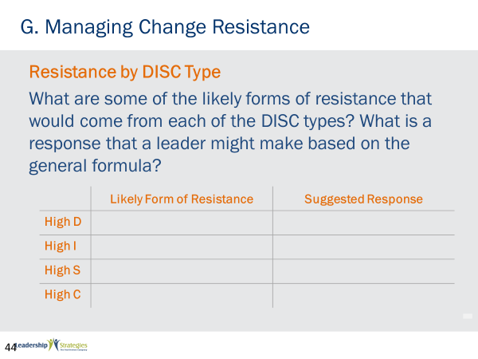 | SHOW POWERPOINT: Managing Change Resistance  SAY:  So together, let’s look at each DISC style, the likely form of resistance, and suggested response.  LEAD a discussion and let the group fill in the table.
 | PPT: Agenda 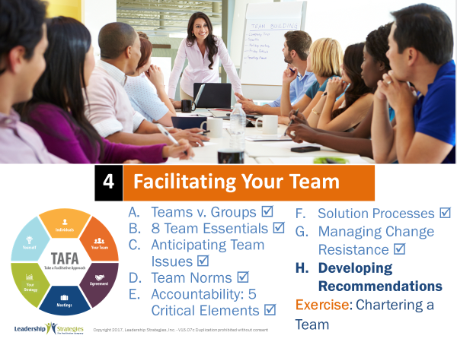   | SHOW POWERPOINT: Agenda  CHECKPOINT:  So, now we have a plan for overcoming resistance to change. Let’s now take a look at how to create a compelling case for change. As leaders, we also have to develop recommendations that are accepted. Let’s take a look at how to do that.
 | PPT: Developing Recommendations 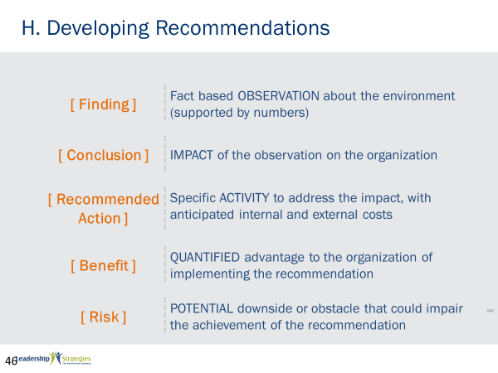 | SHOW POWERPOINT: Developing Recommendations (build)  SAY:  Don’t you hate it when you spend considerable time with the group to develop powerful recommendations, you then present them, and then nothing happens? There could be many reasons why that happens, but one of the reasons could be that the recommendations were not compelling. The recommendations did not drive the receiver of the recommendation to say, “We absolutely need to do this.”  Here is a specific format for your recommendations to help ensure that action is taken. Let’s go through the five parts of a great recommendation.  Now let’s take a look at a specific example on the next slide……  DO:  REVIEW the content on the slide.
 | PPT: Developing Recommendations 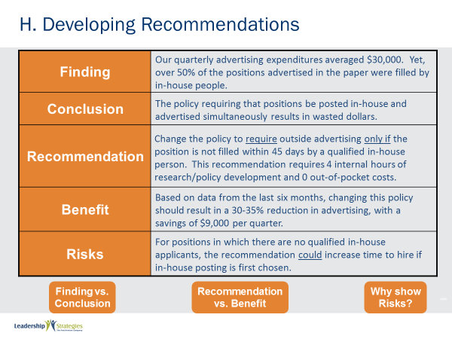 | SHOW POWERPOINT: Developing Recommendations (build)  DO:  REVIEW the content on the slide and ask the following questions.  ASK:  - What is the difference between finding vs. conclusion? (finding of facts, conclusion gives meaning to the facts)  - What is the difference between recommendation vs. the benefit? (recommendations the action to be done, the benefit is the advantage to doing the recommendation.)  - Why show the risk? (to give the possible downside)  - Which DISC type want to see the facts in the finding? (High-C)  - Which type wants to see the conclusion and recommendation? (High-D)  - Which style cares most about the benefit? (High-I)  - Now, which type would be most interested in the risk? (High-C)  NOTE: High-S’ are comfortable however you want to present  POINT OUT:  So, given the most influential person in the room, you might want to start your presentation with that piece of the recommendation he/she might be most interested in.
 | PPT: Agenda 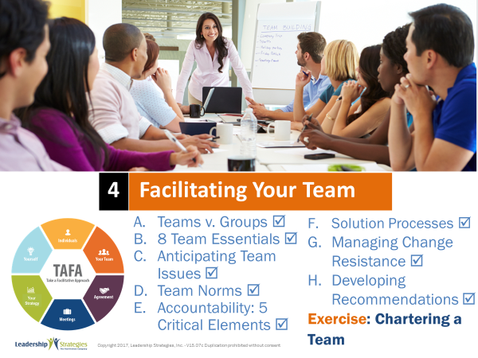 | SHOW POWERPOINT: Agenda  CHECKPOINT:  Now that we have covered all components, let’s put it all together.
 | PPT: 4a Chartering a Team 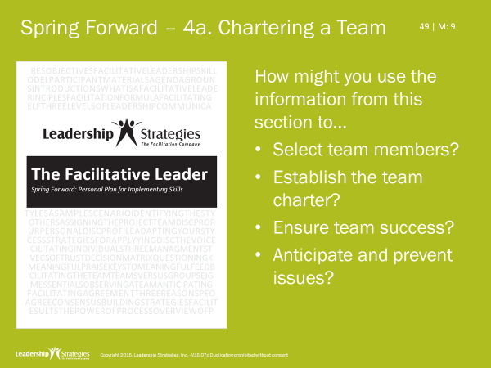 | SHOW POWERPOINT: 4a Chartering a Team  SAY:  Let’s now apply what we have learned by thinking about the 8 essentials for a team.  DO:  INSTRUCT the group to complete the Spring Forward Exercise, 4a.  PURPOSE: To apply chartering information to their teams.  EXAMPLE: (not needed)  DIRECTIONS: Individually answer the questions on 4a.  EXCEPTIONS: If you do not lead a team, think about a team you might lead.  QUESTIONS: What questions do you have?  To DEBRIEF: Ask 2-3 people to share what they wrote.
 | PPT: Review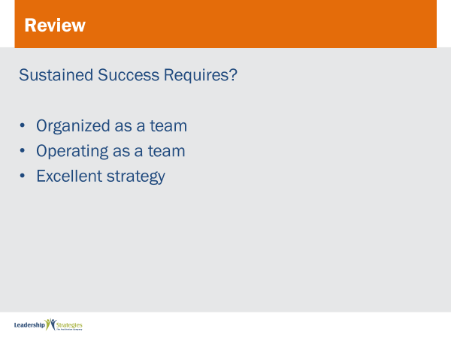 | SHOW POWERPOINT: Review  DO:  Post each review slide and ask for someone to raise their hand to answer the question. If they get it correct, award them a dot.  Continue until all review slides have been completed.
 | PPT: 4b. 8 Team Essentials 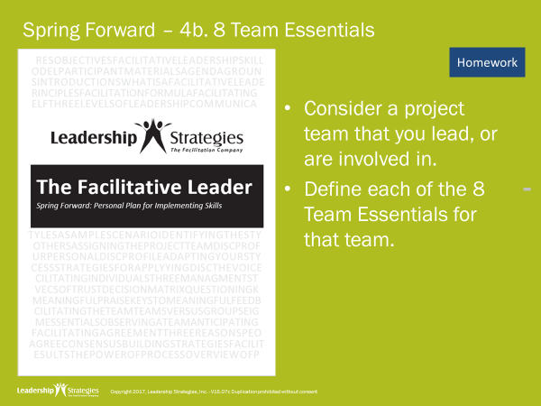 | SHOW POWERPOINT: 4b. 8 Team Essentials  DO:  EXPLAIN the homework assignment.  PURPOSE: To apply the 8 essentials to your team.  EXAMPLE: (not needed)  DIRECTIONS: Individually answer the questions on 4b. Bring it with you to the next class.  EXCEPTIONS: If you do not lead a team, think about a team you might lead.  QUESTIONS: What questions do you have?
 | PPT: Agenda 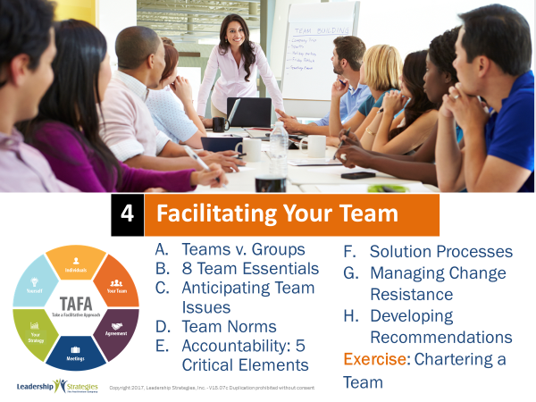 | SHOW POWERPOINT: Agenda  CHECKPOINT:  We have covered a lot – and hopefully given you some new ideas on how to better facilitate your team. Let’s connect what we have covered to the TAFA Model…
 | PPT: TAFA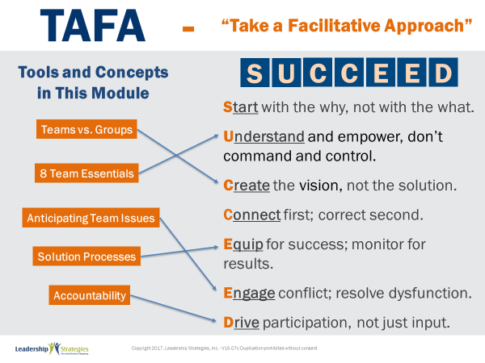 | SHOW POWERPOINT: TAFA (build)  SAY:  Let’s take a moment to look at some of the concepts we’ve learned in this module and examine how they reflect the TAFA principles.  DO:  REVIEW slide and lead discussion by asking if there are other principles that are reflected by the concepts.
 | PPT: Checkpoint | SHOW POWERPOINT: Checkpoint (build)  CHECKPOINT:  We have just completed the Facilitating Your Team module. Next, we will be looking at specific strategies for Facilitating Agreements. These techniques will help you facilitate your teams to get buy-in on decisions made by team.
 | PPT: LSI Connect 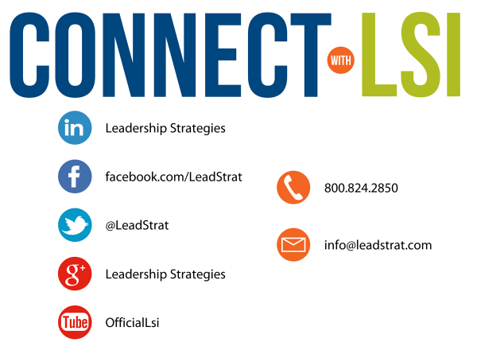 | SHOW POWERPOINTS: Connect with LSI  Note to Instructor: this slide may be excluded if you are going directly into the next module. In that case, hide the slide.  SAY:  We fundamentally believe facilitation is a skill that applies in a multitude of situations. We also are confident that, in our quest to “share the power of facilitation with the world,” connecting via social media is a way for all of us to collectively share our successes, our challenges and our facilitation work. To “facilitate” that process, we want to ensure you are aware of how we can all stay connected using social media.  How many of you have found many of the skills in the class helpful? [raise your hand] I know that one of the things I did after attending was share what I learned with many of my colleagues. Have some of you already thought about that? [nod your head]  Then, one request we would like to make of you is to update your “education or classes attended” on your LinkedIn profile. That visibility will help all of us to “share the power” I have been referring to. Any questions?  FACILITATE the discussion.
 | PPT: Congratulations 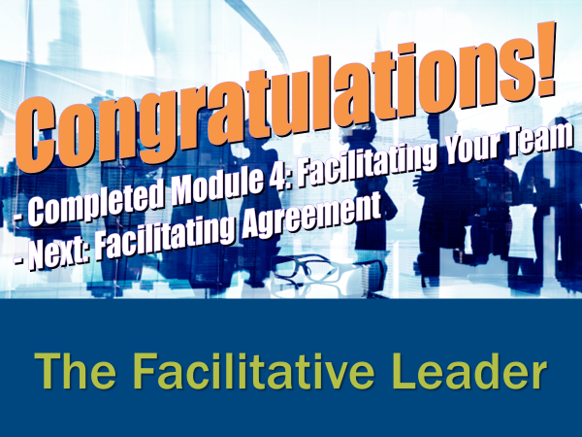 | SHOW POWERPOINT: Congratulations! (build)  Note to Instructor:  There are three congratulation slides. Select the correct slide depending on whether you are:  - Moving on to the next module immediately (slide 1)  - Coming back another day to do the next module and therefore need to do an evaluation (slide 2)  - Have completed the workshop and therefore need to close out the class with the post-test, evaluations, dot winner (MVP), and the From Classroom to Application sheet (slide 3)  Hide the other two congratulations slides.  DO:  REVIEW and execute the content on slide.  EXECUTE THE POST TEST:  If appropriate, handout the post-test. Give people five minutes to complete. Ask teams to give their cheer once completed.  Once completed, have team members pass their post-test clockwise to a new person. Go through each question and have the group give responses. Instruct them to place a checkmark for each correct response.  Once completed have people add up the number of check marks and place the total at the top.  Since each post-test has eight questions, place the number 8 through 0 in the first column of a two-column chart.  Before people hand the post-tests back to the owner, do a round robin and have people indicate the number the person got corrected. Place a tick mark next to that number each time that number is reported.  THANK participants and dismiss class.
 |  | END OF MANAGER EXPERIENCE MODULE FOUR

