The Facilitative Leader
Module 2: Facilitating Communication

Instructor Guide

Table of Contents
Facilitator’s Information
Table of Contents 1
How to Use This Guide 2
Symbols Used in the Facilitator’s Guide 4
Participant Pre-Work 5
Materials & Equipment for Module One of The Facilitative Leader 6
The Facilitative Leader Module Two: Agenda 7
Module 2: Overview 10
History of the DISC Assessment (from Wikipedia 9/28/17) 12
Module 2: Getting Started Contents 13

How to Use This Guide
This Facilitator’s Guide covers the following:
- Work you’ll need to do prior to the workshop,
- Materials and equipment you’ll need for the workshop, and
- Instructions and verbiage to conduct the workshop.
Headings
The heading for each section indicate the information that will be covered in that particular section.
Instructions Section
On the right-hand side of the workshop instructions pages you’ll find the approximate number of minutes required to complete a topic.
The format for the instructions section contains 2 columns as follows:

- Left-hand Column:  - Contains graphics, such as a copy of a slide or an icon, indicating the major aspect of the training segment. For example, a television set icon indicates that a video will be shown. The next page shows the various icons used. | - Right-hand Column  - Lists the information or instructions to be conveyed to the participants and contains possible starting questions you can ask about the topic to engage participants in a discussion or an activity.  - Describes the activity to be completed. Note that actions to be done will always be in bold.  NOTE: This Facilitator’s Guide is not intended to be used as a script. The words in this column give you one example of how to deliver the content. Part of your preparation is to review this guide and become familiar with its contents, structure, and flow. You should feel free to use your own words, adjust the delivery to your own style, while also adapting to the needs of the group you are facilitating. At all times, be sure to show enthusiasm and comfort with the material when you are presenting. This will provide a more enjoyable and meaningful session for your participants.
 | Anything in a gray box means that you will be “doing” something rather than presenting.

Symbols Used in the Facilitator’s Guide
There are many symbols used in this Facilitator’s Guide to serve as prompts for the type of activity occurring at that point in the program. Here is a list of those symbols and what they mean.
 | Presentation |  |  | Key Information
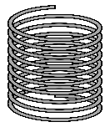 | Spring Forward Exercise |  |  | Pull through previous learnings
 | Pair Discussion/Exercise |  |  | Participant Manual “Write-along”
 | Group Discussion/Exercise |  |  | UMU activity
 | Write responses on a flip chart |  |  | Checkpoint
 | Transition to next topic |  |  | Individual Activity
In some cases, an activity will transition from one type to the other (e.g. from individual to group discussion). In such cases, more than one symbol may be used in chronological order.

Participant Pre-Work
Participants will need to complete and return the Communication Style Survey at least a week before the program.

Materials & Equipment for Module One of The Facilitative Leader
Following is a list of the materials to be used in this training session. Be sure to become familiar with all of them.
- Projector and Screen
- Laptop
- PowerPoint Slides – “The Facilitative Leader 2: Facilitating Communication”
- Facilitator Guide (this document)
- Updated Participant List
- Participant Packets (one for each participant)
  - Tent Cards
  - Participant Manual
  - Spring Forward Booklet
- Flipcharts – one for Facilitator, plus one for each table group)
- Pins/tape to hang posters
- Tape suitable for marking a cross shape on the ground
- Pens and Markers
- Post-it notes (one different color package for each table group)
Flip Charts:
- Course Objectives (posted, if appropriate)
- Ground Rules (posted)
- Coming Attractions (posted)
- Module 2 Agenda
- Post Test

The Facilitative Leader Module Two: Agenda
TIME | TOPIC
5 minutes | Workshop Introduction  - Checkpoint  - Course Objectives  - TAFA  - Ground Rules  - Your Materials
7 minutes | Homework Review
 | - Have participants share results of their homework (in pairs, table groups, and/or with the class)
2 minutes | Workshop Introduction  - Agenda (Compare to participant objectives)
5 minutes | “Difficult to Communicate with” Activity
5 minutes | - Participants write in their manual a person with whom they have difficulty communicating and three reasons why.
7 minutes | Four Quadrants Activity
7 minutes | - Using tape, make a cross shape on the classroom floor/carpet to create four quadrants.  - Ask participants to move to the top half or the bottom half based on whether the person they are thinking about is direct or indirect and then move to the left or to the right depending upon whether the person is task or people oriented. Then review.
20 Minutes | - Communication Styles  - Introduction to DISC  - The High D  - The High I  - The High S  - The High C
8 minutes | Review Activity
 | - Instruct teams that you will take turns asking each team the questions. Award dots as appropriate.
 | - Adapting to the Styles of Others
5 minutes | A Problem has arisen in your area Activity
5 minutes | - Ask table groups to brainstorm how to start an impromptu meeting with each of the communication style types.
10 minutes | Time and Agenda Order Activity
10 minutes | - For each of the styles, table groups will determine the time needed to meet with them, then order the tasks to create a meeting agenda for each style.
10 minutes | Spring Forward 2a – Adapting to Your Team’s Styles
10 minutes | - Individual participants write down names of folks they have trouble communication with.  - Participants determine each person’s communication style.  - Then they determine one action they can take to adapt to each person’s style.
10 minutes | - Identifying Styles  - 2 Dimensions of DISC: direct vs. indirect, task vs. people  - The Voice mail: ask group to determine a person’s style based on a person’s voice mail.  - Videos: ask the group to determine a person’s style based on a video of them.  - Celebrity DISC Profiles
4 minutes | - Recognizing and Addressing Style Clashes  - Strong Dislike: High I; Strong Dislike High D
7 minutes | Assigning the Project Team: What Would be the Key Issue?
7 minutes | - Ask teams to identify the following, for teams consisting of all the same style type: Key Issue, Would They Finish, Quality, How Would They Feel About Each Other.
5 minutes | Assigning the Project Team: Which Style Would be Best?
5 minutes | - Ask teams to identify which style would be best at specific project tasks.
5 minutes | - Recognizing and Addressing Style Clashes (cont.)  - Overall strategy for addressing different styles.  - Style clash warning signs and transition phrases.
35 minutes | Spring Forward 2b – Communicating Across Styles
 | - Role play where participants take turns communicating with an “other person” in the context of several case studies. Communicator should attempt to identify and adapt to “other person’s” communication style.
5 minutes (can be combined with a break to save time) | - Your Personal DISC Profile
 | - Participants review their profiles marking items they agreed with, disagreed with, or have questions about.
0 minutes (if time allows) | Optional Activity
- Participants form in groups according to communication styles.
- They answer questions about how they best work with other people.
8 minutes | Review Activity
8 minutes | - Instruct teams that you will take turns asking each team the questions. Award dots as appropriate.
7 minutes | Spring Forward 2c – The Agenda
7 minutes | - Participants select a report with whom they will be having a one-on-one, determine that person’s DISC style, and plan an agenda based on the person’s style.
15 minutes | Session Close (Will vary based on FL “package” being delivered.)  - Review Agenda  - TAFA: Tools and Concepts in this Module  - Checkpoint to next module if appropriate  - Connect with LSI  - Congratulations slide with appropriate closing activities depending on whether this module is delivered as part of the four-day or as a stand-alone  - Execute Post-Test if appropriate  - Award dot winner MVP prize if appropriate  - Complete From Classroom to Application if appropriate  - Execute Evaluation if appropriate  - Formally close the session.
180 minutes  (3 hours) | Total Training Time

Module 2: Overview
Overview
- Reviewing the TAFA Principles.
- Course introduction including ground rules and introductions.
- Homework review (if applicable).
- Understanding the DISC communication styles (Value, Potential Weaknesses, Key Factor, Communication Do’s, Communication Don’ts, Suggested Action).
- Strategies for adapting to the styles of others.
- Identifying the DISC styles of others.
- Examining how the different styles interact with those of different and the same styles.
- Recognizing warning signs and addressing when you are clashing with another person’s style.
- Looking at your own style via the report.
- Examining how your style interacts with others.
- Reviewing how the concepts and techniques from the course reflect the TAFA Principles.
Activities include the following:
- Identifying a person with whom you have trouble communicating.
- Quadrant for identifying the styles of others.
- Modifying your approach to kicking off a meeting based on the style of the person with whom you will be meeting.
- Understanding how the different styles contribute to projects.
- Creating different approaches to improve communication with several people of various styles.
- Recognizing how styles interact and work with those of different and the same styles.
- Role play interacting with different styles.
- Reviewing your Personal DISC profile
- Optional activity on how your style interacts with others
- Planning an agenda for a one-on-one meeting with a boss or direct report.
Key Learnings
- Recognize that when having challenges trying to communicate with an individual, it may be because the other person “speaks another language,” that is, has a different communication style.
- Identify the common behaviors and dysfunctions and communication do’s and don’ts of each style.
- Examine the difference between the styles based on task vs. people oriented and direct vs. indirect.
- Recognize the importance of appreciating the styles of others and how the styles can complement each other (or not).
- Understand that certain styles are better suited to certain activities.
- Recognize the importance of adapting to the styles of others including recognizing style clashes and what to do about them
- Understand how the concepts and techniques of the workshop reflect the TAFA principles.
Facilitation Tips/Background Information
- Post on the wall ahead of time three flip chart pages with the following titles
  - Objectives
  - Agenda
  - Coming Attractions
- Accommodate participant objectives where possible, but do not be tempted into shoe-horning their objectives into the planned activities. If it’s not going to be covered, explain why it is out of the parameters of this workshop. If appropriate, consider covering out-of-scope objectives over lunch, on breaks, or in some other way.
- Be familiar with the background and history behind the DISC profiles (see History of the DISC Assessment in this guide.
Timing: 3 hours

History of the DISC Assessment (from Wikipedia 9/28/17)
- DISC is a behavior assessment tool based on the DISC theory of psychologist William Moulton Marston, which centers on four different behavioral traits: dominance, inducement, submission, and compliance. This theory was then developed into a behavioral assessment tool by industrial psychologist Walter Vernon Clarke.
- Marston was a lawyer and a psychologist; he also contributed to the first polygraph test, authored self-help books and created the character Wonder Woman. His major contribution to psychology came when he generated the DISC characteristics of emotions and behavior of normal people. Marston, after conducting research on human emotions, published his findings in his 1928 book called Emotions of Normal People in which he explained that people illustrate their emotions using four behavior types: Dominance (D), Inducement (I), Submission (S), and Compliance (C). Also, he argued that these behavioral types came from people's sense of self and their interaction with the environment.^{[1]} He included two dimensions that influenced people's emotional behavior. The first dimension is whether a person views his environment as favorable or unfavorable. The second dimension is whether a person perceives himself as having control or lack of control over his environment. His work was the foundation of the DISC assessment that has been used by more than 50 million people since it was first introduced in 1972.
- Although Marston contributed to the creation of the DISC assessment, he did not create it. In 1956, Walter Clarke, an industrial psychologist, constructed the DISC assessment using Marston's theory of the DISC model. He did this by publishing the Activity Vector Analysis, a checklist of adjectives on which he asked people to indicate descriptions that were accurate about themselves. This assessment was intended for use in businesses needing assistance in choosing qualified employees.
- About 10 years later, Walter Clarke Associates developed a new version of this instrument. It was called Self Description. Instead of using a checklist, this test forced respondents to make a choice between two or more terms. Factor analysis of this assessment added to the support of a DISC-based instrument. Self Description was used by John Geier to create the original Personal Profile System in the 1970s. Through hundreds of clinical interviews, he furthered the understanding of the 15 basic patterns discovered by Clarke.
- Since then, many publishers have updated and/or generated their own versions of the DISC assessment. In 1984, Jack Morrison's doctoral dissertation, A Correlation Study of the Personal Profile System with the Sixteen Personality Factors Questionnaire concluded that the DISC has construct validity with significant correlations compared to the 16 PF strongly suggesting that it has scientific validity as a psychometric instrument.

Module 2: Getting Started Contents
- Understanding Communication Styles
- Adapting to the Styles of Others
Exercise: Adapting to Your Team’s Styles
- Identifying Styles
- Recognizing and Addressing Style Clashes
Exercise: Communicating Across Styles
- Your DISC Report: Understanding Your Biases

Timing: 2 hours
PPT: Title Slide   |  | SHOW POWERPOINT: Title Slide  Note to Instructor: Customize your opening depending on the modules the group will be receiving in total, whether you are following a previous module, coming back from time in-between modules, or only running this workshop for this group.  SAY:  Welcome to Facilitative Leadership. My name is…and I am excited about having the opportunity to show you the amazing impact leaders can have by taking a facilitative approach to decision making, problem solving, managing people and so on…  When we are done with this course, you will walk away with a foundation in seven core principles that will make your more effective in engaging your team, creating your strategic vision, driving consensus within your organization, coaching your people to being more successful, and achieving better decisions with higher levels of buy-in and commitment.
PPT: Facilitating Communication  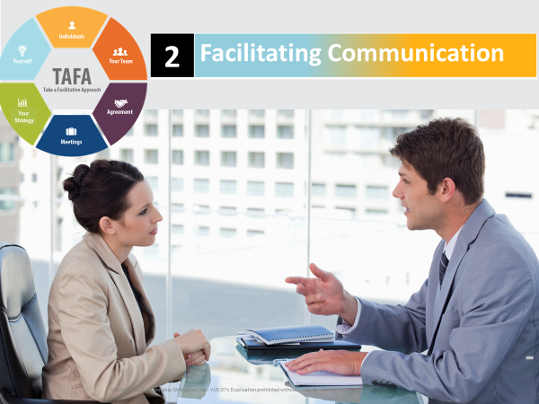 |  | SHOW POWERPOINT: Facilitating Communication  SAY:  Today’s workshop is the second part of our larger Facilitative Leadership curriculum.
PPT: Checkpoint  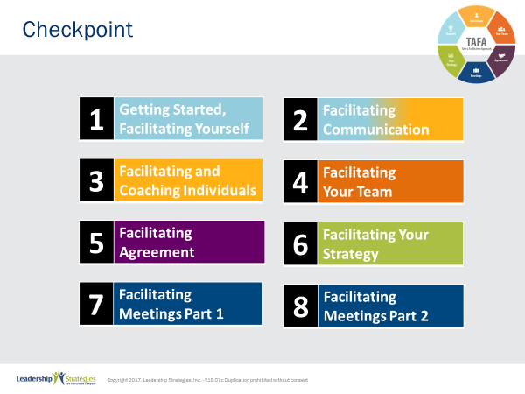 |  | SHOW POWERPOINT: Checkpoint  CHECKPOINT:  Last time, we covered Getting Started and Facilitating Yourself. We looked at the concept of leadership from several angles and talked about how a leader uses facilitative approaches to gain commitment and team effectiveness. Today, we are all about communication. How often have you felt like you just weren’t connecting with others, not on the same page, or just not getting through to them? This workshop will explain why that happens and what you can do to facilitate better discourse with your reports, colleagues, and boss.  [Note that only modules 1-4 are covered in the Public class, but do point out the additional modules that make up the series.]  READ agenda on slide.  TRANSITION:  Of course, our entire Facilitative Leadership curriculum is based on the seven TAFA principles, so let’s take a minute to review those.
PPT: TAFA  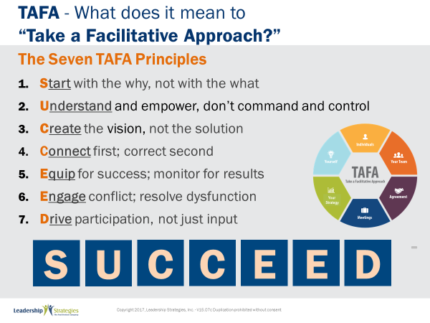 |  | SHOW POWERPOINT: TAFA  SAY:  Let’s review the TAFA principles:  There are 7 key TAFA principles – the principles of taking a facilitation approach. Any time you have a decision to make, a problem to solve, someone to coach or correct, we are going to be giving you tools and techniques for implementing these principles.  Let’s walk through them together.  People are often inspired when they are connected and aligned with purpose. Unfortunately, as leaders we often focus on what we want done and start there. Facilitative leaders understand the importance of why and always start any discussion, meeting, initiative kickoff, etc., with the why.  Often leaders don’t involve those impacted because they believe they need to control all aspects of what is done to achieve their desired result. They don’t take the time to understand how to adapt to the styles of their people to inspire performance because they don’t understand the relationship between engagement and results.  However, leaders who take a facilitative approach understand how to empower others by defining purpose and providing guidelines that allow teams to create recommendations that are thoughtful and innovative, but also practical and implementable. They adjust their own management styles to get the most out of their people.  One of the key roles of leaders is to set a vision of success with a clear and compelling “why” that inspires success. Facilitative leaders understand that once they set the vision they must give their people the authority, resources, support and coaching so that their people can develop and implement solutions and strategies that bring the vision into reality.  Some leaders are expert at pointing out mistakes their people make. They seem to enjoy demonstrating their superiority by identifying errors and then showing their people what they have done wrong.  Leaders who take a facilitative approach understand the importance of connecting with people first and helping them discover their own errors. They recognize the power of being the “guide on the side” rather than the “sage on the stage.” They strive to leave every interaction with the person feeling lifted rather than beaten down.  So many teams are essentially destined to fail from the start because they are not properly equipped for success. Facilitative leaders understand that teams require eight essentials and provide teams the essentials they need to accomplish their work. At the same time, many plans fall short of their desired ends due to lack of monitoring for results. For example, how often do strategic plans get written and then put on a shelf? Facilitative leaders understand the need to monitor for results every step of the way.  Leaders who don’t have the tools to effectively manage conflict and dysfunction tend to respond with either a “fight or flight” strategy when faced with a challenging situation. Those leaders who take the flight approach will avoid addressing issues and hope they go away on their own. Those employing the fight strategy tend to try to overpower situations by forcing their will without listening to or considering other alternatives.  Leaders skilled in taking a facilitative approach view disagreement as an opportunity to identify better solutions; they view dysfunction as a sign that something important is not being addressed. They understand the three reasons people disagree and have strategies for addressing each one. They fully buy-in to the dysfunction principles--conscious prevention, early detection, and clean resolution--and use appropriate techniques to prevent, detect and resolve dysfunction.  How often does a decision come down from headquarters which the people in the field know makes absolutely no sense? The idea couldn’t possibly work and everyone knows it, except the leaders. What happens? Time and energy is wasted implementing something that months later gets abandoned when the leaders finally figure out it was a bad idea. If they had only asked, the wasted time and resources could have been put to a much more productive use. If they had only asked.  Or how often, when trying to make a needed change, does the change get met with blatant rejection or subtle subterfuge simply because those expected to implement the change were not involved up front in the creation?  Leaders who take a facilitative approach recognize that you can get better decisions and achieve higher levels of buy-in when those impacted by the decision are involved in creating it.  - In the first case of a decision coming from headquarters, the involvement of those who would have to implement the decision would have likely yielded an even better solution that considered issues and situations that the workers understood but of which the leaders were unaware.  - In the case of the needed change that was met with significant opposition, involvement up front could have yielded greater buy-in and commitment to the implementation.  SUMMARIZE:  These principles outline what it means to take a facilitative approach inside an organization. As more and more leaders adopt a facilitative approach to leadership, we expect to see greater business results through higher levels of buy-in and commitment throughout the organization.
  1 | Start with the why, not with the what
  2 | Understand and empower; don’t command and control
  3 | Create the Vision, not the solution
  4 | Connect first; correct second
  5 | Equip for success; monitor for results
  6 | Engage conflict; address dysfunction
  7 | Drive participation, not just input
TRANSITION:
Just a few quick housekeeping items before we jump into the meat of today’s workshop.
PPT: Ground Rules  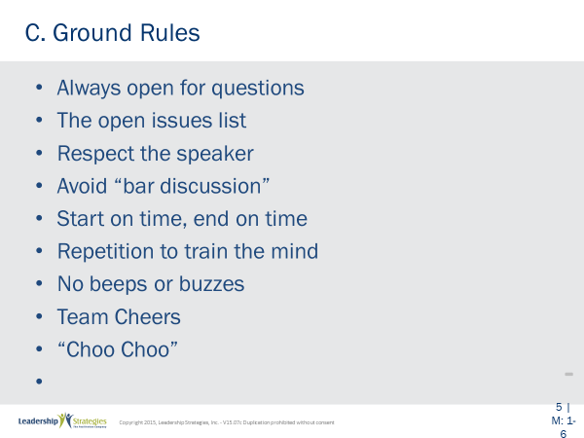 |  | SHOW POWERPOINT: Ground Rules  SAY:  Well, as you can see, we have a very ambitious agenda over the next [two] days. To get through it smoothly, I would like us to agree on some “Ground Rules” or “Session Guidelines.”  ASK:  By a show of hands, how many of you have been in some type of training class before? [Raise your hand.]  SAY:  So, you know those things that work and don’t work. I value your time. I want this to be a productive session for you. So, what are those guidelines that we need to have in place to make this a productive session for you? Let’s look at these ground rules for how we will conduct our session for the next [two] days and reach an agreement on them.  DO:  REVIEW ground rules on slide. ASK group if they would like to add or delete any of these ground rules.  ASK for a show of hands to adopt the ground rules as revised.
TRANSITION:
Another thing we want to do is ensure you are familiar with the course materials.
PPT: Your Materials  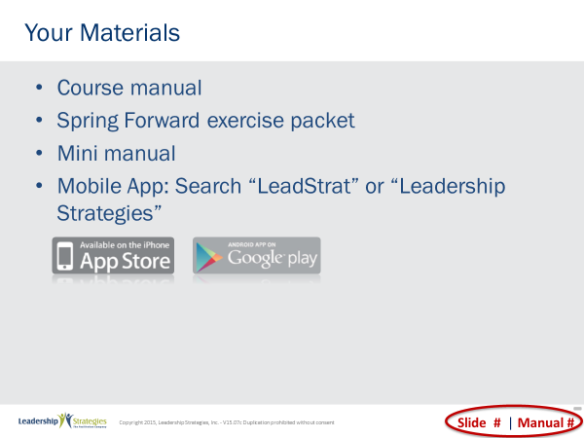 |  | SHOW POWERPOINT: Your Materials (build)  DO:  WALK participants through the course materials. Review Spring Forward last to transition to the homework review (if needed).
PPT: Homework Review  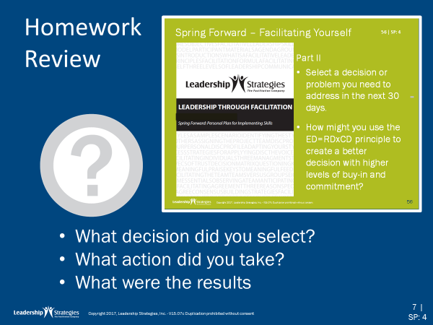  or |  | SHOW POWERPOINT: Homework Review  SAY:  Let’s pull out the Spring Forward manual so we can discuss how we applied what we learned last time.  DO:  READ through the activity to remind people …process responses, for example, have them talk at tables, have them share with one partner, or have one person from each table share their view, etc.
TRANSITION:
Now that we’ve had a chance to put into practice a decision-making process that can yield better buy-in and implementation, let’s take an even deeper dive into more effective interpersonal communication.
PPT: Agenda  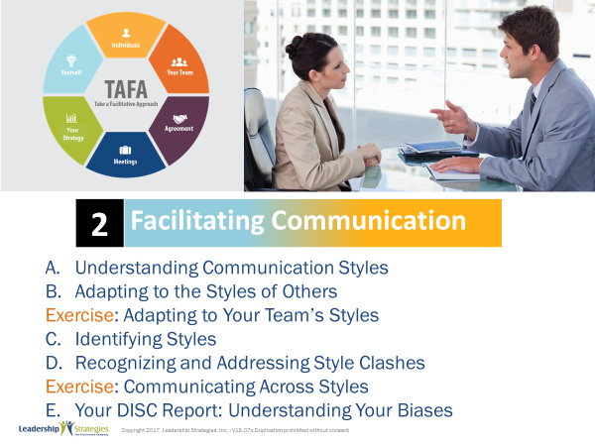 |  | SHOW POWERPOINT: Agenda  Review agenda items to be covered.
PPT: Agenda: Understanding Communicaton  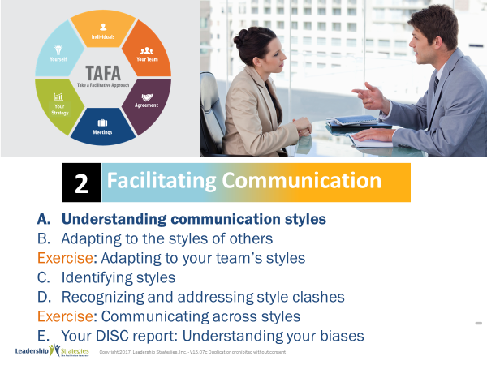 |  | SHOW POWERPOINT: Agenda: Understanding Communication  Checkpoint:  We’ve done all our setup for today. The first item on our agenda is understanding communication styles. This is the foundation for all our work today. Understanding the communication styles is critical to being able to be more successful in your communication.
PPT: Communication Styles  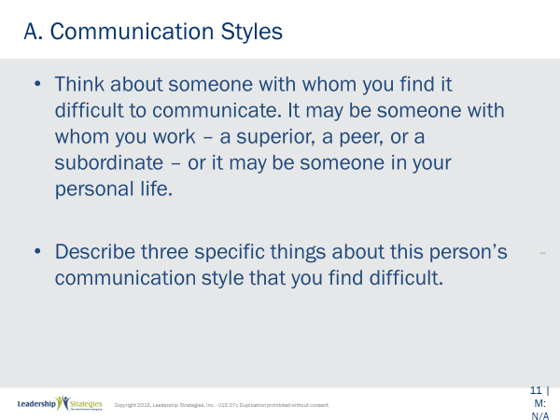 |  | SHOW POWERPOINT: Communication Styles (build)  SAY:  Let me ask each of you to turn to page ___ in your participant manuals. In the spaces provided write in the following. (READ the words on the slide.) You may want to include the person’s name or at least his/her initials. Let me give you about 30 seconds to do that.  When the time is up:  Let me start with (name) and go around the room clockwise so that you can share those 3 things each of you listed.  (Make some comments including things that are similar, different, what they mean about communicating, etc.)
PPT: Understanding Communication Styles  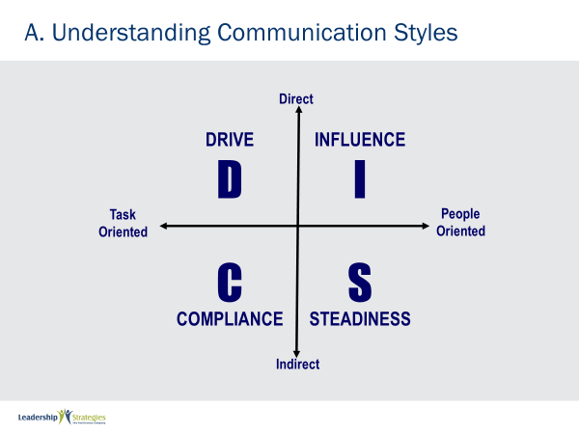 |  | SHOW POWERPOINT: Understanding Communication Styles  To help people understand the DISC system, using tape to create the four quadrants on the floor in the training room.  Explain that you would like to get people to think about that person they are having trouble communicating with.  Then first describe the north/south dimension (direct/indirect) and have people represent the person they have trouble communicating with and ask them to physically place themselves above or below the horizontal bar based on if the person they are describing is direct or indirect.  Then describe the west/east dimension (task versus people) and have people move to the right or left.  This will get people in the quadrants, then use the PowerPoint to name the four dimensions.
PPT: Communication Styles: Where did it come from?  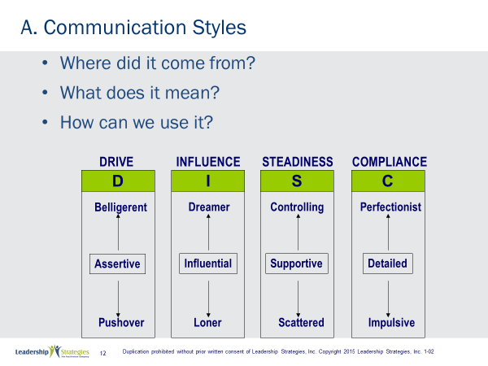 |  | SHOW POWERPOINT: Communication Styles: Where did it come from?  SAY:  What do we mean by communication styles? How does that relate to us as leaders? How may we use it? Let me ask this: have you ever been in a situation with someone where you explain, and explain, and simply do not connect? I mean you have tried your hardest but the person you are trying to explain something to just isn’t getting it. And then to add insult to injury, in comes someone else, he/she explains it (and you’re thinking, hey, that’s what I’ve been saying) and immediately the other person says, “Oh, I get it. That makes a lot of sense to me.” Again, you’re thinking, “That is exactly what I was saying! Why were you not getting it when I said it?”  POINT OUT:  Essentially, if it feels to you like you are speaking a different language, you just might be! We call that the language of DISC.  We want you to learn about the DISC Model so that you can communicate more effectively. At the same time, we do not want to “pigeonhole” people --- by remembering that all of us have some of each characteristic D, I, S and C.
TRANSITION:
To help us understand the different communication styles, imagine your task is to get over a brick wall that is standing before you. Let’s look at how the various styles would tackle that task. Keep in mind that most people are not as high as the high characteristics we are going to be talking about for the next few minutes. These are extremes. Think about it as if this person had only 1 communication style and not the combination each of us actually does have. View these extremes as kind of a caricature to help us understand the characteristics of each style.
PPT: The High D: Breaks through the wall  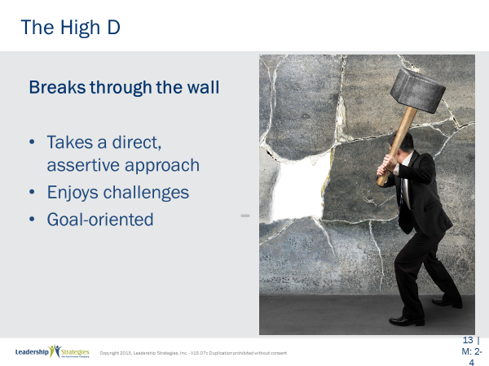 |  | SHOW POWERPOINT: The High D: Breaks through the wall  ASK:  So what do you think the High D would do about that wall (red) team? That’s right High Ds would lower their shoulder and break through the wall!  DO:  Review characteristics of the High D on the slide.
PPT: The High D: Value to the Organization  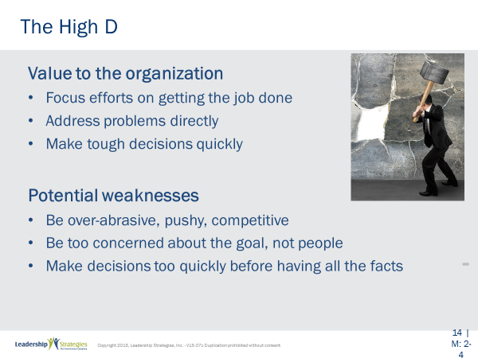 |  | SHOW POWERPOINT: The High D: Value to the Organization  SAY:  (Name) get us started: read the 3 key points at the top of the slide. What is the value to the organization of the High D?  OK, (name of next participant), what are those potential weaknesses?  ASK:  What do you think are some classic occupations of High Ds?  (LOOK FOR: Director, C-level, entrepreneur, etc.)
PPT: The High D: Key for D  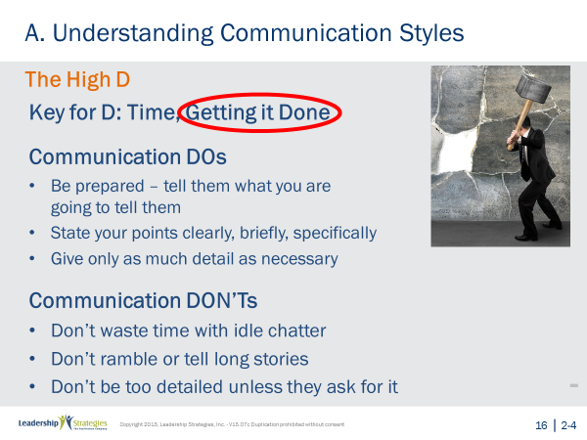 |  | SHOW POWERPOINT: The High D: Key for D  SAY:  Notice the High D is all about getting it done. Please circle “Getting it Done” in your manual. (Name) what about the communication dos for the D. And, (name), what about those communication don’ts, please.
PPT: The High D: Be prepared…  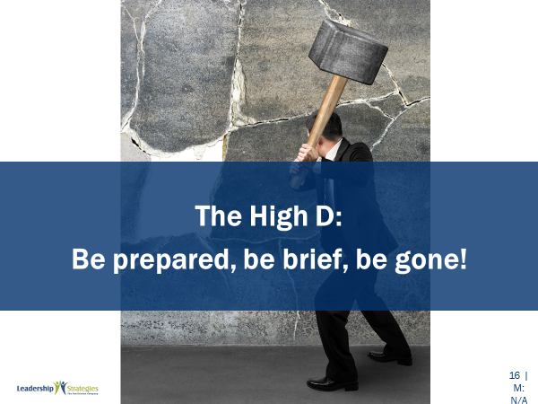 |  | SHOW POWERPOINT: The High D: Be prepared…  POINT OUT:  Great, what we like to think of as the tagline for those High Ds at Leadership Strategies is the following: “Be Prepared, Be Brief and Be Gone.”  Again, please make sure that you have circled “Getting it Done” and write that tagline, “Be Prepared, Be Brief, Be Gone” in your participant manuals. Before we move on, can you think about people you know like this (raise your hand)? Yes, me too.
PPT 1: The High I  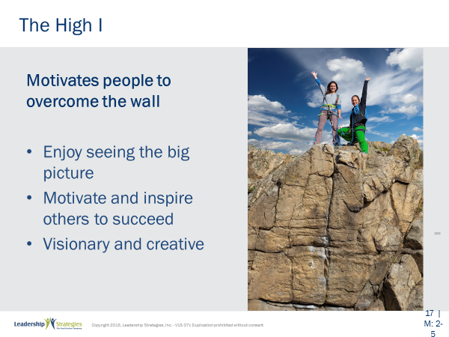 |  | SHOW POWERPOINT: The High I  SAY:  Here is that wall again. It’s easy to understand the types by thinking of them as how each type gets to the other side of this wall that is a barrier to their goal.  But before we look at that High I, let’s do some review of the D.  ASK:  (Red) team, how do High Ds tackle the wall? That’s right they put their shoulder down and go through it.  (Green) team, what are the classic occupations for the High D? That’s right directors, C-level and entrepreneurs.  (Blue) team: The value to the organization?  (Purple) team: The potential weaknesses?  NOTE TO INSTRUCTOR: conduct a backward build-up like this as you begin the next communication style each time. ALWAYS START WITH A DIFFERENT TEAM. For example, as you start the S and review both the D and the I, begin with the (green) team instead of the (red) team, and then when you start the C and review the D, the I and the S, start with the (blue) team instead of the (red) or the (green) team.  SAY:  Now, back to our High I. How do you think he/she deals with that wall? (Take a comment or two). Good, you are on the right track. The High I is the one with the megaphone shouting, “Hey, folks, let’s go, we can all get over that wall! It’s great on the other side!” They are cheering people over that wall and making it fun to tackle it.
PPT: The High I: Value to the Organization  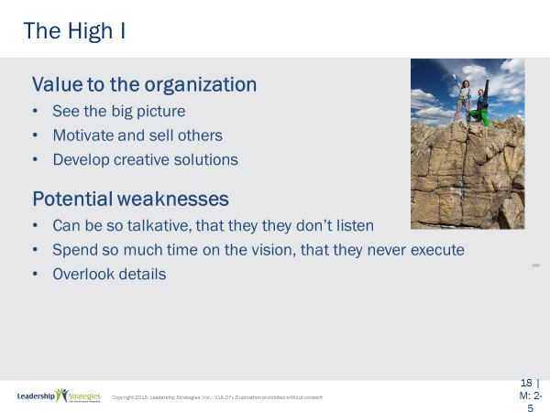 |  | SHOW POWERPOINT: The High I: Value to the organization  SAY:  (Name) get us started, read the 3 key points at the top of the slide. Next (name) what is the value to the organization of the High I? Ok, (name), what are those potential weaknesses?  ASK:  What do you think are some classic occupations of High Is?  (LOOK FOR: Sales, instructor, facilitator, actor/actress, etc.)
PPT: The High I: Key for I  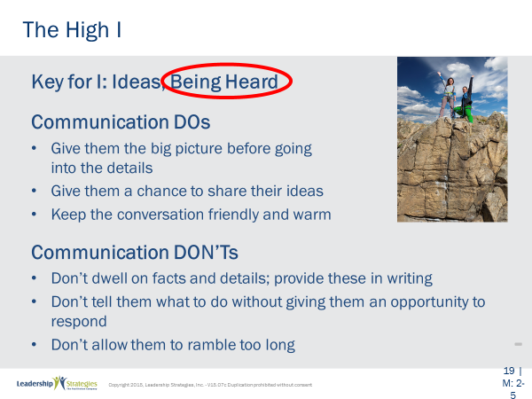 |  | SHOW POWERPOINT: The High I: Key for I  SAY:  Notice the High I is all about being heard. Please circle “Being Heard” in your manual. (Name) what about the communication dos for the I? And, (name), what about those communication don’ts, please?
PPT: The High I: Let them…   |  | SHOW POWERPOINT: The High I: Let them sell themselves!  POINT OUT:  Great, what we like to think of as the tagline for those High Is at Leadership Strategies is the following: “Let them sell themselves.”  Again, please make sure that you have circled “Being Heard” and write that tagline, “Let them sell themselves” in your participant manuals. Before we move on, can you think about people you know like this (raise your hand)? Yes, me too.
PPT: The High S: Helps others…  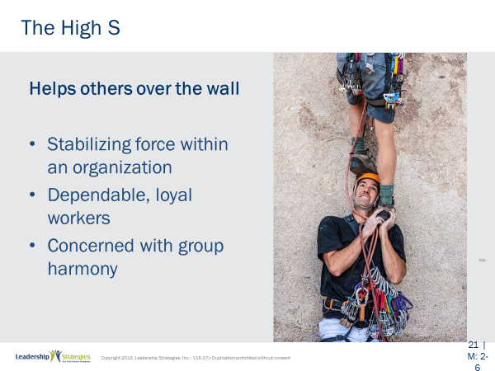 |  | SHOW POWERPOINT: The High S: Helps others over the wall  SAY:  Here is that wall again! It’s easy to understand the types by thinking of them as how each type gets to the other side of this wall that is a barrier to their goal. But before we look at that High S, let’s do some review of the D and I.  DO:  Continue the backward build up review by reviewing High I in the same way.  SAY:  Now, back to our High S. How do you think he/she deals with that wall (take a comment or two)? Good, you are on the right track. The High S is the first person to stand in front of that wall with their hands cupped ready to boost/help others over that wall to get to the other side.
PPT: The High S: Value to the Organization  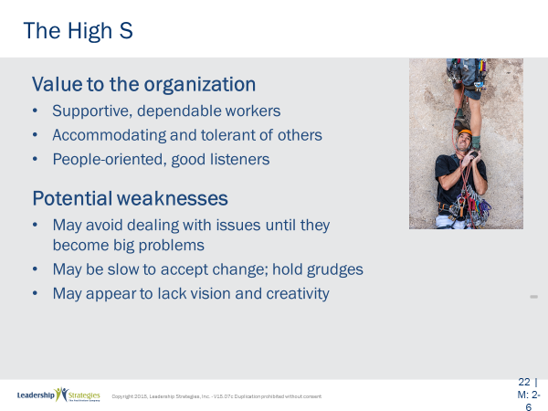 |  | SHOW POWERPOINT: The High S: Value to the Organization  SAY:  (Name) get us started, please read the 3 key points at the top of the slide. Next (name) what is the value to the organization of the High S? OK, (name), what are those potential weaknesses?  ASK:  What do you think are some classic occupations of High Ss?  (LOOK FOR: Social worker, counselor, teacher, nurse, etc.)
PPT: The High S: Key for S  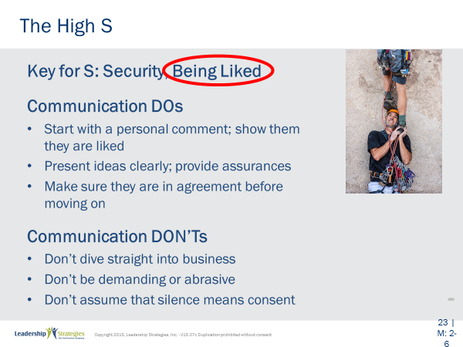 |  | SHOW POWERPOINT: The High S: Key for S  SAY:  Notice the High S is all about being liked. Please circle “Being Liked” in your manual. (Name) what about the communication dos for the S? And, (name), what about those communication don’ts, please?
PPT: The High S: Start personal; don’t assume  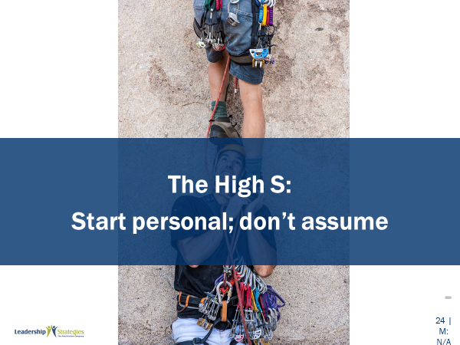 |  | SHOW POWERPOINT: The High S: Start personal: don’t assume  POINT OUT:  Great, what we like to think of as the tagline for those High Ss at Leadership Strategies is the following: “Start personal; don’t assume silence means consent.” Again, please make sure that you have circled “Being Liked” and write that tagline, “Start personal; don’t assume silence means consent” in your participant manuals. Before we move on, can you think about people you know like this (raise your hand)? Yes, I can think of some as well.
PPT: The High C: Develops….  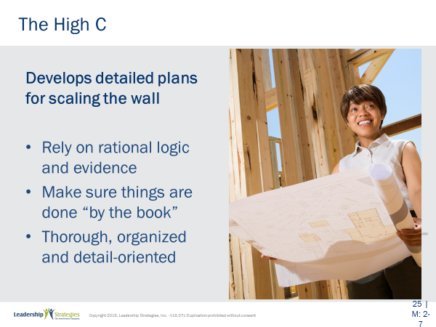 |  | SHOW POWERPOINT: The High C: Develops detailed plans for scaling the wall  SAY:  Here is that wall again. It’s easy to understand the types by thinking of them as how each type gets to the other side of this wall that is a barrier to their goal.  But before we look at that High C, let’s do some review of the D, the I and S.  (Blue) team, how do High Ds tackle the wall? That’s right they put their shoulder down and go through it.  (Purple) team, what are the classic occupations for the High D? That’s right directors, C-level and entrepreneurs.  (Red) team: The value to the organization?  (Green) team: The potential weaknesses?  Continue the backward build up review by reviewing High I and High S in the same way.  SAY:  Now, back to our High C. How do you think he/she deals with that wall (take a comment or two)? Good, you are on the right track. High Cs get out the ruler, the spreadsheet, and gather all the data they can. A few weeks later they will tell you something like “the wind is from the NE at 5 knots, so if you run at a speed of 9 miles/hour, hit the wall at 100-lbs psi at an angle of 45 degrees, you will get over that wall and land 3 feet 2 inches on the other side.”
PPT: The High C: Value to the organization  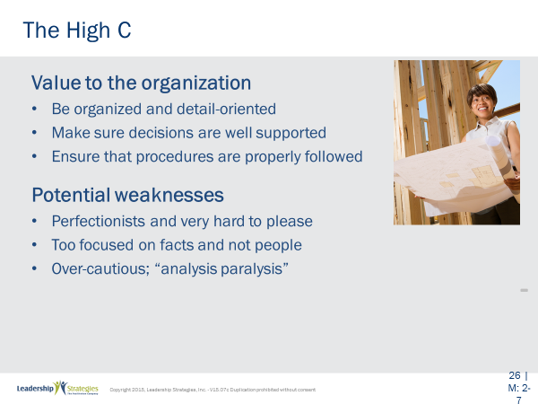 |  | SHOW POWERPOINT: The High C: Value to the organization  SAY:  (Name) get us started, read the 3 key points at the top of the slide. Next (name) what is the value to the organization of the High C?  ASK:  What do you think are some classic occupations of High Cs?  (LOOK FOR: Administrative professional, accountant, chemist, architect, etc.)
PPT: The High C: Key for C  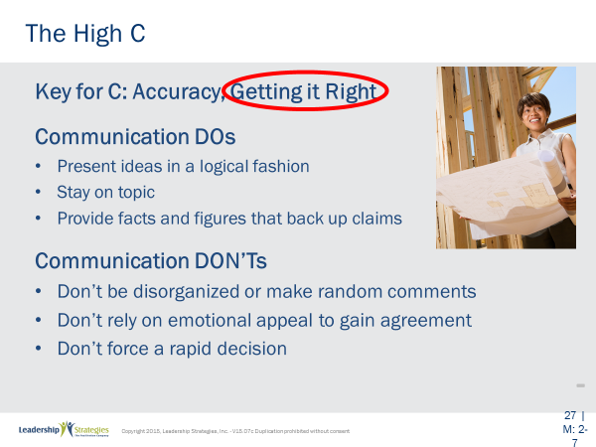 |  | SHOW POWERPOINT: The High C: Key for C  SAY:  Notice the High C is all about getting it right. Please circle “Getting it Right” in your manual. They do not need to be right; but when it comes to the solution or the answer they want to make sure the team gets it right. (Name) what about the communication dos for the C? And, (name), what about those communication don’ts, please? Great.
PPT: The High C: Give them time for the details   |  | SHOW POWERPOINT: The High C: Give them time for the details  POINT OUT:  What we like to think of as the tagline for those High C’ s at Leadership Strategies is, “Give them time for the details.” Again, please make sure that you have circled “Getting it Right” and write that tagline, “Give them time for the details” in your participant manuals. Before we move on, can you think about people you know like this (raise your hand)? Yes, I can think of some as well.  DO:  Time permitting, conduct one final round of review of the key points of each of the 4 styles – but asking the questions differently. For example:  SAY:  (Team red), tell me what each of the 4 letters in DISC stands for? Next team, tell me what each style does at the wall? Next team, what value does each style bring? Next team, what is a downside of each style? Next team, what is the key factor for each? Next team, what is the shorthand for dealing with each style?
PPTs: Review Slides  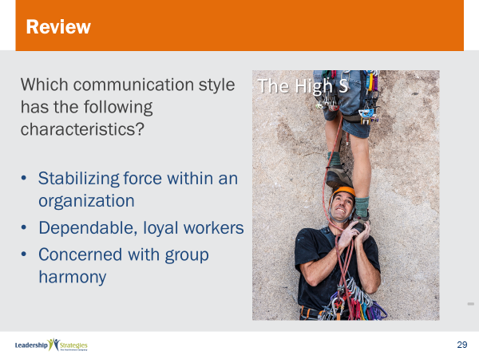 |  | SHOW POWERPOINT: Review Slides  SAY:  Now it is time to do some review. We’ll do this by table teams, starting with the (color) team and rotating clockwise. If your team gets the answer, dots for everyone on the team.
PPT: Agenda: Adapting to the styles of others  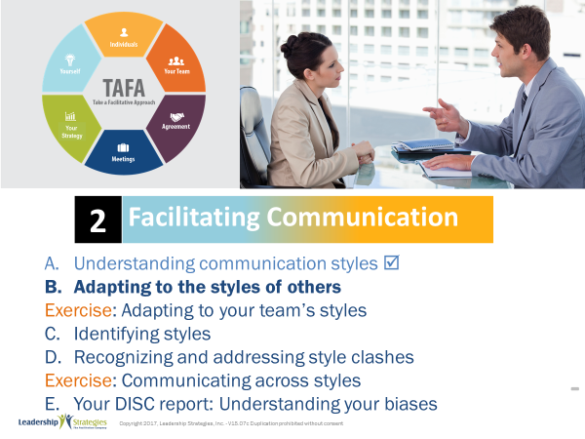 |  | SHOW POWERPOINT: Agenda: Adapting to the styles of others  Checkpoint:  We’ve taken a look at the four communication styles as a basis for our understanding and for creating a better communication strategy. Now, let’s continue laying the foundation for that strategy by looking at how one can adapt to the style of the person you are communicating with.
PPT: A Problem has arisen in your area  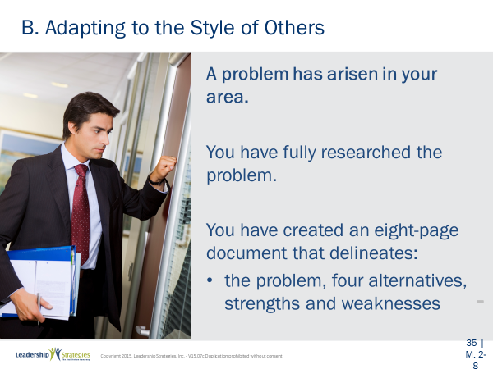 |  | SHOW POWERPOINT: B. A problem has arisen in your area  SAY:  Let’s try to apply what we have just covered about the characteristics of the 4 styles by using the scenario as follows.  DO:  Review scenario on slide
PPT: You favor alternative #4  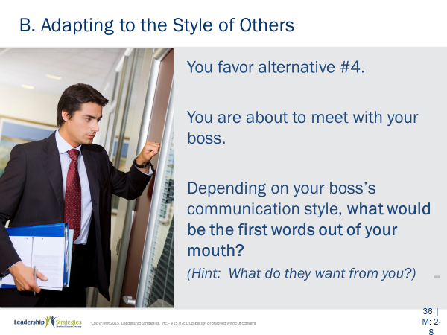 |  | SHOW POWERPOINT: B. You favor alternative #4  DO:  Continue reviewing scenario on slide.
DO:
Provide directions for the activity.
SAY:
Purpose:
In your table teams, apply the ways to adjust our styles based on the communication style of our boss or client. Let’s do the first one together.
Example:
(Do the review of the slide and conduct the High D together with your leading the first words out of your mouth.)
Directions:
Now that we are clear on what we need to do, let’s first assign new team leaders/spokesperson for each team.
(Use an appropriate method for designating team leaders such as first name farthest down in the alphabet, etc.)
Now, let me ask each team to take 3 minutes to decide how you would approach the I, the S and the C. Note that there is a space to write your answers in your participant manual. Team leaders, your manual is your teams answer sheet. So, if your team can’t come to agreement, YOU are the decision maker!
Questions:
Before we begin, are there any questions?
DO:
Start the timer. Allow 3 minutes.
When time is up, have a different team go first for each of the 3 styles checking in with other teams to discuss differences.
PPT: Your Boss is a High D  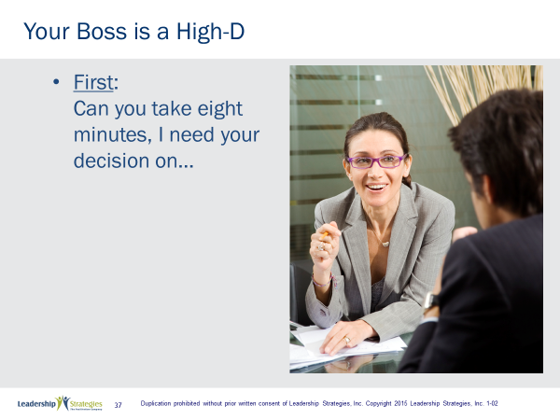 |  | SHOW POWERPOINT: Your Boss is a High D  SAY:  The first words out of your mouth are on the slide.
PPT: Your Boss is a High I  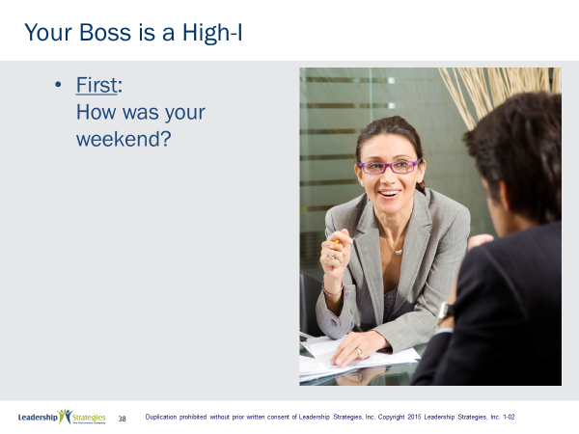 |  | SHOW POWERPOINT: Your Boss is a High I  SAY:  The first words out of your mouth are on the slide.
PPT 1: Your Boss is a High S  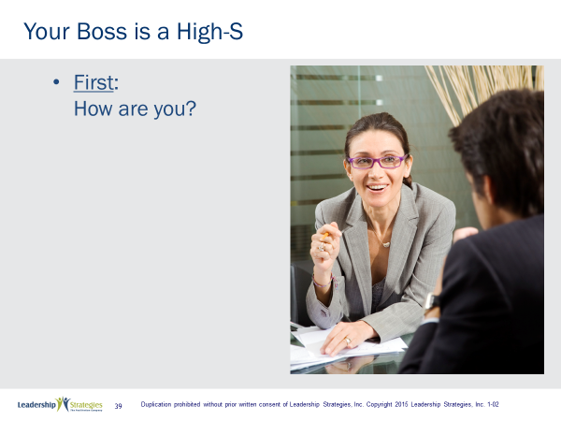 |  | SHOW POWERPOINT: Communication Styles  SAY:  First words out of your mouth are on the slide.
PPT: Your Boss is a High C  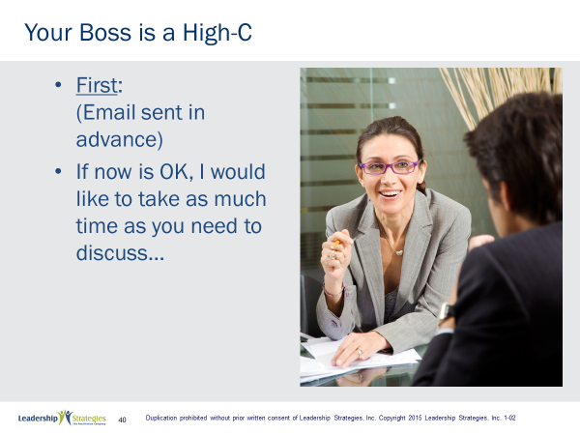 |  | SHOW POWERPOINT: Your Boss is a High C  SAY:  First words out of your mouth on the slide.
TRANSITION:
Now that you are warmed up, let’s go through the full conversation you would have with your boss depending upon your boss’ style.
PPT: Adapting to the Styles of Others  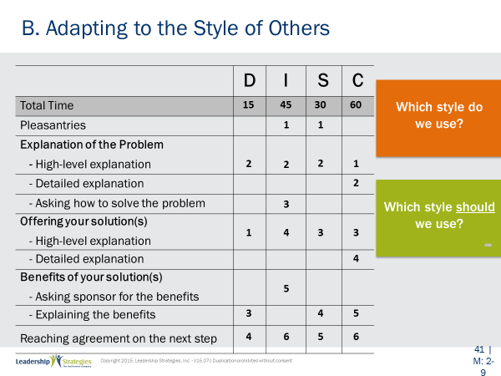 |  | SHOW POWERPOINT: B. Adapting to the Styles of Others  SAY:  Let’s assume that you are going to take 15, 30, 45 or 60 minutes to meet with your boss, with which style would you think you would plan to spend just 15 minutes? (Purple) team, what do you think? (Red) team do you agree? Other teams, any different thoughts? OK, that’s correct it would be the High D. Remember our friend the High D? The tagline for communicating with him/her is “be prepared, be brief, be gone,” so 15 minutes would be correct. Who would be 60 minutes? 45 minutes? 30 minutes?  SAY:  Now let’s look at the full conversation for each style. I am going to read through the list of activities and (Red) team, you tell me which activity you would do first for a High D.  DO: Read the list of activities on the slide.  SAY:  That’s correct, you would give a high-level explanation of the solution. What would you do next? And next…  DO:  Go through each of the four styles in this way. (See the Additional Detail About Each Style that follows this section.)  Key points to make:  - With High-Is you ask them how to solve the problem because this is the fun part for them, brainstorming solutions.  - If you asked High Ds how to solve the problem, they would kick you out of their office for being incompetent!  - With High Is you ask them for the benefit of the solution so that they will sell themselves on your idea. If you are telling them the benefits of your solution, the wrong person is speaking.  - You don’t ask High Ss how to solve the problem because that puts them on the spot.  - With High Cs the conversation is long because you are doing a lot of the talking. With High Is the conversation is long because they are doing a lot of the talking.  SAY:  - I would guess that the far majority of the people in this room use exactly the same style with their boss. Which style do you think it is? How many would say High D? I? S? C? Well, it is none of these styles. You know which style we use? OUR style! Which style should we use? THEIR style.  - Unfortunately, in most interactions, there is a conversation battle going on where each person is insisting that the other person communicates in his/her style.  - We say, “Stop the battle!”  - Effective communicators understand that you can be some much more effective when you communicate in the style of the other person.
TRANSITION:
OK, any questions or comments? Great, then let’s look at the two dimensions we have been using for the DISC communication styles and look at some other tips for adapting our styles to improved our communication with that style.

ADDITIONAL DETAIL ABOUT EACH STYLE
(Below is additional detail on the actual conversation with each style.)
Your Boss is a High D
- The alternative you are recommending
- The problem it solves
- Benefits associated with your recommendations
- Get confirmation on moving forward with your recommendation
Your Boss is a High I
(After pleasantries)
- I would like your input on….
- High level of the problem
- Ask for possible solutions
- Share your alternative…ask for comments/input
- Ask for associated benefits
- Ask for agreement to moving forward
Your Boss is a High S
(After pleasantries)
- I would like your help on something
- Summary of the problem
- Share your recommendation
- Share the benefits
- Ask for agreement to move forward
Your Boss is a High C
- High-level followed by detailed description of the problem area
- High-level review of the four alternative followed by a detailed review of +s and –s of each alternative
- Detail rationale for the alternative you are recommending
- Outline the need for consideration and the cost of any delay beyond (pick a date you need to get recommendation started)
- Gain agreement on how to move forward (which might include time for reflection)

PPT: Agenda: Exerciese: Adapting…  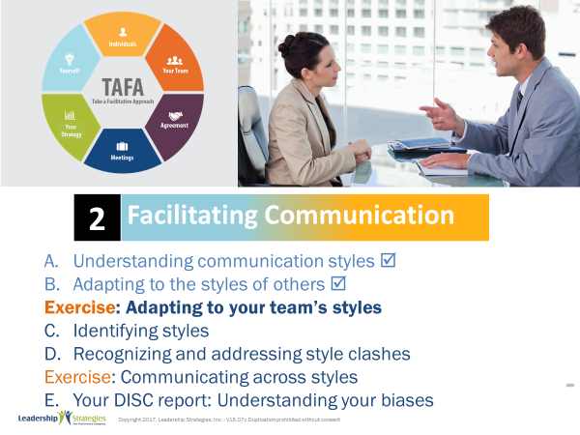 |  | SHOW POWERPOINT: Agenda: Exercise: Adapting to your team’s styles  Checkpoint:  We’ve looked at how one can adapt to the style of the person you are communicating with. Let’s apply this learning to your real situation so that you can begin improving your interpersonal communication with some specific individuals.
PPT: Spring Forward 2a: Adapting…  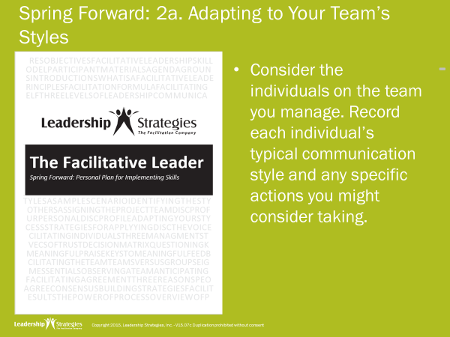 |  | SHOW POWERPOINT: Spring Forward 2a: Adapting to Your Team’s Styles  SAY:  Purpose:  The purpose of this exercise is to begin to explore communication strategies for people with whom you interact on a regular basis.  Example:  (Provide a personal example to ensure participants understand what to do. For example:  One of my colleagues, let’s name him Pat, is a (D, I, S, or C). One of the actions I’ve determined to take when communicating with Pat is to….)  Directions:  In the first column, write the names of those with whom you wish to improve your communication. You can start with the people you wrote down in your participant manual earlier. Then indicate their likely communication style. In the far-right column, write down at least one action you will take to adapt to each person’s communication style.  Questions:  What questions do you have about this exercise?  DO:  ALLOW 5 minutes. Ask for volunteers to share the communication style and the action they will take to adapt for one of the people on their list.
PPT: Agenda: Identifying Styles  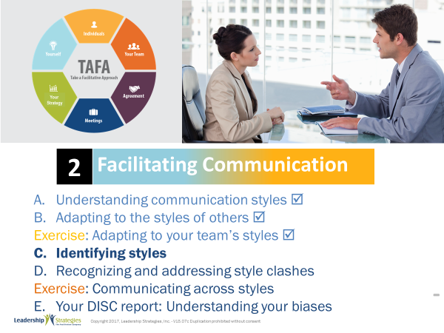 |  | SHOW POWERPOINT: Agenda: Identifying Styles  Checkpoint:  We’ve looked at the four styles and what drives them, and then some exercises around adapting to the styles of others. But what about if you don’t know the other person’s style? The good news is people “leak” by revealing their styles through their words, non-verbal cues, actions, and more! Let’s look at how to identify the styles of others so that we can adapt to that style and improve the communication.
PPT: Identifying Styles  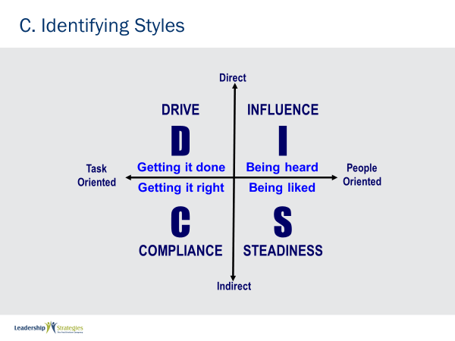 |  | SHOW POWERPOINT: C. Identifying Styles  SAY:  We could carry around a DISC test and ask our clients or colleagues to complete it so we can know how to communicate with them, but how realistic would that be? (Shake your head “no.”) Instead, let’s put more “meat on the bones” and look at the 2 dimensions of DISC.  Note: build the axis 1 at a time starting with Y then X.  SAY:  So, let’s start with the Y axis. DISC says there are direct communicators and indirect communicators. For example, if a direct communicator came into this room and the temperature was about 60 degrees, (red) team, what would a direct communicator say? That’s about right, “It’s cold in here” or words to that effect.  On the other hand, if an indirect communicator came into the same room at the same temperature, they might say something like, “Is anybody uncomfortable?” It’s not right, it’s not wrong, it just is. We need to realize that when an indirect communicator says, “Is anybody uncomfortable?” that is the same as when the Direct Communicator says, “It’s cold in here.”  Now, let’s look at the X axis. You’ll note how those who are task-oriented focus on “getting” – getting it done, getting it right, while those who are people oriented focus on “being” – being heard, being liked.  As an example, assume your manager has been on vacation for two weeks. On her first day back at the office, she sees you walking down the hall. If she is people-oriented, what would might be the first words out of her mouth? That’s right, “How are you doing? How’s your family?”  She would be concerned about your relationship. She wants to get an update on what is happening with you and your life. Now, if she were task-focused what would be the first words out of her mouth. That’s right. Something like, “Joe, I’m glad I ran into you. How is the project going? What’s the status? Anything I need to be aware of?”  Once more, it is a different orientation. So let’s go back to the chart. People who are direct and task-oriented tend to communicate like a high D. People who are direct and people-oriented tend to communicate like high Is. High Ss tend to be people-oriented and indirect, and high Cs tend to be indirect and task-oriented.  Notice that the styles on the left tend to be about “getting it” while styles on the right tend to be about “being.” Once more, a different focus.  So let’s take some examples of people we all know. How about our president. Is this person direct or indirect? Task-focused or people-focused? So this person tends to communicate like a…Let’s take another…And one more…
TRANSITION:
So you can use the quadrants to help you identify someone’s communication style. But let’s look at other ways in which folks “leak” their communication styles.
PPT: Identifying Styles: The Voice Mail  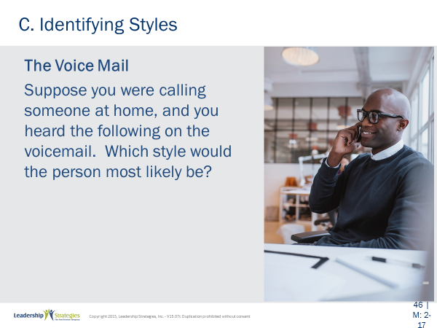 |  | SHOW POWERPOINT: Identifying Styles: The Voice Mail  Read the scenario on the slide.
PPT: Identifying Styles: The Voice Mail: D  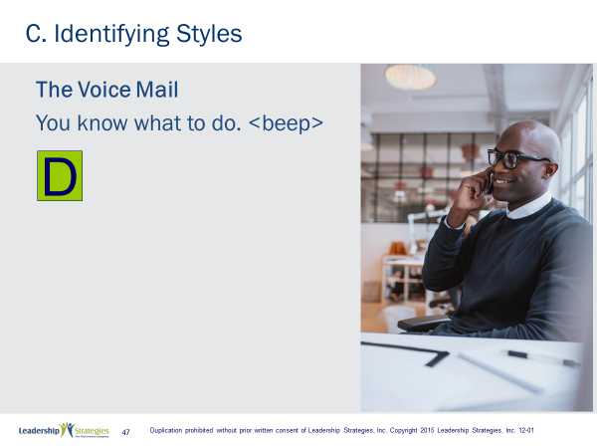 |  | SHOW POWERPOINT: Identifying Styles: The Voice Mail: D (build)  DO:  For this, and the next 3 slides, read the voice mail message and ask the group to identify which DISC style would leave that type of message.  REVEAL the style type on the slide.
PPT: Identifying Styles: The Voice Mail: C  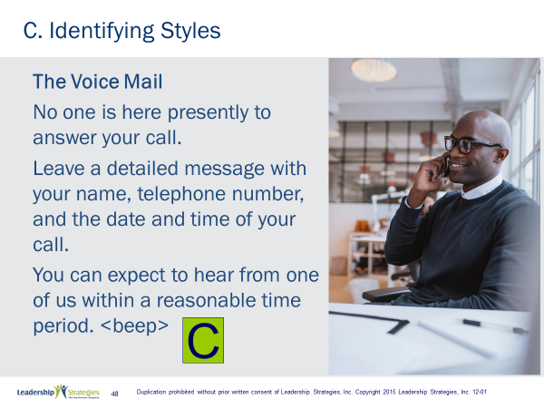 |  | SHOW POWERPOINT: Identifying Styles: The Voice Mail: C (build)  DO:  Read the voice mail message and ask the group to identify which DISC style would leave that type of message.  REVEAL the style type on the slide.
PPT: Identifying Styles: The Voice Mail: S  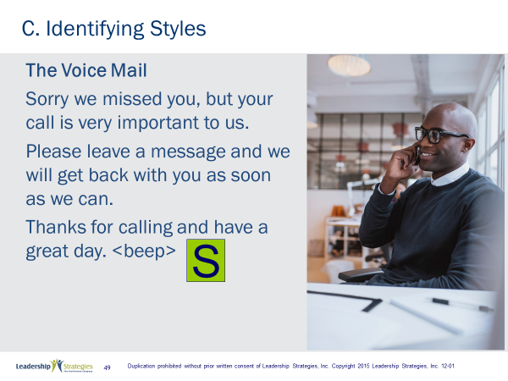 |  | SHOW POWERPOINT: Identifying Styles: The Voice Mail: S (build)  DO:  Read the voice mail message and ask the group to identify which DISC style would leave that type of message.  REVEAL the style type on the slide.
PPT: Identifying Styles: The Voice Mail: I  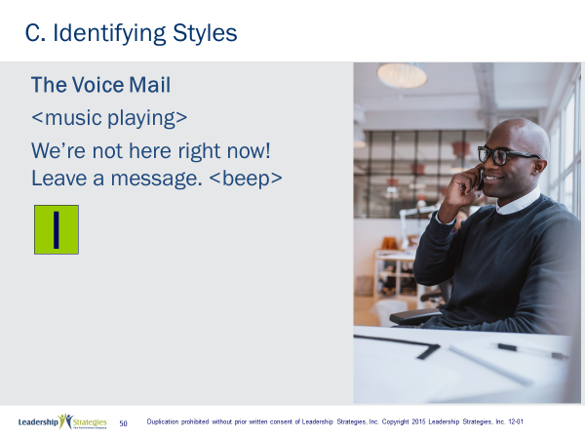 |  | SHOW POWERPOINT: Identifying Styles: The Voice Mail: I  DO:  Read the voice mail message and ask the group to identify which DISC style would leave that type of message.  REVEAL the style type on the slide.
TRANSITION:
Great! You see? People leak! Let’s look at some actual folks speaking, and see if we can identify their style.
PPT: Identifying Styles: Videos  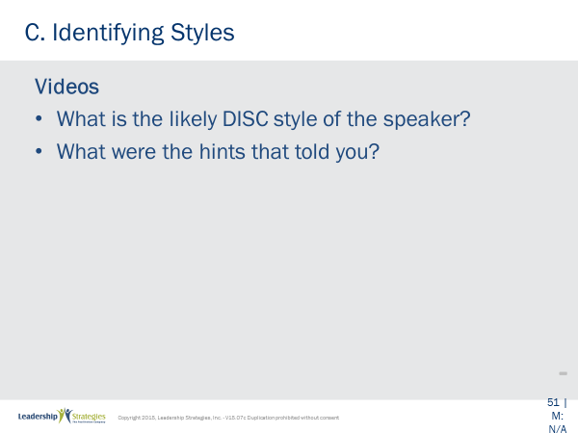 |  | SHOW POWERPOINT: Identifying Styles: Videos  SAY:  We are going to look at four videos. For each video, see if you can determine the primary communication style of the person in the video. These people work for Leadership Strategies and were asked two questions, “What do you like about working here?” and “What would you change to make it better?” Listen to answers to the second question especially. When you ask people what they don’t like or how to improve something, you can get much greater insights into their communication style.
PPT: Jamie’s DISC Style  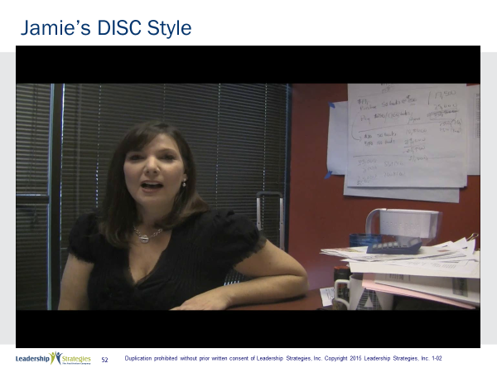 |  | SHOW POWERPOINT: Jamie’s DISC Styles  DO:  ASK participants which is Jamie’s primary communication style.
PPT:Doug’s DISC Style  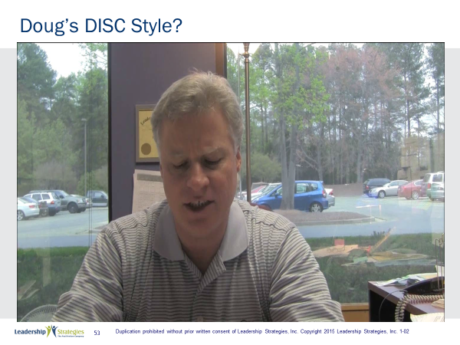 |  | SHOW POWERPOINT: Doug’s DISC Styles  DO:  ASK participants which is Doug’s primary communication style.
PPT: Sandra’s DISC Style  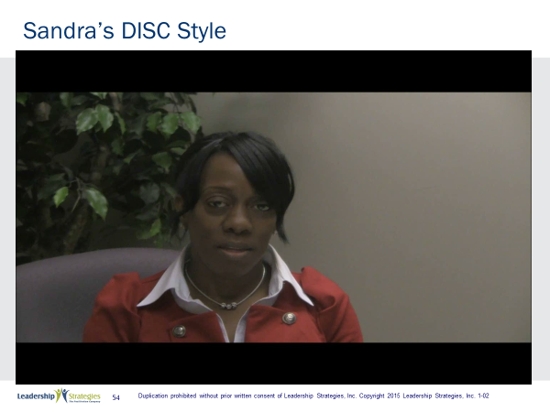 |  | SHOW POWERPOINT: Sandra’s DISC Styles  DO:  ASK participants which is Sandra’s primary communication style.
PPT: Patty’s DISC Style  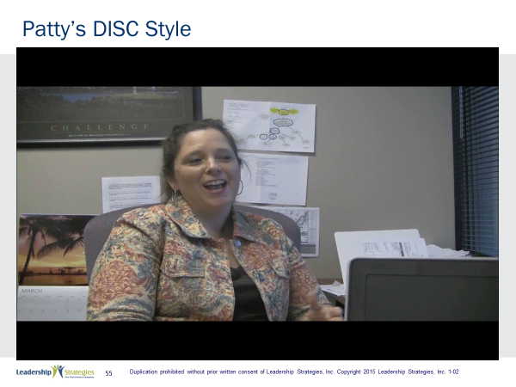 |  | SHOW POWERPOINT: Patty’s DISC Styles  DO:  ASK participants which is Patty’s primary communication style.
TRANSITION:
And I have to work with those people! Just kidding! Actually, having a balance of communication styles on our team is one of the things that makes us more effective. At Leadership Strategies we like to celebrate communication styles!
Next, let’s look at some folks that you may already know, celebrities, and examine their communication styles.
PPT: Mark Cuban  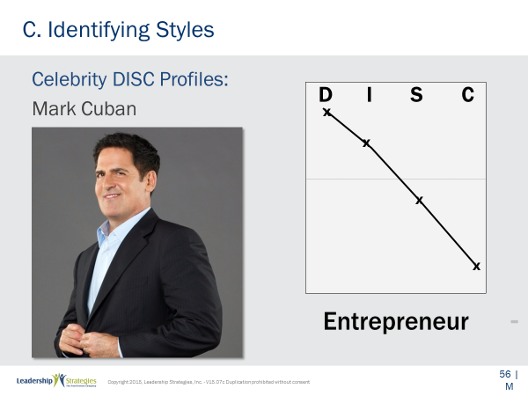 |  | SHOW POWERPOINT: Mark Cuban  SAY:  Here is a sample of a typical DISC profile for a famous High D, Mark Cuban. (Red) team, help us by telling us what your observation is on this profile.  DO:  Guide the discussion.
PPT: Oprah Winfrey  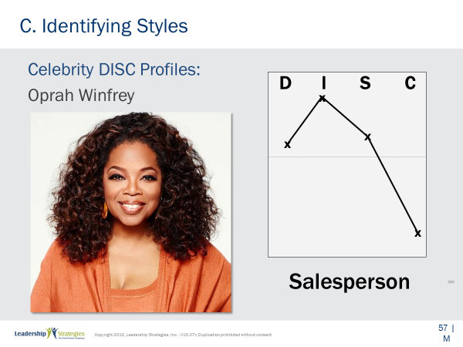 |  | SHOW POWERPOINT: Oprah Winfrey  SAY:  Here is a sample of a typical DISC profile for a famous High I, Oprah Winfrey. (Green) team, help us by telling us what your observation is on this profile  DO:  Guide the discussion.
PPT: Michelle Obama  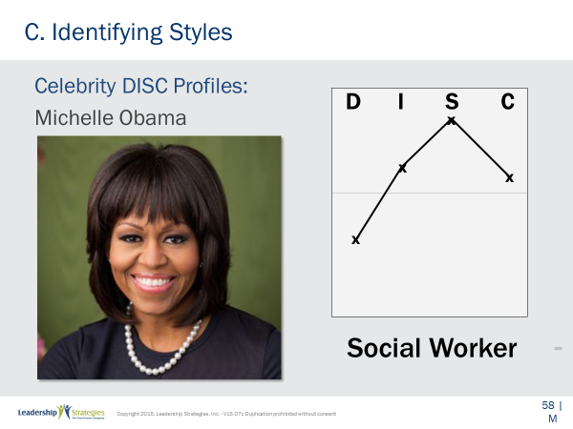 |  | SHOW POWERPOINT: Michelle Obama  SAY:  Here is a sample of a typical DISC profile for a famous High S, Michelle Obama. (Blue) team, help us by telling us what your observation is on this profile.  DO:  Guide the discussion.
PPT: Bill Gates  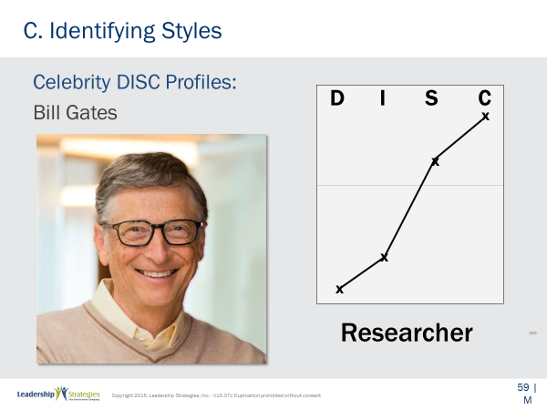 |  | SHOW POWERPOINT: Bill Gates  SAY:  Finally, here is a sample of a typical DISC profile for a famous High C, Bill Gates. (Purple) team, help us by telling us what your observation is on this profile.  DO:  Guide the discussion.
PPT: Agenda: Recognizing and …  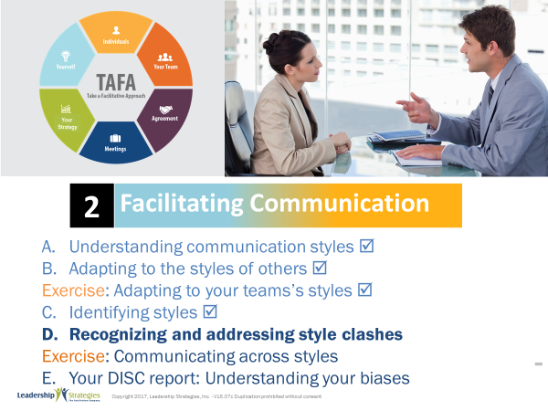 |  | SHOW POWERPOINT: Agenda: Recognizing and addressing style clashes  Checkpoint:  We’ve looked at the four styles and what drives them, and then how to adapt to the styles of others, and then recognizing other styles. But what happens when our style really clashes with the other person’s style. What drives those style clashes and knowing that, how can we adjust to avoid them?
PPT: Recognizing and Addressing Style Clashes: Strong Dislike High I  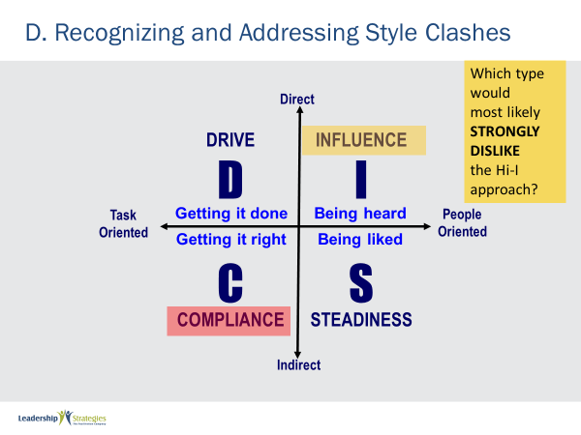 |  | SHOW POWERPOINT: Strong Dislike: High I  ASK the question on the slide.  SAY:  That’s right: the High C. If you think about it, it makes sense that folks that who are direct, people oriented, and focus on being heard, would have challenges communicating with folks who are indirect, task oriented, and focused on getting it right.  What would the High Cs say about the High Is? That’s right, “They are too fluffy, unrealistic, not focused.” What would the High Is say about the High Cs? “They are too cautious, too detailed, kill joys.”  POINT OUT:  What’s interesting is that if you think about it, the two styles actually complement each other very well. What does a High I need? Someone to do the detail work. What does a High C need, so what to bring the ideas. So, when a High I and a High C learn to communicate with each other effectively, it can be a match made in heaven. When that doesn’t happen, it can be a match made in the other place.
PPT: Recognizing and Addressing Style Clashes: Strong Dislike High D  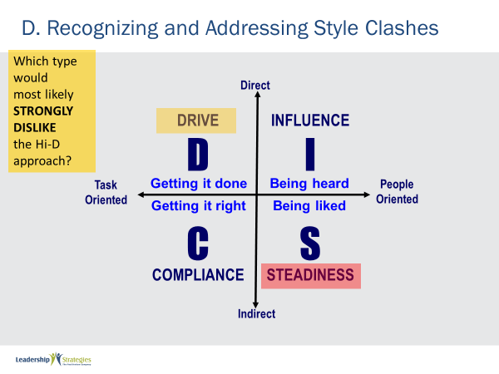 |  | SHOW POWERPOINT: Strong Dislike: High D  DO:  ASK the question on the slide.  SAY:  That’s right: the High S. If you think about it, it makes sense that folks that who are direct, task oriented, and focus on getting it done, would have challenges communicating with folks who are indirect, people oriented, and focused on being liked.  What would the High Ss say about the High Ds? That’s right, “They are pushy, demanding, and sometimes mean.” What would the High Ds say about the High Is? “They are too soft, don’t take a stand, and not willing to make the tough decisions.”  POINT OUT:  What’s interesting is that if you think about it, the two styles actually complement each other very well. What does a High D need? People to follow them. What do most Ss look for? A leader they can believe in. So when a High D and a High S learn to communicate with each other effectively, it can be a match made in heaven. When that doesn’t happen, it can be a match made in the other place.  SAY:  Look at those folks whom you identified at the beginning of this section of the workshop. Are you starting to see why you are having challenges communicating with those persons?
TRANSITION:
Let’s try another activity in our teams.
PPT: Assigning the Project Team  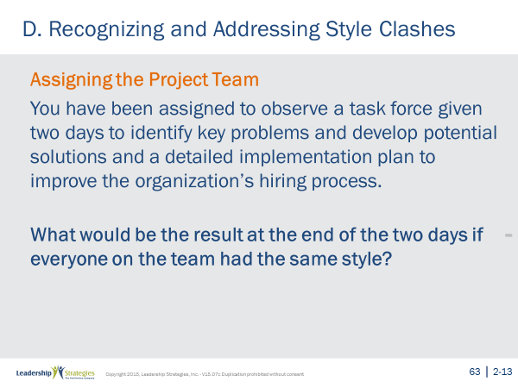 |  | SHOW POWERPOINT: Assigning the Project Team  SAY:  Purpose:  Let’s see what would happen if there were a team of people all with the same communication style. In other words, we are observing a group of people working together, and all of them are High Ds, High Is, High Ss or High Cs.  First, let’s answer the first column together. “What would be the key issue or dysfunction with the group?” If everyone in the room was a High D, what would be the key issue? The way to look at that would be to ask if the key factor is “getting it done,” then what would be the key issue be with that group? Fill in the blank with a one-word verb. Who _____. That’s right, who leads. Can you imagine what the conversation would be like as each one tried to command the group? What about if each person was a High I? How about a High S? How about a High C?
PPT: Assigning the Project Team What would be the key issue….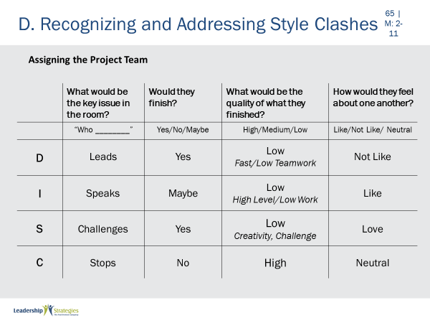 |  | SHOW POWERPOINT: Assigning the Project Team: What would be the key issue in the room? (build)  GIVE DIRECTIONS:  So let’s have your teams fill out the other 3 columns. First, let’s assign a new leader of each team.  (Use an appropriate method for designating team leaders such as team member with the most siblings, etc.)  Team leaders, here are the three other questions we would like you and your team to answer for each group:  The 2nd column is answered this way, “if this communication style was assigned that task, would they finish it in the assigned time?” In other words, would a group of High Ds, High Is, High Ss or High Cs complete the task assigned to them?  For the 3rd column, we would like you to ask yourselves this question: “Regardless of whether they finished, what would be the quality of they did finish?”  The last column answers, “At the end of the task, how would the team members feel about each other?”  (NOTE: After completing the first column together you may assign a row to each team to complete.)  QUESTIONS:  Are there any questions?  DO:  Allow 2 minutes then ask teams to share out.
TRANSITION:
Here is another perspective to think about: while we might prefer to interact with certain people, effective teams have a multitude of styles to be most effective.
POINT OUT:
There are many reasons for this, and this activity will demonstrate 1 key reason: certain activities are often better suited to different styles.
PPT: Assigning the Project Team: Which style would be best?  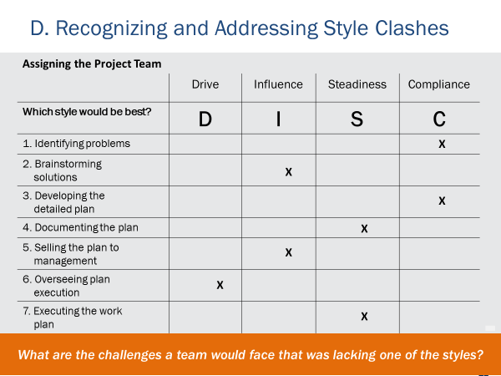 |  | SHOW POWERPOINT: Assigning the Project Team: Which style would be best?  DIRECTIONS:  Let’s complete this activity as follows. For each of the activities the project team will have to complete, which communication style would be best at that activity?  ACTION:  Either do as an entire group with a team round robin or break into small teams, each team completes their answers and then do round robin by teams to review responses.
PPT: Recognizing and Addresssing Style Clashes  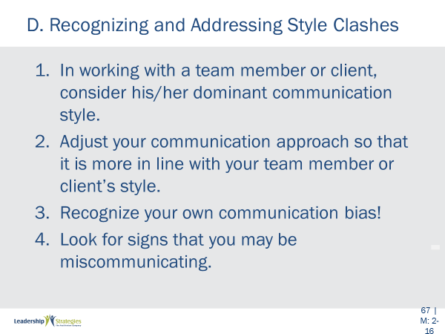 |  | SHOW POWERPOINT: Recognizing and Addressing Style Clashes  POINT OUT:  We’ve talked about the “What” (different communication styles) and the “So What” (the importance of adapting to the style of others), let’s move to the “Now What.” To be the most effective communicator possible, it is not enough to understand the communication styles and their characteristics, and it’s not enough to by willing to adapt our style for better communication with others (although this is a good start). To be truly effective, you must do these things well and also be constantly vigilant to recognize when you may be miscommunicating. The key here is to understand your own bias, recognize the signs of miscommunication, and know how to quickly adjust to let others know you are able and willing to communicate more effectively with them.
PPT: Warning Signs: D&I  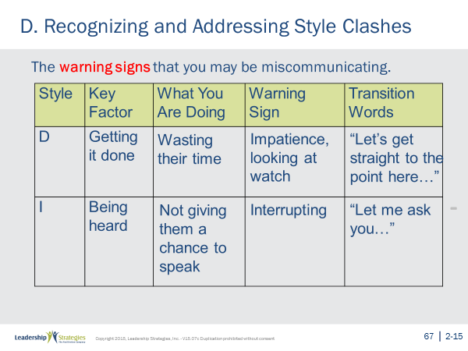 |  | SHOW POWERPOINT: Warning Signs: D&I  SAY:  Let’s look at the 4 DISC styles, each of the styles’ key factors, and then determine some of the signs we might look for that would alert us that we might be miscommunicating with each of the styles.  DO:  Go through each style asking a team and facilitating the discussion. Some key points:  - High Ds: Might work on other things, could even say, “That’s OK, go ahead, I’m listening”, tap their feet, turn to their PC to multitask, look at their watch for time, etc.  - High Is: Interrupt constantly, ramble or go back to talk about something that has already been covered because they did not get to finish what they wanted to say, etc.
PPTs: Warning Signs: S&C  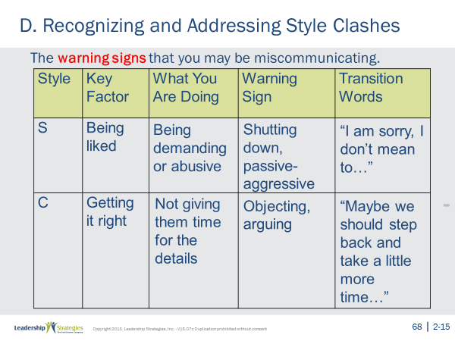 |  | SHOW POWERPOINTS: Warning Signs: S&C  DO:  Go through each style asking a team and facilitating the discussion. Some key points:  - High Ss: Can be difficult to read, tend to provide less eye contact and get very quiet. (You may want to be very careful in wording your questions from, “What do you think?” to “How might we make this better?” Over the longer term look for head nods in the meeting but no action after the meeting.)  - High Cs: Keep asking for more data and research, object or argues with you, ask you to take them through what you did, keep returning to previous topics to get additional information, etc.
PPT: Agenda: Exercise: Communicating across styles  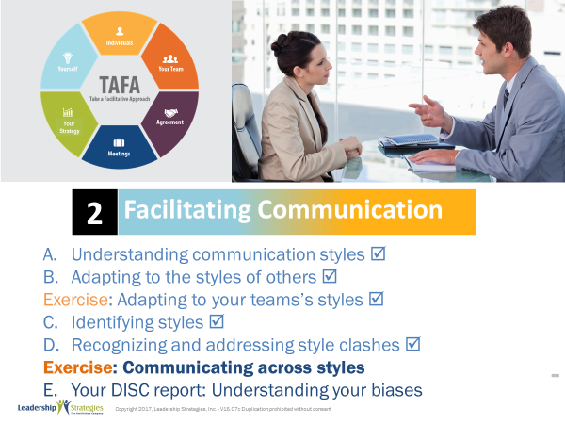 |  | SHOW POWERPOINT: Agenda: Exercise: Communicating across styles.  CHECKPOINT:  So, we have learned how to identify and communicate with the four styles, and even looked at how to identify and overcome style clashes. Now, let’s put what we’ve learned so far all together with our next exercise. By practicing what we’ve learned, you’ll be better able to apply your new skills in your actual situations.
PPT: Spring Forward 2b  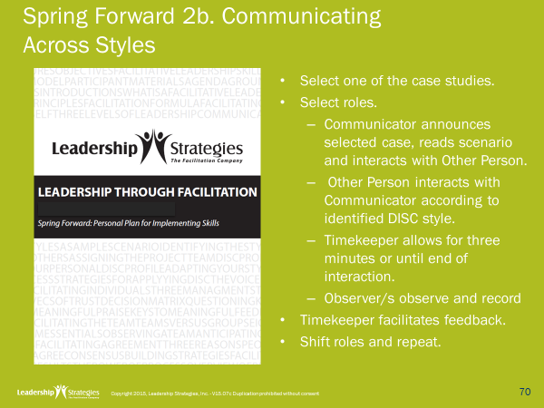 |  | SHOW POWERPOINT: Spring Forward 2b  ACTION:  For this exercise, work in teams of 3 or 4. Assume that it will require you 5 minutes to explain, 5 minutes for them to get started, 6 minutes per participant, and 5 minutes to debrief the activity. So, if your largest team is 4 this will require about 40 minutes in total.  SAY:  Purpose:  The purpose of this activity is to practice applying what you’ve learned so that you can be a better communicator.  Directions:  (Review directions in Spring Forward booklet. You may wish to do this as a read-around.)  Questions:  Are there any questions?  DO:  Allow up to 40 minutes depending on group sizes.  DEBRIEF the activity by asking:  - What went well?  - What was challenging?  - What did you learn?  - How can you apply what you’ve learned in your real-life situations?
PPT 1: Your DISC report: Understanding your biases  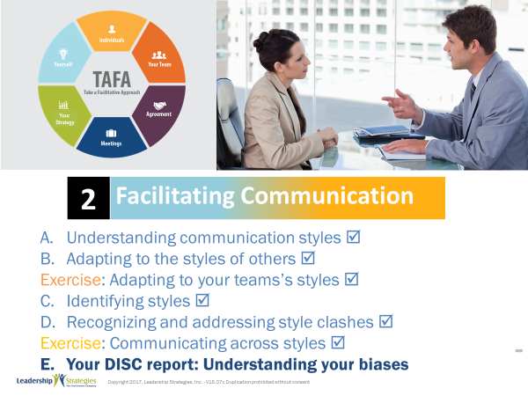 |  | SHOW POWERPOINT: Your DISC report: Understanding your biases  CHECKPOINT:  We’ve spent most of our time focusing on the communications styles of others and how to adapt to them. But I’m sure you all have been dying to see your DISC report, so let’s look at your style. This will allow you to be even more effective in communicating with others by understanding your own communication preferences and biases.
PPT: Your Personal DISC Profile  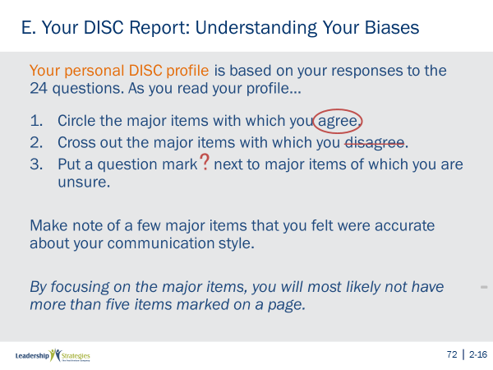 |  | SHOW POWERPOINT: Your Personal DISC Profile (build)  SAY:  For our next activity, we would like you to review your DISC profile and do the following:  - Circle the major items with which you agree.  - For items with which you do not agree, mark those with an “X.”  - For items you are not certain about, or think that they might or might not describe you, mark those with a question mark.  You may find it very interesting to ask someone that knows you very well to review your DISC Profile and do the same as you. You may find that person’s comments very insightful as they can give you another perspective on how other people may “see” you.
PPT: Optional Activity  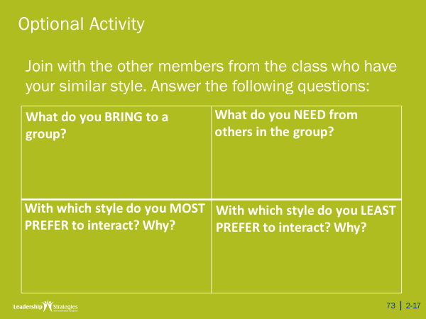 |  | SHOW POWERPOINT: Optional Activity  If time permits, you may conduct this optional activity. You may want to have this slide hidden unless you are sure you will use it.  SAY:  Purpose:  The purpose of this activity is to identify how you can best interact with others in a group.  DO:  READ the directions on the slide. Facilitate by pointing out a space in the room for each of the communication types to gather and complete the exercise on a flip chart.  You may want to have individuals complete before discussing with their style group. You can remind participants that there is space in the participant manual to record their answers.  Allow 8-10 minutes depending on how much time is remaining.  Debrief by having groups report out.  KEY POINTS:  - During the exercise, look for group behaviors that might be characteristic of their style (e.g., the chart from the High Cs being exceptional detailed; the High Ds finishing first; the energy and loudness of the High Is, the supportive comments prevalent with the High Ss).  - During the debrief ask the groups to self-identify behaviors that might be characteristic of their style. Share behaviors you have noticed.  - For the quadrant “With which style do you least prefer to interact with? Why?” ask the group who wrote the chart, “What do you typically do when that style exhibits the behavior”  - Then turn to the group that was “least preferred” and ask them, “In general, would that response be effective with you?”  - Follow-up with a second question to the “least preferred” group, “What response might be even more effective?”  - Once you have processed all four groups in this way, be sure to point out, “What do most of us do when we are having trouble with a style different from our own? We go to people with our same style, who commiserate with us because they are having the same problem with that style! Instead we should go to someone with the style of the other person to gain insights on how we can be more effective.”
PPTs: Review Slides  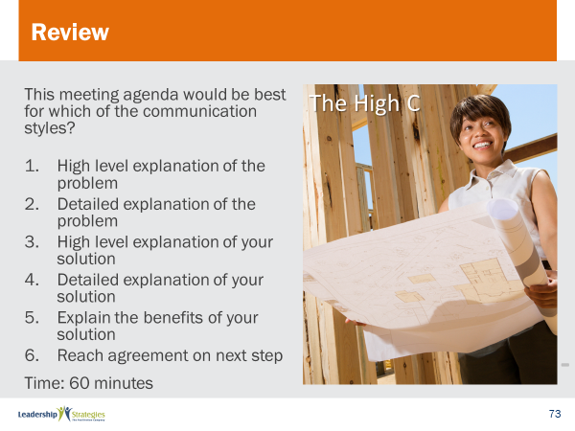 |  | SHOW POWERPOINTS: Review Slides  SAY:  Now it is time to do some review. We’ll do this by table teams, starting with the (color) team and rotating clockwise. If your team gets the answer, dots for everyone on the team.
PPT: Spring Forward In-Class/Homework  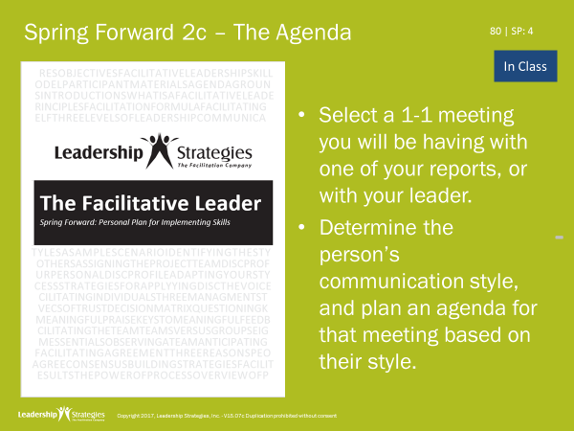  Or  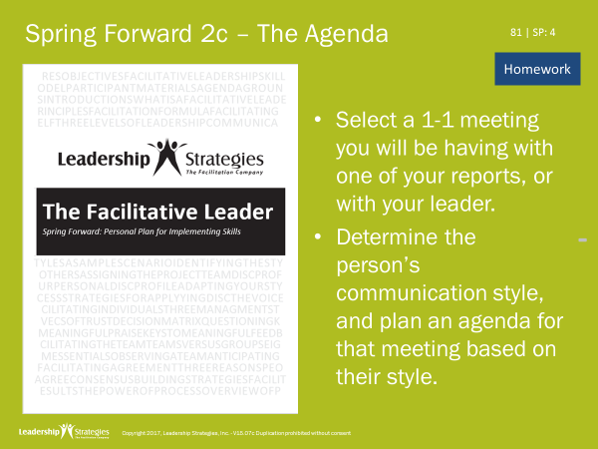 |  | SHOW POWERPOINT: In-class/Homework slides (builds)  Note to Instructor: This will either be an in-class activity (if another module follows or it is the last module for the client) or it will be homework because the participants will be coming back at another time. Use the appropriate slide.  IN-CLASS ACTIVITY:  SAY:  Let’s pull out the Spring Forward manual so we can focus on applying what we just learned.  DO:  READ through the activity. ALLOW 10 minutes. PROCESS responses as time allows. For example, have them share with one partner, have them talk at tables, have one person from each table share their view, etc.  or  DESCRIBE HOMEWORK:  SAY:  Before closing out, let’s talk about homework that will help put application to what we’ve learned today.  (READ the first two bullets.)  SAY:  When we come back together we will want to hear three things:  - Who did you select (title)?  - What was the person’s communication style?  - How did you change your agenda to adapt to that person’s style?
PPT: Agenda  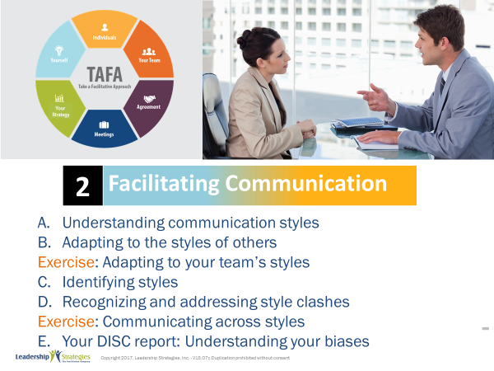 |  | SHOW POWERPOINTS: Agenda  SAY:  We have just completed the module!
PPT: TAFA  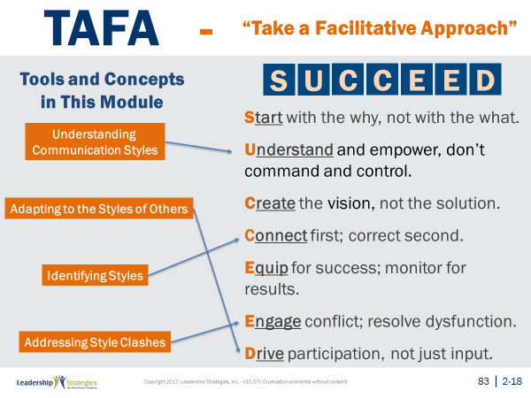 |  | SHOW POWERPOINTS: TAFA (build)  SAY:  Let’s take a moment to look at some of the concepts we’ve learned in this module and examine how they reflect the TAFA principles.  DO:  REVIEW slide and lead discussion by asking if there are other principles that are reflected by the concepts.
PPT: Checkpoint  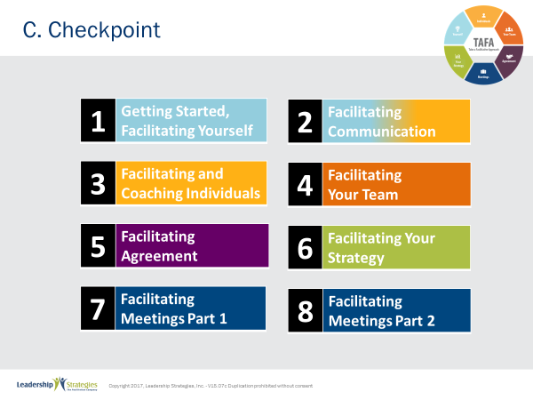 |  | SHOW POWERPOINTS: Checkpoint  CHECKPOINT:  We have just completed our Facilitating Communication module. Next we will be looking at specific strategies for coaching individuals. These techniques will help you facilitate the development of your people so they can be more effective and successful.
PPT: Connect with LSI  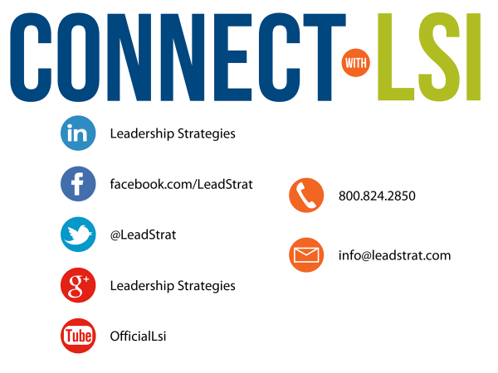 |  | SHOW POWERPOINTS: Connect with LSI  Note to Instructor: this slide may be excluded if you are going directly into the next module. In that case, hide the slide.  SAY:  We fundamentally believe facilitation is a skill that applies in a multitude of situations. We also are confident that, in our quest to “share the power of facilitation with the world,” connecting via social media is a way for all of us to collectively share our successes, our challenges and our facilitation work. To “facilitate” that process, we want to ensure you are aware of how we can all stay connected using social media.  How many of you have found many of the skills in the class helpful? [raise your hand] I know that one of the things I did after attending was share what I learned with many of my colleagues. Have some of you already thought about that? [nod your head]  Then, one request we would like to make of you is to update your “education or classes attended” on your LinkedIn profile. That visibility will help all of us to “share the power” I have been referring to. Any questions?  FACILITATE the discussion
PPT: Congratulations!  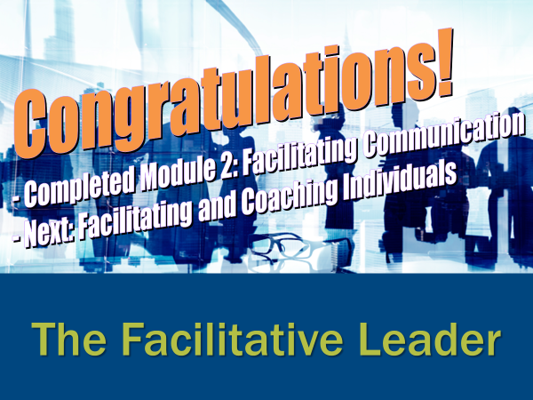  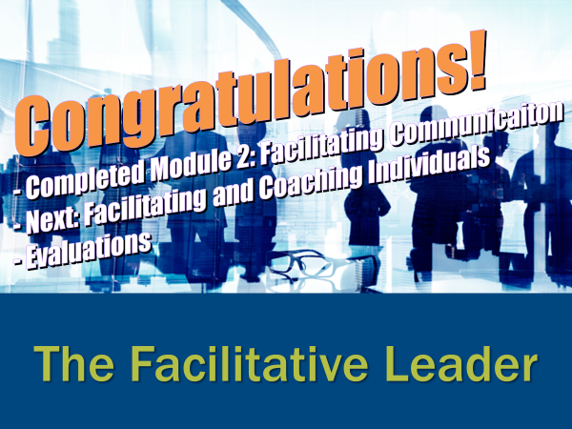   |  | SHOW POWERPOINT: Congratulations! (builds)  Note to Instructor:  There are three congratulation slides. Select the correct slide depending on whether you are:  - Moving on to the next module immediately (slide 1)  - Coming back another day to do the next module and therefore need to do an evaluation (slide 2)  - Have completed the workshop and therefore need to close out the class with the post-test, evaluations, dot winner (MVP), and the From Classroom to Application sheet (slide 3)  Hide the other two congratulations slides.  DO:  REVIEW and execute the content on slide.  EXECUTE THE POST TEST:  If appropriate, handout the post-test. Give people five minutes to complete. Ask teams to give their cheer once completed.  Once completed, have team members pass their post-test clockwise to a new person. Go through each question and have the group give responses. Instruct them to place a checkmark for each correct response.  Once completed have people add up the number of check marks and place the total at the top.  Since each post-test has eight questions, place the number 8 through 0 in the first column of a two-column chart.  Before people hand the post-tests back to the owner, do a round robin and have people indicate the number the person got corrected. Place a tick mark next to that number each time that number is reported.  THANK participants and dismiss class.
 | End | END OF THE FACILITATIVE LEADER MODULE TWO

