The Facilitative Leader
Module 1: Facilitating Yourself

Instructor Guide

Table of Contents
Facilitator’s Information
Table of Contents 1
How to Use This Guide 2
Symbols Used in the Facilitator’s Guide 3
Participant Pre-Work 4
Materials & Equipment for Module One of The Facilitative Leader 5
The Facilitative Leader Module One: Summary Agenda 6
Module 1: Overview 9
Module 1: Getting Started Contents 10

How to Use This Guide
Each section of the Facilitator’s Guide covers the following:
- Work you’ll need to do prior to the workshop,
- Materials and equipment you’ll need for the workshop, and
- Instructions and verbiage to conduct the workshop.
Headings
The heading for each section indicate the information that will be covered in that particular section.
Instructions Section
On the right-hand side of the workshop instructions pages you’ll find the approximate number of minutes required to complete a topic.
The format for the instructions section contains 2 columns as follows:
- Left-hand Column:  - Contains graphics, such as a copy of a slide or an icon, indicating the major aspect of the training segment. For example, a television set icon indicates that a video will be shown. The next page shows the various icons used. | - Right-hand Column  - Describes the activity to be completed and contains possible starting questions you can ask about the topic to engage participants in a discussion or an activity.  - Lists the information or instructions to be conveyed to the participants.  NOTE: This Facilitator’s Guide is not intended to be used as a script. The words in this column give you one particular example of how to deliver the content. Part of your preparation is to review this guide and become familiar with its contents, structure, and flow. You should feel free to use your own words, adjust the delivery to your own style, while also adapting to the needs of the particular group you are facilitating. At all times, be sure to show enthusiasm and comfort with the material when you are presenting. This will provide a more enjoyable and meaningful session for your participants.
For each activity, before the facilitator directions, there is an introductory section outlining:
- Materials needed.
- Realizations or key learnings that should take place.
- Facilitation tips.
 | Anything in a gray box means that you will be “doing” something rather than presenting.

Symbols Used in the Facilitator’s Guide
There are a number of symbols used in this Facilitator’s Guide to serve as prompts for the type of activity occurring at that point in the program. Here is a list of those symbols and what they mean.
 | Presentation |  |  | Point out key information
 | Spring Forward Exercise |  |  | Pull through previous learnings
 | Pair Discussion/Exercise |  |  | Participant Manual “Write-along”
 | Group Discussion/Exercise |  |  | UMU activity
 | Write responses on a flip chart |  |  | Checkpoint
 | Transition to next topic
In some cases, an activity will transition from one type to the other (e.g. from individual to group discussion). In such cases, more than one symbol may be used in chronological order.

Participant Pre-Work
None for this module.

Materials & Equipment for Module One of The Facilitative Leader
Following is a list of the materials to be used in this training session. Be sure to become familiar with all of them.
- Projector and Screen
- Laptop
- PowerPoint Slides – “The Facilitative Leader 1: Getting Started, Facilitating Yourself”
- Facilitator Guide (this document)
- Updated Participant List
- Participant Packets
  - Tent Cards
  - Participant Manual– one for each participant
  - Spring Forward Booklet
- Flipcharts – one for Facilitator, plus one for each table group)
- Pins/Tape
- Pens and Markers
- UMU Login and PIN
Flip Charts:
- Course Objectives (posted, if appropriate)
- Ground Rules (posted)
- Coming Attractions (posted)
- Manager vs. Leader
- Leadership Skills to Improve
- Module 1 Agenda
- Who is Responsible for Development of Leaders?

The Facilitative Leader Module One: Summary Agenda
TIME | TOPIC
5 minutes | - Imagine this  - Traditional approaches to Leadership
15 minutes | - Manager vs. Leader Activity
- Teams write down on sticky notes the differences between managers and leaders in the categories of People, Vision, Problems, and Client Needs.
- Instructor places them on a prepared flip chart and reviews for each one while revealing and discussion answers on the slide.
20 Minutes | - The 3 Levels of Leadership  - Level 1 vs. Level 2  - Three Principles of Operation  - Level 3 Leaders  - Example 1: the CIO  - Level 1  - Example 2: Principal to CEO
15 minutes | 3 Levels of Leadership Questions Activity
15 minutes | - Instructor asks series of questions on slides, reveals answers, and discusses.
4 minutes | - The 3 Levels of Leadership: Responsibility for Leadership Development
10 minutes | Spring Forward 1a – How Do You Move to the Next Level
10 minutes | - Instructor directs participants to the Spring Forward packet to answer the question.  - Ask participants to share out their answers and discuss.
2 minutes | - Workshop Introduction  - Course Objectives
15 minutes | Leadership Skills to Improve Involve Activity
15 minutes | - Introduce concept of teams.  - Ask for team leaders.  - Get team cheers.  - Explain dots, and have team leaders transfer to new team leaders.  - Explain rules (use marker and pen color for team, on item per post-it, cap pens when time is up).  - Read starting question.  - Collect post-its, award quantity prize.  - Group on flip chart, award quality prize.
5 minutes | - Workshop Introduction (cont.)  - Review Workshop Agenda  - Review module 1 agenda, and other module agendas as appropriate
15 minutes | Match Personal Objectives to Agenda Activity
15 minutes | - For each category, ask the group where the items will be covered in the agenda.  - Adapt the agenda to meet the needs of the group.
2 minutes | - Workshop Introduction (cont.)  - Ground Rules  - Your Materials
20 minutes | Introductions
20 minutes | - Participants write down their introductions according to directions on slide.  - Participants introduce themselves.
5 minutes | - What is Facilitative Leadership?  - The Scenario: Facilitating Solutions  - The Fundamental Principal of Facilitation
5 minutes | Balanced Score Card Activity
5 minutes | - Review Old Way with participants.  - Direct teams to discuss New Way.  - Have teams report out and lead discussion.
10 minutes | - The TAFA Principles  - Review TAFA Principles with group
8 minutes | Review Activity
8 minutes | - Instruct teams that you will take turns asking each team the questions. Award dots as appropriate.
10 minutes | Spring Forward 1b – How Do You Move to the Next Level
10 minutes | - Assign answering the questions as an in-class activity or as exercise.  - If done in-class, ask for volunteer participants to share answers and lead discussion.
15 minutes | Session Close  - TAFA: Tools and Concepts in this Module  - Review Agenda  - Execute Post-Test if appropriate  - Checkpoint to next module if appropriate  - Congratulations slide with appropriate closing activities
180 minutes  (3 hours) | Total Training Time

Module 1: Overview
Overview
- Understanding the difference between managers and leaders
- Reviewing the three levels of leadership
- Course introduction including ground rules and introductions
- Reviewing the larger course
- Defining facilitative leadership
- Introducing ED=RDxCD
Activities include the following:
- How to move to the next level of leadership
- Applying ED=RDXCD to decision making
Key Learnings
- Facilitative Leadership is a fourth approach to leadership.
- Leaders are different from managers in that they are more proactive and forward focused.
- Leaders are not born, they are developed over three levels.
- To move to the next level of leadership one must have the necessary things in place.
- Everyone in the organization has a critical role in leadership development.
- Decisions are more effective when they are created, understood, and accepted by the people impacted by the decision.
- The Seven TAFA Principles are the foundation for how a facilitative leader makes decisions, solves problems, and engages people.
Facilitation Tips/Background Information
- Be prepared to keep a record of attendance.
- Be familiar with how to use UMU for activities, attendance, evaluations, etc.
- Post on the wall ahead of time three flip chart pages with the following titles
  - Objectives
  - Agenda
  - Coming Attractions
- Accommodate participant objectives where possible, but do not be tempted into shoe-horning their objectives into the planned activities. If it’s not going to be covered, explain why it is out of the parameters of this workshop. If appropriate, consider covering out-of-scope objectives over lunch, on breaks, or in some other way.
- Timing: 3 hours

Module 1: Getting Started Contents
Imagine This
- Manager vs. Leader
- 3 Levels of Leadership
Exercise: How do you move to then next level?
- Workshop Introduction
- What is a Facilitative Leader?
- TAFA Principles
Close

Module 1: Getting Started, Facilitating Yourself Timing: 3 hours

PPT: Title   |  | SHOW POWERPOINT: Title Slide  SAY:  Welcome to Driving Results through Facilitative Leadership. My name is…and I am excited about having the opportunity to show you the amazing impact leaders can have by taking a facilitative approach to decision making, problem solving, managing people and so on…  When we are done with this course, you will walk away with a foundation in seven core principles that will make your more effective in engaging your team, creating your strategic vision, driving consensus within your organization, coaching your people to being more successful, and achieving better decisions with higher levels of buy-in and commitment.
PPT: Getting Started, Facilitating Yourself   |  | SHOW POWERPOINT: Getting Started, Facilitating Yourself  SAY:  But you will hear a lot more about this in a moment, let’s jump right into Getting Started and what this course is all about.
PPT: Imagine This  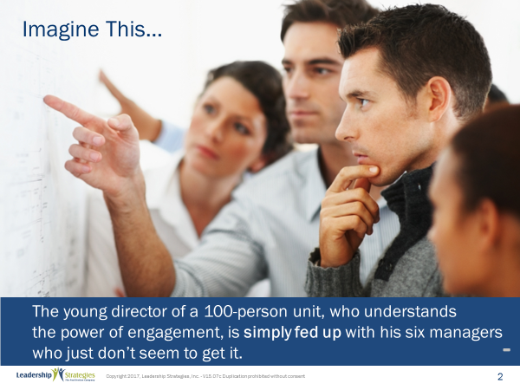 |  | SHOW POWERPOINT: Getting Started, Facilitating Yourself (slide 4 is a build)  Read slides
PPT: Traditional Approaches to Leadership  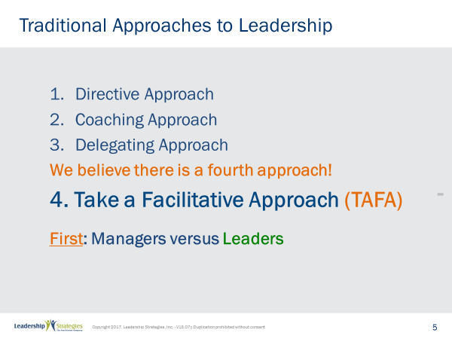 |  | SHOW POWERPOINT: Getting Started, Facilitating Yourself (build)  SAY:  While there are three traditional approaches to leadership…directive, coaching, and delegating. We believe there is a fourth approach…Taking a Facilitative Approach to Leadership. But before getting into, let’s understand the difference between a manager and a leader.
PPT: Manager vs. Leader: The Difference  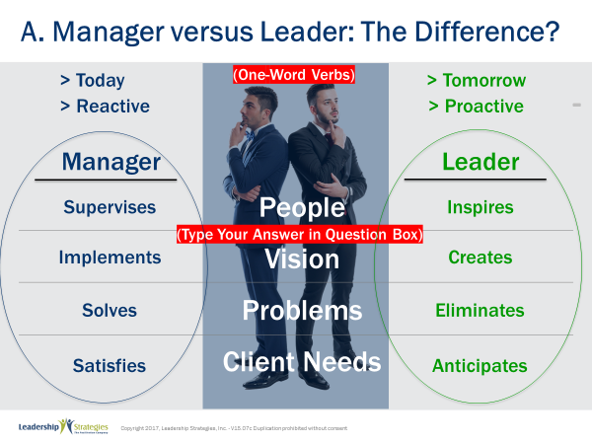 |  | SHOW POWERPOINT: Manager vs. Leader: The Difference (build)  SAY:  Let’s look at the difference between a manager and a leader across four dimensions. Let’s first get a team leader for each team…  Now team leaders, please grab the marker and set of sticky notes. Would you put a small M1 in the top right hand corner of one sticky note, and an L1 in the top right hand corner of another sticky note. And then a M2 and L2 on two other sticky notes. M3 and L3, and finally M4 and L4.  We are going to ask you to work in your teams and to identify one-word verbs for each of the four dimensions for both Managers and Leaders.  For example, under what does a manager do with people, you might say a manager speaks to people while a leader talks to people. Well that's not the answer of course but that's what we're looking for, one-word verbs such as talks or speaks.  You're going to have 4 minutes in your teams to come up with answers to each of those eight boxes so M1 what does a manager do with people L1 what does a leader do with people. M2 what does a manager do with vision L2 what does a leader do with vision, and so on.  Any questions? okay let's get started then. You have four minutes. If your team finishes before the allotted time, just give your team cheer. When I hear <four> cheers, I will know that everyone has finished early.  Allow 4 minutes.  SAY:  So, let’s hear your responses.  POST each teams response on the flip chart titled Manager vs. Leader for M1, then L1, M2, L2, M3, L3, and M4, L4, and then review. Check the post-its with the same or similar answers as the slides; give one dot for teach team member for the team with the most correct responses.  (Alternatively: You might ask one team only to give the answer for each row, and give a dot to each team member for each correct answer)
REVEAL answers on slide and review those not discussed.
POINT OUT:
While both managers and leaders play important organizational roles, there are several key distinctions.
- While a manager supervises people, a leader inspires people.
- While a manager solves problems, a leader eliminates problems.
- While a manager responds to client needs, a leader anticipates client needs.
- While a manager implements vision, a leader creates vision.
To summarize, we might say that…
- While a manager is reactive, a leader is proactive.
- While a manager tends to focus on today, a leader focuses on tomorrow.
- While a manager ensures people are doing the job right, a leader ensures people are doing the right job.
TRANSITION:
And we find that managers are not born they are developed and developed over three levels.
PPT: The 3 Levels of Leadership (Overseer and Coach)  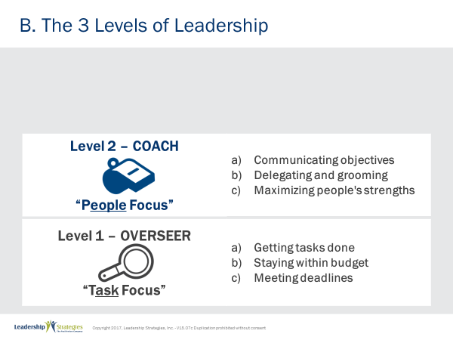 |  | SHOW POWERPOINT: The 3 Levels of Leadership: Overseer and Coach (build)  SAY:  When people are first appointed to the manager role, they tend to behave like overseers and become task focused. We call this Level 1. They are just trying to figure it all out. “What are we trying to do here? How do we get it done?” Everything centers around staying with budget, meeting deadlines, getting the job done.  Once leaders understand what it takes to be successful in the work, they then begin to realize that they can be more effective if their people are more effective. When that happens, they make the leap to Level 2. They go from being an overseer to a coach, from being task-focused to people-focused.  Level 2 leaders direct their energies toward understanding their people’s skills, maximizing their strengths and minimizing their weaknesses. Level 2 leaders focus on communicating the overall picture of what they are trying to accomplish. They delegate, they groom, and they spend a lot of time ensuring that everyone is clear about the goals. They understand that to be successful, their people have to understand the leader’s objectives and the key principles for decision-making.  When you are in the presence of a Level 2 leader, you know it because the difference is like night and day. Level 1 leaders talk about the tasks, the deliverables and the factors related to accomplishing them. Level 2 leaders, however, tend to be focused on people. They realize that they can be more successful if their people are more successful.
TRANSITION:
Let me give you an example of what I mean about communicating objectives.
PPT: Three Principles of Operation  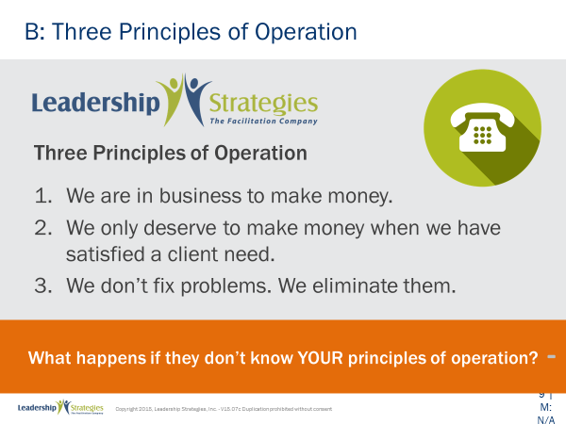 |  | SHOW POWERPOINT: The Three Principles of Operation (build)  SAY:  Among the things we do at Leadership Strategies, is we offer public classes in a number of cities across the U.S. as well as across the globe. Suppose in the next 5 minutes, a call comes into our office where a person is complaining about a class. The person might say, “I took that facilitation skills course last month and I hated it and I want my money back.” Now our Managing Director would want the person from the organization who answers that call to answer it the same way he would, wouldn’t he? And that person will answer it the same way he would, if that person understands our three basic principles of operations.  Number 1, we are in business to make money. If we are not making money we will not be in business long.  Number 2, we only deserve to make money when we have satisfied a client need.  Number 3, we do not fix problems; we eliminate them.  Suppose the person from our organization who answers the call understands only our first principle operation. We are in business to make money. How will this person answer the call? That's right, “Sorry we don't give refunds.” Well let's just say that's not the way we would want that call handled.  Suppose the person understands just our first two principles of operation. We are in business to make money, and we only deserve to make money when we have satisfied a client need. How will the person answer the call then? Yes, that's right the person might say “Sorry we didn't satisfy your need, we will gladly refund your money.” Agreed that is a better way for the call to be handled, but not quite the way our Managing Director would want it done.  But suppose the person understands all three principles of operation: We are in business to make money, we only deserve to make money when we have satisfied the client need, and we don't fix problems we eliminate them? How would the person answer the call now? That's right. “We are sorry our class wasn't helpful to you. We will gladly refund your money. But would you mind helping us? We don't want another client to have the experience that you had. So, help me understand what were you looking to gain from the class?” In this case the person might say “Well, I was looking to understand how to work better with my clients, how to build stronger relationships, how to do a better job of defining their needs.” And the person from my organization will readily recognize that the person took the wrong class because those skills and techniques we address in our consulting skills class, not our facilitation class.  Our person might ask, “Who talked with you from our organization when you signed up for the class?” The person might answer, “I didn’t speak with anyone. I signed up online on my own.” “Did someone contact you after your signed up?” The person might say, “Oh wow is that what that call was for.” Now we've learned that we need to make sure that we contact anyone who signs up on the web.  Then we might ask a question: “It sounds like we had you in the wrong class. It sounds like you wanted to learn how to diagnose your clients’ need, build stronger relationships with them, get to consensus, and how to communicate in their style. These are the exact skills that we teach in our consulting class not in our facilitation class. If you're okay with it instead of refunding your money I would love to transfer your registration to the consulting class at no additional cost to you so that you get exactly what you need.” See, we are indeed in business to make money!
POINT OUT:
So, that’s what we mean by a Level 2 Leader being able to communicate objectives. And that is a key difference between Level 1 and Level 2 leaders.
TRANSITION:
But while the difference between Level 1 and Level 2 leaders is significant, the difference between Level 2 and Level 3 leaders is even more so. While Level 1 leaders focus on task, and Level 2 leaders focus on people, Level 3 leaders focus on the future. They are constantly forward focused. We call Level 3 the visionary level.
PPT: The 3 Levels of Leadership (Overseer, Coach, and Visionary)  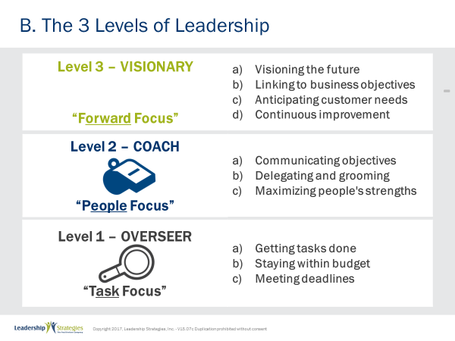 |  | SHOW POWERPOINT: The 3 Levels of Leadership: Overseer, Coach, and Visionary (build)  SAY:  Level 3 leaders want to know how decisions today will impact the future. They consistently ask themselves, “Where is the business going? How do we align our efforts with the business objectives? What do our customers want? What is coming down the pike that we need to be preparing for today? What do we need to be doing today to better prepare our business for the future?”  SAY:  Don’t leaders have to operate at all three levels? So how do I know at what level I am operating?
POINT OUT:
Yes, to some extent all leaders have to operate at all three levels. But where is your focus? What is getting your mindshare? What are you spending your time thinking about and addressing? Is your principle focus on task, people, or the future? The answers to these questions will tell you at what level you are operating.
SAY:
Are the levels the same as positions in an organization?
SAY:
No, the three levels are not positions in an organization. They are levels of development for a leader. Tragically, you can have the CEO of an organization operating at Level 1. You can also have someone in a position like receptionist acting at Level 3.
ASK:
What is the difference between a Level 1 receptionist and a Level 3 receptionist?
LOOK FOR:
- A Level 1 receptionist is just trying to get all the phone calls answered while greeting people who walk through the door.
- A Level 3 receptionist would be constantly looking for ways to improve how the phone and greeting processes could better support the business. A Level 3 receptionist might arrange for a meeting with the COO to suggest that, with the organization’s emphasis on being easy for customers to work with, it might be much more appropriate to replace the automated device that answers phone calls with a person.
TRANSITION:
Let’s take a look at another example.
PPT: Example 1: The CIO  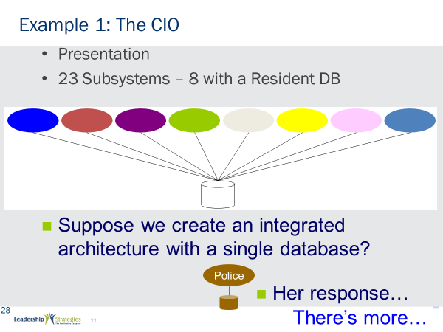 |  | SHOW POWERPOINT: The CIO (build)  SAY:  Our founder, Michael Wilkinson started his career in IT and was an information systems consultant with one of the big four consulting firms. At the time, he was in charge of the account for a large metropolitan city. At one point the city named a new CIO to head their systems area, and when she was on board for six months Michael made an appointment to meet with her.  In the meeting, he explained that there were 23 major computer applications for the city and that of those 23 systems, eight of them had a resident database, each one acting like a silo system. Any time a resident moved it was a problem because all eight of the databases had to be updated, separately, very inefficient. But also, frequently not all 8 databases were updated. And citizens would continue to get mail and other items at their old location. This was costly, inefficient, and poor customer service.  Michael presented to her the idea of creating an integrated systems architecture in which all eight systems would update a single resident database. Of course, they could not spend money on moving all their systems to this new architecture at once. But if they designed and created the architecture, as new systems came on board they could be moved to the integrated architecture – no more silos. And when an old system was updated, that system also could be moved to the integrated architecture. So, over three to five years all systems would be on the new architecture.  On paper, it was a great presentation: he gave her the reasons to change, a vision for change, a way to change. It was incredible. The heavens opened, the Angels wept, it was fantastic.  But you know what she said? “I just got a request in from the Police Bureau to implement a new system, can you do this for us?” Michael was devastated. He had presented to her this incredible vision of integrated systems, and she was asking him to implement another silo database.  But here's the good news, that was not the end of the story.
PPT: Example 1: The CIO (2 years later)  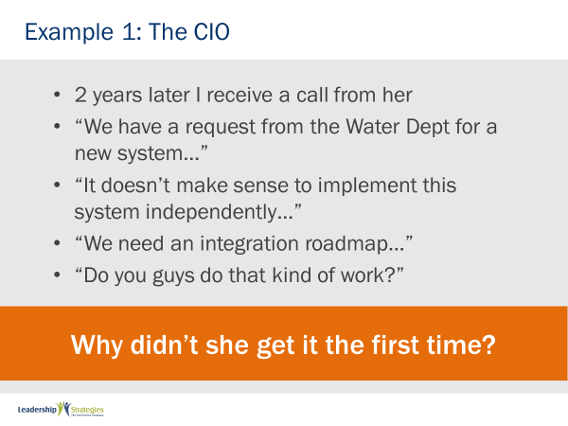 |  | SHOW POWERPOINT: The CIO (build)  READ slide.  ASK:  Here she was asking Michael to implement the same type of system, and integrated architecture, that they had talked about two years before. When he mentioned it to her, she didn't even remember the presentation! Why was that do you think?  LOOK FOR:  The first time he presented to her, she was at level one.
PPT: The 3 Levels of Leadership (Overseer)  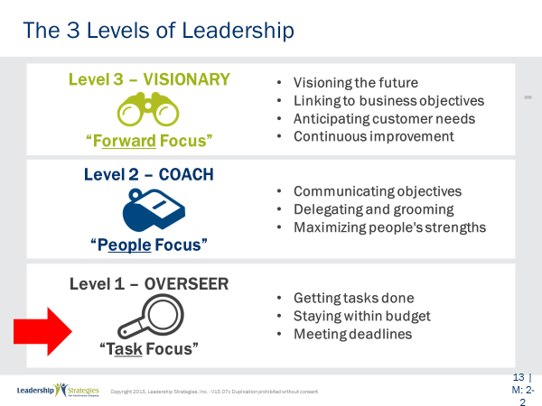 |  | SHOW POWERPOINT: The 3 Levels of Leadership: Overseer (animation)  POINT OUT:  Yes, that's right. She had been on board for only six months and was operating at level one. Michael was recommending a Level 3 vision to her. It was clearly a recommendation that didn't fit with the level she was operating on. Michael didn't understand this model at the time, but if he did he would have recognized, when a year later she was sending people to our classes, which meant what? That's right, she had moved to Level 2. All Michael had to do was think, “Give it time she'll get there.” So, he was presenting a Level 3 proposal to someone who was operating at Level 1.
PPT: The 3 Levels of Leadership (Example #2)  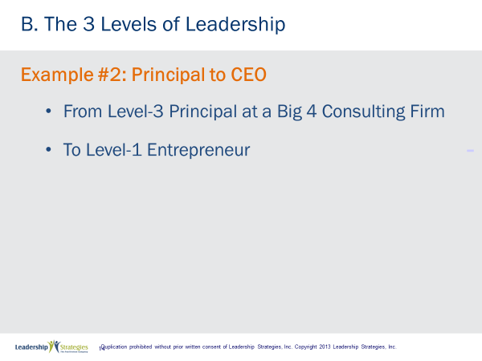 |  | SHOW POWERPOINT: The 3 Levels of Leadership, Example #2: Principal to CEO (build)  SAY:  One other example, by the time Michael had left that that big four consulting firm, he had been a principal for three years. He understood what it took to be successful as a principal, and was operating pretty close to Level 3. Then he left that consulting firm and became the first full-time employee of Leadership Strategies, the Facilitation Company, world headquarters: his second bedroom.  POINT OUT:  What happened to this Level 3 principal? That's right he moved from a Level 3 principal to a Level 1 entrepreneur. That makes sense, doesn't it? It may have kicked his behind just to get an invoice out the door. But if he didn't drop down to Level 1, where might our company be today?
PPT: Level 1 to 2  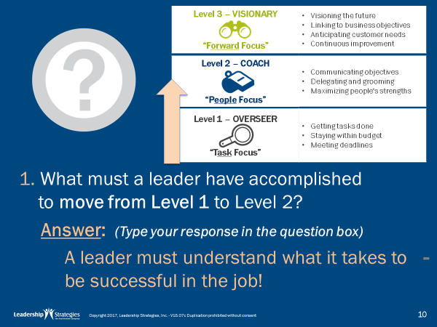 |  | SHOW POWERPOINT: Level 1 to 2 (build)  SAY:  Let’s go through some questions now.  DIRECT participants to page 1-5 of the Participant Manual.  ASK:  What must a leader have accomplished to move from Level 1 to Level 2?  LOOK FOR:  Any answers.  REVEAL answer on slide.
POINT OUT:
To move from Level 1 to Level 2, you have to understand what it takes to be successful in the job. You don’t have to know how to do the job, just what it takes to be successful so you can recruit, coach, groom and evaluate others. Until you are clear on what it takes to be successful, we recommend focusing your energies on Level 1 activities.
PPT: Level 2 to 3  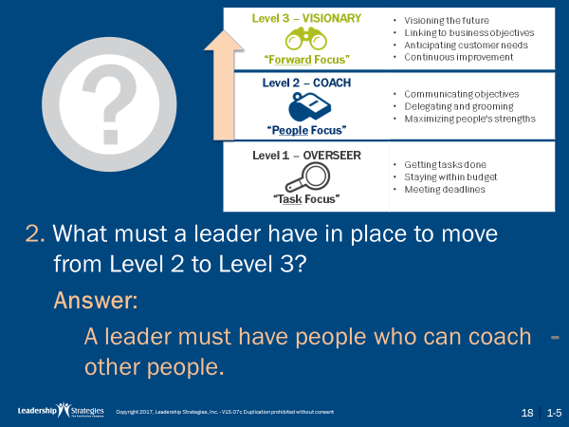 |  | SHOW POWERPOINT: Level 2 to 3  ASK:  What must a leader have in place to move from Level 2 to Level 3?  LOOK FOR:  Any answers.  REVEAL answer on slide.
POINT OUT:
Remember, Level 2 is called coach. Therefore, to have the luxury of focusing your energies on Level 3, you have to have people in place who know what it takes to be successful and who can coach other people. If you do not have people who can coach others, you will be kept at Level 2 because you will be the one coaching. To move from Level 2 to Level 3, you have to have people who know what they are doing, but those people must also know how to develop other people.
PPT: Never past Level 1?  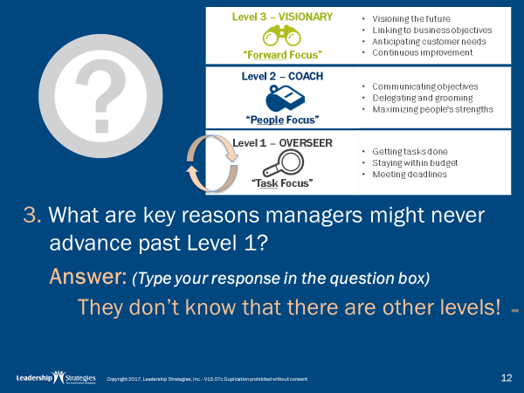 |  | SHOW POWERPOINT: Never past Level 1 (build)  ASK:  What are the key reasons a manager might never advance beyond Level 1?  LOOK FOR:  Any answers.  REVEAL answer on slide.  POINT OUT:  There are many reasons, but we find two primary ones. First, the manager lacks either the desire or the people skills to move to Level 2. In the information technology world especially, this is a frequent occurrence. However, it is the second reason that is the more challenging: many managers never get beyond Level 1 because they don’t know that there are other levels. Everyone who has ever managed them have operated at Level 1, so they believe that is what leadership is all about! They lack a vision of what leadership can be.
PPT: Start Back at Level 1  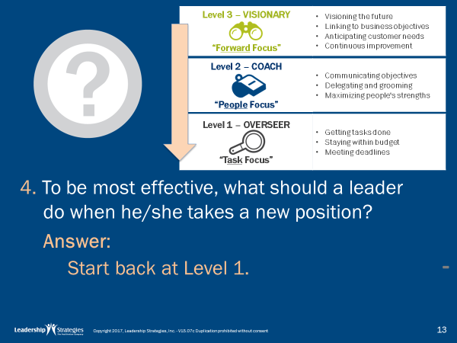 |  | SHOW POWERPOINT: Start Back at Level 1 (build)  ASK:  To be most effective, what should a leader do when he/she takes a new position?  LOOK FOR:  Any answers.  REVEAL answer on slide.  POINT OUT:  When leaders change job, they must drop back to Level 1 so they can understand what it takes to be successful in that position.
PPT: Who is Responsible…?  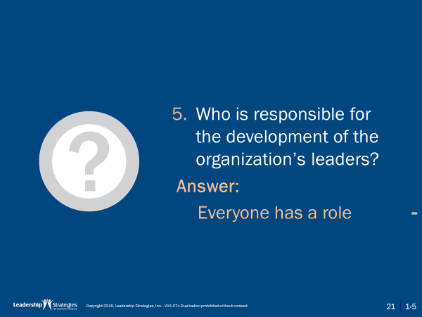 |  | SHOW POWERPOINT: Who is Responsible? (build)  ASK:  Who is responsible for the development of the organization’s leaders? Let’s give you one minute in your teams to answer this one. Let’s get new team leaders…  Okay team leaders, we would like your answer on a single post-it please. You have one minute in your teams.  Okay, let’s hear your responses.  PLACE each teams’ response on a flip chart titled “Who is Responsible for Development of Leaders?” and read them out loud.
PPT: The 3 Levels of Leadership: Responsibility for Leadership Development  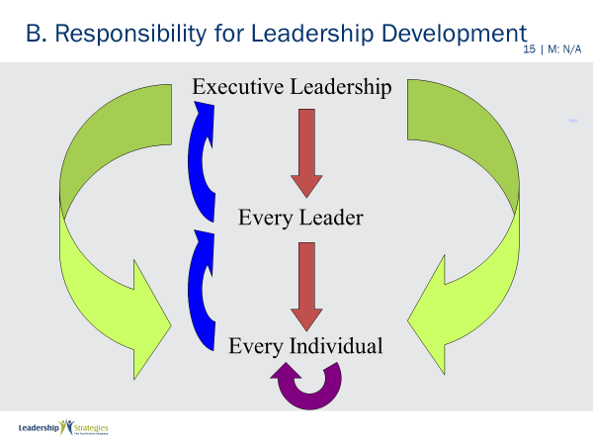 |  | SHOW POWERPOINT: The 3 Levels of Leadership: Responsibility for Leadership Development (build)  ASK:  Who is responsible for making sure leaders progress through the levels?  SAY:  - Some might say that leadership development is the responsibility of the top executive.  - Others might say that all leaders are responsible for developing the leaders under them.  - And still others might say each individual is responsible for his or her own leadership development.  ASK:  So, which is it? Who is responsible for leadership development?  POINT OUT:  In our model, we believe everyone is responsible for leadership development. But you might be aware of the truism, “When everyone is responsible that means that no one is accountable for the result.”  So, when we say, everyone is responsible, we mean everyone is responsible for playing his or her role in leadership development. Specifically:
REVEAL build on slide (green arrows).
- Responsibility for leadership development starts at the top. Executive leadership has a responsibility to create an environment for leadership development. Their role is to put in place the rewards systems for leadership development, to implement the opportunities for people to learn how to develop others, and to instill in the culture the idea that it is every leader’s responsibility to develop the leaders under them.
REVEAL build on slide (red arrows).
- The story does not stop there, however. In addition, every leader is responsible for developing the people under him or her.
REVEAL build on slide (purple arrow).
- Yet, the story continues. Every individual is responsible for grabbing these leadership opportunities. If opportunities are offered but not taken advantage of, that too is problematic.
REVEAL build on slide (blue arrows).
- And finally, every individual is responsible for developing the leaders above him/her. This is the feedback loop. As a person who heads up an organization, our Managing Director receives a lot of feedback on how to be a better leader. Sometimes more feedback then he would like! But as he says, “Often humbling, but always helpful.”
SAY:
Note that if any of the roles is not fulfilled, leadership development breaks down inside an organization. If the environment isn’t created, or if leaders don’t mentor others, or if individuals don’t take advantage of the opportunities, or if the feedback loop is missing, there is a leadership development breakdown inside the organization.
ASK:
How strong is the leadership development in your organization? Where is the weakest link?
REVIEW:
The Level 3 model is intended to encourage striving for a higher vision for leadership. However, if we only reward people who get things done on time and under budget, our leaders will be encouraged to focus on Level 1. We must have rewards and incentives for building leadership skills in others, anticipating customer needs, and creating and implementing higher visions.
SAY:
How does a leader move to a higher level?
POINT OUT:
- Leaders can move from Level 1 to Level 2 when they understand what it takes for their organization to be successful. Accordingly, leaders named to a new position should almost always drop back to Level 1, even though they may have been at Level 3 in their previous position.
- Leaders can move from Level 2 to Level 3 when they have people in place who can coach and develop others. Otherwise, they themselves will be stuck at level 2 coaching everyone else. Of course, Level-3 leaders should always be coaching their direct reports...and coaching them to move to Level 3!
PPT: Spring Forward 1a  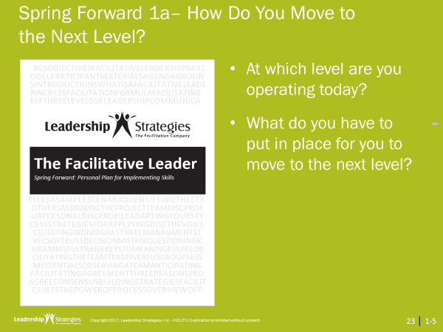 |  | SHOW POWERPOINT: Spring Forward 1a  DIRECT participants to open their Spring Forward booklet.  SAY:  Let’s pull out your Spring Forward document now and answer the two questions: At what level are you operating today, and what must you do to move to a higher level? Let’s give you four minutes to do that. And then we will hear from one volunteer at each table.  ALLOW four minutes and then take responses from each table team.
BREAK |  | SAY:  Alright, thanks everybody. Let’s take our first break. I am going to start the clock for (12) minutes. We will begin again in (12) minutes.  SAY:  Before we start the break, let me tell you about one more thing. At the end of each break, if all members of your team are back AND in their seat, that will result in a dot for each team member. If any member of the team is not back AND in their seat, you know what that means? Yes, no dots for any member of that team. So, team members, help each other. Let’s start the break.  START clock and consider showing the LSI timer on the screen.
PPT: Agenda: Agenda: Getting Started, Facilitating Yourself, Workshop Introduction  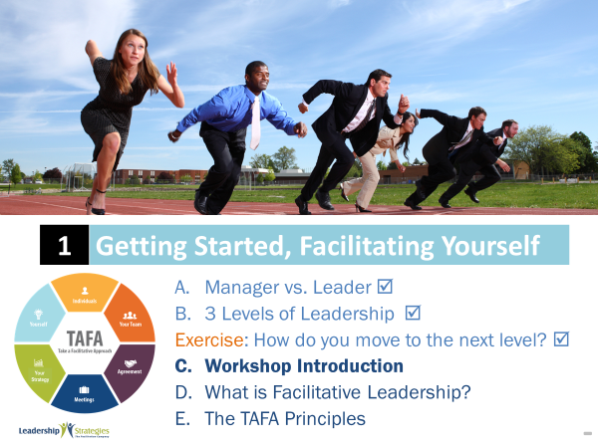 |  | SHOW POWERPOINT: Agenda: Getting Started, Facilitating Yourself, Workshop Introduction  SAY:  Now that we have gotten into the meat of the material, let’s step back now and take a look at the material in the course. Reviewing things like our agenda, your needs, ground rules, and introductions will set the path for us for the next [two days].
PPT: Workshop Introduction: Course Objectives 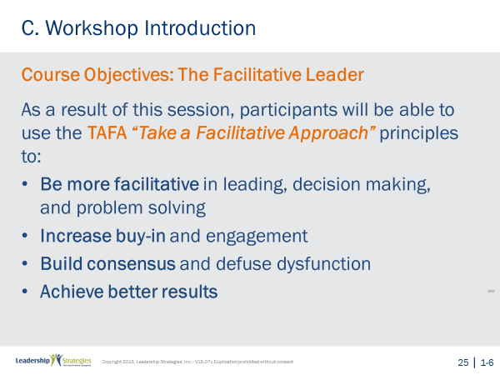 |  | NOTE TO INSTRUCTOR: Workshop Introduction slides are to be used for when the entire course is being taught. They should be hidden if this module is being taught as a stand-alone.  SHOW POWERPOINT 23: Workshop Introduction: Course Objectives (build)  READ objectives on slide.
TRANSITION:
These, our objectives, are important, and we want to ensure every participant has the opportunity to meet these objectives. But, let’s make a deal – this is your class. As I stated earlier, I want this to be the most productive [two days] that you have ever spent. I value your time, so I want to make sure I cover what is important to you. However, to do that, you have to tell me what that is. Here is how I would like to accomplish that.
PPT: Workshop Introduction: Leadership Skils to Improve (may be hidden)  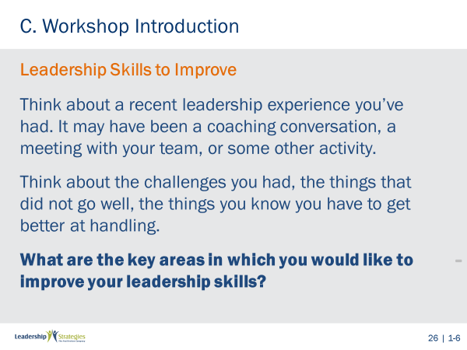 |  | SHOW POWERPOINT: Workshop Introduction: Leadership Skills to Improve (Build slide)  INTRODUCE the teams:  Over to my left we have the (red) team. Can we give the (red) team a hand? And, next we have the (green) team, etc. [Introduce each team, clap and raise the energy level, get people ready to engage and demonstrate how engagement starts early and the impact that can have in a room/meeting/training.]  To help in the team process, I need a volunteer from each team to stand. Now, I want to tell you that with risk, comes reward --- and that is at LSI, we protect our volunteers. So, trust me, it is a good thing to volunteer. (Red) team, can I have a volunteer? Thank you, (name).  AWARD the volunteer a dot.  SAY:  Has anyone here ever used dots? Great, (name), would you share with us what you have used dots for in the past? Anyone else? OK, great, so what we are going to use dots for during the next (three) days are to recognize participation. We will award dots for questions, for answers, and for helping to “share the power of facilitation” with the group. At the end of our (three) days, we are going to award a great prize, well maybe it’s not a great prize but it is a good prize, to the person with the most dots.  After each team has their volunteer, SAY:  Now, volunteers, I need each of you to grab the pad and color marker in one hand and with your other hand, touch the shoulder of one of  your teammates. The person you are touching is now the Team Leader for this exercise. Volunteers, you may now sit down.  AWARD dots to each new team leader.  SAY:  We now have instructions for the Team Leaders and Team Members. Team Leaders, you and your teams will have 90 seconds to identify as many topics as you can that you want to see covered in this class related to facilitation. There are only three rules:  - You must use the pad and marker you have been given. Note, the marker is pretty big, and the Post-it notes are pretty small. So, write accordingly.  - Each answer must be written on its own, individual Post-it note. That’s right, only one item per Post-it and you can have as many items as you please. So, (blue) team, if you have 5 items, how many post –its will you have? Great, 5, and that is as complicated as the math will be for the next few days.  - When the two minutes are up, you must have your pens capped and in the air; otherwise, you will lose two Post-its. When you lose two Post-its, guess how many dots you lose?  That’s right quantity and quality count. The more Post-its, the more dots. Team Members, your job is to contribute.  ASK:  Any questions?  ANSWER questions.  REVEAL and READ the starting question on the slide:  Think about a recent leadership experience you’ve had. It may have been a coaching conversation, a meeting with your team, or some other activity.  Think about the challenges you had, the things that did not go well, the things you know you have to get better at handling.  What are the key areas in which you would like to improve your leadership skills?  ALLOW 2 minutes.  When the time is up, COLLECT the Post-it notes. AWARD the team with the most post-it’s the Quantity award (a dot for each person on the team.
GROUP and post participant key areas to improve on a flip chart.
When the grouping is complete, AWARD the quality award to the team that has at least 1 Post-it note in the most # of categories.
PPT: Workshop Introduction: The Course Modules 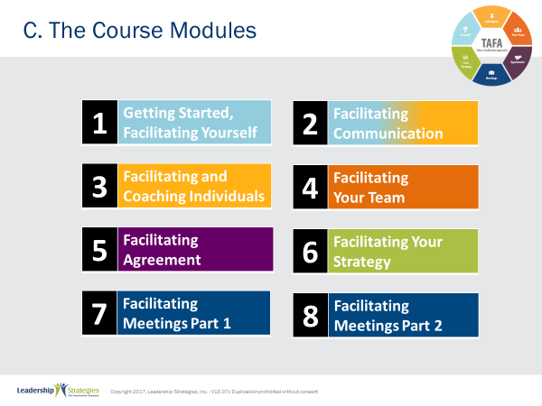 |  | SHOW POWERPOINT: Workshop Introduction: Leadership Skills to Improve (Build slide)  SAY:  We will come back to those improvement areas in just a minute, but first let’s take a look at our agenda for the next [two days].  [Note that only modules 1-4 are covered in the Public class, but do point out the additional modules that make up the series.]  READ agenda on slide.  TRANSITION:  Now, let’s walk through each of the modules and the content in each.
PPTs: (Module Agendas)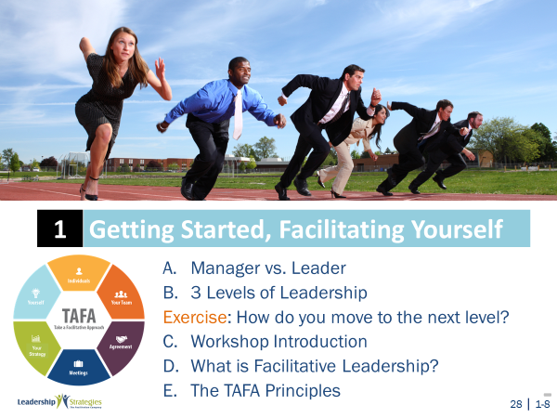 |  | SHOW POWERPOINTS: (Module Agendas)  REVIEW the agendas for each of the modules using the agenda slides. Be sure to highlight the most valuable content in each module as a teaser to the participants.  [Note that only modules 1-4 are covered in the Public class, no need to go over the individual agendas for those classes at this point. Hide slides 30-32.]
PPT: The Course Modules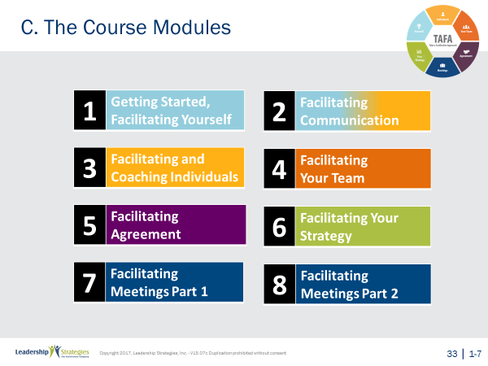 |  | SHOW POWERPOINT: The Course Modules  SAY:  OK, while we have the complete course agenda in front of us, let’s go back to our grouped objectives.  Go back to each category from the grouped objectives collected earlier and ASK the group where that item will be covered. MATCH their objectives to the agenda items and demonstrate how to adapt the agenda to meet the need for any group of items that is not covered by the modules.
PPT: Workshop Introduction: Ground Rules 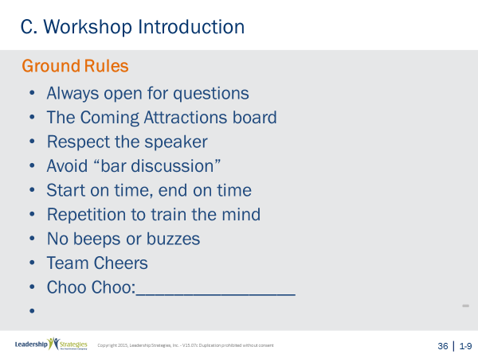 |  | SHOW POWERPOINT: Workshop Introduction: Ground Rules  SAY:  Well, as you can see, we have a very ambitious agenda over the next [two] days. In order to get through it smoothly, I would like us to agree on some “Ground Rules” or “Session Guidelines.”  ASK:  By a show of hands, how many of you have been in some type of training class before? [Raise your hand.]  SAY:  So, you know those things that work and don’t work. I value your time. I want this to be a productive session for you. So, what are those guidelines that we need to have in place to make this a productive session for you? Let’s take a look at these ground rules for how we will conduct our session for the next [two] days and reach an agreement on them.  REVIEW ground rules on slide. ASK group if they would like to add or delete any of these ground rules.  ASK for a show of hands to adopt the ground rules as revised.
PPT: Your Materials 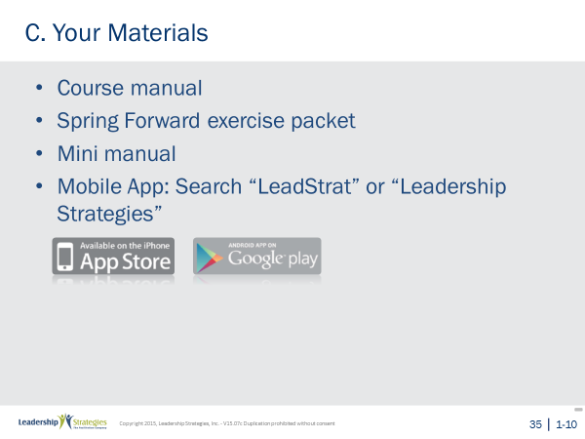 |  | SHOW POWERPOINT: Your Materials (build)  WALK participants through the course materials.
PPT: Workshop Introduction: Introductions 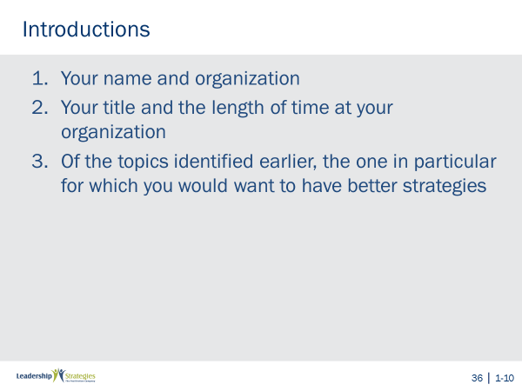 |  | SHOW POWERPOINT: Workshop Introduction: Ground Rules  SAY:  Before we get into the session formally, I would like each person to introduce himself/herself by stating:  - Your name and organization  - Your title and the length of time at your organization  - Of the topics identified earlier, the one in particular for which you would want to have better strategies  MODEL the use of the three steps by conducing your introduction.  SAY:  Before we start… Please, we want the Reader’s Digest version and not the, “I was born in a log cabin where we had no running water, walked uphill both to and from school, etc.” So, let’s not make it more than one minute/person.  Now, if we start here with (name), by the time we get to (5th or so person), he/she will have been so busy thinking of what to say, that he/she won’t remember anything anyone said prior. So, let’s take a minute for each of you to jot down or think about what you will say. And, when the minute is up, we will start with the (blue) team and with (name). Any questions?  TAKE questions.  SAY:  Alright, let me start the clock, so you can prepare what you will each say.  START the clock for a minute, and when the minute is up, begin with the person you announced at the beginning.
PPT: Agenda: What is Facilitative Leadership? 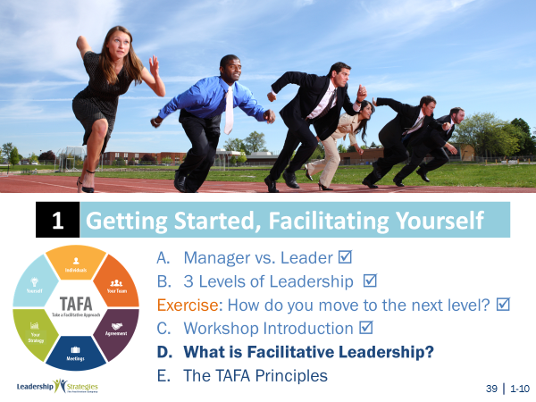 |  | SHOW POWERPOINT: Agenda: What is Facilitative Leadership?  CHECKPOINT:  Now that we’ve completed the course introduction, let’s define what we mean by Facilitative Leadership. This will set the foundation for the skills and techniques you will be learning.  SAY:  So, let’s explain what we mean by Facilitative Leadership. For us, facilitative leaders take a facilitative approach to making decisions, solving problems, managing people, and inspiring performance. Let me describe what we mean by this.
PPT: What is Facilitative Leadership?: The Scenario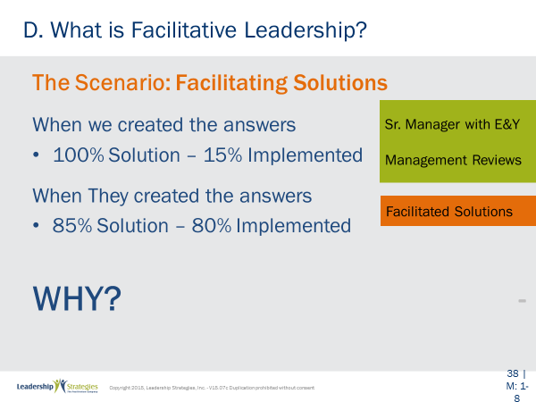 |  | SHOW POWERPOINT: What is Facilitative Leadership?: The Scenario (build)  SAY:  When Michael Wilkinson, our founder, began understanding the fundamental secret of facilitation during his career with the management consulting division of what was then one of the Big 8 accounting and consulting firms. In the eight years he spent in that consulting practice, they had a standard way of addressing a client’s problem. They might be called in to review a particular department or activity. They would arrive with an army of bright people, interview those who they believed were the key stakeholders, develop a set of recommendations based on interviews and experience, and create what might be called the “100 percent solution.” They would go away and come back a year later, and, if they were lucky, perhaps 15 percent of their recommendations would be implemented.  Later, the practice in which he worked began taking a different, more facilitative approach. They would come in with a smaller group of consultants and work shoulder-to-shoulder with client personnel. Together they would convene group interviews (facilitated sessions), which typically included eight to twenty people. In the facilitated sessions, the participants—not the consultants—would create the recommendations. In most cases, they would come up with what might be considered only the 60 or 70 percent solution. So, they would float ideas based on their experience. Some the client would accept; others they would reject as “not beneficial” or “not implementable” in their environment. When all was done, they might have created what the consultants would consider the 85 percent solution. Yet when Michael’s firm came back a year later, amazingly 80 to 90 percent of the solution would be implemented!  ASK:  Why did this happen?
TRANSITION:
We believe it happened because of what we call the fundamental secret of facilitation.
PPT: What is Facilitative Leadership?: The Fundamental Principle of Facilitation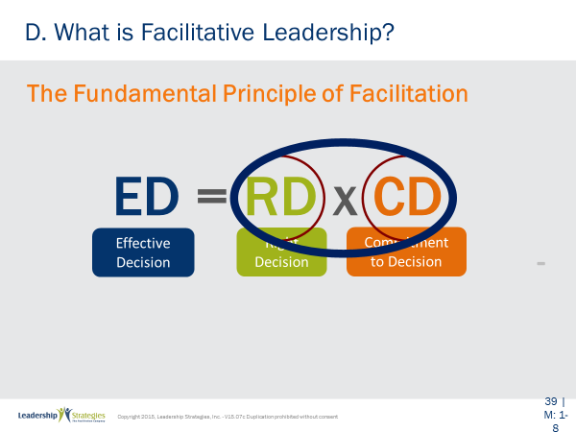 |  | SHOW POWERPOINT: What is Facilitative Leadership?: The Fundamental Principle of Facilitation  SAY:  You can achieve more effective results when solutions are created, understood, and accepted by the people impacted.  In essence, when you get the people impacted by a decision involved in the decision-making, you can arrive at better solutions and achieve much higher levels of buy-in and commitment to implementation.  Dr. Robert Zawacki from the University of Colorado in his book “Transforming the Mature Information Technology Organization” put the secret this way:  REVEAL slide to coincide with the explanation of the formula.  Effective Decisions = The Right Decision times Commitment to the Decision.  SAY:  Dr. Zawacki’s point is that the multiplication sign in the formula means that even the best decision can be rendered completely ineffective if commitment to the decision is lacking. A group of consultants might have created the 100% solution for a client, but if the client doesn’t buy-in to the solution, the effectiveness of the solution would be essentially zero. Likewise, if leaders create the solutions that their people don’t buy-in to, once more, the effectiveness is zero.
TRANSITION:
How do you apply this fundamental principle? Let’s take one example, and let’s look at the old way of doing things and you give me your ideas of how you might do this the new way by taking a facilitative approach.
PPT: What is Facilitative Leadership?: Old Way vs. New Way: Old Way  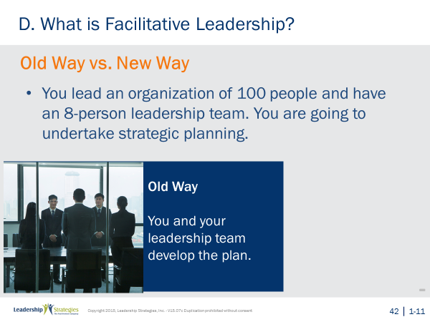 |  | SHOW POWERPOINT: What is Facilitative Leadership?: Old Way vs. New Way (build slide)  RELATE:  You lead an organization of 100 people and have an 8-person leadership team. You are going to undertake strategic planning.  ASK:  What is the traditional way that this is done?  REVEAL Old Way build on slide.  SAY:  Traditionally, the leadership team would develop the plan, and then push it down through the organization.  DIRECT:  In your table groups, I would like to allow you two minutes to answer the following question: Given what you just heard about ED=RDxCD, what method could you use instead that would be more facilitative?  ALLOW two minutes and take answers from each of the groups.  REVEAL New Way build on slide. Discuss advantages to this new way.
TRANSITION:
So, how do you define this new way? What are the fundamental principles that guide this new way?
PPT: The TAFA Principles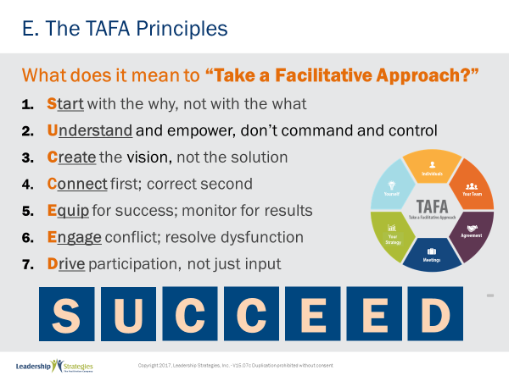 |  | SHOW POWERPOINT: The TAFA Principles (build)  SAY:  There are 7 key TAFA principles – the principles of taking a facilitation approach. Any time you have a decision to make, a problem to solve, someone to coach or correct, we are going to be giving you tools and techniques for implementing these principles.  Let’s walk through them together.  People are often inspired when they are connected and aligned with purpose. Unfortunately, as leaders we often focus on what we want done and start there. Facilitative leaders understand the importance of why and always start any discussion, meeting, initiative kickoff, etc., with the why.  Often leaders don’t involve those impacted because they believe they need to control all aspects of what is done in order to achieve their desired result.  However, leaders who take a facilitative approach understand how to empower others by defining purpose and providing guidelines that allow teams to create recommendations that are thoughtful and innovative, but also practical and implementable.  One of the key roles of leaders is to set a vision of success with a clear and compelling “why” that inspires success. Facilitative leaders understand that once they set the vision they must give their people the authority, resources, support and coaching so that their people can develop and implement solutions and strategies that bring the vision into reality.  Some leaders are expert at pointing out mistakes their people make. They seem to enjoy demonstrating their superiority by identifying errors and then showing their people what they have done wrong.  Leaders who take a facilitative approach understand the importance of connecting with people first and helping them discover their own errors. They recognize the power of being the “guide on the side” rather than the “sage on the stage.” They strive to leave every interaction with the person feeling lifted up rather than beaten down.  So many teams are essentially destined to fail from the start because they are not properly equipped for success. Facilitative leaders understand that teams require eight essentials and provide teams the essentials they need to accomplish their work. At the same time, many plans fall short of their desired ends due to lack of monitoring for results. For example, how often do strategic plans get written and then put on a shelf? Facilitative leaders understand the need to monitor for results every step of the way.  Leaders who don’t have the tools to effectively manage conflict and dysfunction tend to respond with either a “fight or flight” strategy when faced with a challenging situation. Those leaders who take the flight approach will avoid addressing the issue and will hope it goes away on its own. Those employing the fight strategy tend to try to overpower the situation by forcing their will without listening to or considering other alternatives.  Leaders skilled in taking a facilitative approach view conflict as a symptom that perhaps better solutions are available; they view dysfunction as a sign that something important is not being addressed. They understand the three reasons people disagree and have strategies for addressing each one. They fully buy-in to the dysfunction principle--conscious prevention, early detection, clean resolution--and use appropriate techniques to prevent, detect and resolve dysfunction.  How often does a decision come down from headquarters which the people in the field know makes absolutely no sense? The idea couldn’t possibly work and everyone knows it, except the leaders. What happens? Time and energy is wasted implementing something that months later gets abandoned when the leaders finally figure out it was a bad idea. If they had only asked, the wasted time and resources could have been put to a much more productive use. If they had only asked.  Or how often, when trying to make a needed change, does the change get met with blatant rejection or subtle subterfuge simply because those expected to implement the change had no involvement up front in the creation?  Leaders who take a facilitative approach recognize that you can get better decisions and achieve higher levels of buy-in when those impacted by the decision are involved in creating it.  - In the first case of a decision coming from headquarters, the involvement of those who would have to implement the decision would have likely yielded an even better solution that took into account issues and situations that the workers understood but of which the leaders were unaware.  - In the case of the needed change that was met with significant opposition, involvement up front could have yielded greater buy-in and commitment to the implementation.  SUMMARIZE:  These principles outline what it means to take a facilitative approach inside an organization. As more and more leaders adopt a facilitative approach to leadership, we expect to see greater business results through higher levels of buy-in and commitment throughout the organization.
  1 | Start with the why, not with the what
  2 | Understand and empower; don’t command and control
  3 | Create the Vision, not the solution
  4 | Connect first; correct second
  5 | Equip for success; monitor for results
  6 | Engage conflict; address dysfunction
  7 | Drive participation, not just input
PPT: Review Slides  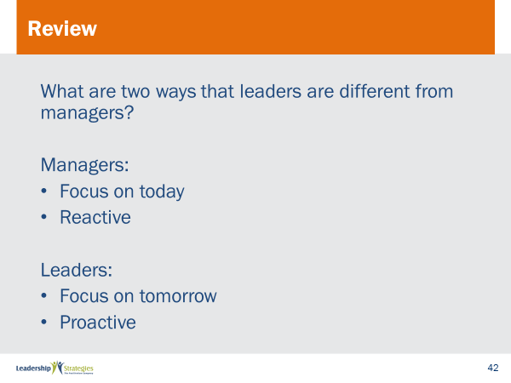 |  | SHOW POWERPOINTS: Review Slides (builds)  SAY:  Now it is time to do some review. We’ll do this by table teams, starting with the (color) team and rotating clockwise. If your team gets the answer, dots for everyone on the team.
PPT: In-class / Homework Slides  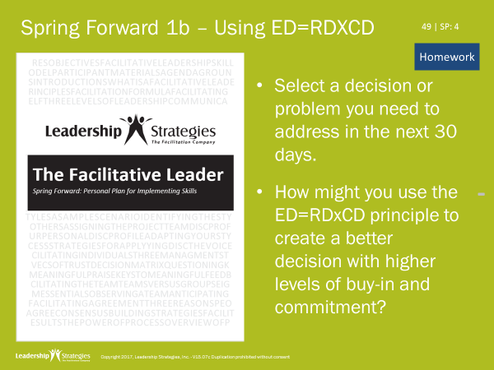  or |  | SHOW POWERPOINT: In-class/Homework slides (builds)  Note to Instructor: This will either be an in-class activity (if another module follows or it is the last module for the client) or it will be homework because the participants will be coming back at another time. Use the appropriate slide.  IN-CLASS ACTIVITY:  SAY:  Let’s pull out the Spring Forward manual so we can focus on applying what we just learned.  READ through the activity. ALLOW 5 minutes. PROCESS responses as time allows. For example, have them share with one partner, have them talk at tables, have one person from each table share their view, etc.  or  HOMEWORK:  SAY:  Before closing out, let’s talk about homework that will help put application to what we’ve learned today.  READ the first two bullets.  SAY:  When we come back together we will want to hear three things: we will be discussing the problem you needed to address, how you applied ED=RDxCD and the results you achieved.
PPT: TAFA 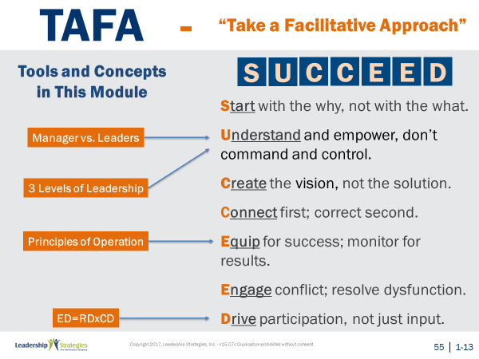 |  | SHOW POWERPOINTS: TAFA (build)  SAY:  Let’s take a moment to look at some of the concepts we’ve learned in this module and examine how they reflect the TAFA principles.  REVIEW slide and lead discussion by asking if there are other principles that are reflected by the concepts.
PPT: Agenda 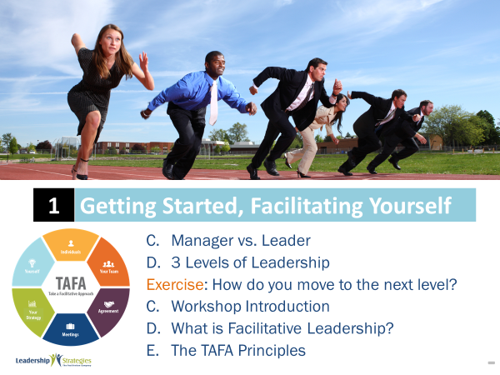 |  | SHOW POWERPOINTS: Agenda  SAY:  We have just completed the module!
PPT: Checkpoint 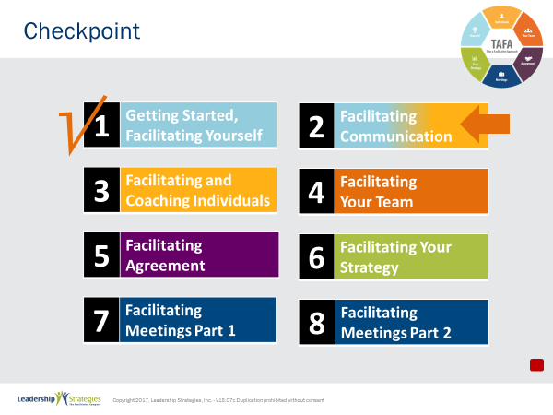 |  | SHOW POWERPOINTS: Checkpoint  SAY:  We have just completed our first module where we examined the concept of leadership including manager vs. leader, the three levels of leadership, and the concept of Facilitative Leadership. [For multi-day courses] We also completed our course introduction which set the foundation for how we will work together these (two) days.  Our next module is all about communication. This is one of the most critical things we do as leaders, and, as we will teach you, it is all about understanding others and how they communicate in order to be the most effective communicator.
PPT: Connect with LSI 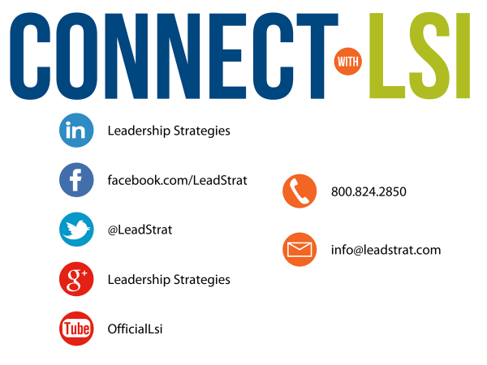 |  | SHOW POWERPOINTS: Connect with LSI  Note to Instructor: this slide may be excluded if you are going directly into the next module. In that case, hide the slide.  SAY:  We fundamentally believe facilitation is a skill that applies in a multitude of situations. We also are confident that in our quest to “share the power of facilitation with the world” that connecting via social media is a way for all of us to collectively share our successes, our challenges and our facilitation work. To “facilitate” that process, we want to ensure you are aware of how we can all stay connected using social media.  How many of you have found many of the skills in the class helpful? [raise your hand] I know that one of the things I did after attending was share what I learned with many of my colleagues. Have some of you already thought about that? [nod your head]  Then, one request we would like to make of you is to update your “education or classes attended” on your LinkedIn profile. That visibility will help all of us to “share the power” I have been referring to. Any questions?  FACILITATE the discussion.
PPT: Congratulations!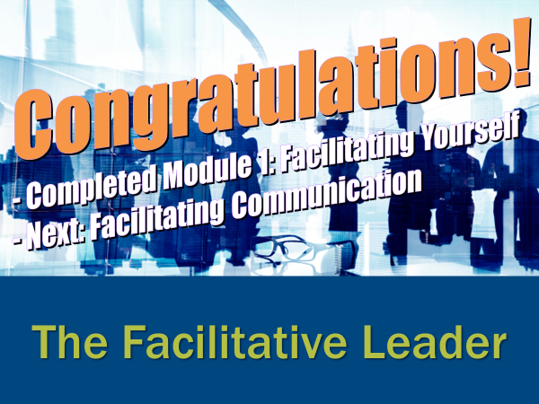 |  | SHOW POWERPOINT: Congratulations! (builds)  Note to Instructor: Select the correct slide depending on whether you are moving on to the next module, coming back another day, or have completed the workshop for this group. Hide the other Congratulations! Slides.  REVIEW content on slide. Conduct Post-Test, Evaluations, Dot winner (MVP), and From Classroom to Application as appropriate.  Directions for Post Test:  If appropriate, handout the post-test. Give people five minutes to complete. Ask teams to give their cheer once completed.  Once completed, have team members pass their post-test clockwise to a new person. Go through each question and have the group give responses. Instruct them to place a checkmark for each correct response.  Once completed have people add up the number of check marks and place the total at the top.  Since each post-test has eight questions, place the number 8 through 0 in the first column of a two-column chart.  Before people had the post-tests back to the owner, do a round robin and have people indicate the number the person got corrected. Place a tick mark next to that number each time that number is reported.  THANK participants and dismiss class.
 | End | END OF THE FACILITATIVE LEADER MODULE ONE

